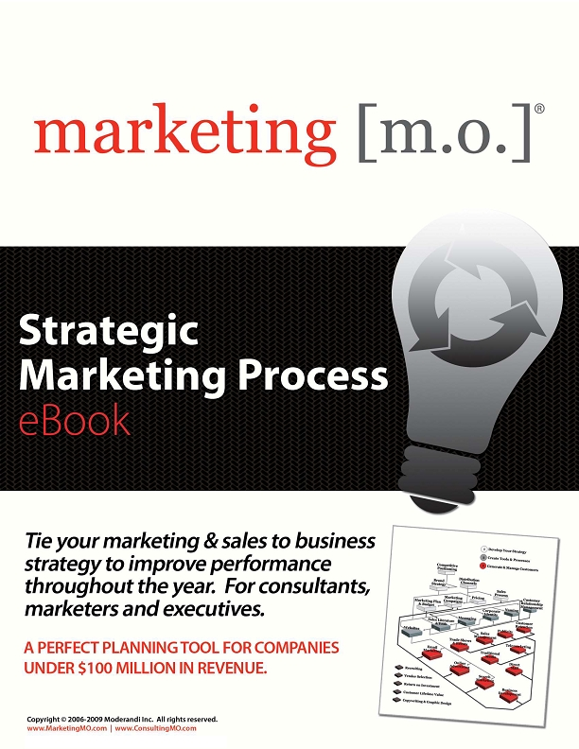

•
•
•
•
•
•
•
•
•
•
•
•
•
•
•
•
•
•
•
•
•
•
•
•
•
•
•
•
•
•
•
•
•
•
•
•
•
•
•
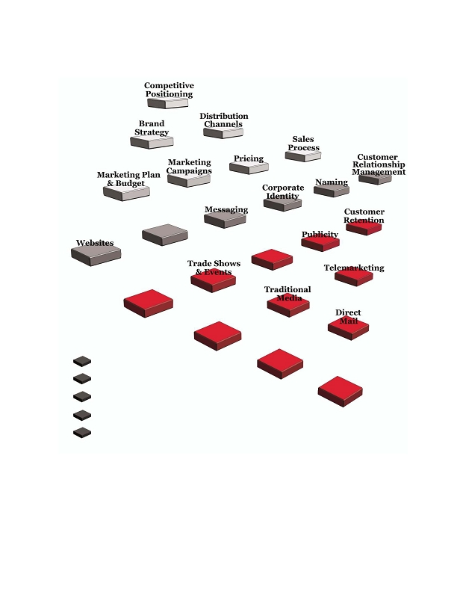
Preface
Most small to medium-sized businesses struggle with marketing. The marketing function is often treated as a
cost center--ad hoc activities that don't produce measurable results that are tracked to the top and bottom line.

This e-book defines a marketing process that businesses can use to put structure around their daily, monthly
and annual revenue-generating activities.

It covers more than just "traditional" marketing and ties together all go-to-market business activities: strategic
planning, financial planning and measurement, creative development, marketing execution and sales.

If you're a business marketer or executive, complete the Key Concepts and Steps section in each subject to
improve your performance throughout the year. If you'd like to access a complete set of exercises and marketing
tools based on this e-book, check out our offering at www.GrowthPanel.com.

Growth Panel delivers hundreds of marketing tools from each subject of the process. Download a career's worth
of tools to use on the job -- over 1,600 pages of marketing tools published in Word and Excel and over 30,000
combinations of marketing execution plans. They're comprehensive, detailed and granular.

If you like detailed planning from the 30,000 foot level down to the 5 foot execution level, you'll love our tool.
We have a version for marketers and entrepreneurs and a Professional version for consultants and services
firms to use under their own brand.

Typical Professional users are:

• Business consultants
• Marketing consultants with expertise in a specific function
• Sales coaches
• Advertising agencies
• Graphic design firms
• Marketing communications firms
• Web design/development firms
• PR firms
• Aspiring entrepreneurs who are looking for a new business opportunity

Connect with us to learn more. http://www.growthpanel.com/versions/get-started.html

Enjoy the e-book!
• fffiffi,-ff./0fi1230fffi00 fffiff4056ff0ff,,,78 fffi897.7
1

Contents

page3
Introduction
6
13
10
21
24
17
47
28
36
32
38
74
44
41
Sales 0Literature
& Tools
56
50
Sales
Management

80
62
59
65
Email
Marketing
71
Online
Advertising
77
68
Search
Marketing
Recruiting 83

Vendor Selection
85
53
Business
Development
Return on Investment
87
Customer Lifetime Value
90
Copywriting & Graphic Design
93
What's Next
page 96
..00.0,ffi fffi/0201fiffi fffi4.00,,,7,ffi fi/7.7
2
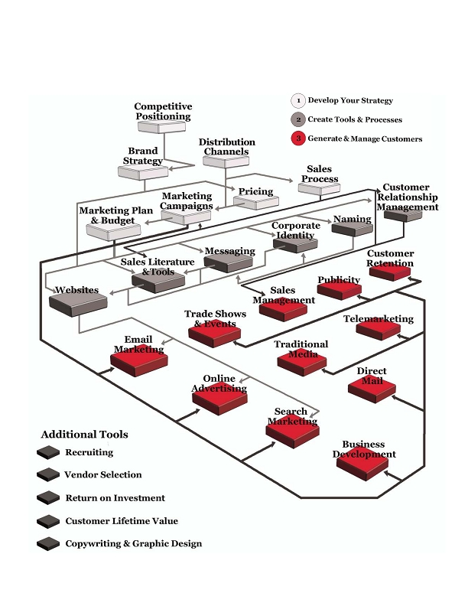
Introduction
What is marketing? It's a broad, challenging and often misunderstood function. Ask several people to
define it and you'll probably get very different answers:

• It's brochures and slogans and print ads in magazines
• It's websites and email campaigns
• It's communicating with customers
• It's an MBA crunching numbers on brand equity and market share

Yet marketing is much more than brochures and websites and numbers; it's an investment that generates
revenue, profit and opportunity for growth.

Marketing is the process of developing and communicating value to your prospects and
customers. Think about every step you take to sell, service and manage your customers:

• Your knowledge of the market and your strategy to penetrate it
• The distribution channels you use to connect with your customers
• Your pricing strategy
• The messages you deliver to your market
• The look and feel of your marketing materials
• The experience you deliver to your market and customers
• The actions of your sales and service reps
• All of the planning, preparation, forecasting and measurement of your investments

Good marketing is essential for every company. It can make a company with a mediocre product
successful, but poor marketing can send a good company out of business. Yet even business-to-business (B2B)
marketing is often seen as a soft creative field instead of the engine that drives company revenue.
• fffiffi,-ff./0fi1230fffi00 fffiff4056ff0ff,,,78 fffi897.7
3

Key concepts & steps
•

The Strategic Marketing Process organizes 29 marketing subjects into three categories:
..00.0,ffi fffi/0201fiffi fffi4.00,,,7,ffi fi/7.7
4

This guidebook provides a short, essential introduction for each subject. The maps also show how one subject is
linked to others.

In a perfect world, you would start with competitive positioning and build your entire marketing program
following this process. Unless you're a startup company, you probably don't have time to do so; you need to
focus on the task at hand. That's fine. Use your M.O. to tackle projects as they come up.

Marketing is complex, but don't shy away from subjects that could help you grow your business; repetition is
the key to success. Embrace marketing, and most importantly, enjoy creating and communicating your value to
your market.

Good luck!
•
•
•
•
•
•
•
•
•
•
•
•
•
•
•
•
•
•
•
NOTE

The Strategic Marketing Process is designed for
business-to-business (B2B) marketers. Business-to-
consumer marketers (B2C) follow a similar process, with a
few additional subjects like product placement, market
demographics and packaging.

In addition, all of the concepts and instructions in
the process apply to both product marketing and
service marketing. However, the phrase
"product/service" is long and distracting, so we just use the
term "product."
• fffiffi,-ff./0fi1230fffi00 fffiff4056ff0ff,,,78 fffi897.7
5
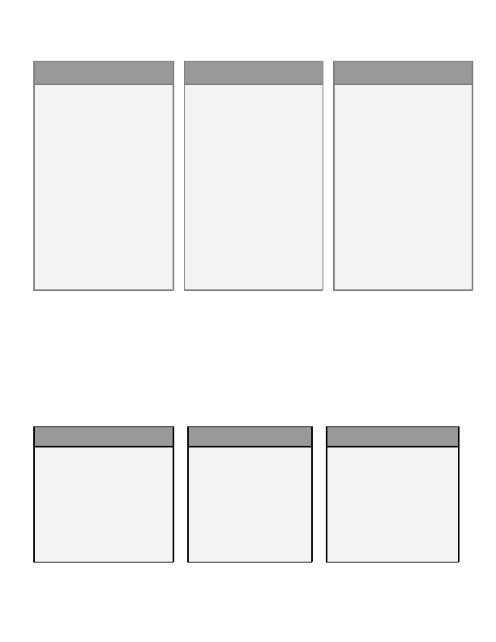
Competitive Positioning
What sets your product, service and company apart from your competitors? What value do you provide and
how is it different than the alternatives?

Competitive positioning is about defining how you'll "differentiate" your offering and create
value for your market. It's about carving out a spot in the competitive landscape and focusing your
company to deliver on that strategy. A good strategy includes:

• Market profile: size, competitors, stage of growth
• Customer segments: groups of prospects with similar wants & needs
• Competitive analysis: strengths, weaknesses, opportunities and threats in the landscape
• Positioning strategy: how you'll position your offering to focus on opportunities in the market
• Value proposition: the type of value you'll deliver to the market

When your market clearly sees how your offering is different than that of your competition, it's easier to
generate new prospects and guide them to buy. Without differentiation, it takes more time and money to show
prospects why they should choose you; as a result, you often end up competing on price - a tough position to
sustain over the long term.

One of the key elements of your positioning strategy is your value proposition. There are three
essential types of value: operational excellence, product leadership and customer intimacy.
..00.0,ffi fffi/0201fiffi fffi4.00,,,7,ffi fi/7.7
6

Here is a hypothetical example of each type of value.
OPERATIONAL
EXCELLENCE

Carrot Technology's customers don't
want bells and whistles, just a good
product at the lowest possible price.

Carrot focuses on operational
excellence so they can continually
offer the lowest price in the market.
For example, they just patented a new
machine that dramatically lowers
their costs. They're not trying to come
up with new or better products; they
just want to produce more volume at a
lower cost.

Carrot's value proposition is
operational excellence; they convey it
in their messages and in everything
they do.
PRODUCT LEADERSHIP
Alpha Co.'s customers care most
about quality - they want the best
product.

Alpha is completely dedicated to
innovation and quality. They're
constantly working on product
improvements and new ideas that
they can bring to market. They know
what their competitors are doing and
are completely focused on staying one
step ahead in order to capture a
greater share of their market.

Alpha's culture is all about product
leadership, and their prospects see it
even before they become customers.
CUSTOMER INTIMACY

Starboard's market is flooded with
products at all ends of the price
spectrum.

Yet Starboard's customers want more
than a product off the shelf; they
want customized solutions. So
Starboard's mission is to know as
much as possible about their
customers' businesses so they can
deliver the correct solutions over
time.

Starboard knows they can't just say
"We offer great service." Starboard's
team knows they have to deliver on
that value proposition in every
interaction they have with prospects
and customers.
These companies are totally focused on delivering their value propositions. They don't just say it -- they do it,
and that makes it easier to win in their respective markets.

Rather than leaving your positioning and value proposition to chance, establish a strategy. Think impartially
about the wants and needs of your customers and what your competition offers. You may find an unmet need
in the market, or you may realize that you need to find a way to differentiate from your competitors.

As a result, you may decide to promote a different attribute of your product, or you may find entirely new
opportunities to create new products and services. Either way, you'll strengthen your business in both the short
and long term.
BEST CASE

You provide a one-of-a-kind
product/service that your market
needs and wants. You have a strong
value proposition that differentiates
you from your competitors; you
communicate it consistently in
everything you do. Your prospects
respond because you're meeting their
needs, and your company has found
success in the market.
NEUTRAL CASE

Your product is somewhat
different and better than those of
your competitors and you
communicate that difference,
though probably not as
consistently as you should. Your
prospects partially buy into the
value you provide, but you don't
win all of the deals that you
could.
WORST CASE

Your prospects see little difference
between you and your competitors,
so you're competing solely on price.

You have to fight long and hard for
every sale.

It's very difficult to meet your
revenue and profit goals.
• fffiffi,-ff./0fi1230fffi00 fffiff4056ff0ff,,,78 fffi897.7
7

Key concepts & steps

Before you begin

Your competitive positioning strategy is the foundation of your entire business - it's the
first thing you should do if you're launching a new company or product. It's also
important when you're expanding or looking for a new edge.

Profile your market

• Document the size of your market, major competitors and how they're positioned.
• Determine whether your market is in the introductory, growth, mature, or declining stage of its life.
This "lifecycle stage" affects your entire marketing strategy.

Segment your market

• Understand the problems that your market faces. Talk with prospects and customers, or conduct
research if you have the time, budget and opportunity. Uncover their true wants and needs - you'll
learn a great deal about what you can deliver to solve their problems and beat your competitors.
• Group your prospects into "segments" that have similar problems and can use your product in similar
ways. By grouping them into segments, you can efficiently market to each group.

Evaluate your competition

• List your competitors. Include any competitors that can solve your customers' problems, even if their
solutions are much different than yours - they're still your competition.
• Rate your own company and your direct competitors on operational efficiency (price), product
leadership and customer intimacy. It's easy to think you're the best, so be as impartial as you can.

Stake a position

• Identify areas where your competition is vulnerable.
• Determine whether you can focus on those vulnerable areas - they're major opportunities.
• Identify products/services you can offer to meet the true needs of your market in a new and better way.

Define your value proposition

• There are three core types of value that a company can deliver: operational efficiency (the lowest price),
product leadership (the best product), or customer intimacy (the best solution & service). Determine
which one you're best equipped to deliver; your decision is your "value proposition."
•
•
..00.0,ffi fffi/0201fiffi fffi4.00,,,7,ffi fi/7.7
8
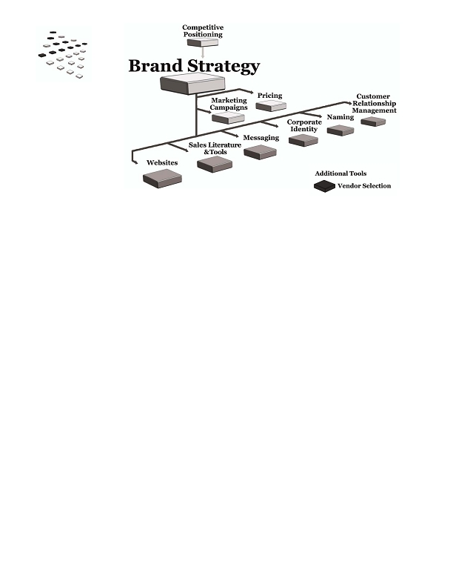
What's next?

Develop a brand strategy to help you communicate your positioning and value
proposition every time you touch your market. Together, these strategies are the
essential building blocks for your business.
• fffiffi,-ff./0fi1230fffi00 fffiff4056ff0ff,,,78 fffi897.7
9
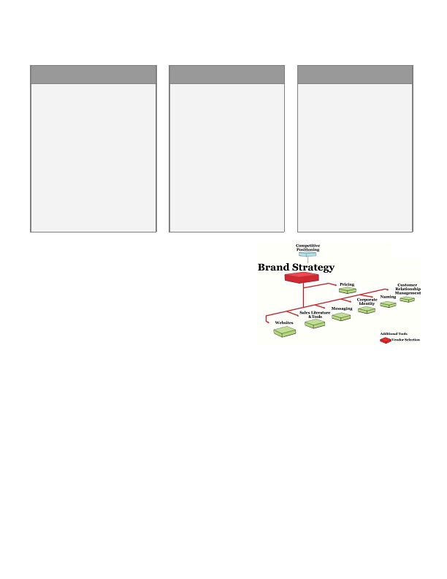
Brand Strategy
What is a brand? Is it a logo? A name or slogan? A graphic design or color scheme?

Your brand is the entire experience your prospects and customers have with your company. It's
what you stand for, a promise you make, and the personality you convey. And while it includes your
logo, color palette and slogan, those are only creative elements that convey your brand. Instead, your brand
lives in every day-t0-day interaction you have with your market:

• The images you convey
• The messages you deliver on your website, proposals and sales materials
• The way your employees interact with customers
• A customer's opinion of you versus your competition

Branding is crucial for products and services sold in huge consumer markets. It's also important in B2B
because it helps you stand out from your competition. It brings your competitive position and value
proposition to life; it positions you as a certain "something" in the mind of your prospects and customers.
Your brand consistently and repeatedly tells your prospects and customers why they should buy from you.
Think about successful consumer brands like Disney, Tiffany or Starbucks. You probably know what each
brand represents. Now imagine that you're competing against one of these companies. If you want to capture
significant market share, start with a strong and unique brand identity or you may not get far.

In your industry, there may or may not be a strong B2B brand. But when you put two companies up against
each other, the one that represents something valuable will have an easier time reaching, engaging, closing and
retaining customers. A strong brand strategy can be a big advantage.

Successful branding also creates "brand equity" - the amount of money that customers are willing to pay just
because it's your brand. In addition to generating revenue, brand equity makes your company itself more
valuable over the long term.
..00.0,ffi fffi/0201fiffi fffi4.00,,,7,ffi fi/7.7
10
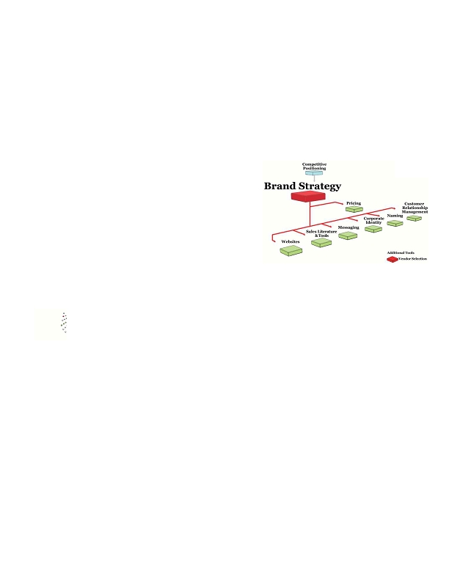
By defining your brand strategy and using it in every interaction with your market, you strengthen your
messages and relationships.
BEST CASE

Prospects and customers know exactly
what you deliver.

It's easy to begin dialogue with new
prospects because they quickly
understand what you stand for.

You close deals more quickly because
your prospects' experience with you
supports everything you say.

You can charge a premium because
your market knows why you're better
and is willing to pay for it.
NEUTRAL CASE

The market may not have a
consistent view or impression of
your product and company, but in
general you think it's positive.

You haven't thought a lot about
branding because it doesn't
necessarily seem relevant, but you
admit that you can do a better job
of communicating consistently
with the market.

You're not helping yourself but
you're not hurting yourself either.
WORST CASE

You don't have a brand strategy
and it shows. It's more difficult to
communicate with prospects and
convince them to buy. They don't
have an impression of your
product or why it's better.

What you do, what you say and
how you say it may contradict each
other and confuse your prospects.

Competitors who communicate
more strongly have a better shot at
talking with and closing your
prospective customers.
Key concepts & steps

Before you begin

Before working on your brand strategy, make sure you've
identified your competitive position - your brand strategy
will bring it to life.

If you have a brand strategy, make sure it's as effective
as possible
•
• Poll your customers, employees and vendors. Are their impressions consistent with your strategy? If
not, work on the elements you can improve.
•
Develop your brand strategy around emotional benefits

• List the features and benefits of your product / service. A feature is an attribute - a color, a
configuration; a benefit is what that feature does for the customer.
• Determine which benefits are most important to each of your customer segments.
• Identify which benefits are emotional - the most powerful brand strategies tap into emotions, even
among business buyers.
• Look at the emotional benefits and boil them down to one thing that your customers should think of
when they think of you. That's what your brand should represent.
•
• fffiffi,-ff./0fi1230fffi00 fffiff4056ff0ff,,,78 fffi897.7
11
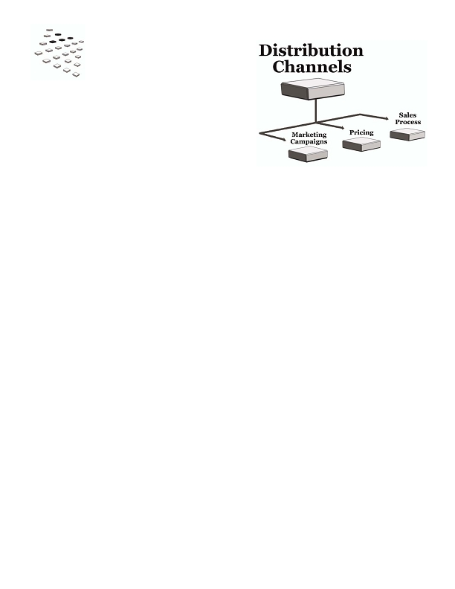
Define your brand
•
• Think of your brand as a person with a distinct personality. Describe him or her, then convey these
traits in everything you do and create.
• Write positioning statements and a story about your brand; use them throughout your company
materials.
• Choose colors, fonts and other visual elements that match your personality.
• Determine how your employees will interact with prospects and customers to convey the personality
and make sure your brand "lives" within your company.
What's next?

Together with your competitive positioning strategy, your
brand strategy is the essence of what you represent. A great
brand strategy helps you communicate more effectively with
your market, so follow it in every interaction you have with
your prospects and customers.

For example, you'll communicate your brand strategy
through your pricing strategy, name and corporate
identity, messages, literature and website. It may also
drive the need to implement a better CRM system to manage customer relationships.
..00.0,ffi fffi/0201fiffi fffi4.00,,,7,ffi fi/7.7
12

Distribution Channels
How do you sell to your end-users? Do you use a direct sales team? Resellers? A catalog or website?

Distribution channels are the pathways that companies use to sell their products to end-users.
B2B companies can sell through a single channel or through multiple channels that may include

• Direct/sales team: One or more sales teams that you employ directly. You may use multiple teams
that specialize in different products or customer segments.
• Direct/internet: Selling through your own e-commerce website.
• Direct/catalog: Selling through your own catalog.
• Wholesaler/distributor: A company that buys products in bulk from many manufacturers and then
re-sells smaller volumes to resellers or retailers.
• Value-added reseller (VAR): A VAR works with end-users to provide custom solutions that may
include multiple products and services from different manufacturers.
• Consultant: A consultant develops relationships with companies and provides either specific or very
broad services; they may recommend a manufacturer's product or simply purchase it to deliver a
solution for the customer.
• Dealer: A company or person who buys inventory from either a manufacturer or distributor, then re-
sells to an end-user.
• Retail: Retailers sell directly to end-users via a physical store, website or catalog.
• Sales agent/manufacturer's rep: You can outsource your sales function to a company that sells
different manufacturers' products to a group of similar customers in a specific territory.

Distribution is one of the classic "4 Ps" of marketing (product, promotion, price, placement a.k.a.
distribution). It's a key element in your entire marketing strategy -- it helps you expand your reach and grow
revenue.

Here are three distribution examples:
• fffiffi,-ff./0fi1230fffi00 fffiff4056ff0ff,,,78 fffi897.7
13

DIRECT TO END USERS

You have a sales team that sells
directly to Fortune 100 companies.

You have a second product line for
small businesses. Instead of using
your sales team, you sell this line
directly to end-users through your
website and marketing campaigns.

You have two markets and two
distribution channels.
SELL THROUGH A
DEALER NETWORK

You sell a product through a
geographical network of dealers
who sell to end-users in their
areas. The dealers may service the
product as well.

Your dealers are essentially your
customers, and you have a strong
program to train and support them
with marketing campaigns and
materials.
SELL THROUGH A VAR
(VALUE-ADDED RESELLER)

You sell a product to a company who
bundles it with services or other
products and re-sells it. That
company is called a Value Added
Reseller (VAR) because it adds value
to your product.

A VAR may work with an end-user to
determine the right products and
configurations, then implement a
system that includes your product.
To create a good distribution program, focus on the needs of your end-users.

• If they need personalized service, you can utilize a local dealer network or reseller program to provide
that service.
• If your users prefer to buy online, you can create an e-commerce website and fulfillment system and sell
direct; you can also sell to another online retailer or a distributor to offer your product on their own
sites.
• You can build your own specialized sales team to prospect and close deals directly with customers.

Wholesalers, resellers, retailers, consultants and agents already have resources and relationships to quickly
bring your product to market. If you sell through these groups instead of (or in addition to) selling direct, treat
the entire channel as a group of customers - and they are, since they're buying your product and re-selling it.
Understand their needs and deliver strong marketing programs; you'll maximize everyone's revenue in the
process.
BEST CASE
NEUTRAL CASE
You've used one or more distribution
channels to grow your revenue and
market share more quickly than you
would have otherwise.

Your end-users get the information
and service they need before and
after the sale.

If you reach your end-user through
wholesalers, VARs or other channel
partners, you've created many
successful marketing programs to
drive revenue through your channel
and you're committed to their
success.
You're using one or more
distribution channels with
average success. You may not
have as many channel partners as
you'd like, but your current
system is working moderately
well.

You devote resources to the
program, but you wonder
whether you'd be better off
building an alternative
distribution method -- one that
could help you grow more
aggressively than you are now.
WORST CASE

You probably aren't hitting your
revenue goals because your
distribution strategy is in trouble.

With your current system, you may
not be effectively reaching your end-
users; your prospects probably aren't
getting the information and service
they need to buy your product.

Your current system may also be
difficult to manage. For example,
channel members may not sell at your
suggested price; they don't follow up
on leads you deliver; they don't
service the product very well and
you're taking calls from angry
customers.
..00.0,ffi fffi/0201fiffi fffi4.00,,,7,ffi fi/7.7
14

Key concepts & steps

Before you begin

You can evaluate a new distribution channel or improve your channel marketing /
management at any time. It's especially important to think about distribution when
you're going after a new customer segment, releasing a new product, or looking for
ways to aggressively grow your business.

Evaluate how your end-users need to buy

Your distribution strategy should deliver the information and service your prospects need. For each customer
segment, consider

• How and where they prefer to buy
• Whether they need personalized education and training
• Whether they need additional products or services to be used alongside yours
• Whether your product needs to be customized or installed
• Whether your product needs to be serviced

Match end-user needs to a distribution strategy

• If your end-users need a great deal of information and service, your company can deliver it directly
through a sales force. You can also build a channel of qualified resellers, consultants or resellers. The
size of the market and your price will probably dictate which scenario is best.
• If the buying process is fairly straightforward, you can sell direct via a website/catalog or perhaps
through a wholesale/retail structure. You may also use an inbound telemarketing group or a field sales
team.
• If you need complete control over your product's delivery and service, adding a channel probably isn't
right for you.
•
Identify natural partners
•
If you want to grow beyond the direct model, look for companies that have relationships with your end-users. If
consultants, wholesalers or retailers already reach your customer base, they're natural partners.

Build your channel

If you're setting up a distribution channel with one or more partners, treat it as a sales process:

• Approach the potential channel partner and "sell" the value of the partnership
• Establish goals, service requirements and reporting requirements
• Deliver inventory (if necessary) and sales/support materials
• Train the partner
• Run promotions and programs to support the partner and help them increase sales
• fffiffi,-ff./0fi1230fffi00 fffiff4056ff0ff,,,78 fffi897.7
15
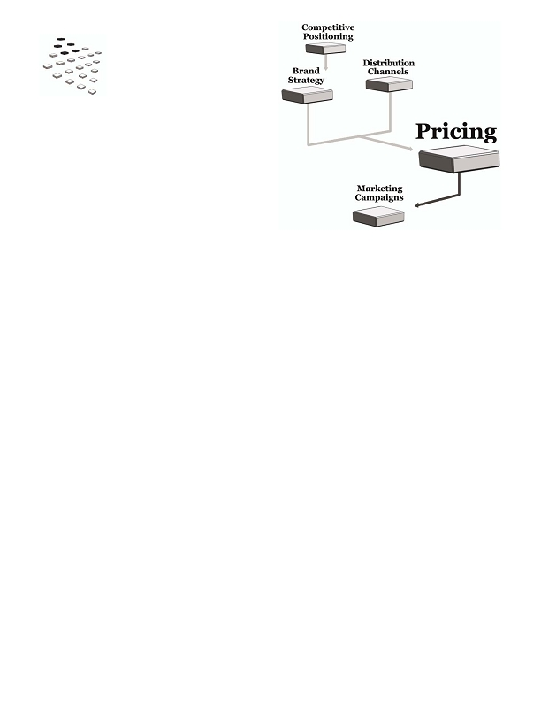
Minimize pricing conflicts

If you use multiple channels, carefully map out the price for each step in your channel and include a fair profit
for each type of partner. Then compare the price that the end-user will pay; if a customer can buy from one
channel at a lower price than another, your partners will rightfully have concerns. Pricing conflict is common
but it can jeopardize your entire strategy, so do your best to map out the price at each step and develop the best
solution possible.

Drive revenue through the channel

Service your channel partners as you'd service your best customers and work with them to drive revenue. For
example, provide them with marketing funds or materials to promote your products; run campaigns to generate
leads and forward them to your partners.
What's next?

As you're creating a new channel you'll need a pricing strategy and sales
process. When your channel is up and running, you can start launching
marketing campaigns to channel partners and end-users.
..00.0,ffi fffi/0201fiffi fffi4.00,,,7,ffi fi/7.7
16

Pricing
Price is one of the classic "4 Ps" of marketing (product, price, place, promotion). Yet in many B2B companies,
marketers aren't necessarily involved in pricing strategy.

Pricing is a complex subject - there are many factors to consider, both short- and long-term. For
example, your prices need to

• Reflect the value you provide versus your competitors
• Consider what the market will truly pay for your offering
• Enable you to reach your revenue and market share goals
• Maximize your profits

When you offer a truly unique product or service with little direct competition, it can be challenging to establish
your price. Put together a strong strategy and competitive analysis so you can see

• What your prospects might pay for other solutions to their problems
• Where your price should fall in relation to theirs

When your price, value proposition and competitive position are aligned, you're in the best
situation to maximize revenue and profits. For example, here are three scenarios that show the
relationship between these elements.
• fffiffi,-ff./0fi1230fffi00 fffiff4056ff0ff,,,78 fffi897.7
17
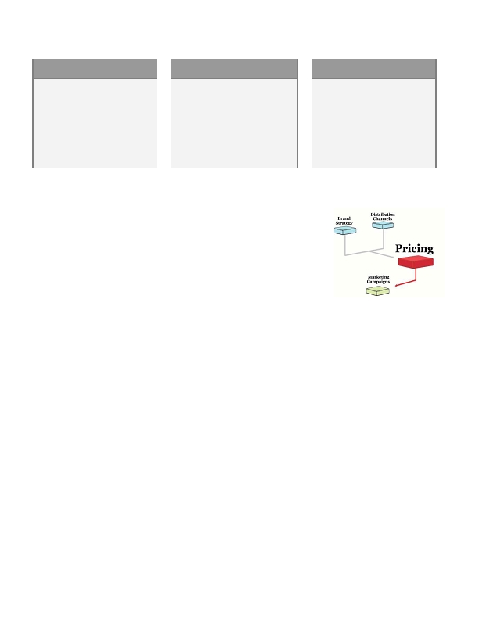
HIGHEST PRICE

Company A is one of the best
consulting firms in the world.
Their consultants come from top
schools, and they work with
Fortune 100 clients to implement
complex, large-scale projects.

Company A's value proposition is
product leadership. Their clients
are buying the best expertise they
can find, and they're less sensitive
to price because they care most
about getting top talent.

Therefore, Company A's services
can be priced as high or higher
than their competitors.
AVERAGE PRICE

Like Company A, Company B's
value proposition is product
leadership, but their secondary
value prop is price. There's a lot of
competition and their product is
only slightly better than the
alternatives.

Company B's messages focus on
product leadership with a
secondary focus on price. They
regularly review the market, run
promotions, and adjust prices to
maintain their competitive position.

The company is also working to
develop a premium product that
can warrant a higher price.
LOWEST PRICE

The market cares most about price
because the product is viewed as a
commodity.

Company C focuses on finding new
ways to lower costs and pass
savings on to customers. Their
value proposition is operational
efficiency and they consistently
deliver the same product at a
better price.

Company C regularly evaluates
their competitors' prices to make
sure they're delivering on their
promise. If a competitor runs a
promotion, Company C counters
with a better one.
What would happen if these companies used a different pricing strategy?
HIGHEST PRICE

By dropping their hourly rate,
Company A gains more clients.
They hire more consultants, but
since they're charging less per
hour, they can't afford the same
top-tier talent.

Company A is putting their
"prestige" brand in jeopardy.
However, if there isn't a strong
market for prestige, this strategy
may be the best one for the
company long-term.
AVERAGE PRICE

If Company B charges a premium
price for an average product, they'll
have a very difficult time generating
interest in their product.

Yet Company B may be able to
implement a small price increase to
raise revenue and profits; it
depends how much more its
customers are willing to spend. By
analyzing price sensitivity and
testing different prices, they can
evaluate the strength and potential
of this new strategy.
LOWEST PRICE

If Company C's prices rise in
relation to those of their
competitors, their sales will
plummet - their market is
shopping on price, not factors like
product leadership or customer
intimacy.

If Company C cannot maintain its
operational efficiency and cost
leadership, it will need to develop
new products or markets for its
existing product.
..00.0,ffi fffi/0201fiffi fffi4.00,,,7,ffi fi/7.7
18
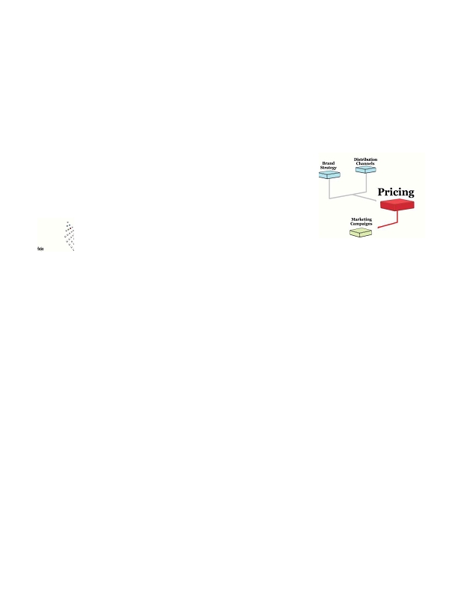
Do you see your company in one of these scenarios?
BEST CASE
Your price completely supports
your value proposition, enabling
you to maximize your revenue and
profit.
NEUTRAL CASE

You don't necessarily have a pricing
strategy but you're probably in the
right range. You enter a moderate
number of price negotiations and
you win some, lose some. You
wonder whether you could increase
revenue and profit with either a
price increase or decrease.
WORST CASE

Your price is misaligned with your
value proposition and what your
market is willing to pay. Your
prospects and customers are
constantly fighting with you on
price and it takes its toll on your
team. You often have to discount
heavily to make a sale.
Key concepts & steps
•
Before you begin

It's best to create your brand strategy and identify your distribution
channels before you develop your pricing strategy. By doing so, you'll ensure
that your pricing reflects your value proposition and reinforces your brand; you
can also minimize pricing conflicts with your channel partners.
•
Match your pricing strategy to your value proposition

Your price sends a strong message to your market - it needs to be consistent with the value you're delivering.

• If your value proposition is operational efficiency, then your price needs to be extremely competitive.
• If your value proposition is product leadership or customer intimacy, a low price sends the wrong
message. After all, if a luxury item isn't expensive, is it really a luxury?

Understand your cost structure and profitability goals

Companies calculate these costs differently, so verify the exact calculations your company uses for

• Cost of goods sold (COGS): the cost to physically produce a product or service
• Gross profit: the difference between the revenue you earn on a product and the cost to physically
produce it

In addition, understand how much profit the company needs to generate. You'll be far more effective
when considering discount promotions - you'll know exactly how low you can go and still be profitable.

Analyze your competitors' prices

Look at a wide variety of direct and indirect competitors to gauge where your price falls. If your value
proposition is operational efficiency, evaluate your competitors on a regular basis to ensure that you're
continually competitive.
• fffiffi,-ff./0fi1230fffi00 fffiff4056ff0ff,,,78 fffi897.7
19
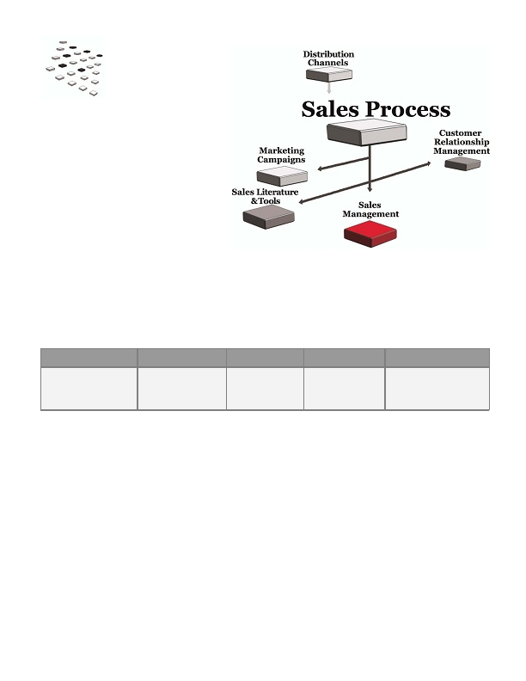
Determine price sensitivity

A higher price typically means lower volume. Yet you may generate more total revenue and/or profit with fewer
units at the higher price; it depends on how sensitive your customers are to price fluctuations. If they're
extremely sensitive, you may be better off at a much lower price with substantially greater volume.

Estimate how sensitive your customers are to fluctuations - it will help you determine the right price and
volume combination. More importantly, you can estimate how a price change can impact your revenue.
What's next?

Once you've finalized your pricing strategy, you can plan and launch your
marketing campaigns.
•
..00.0,ffi fffi/0201fiffi fffi4.00,,,7,ffi fi/7.7
20
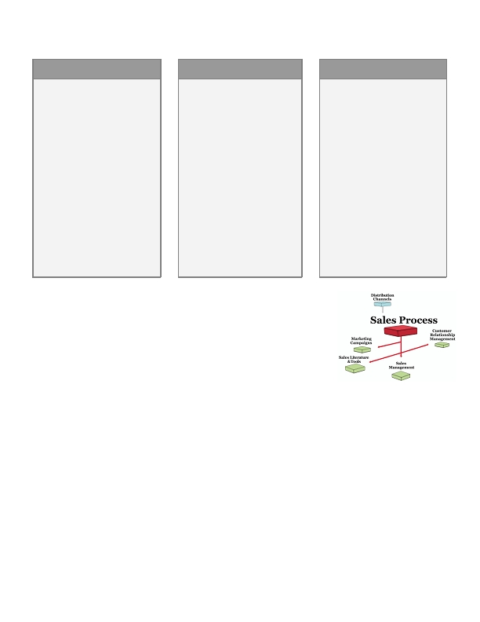
Sales Process
•
How do prospects buy your product or service?
Does a single decision-maker find a product and
buy on the spot, or does s/he go through many steps and approvals first? Perhaps there are multiple
departments involved in the decision, each with its own needs?

A sales process is a defined series of steps you follow as you guide prospects from initial contact
to purchase. It begins when you first identify a new prospect:
•
STEP 1

A prospect responds to
a campaign & requests
information
STEP 2

A sales rep calls the
prospect to explain
your product
STEP 3
STEP 4
In-person meeting Your team submits
& product demo a proposal
STEP 5

Prospect signs an
agreement & makes first
payment
A documented sales process is a flowchart that explains

• Each distinct step a prospect takes
• Knowledge the prospect needs to move to the next step
• Literature & tools you can provide to help the prospect move forward
• Length of time a prospect needs at each step
• Conversion rates: the percentage of prospects who move from one step to the next

With a documented sales process, you have a powerful tool that enables you to

• Sell more efficiently
• Generate more accurate sales and revenue reports
• Estimate the revenue and return on investment (ROI) of your marketing campaigns
• See which stages take the most time and find ways to move prospects forward
• Create better literature and tools
• Improve your campaigns
• Minimize the amount of time your reps spend on estimates and forecasts
• fffiffi,-ff./0fi1230fffi00 fffiff4056ff0ff,,,78 fffi897.7
21
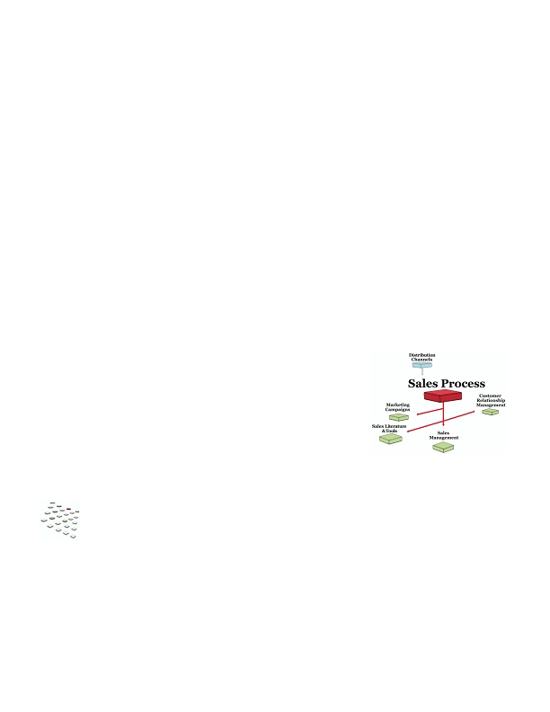
Do you see your company in one of these scenarios?
BEST CASE

You have a well-designed process
that measures the number of
prospects you have at each stage,
how long they stay in each stage,
and the revenue your entire pipeline
represents.

You deliver the right amount of
information prospects need at each
step, which helps them make
decisions more quickly and move to
the next stage.

You use your sales process to create
more successful marketing
campaigns because you can predict
how many leads will become
customers and what those leads will
be worth to your company.
NEUTRAL CASE

You may or may not have a
defined sales process. You
generally follow the same steps to
close a customer, but there's a big
variance in the amount of time it
takes to close. In fact, even your
strongest reps have trouble closing
certain types of prospects.

Your forecasts are probably all
manual and generally accurate,
but you wish you had a thorough
snapshot to show exactly how
many accounts are at a certain
stage and what you need to do to
close.
WORST CASE

You don't have a process or use one
that doesn't match how prospects
want to buy.

You deliver all of the information
about your product but then seem
to lose control of the prospect.
Some prospects end up buying, but
you don't know why the others
don't.

It's a constant battle to figure out
how many real prospects you have
and what they're worth. Your sales
team often spends valuable time
creating manual reports instead of
selling, which further hurts your
revenue.
•
Key concepts & steps
•
Before you begin

If you don't have a defined sales process, it's a valuable investment that can
improve your entire sales and marketing program. Create processes for each
distribution channel, product and/or customer segment.

Determine how your prospects buy

List the steps you think prospects logically take from the time they recognize a problem to the time they buy.
Talk with customers or ask your sales reps for more insight. Figure out what steps they take, what they need to
know and how you can deliver that information most effectively.

Create your process

For each step your prospects need to take, list

• What the prospect needs to learn
• Literature & tools you can provide to help the prospect move forward
• The length of time a prospect needs at the step
• The percentage of prospects who move from each step to the next (your "conversion rate")
..00.0,ffi fffi/0201fiffi fffi4.00,,,7,ffi fi/7.7
22
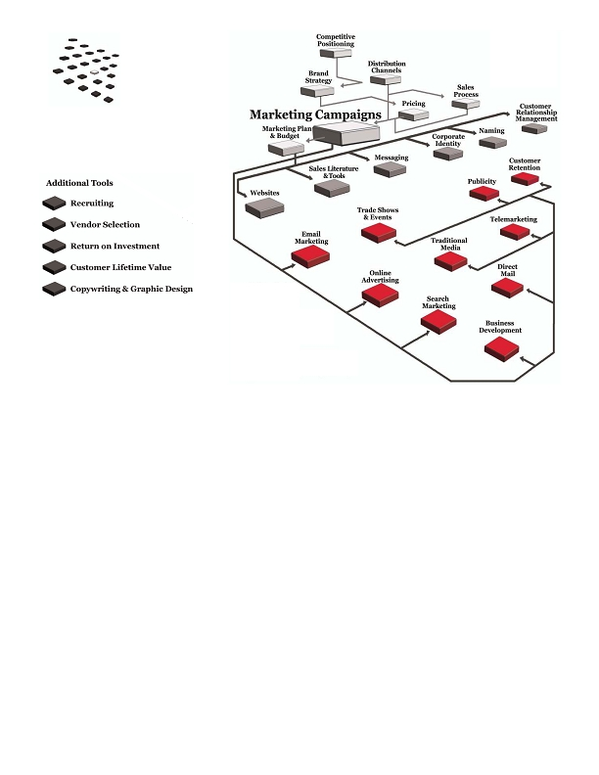
Project campaign results & revenue

When you have a sales process with conversion rates, you can generate solid pipeline and revenue reports. For
example, if you have 50 prospects at the presentation stage, your process may show that 20% will become
customers. That means those 50 prospects should deliver 10 new customers. Your process will also tell you
when that should happen and how much revenue those prospect represent.

You can use a similar calculation to project results from new marketing campaigns. For example, if a campaign
should produce 100 qualified leads, you can estimate the number of meetings, presentations, and new
customers the campaign will generate.

Improve your process to maximize revenue

When you have a defined process, it's easier to test ideas for improving results. For example, you can

• Identify spots where prospects get "stuck" in the process and try new materials or messages to help
them move forward
• Measure how well different reps convert at each step and help those that aren't doing as well
• See how leads from different marketing campaigns convert and improve your campaigns
• Create campaigns to "recycle" leads that fall out of the process at various spots
What's next?

After you've documented your sales process, develop the literature & tools
you'll need to guide your prospects through each step. Add your process to
your customer relationship management (CRM) software so that each
account is assigned to a stage at all times. Then you can run reports and
measure your progress and improve your sales management.

You'll also use your sales process to measure the success of marketing
campaigns; for a specific campaign, you can see how many leads entered
the process and made it to each step.
• fffiffi,-ff./0fi1230fffi00 fffiff4056ff0ff,,,78 fffi897.7
23

Marketing
Campaigns
In many B2B companies, a sales team is the primary method for reaching out to the market. Salespeople call
prospects and customers, but they can only do so much in a day. Marketing campaigns can dramatically
increase your reach.

A marketing campaign is a series of touches with your market to communicate a key message.
The key word is "series" since it usually takes multiple touches for your audience to recognize your message and
respond.

Marketing campaigns can include many different media:
• Email, search, banners and other online
marketing
• Publicity
• Direct mail

Here are three sample campaigns:
• Telemarketing
• Trade shows and events
• Print, radio and other "traditional" media
..00.0,ffi fffi/0201fiffi fffi4.00,,,7,ffi fi/7.7
24
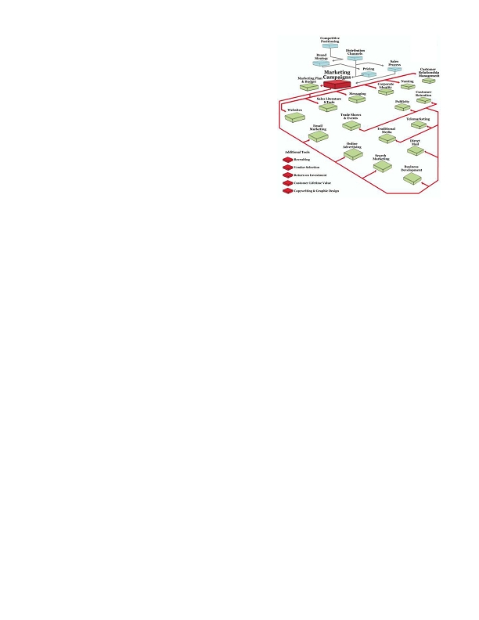
GENERATE NEW LEADS
DRIVE EXISTING
PROSPECTSTO YOUR
TRADE SHOW BOOTH &
VIP RECEPTION
HIT YOUR MARKET WITH
A SPECIAL OFFER
1. Use search to generate traffic to
your website.
2. Prospect requests information
via email.
3. Email the requested
information.
4. Call the prospect; qualify the
prospect further and determine
next steps.
1. Mail a postcard to attendees 3 6. 1. Run banner ads on industry
weeks before the show; invite
them to your booth with an
intriguing incentive.
2. Mail a special invite to key
prospects and customers to for
a VIP reception. Ask them to
RSVP by phone, email or URL.
3. Call key prospects and
customers as a second effort.
4. Send an email to all confirmed
attendees and 3 days before
the event.
5. Email the non-respondents
one last time.
websites and targeted email
newsletters.
2. Send out a special email to your
house list.
3. Create an intriguing story and
tie it to your offer. Write a
search-optimized press release
and post on your site; distribute
releases and pitch to a key
industry reporter.
4. Run a series of paid search ads.
In B2B it's always best to start with your company's annual goals and develop campaigns to meet those
numbers. For example, when you know how many new customers you need, you can calculate how many leads
you'll need, then design campaigns to generate those leads throughout the year.

With solid planning, a jolt of creativity and focus on measurement, you'll be in a strong position for success.
•
BEST CASE

You plan and execute your
campaigns to hit specific goals.
You don't always hit them, but
you test and improve different
elements; the ROI on your
overall budget is above your
goal.

You focus on an offer and call-
to-action, and you touch your
prospects several times and
follow up when appropriate.

You recognize the challenges in
measuring results, but you do
what you can; it helps you
improve the next time around.
NEUTRAL CASE

Your campaigns aren't the
most creative or the splashiest,
but you've hit many of your
marketing goals. You don't test
but your response rate is fine.
You don't know your ROI but
you generally know which
campaigns work best.

Yet when you're faced with
ambitious annual goals, you
have problems gaining budget
approval. Since you stick with
the same campaigns year in
and out, it's also difficult to
figure out how to generate
additional leads.
WORST CASE

Your marketing programs tend
to be reactive -- suddenly you're
low on leads or falling short of
your goals and you launch a
campaign to fix the problem.

Since your programs don't seem
to work, it's difficult to gain
budget approval for future
campaigns that could be more
well-planned and executed.

It's a vicious cycle and you don't
know how to get out of it.
• fffiffi,-ff./0fi1230fffi00 fffiff4056ff0ff,,,78 fffi897.7
25
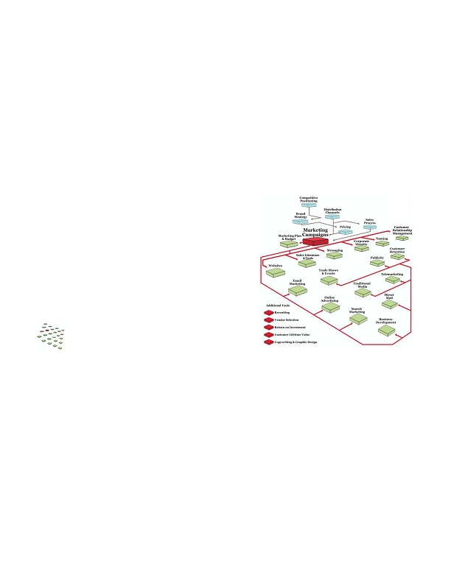
Key concepts & steps
•
Before you begin

Your brand and pricing strategies play a significant role in
your marketing efforts, so nail down those strategies before
launching any major campaigns. If you sell through multiple
distribution channels, don't forget to create campaigns for
each. You'll also refer to your sales process to estimate
revenue and ROI for each campaign.

Quantify your goals

• Plan your campaigns to meet your annual revenue and volume goals. For example, if you're trying to
generate 100 new customers, figure out how many leads you'll need and when you'll need them.
• Think about how you'll use different media. For example, your sales team may be able to generate 30%
of your leads through prospecting; the rest may come from telemarketing, email, direct mail, search
marketing, webinars, trade shows and more.

Generate campaign ideas and strategies

• Identify all of the business goals that will need marketing support. You may need campaigns to
generate and nurture prospects, sell direct or through a channel, or market to existing customers.
• Evaluate ideas and options: traditional sales activities, internet marketing, telemarketing, direct mail,
email, publicity and more.

Target your audience

• With more specific targeting, you can speak more directly to the prospect and raise your response rates
in the process.

Deliver one or two key messages and your call-to-action

• If you include every detail about your product and company, it's easy for prospects to become
overwhelmed. Just move a prospect one step at a time.
• Be creative -- your market is bombarded with messages daily, so grab their attention and engage them.

Plan to measure

When you measure your campaigns, it's easier to gain budget approval the next time around. You'll also know
exactly which programs produce the highest return.

• Establish how you'll measure each campaign. If there are variables you can't measure, decide how you
will account for those results.
• Identify how you'll capture the data you'll need - unique phone numbers, unique URLs, etc.
..00.0,ffi fffi/0201fiffi fffi4.00,,,7,ffi fi/7.7
26
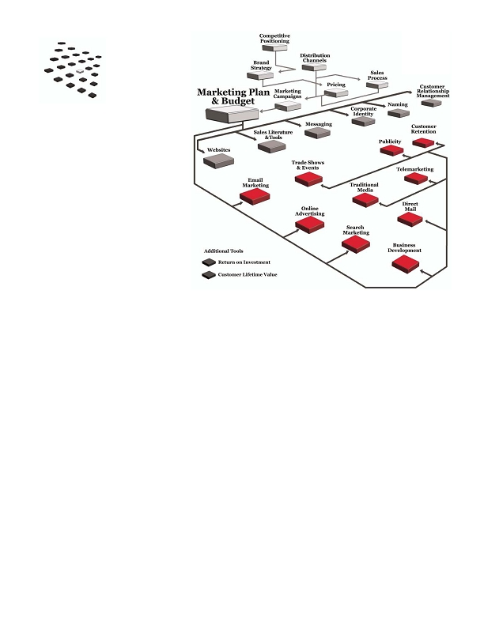
Plan your fulfillment

• Your fulfillment processes can help or hurt your close rate, so make sure you outline your requirements.
For example, if you're running a campaign where prospects request a software demo and it doesn't
arrive for a week, your prospects may lose interest.

Continually test and improve

• Even on a small campaign, you can evaluate your ad, copy, list or other factors before you spend your
entire budget.
• Choose a subset of your list or two versions of an ad; test them in small quantities and choose the best
one for rollout. Then you can test a second variable against the winner in the first test.
• Keep the testing cycle going and track your results over time. You'll improve your response rates and
return on investment.
What's next?

Include your major campaigns in your annual marketing
plan and budget, then implement your plans and strategies
throughout the year: email marketing, business
development, trade shows, publicity, online
advertising, customer retention and more.
• fffiffi,-ff./0fi1230fffi00 fffiff4056ff0ff,,,78 fffi897.7
27
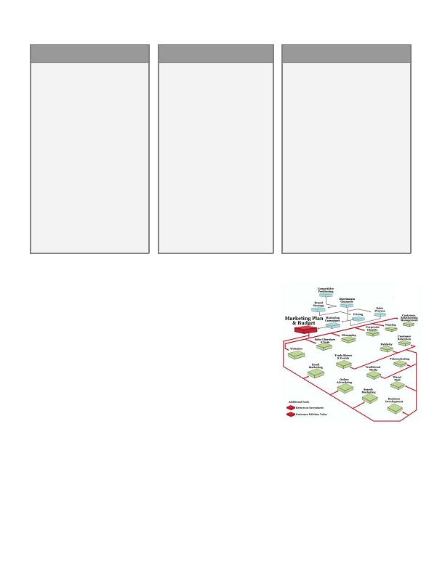
Marketing Plan & Budget
Most businesspeople agree that good planning is essential for success. Even so, it's surprising how many
companies don't create a thorough plan to generate and manage their customers.

A marketing plan is a detailed roadmap that outlines all your marketing strategies, tactics,
activities, costs and projected results over a period of time. The plan keeps your entire team focused
on specific goals - it's a critical resource for your entire company.

A good marketing plan typically includes:
• Financial goals
• Positioning strategy
• Brand strategy
• Product/service overview
• Detailed goals by product, distribution
channel &/or customer segment
• Sales plan
• Major marketing campaigns
• Detailed budget
• Dates to review progress
It takes time to develop a solid plan, but it's important because it ties all of your activities to tangible goals. It's
also a great opportunity to focus on the future, generate new ideas, and inspire your team. Even a simple plan is
better than none, but when you invest more effort upfront, you'll have a better roadmap toward your goals.
..00.0,ffi fffi/0201fiffi fffi4.00,,,7,ffi fi/7.7
28

BEST CASE

Your marketing plan is a detailed
roadmap to meet your goals.

You recognize that the time you
invest to create a solid plan is
perhaps the best time you'll invest
all year - it helps you work through
new strategies, issues, ideas, and
numbers.

When it's done, your team focuses
on executing the plan and
measuring your progress all year
long.

As a result, you've been able to hit
your goals, grow your business, and
enjoy the journey.
NEUTRAL CASE

You're incredibly busy, so it's
difficult to invest the time in a
detailed marketing plan. Instead,
you develop a basic plan that's
based on last year's version.

You include general revenue goals,
general sales strategies, and basic
campaigns; you stick with proven
techniques. Budgets are based on
last year's numbers.

You could be more ambitious with
your revenue goals if your
company was willing to try new
things, but each year you stick
with the tried-and-true.
WORST CASE

You don't typically create a marketing
plan. You have a budget, but the
numbers are haphazard. Things
change so quickly - why spend the
time?

You take a similar approach with the
strategies that should drive a
marketing plan. You probably don't
have a positioning or brand strategy;
you're missing out on distribution
channels or partnerships; your
campaigns are ineffective and you may
not invest in customer retention.

A plan is a compass. Without one, you
may be traveling in the right direction,
but it's incredibly difficult to stay on
course - and that can drastically limit
your success.
Key concepts & steps

Before you begin

A marketing plan should address all of your strategies, tactics and
budget, so you'll need to review your brand strategy, pricing
strategy and distribution channels beforehand. You'll also outline
your major marketing campaigns for the year since they'll be in
your budget.

Set your annual goals

Build your entire marketing plan to achieve the goals that you define:

• Quantitative (numeric) goals such as total revenue, profit,
number of customers, units sold, and breakdowns by product
or channel as needed.
• Strategic goals -- for example, you may want to expand into a
new market with a new distribution channel, or you may need to reposition your brand to reflect a
change in your business.
• fffiffi,-ff./0fi1230fffi00 fffiff4056ff0ff,,,78 fffi897.7
29
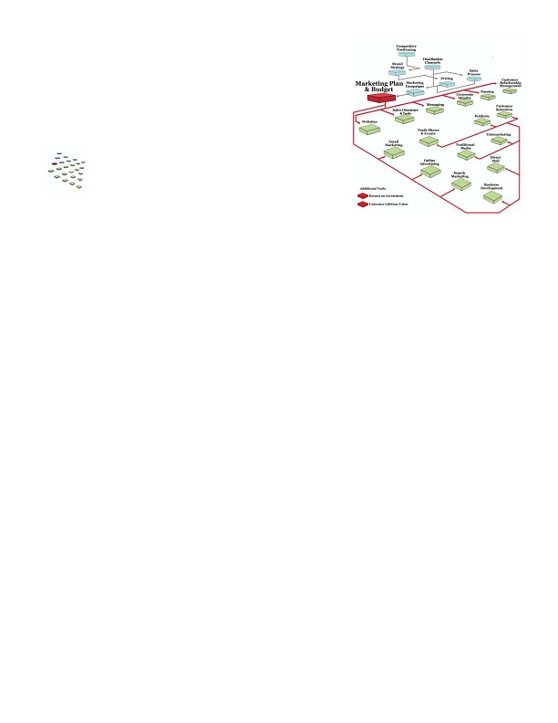
Highlight your competitive position, value proposition and brand strategy

• Your positioning strategy defines how you'll differentiate your offering from your competitors.
• Your value proposition defines the primary value you deliver: operational efficiency, product leadership
or customer intimacy.
• Your brand strategy defines what you stand for and how you'll communicate with the market.

Outline any plans for your products & services

If you need to do anything to strengthen your product line and better deliver on your value proposition, address
those issues in your plan.

Develop your tactical sales plan

• The number of sales reps you'll need and the markets they'll target
• Whether you'll need to hire, train, or develop new compensation plans
• Top priority markets, industries or customer segments; if you have a list of key prospects, include them
• Your plan for managing current customers
• Plans for launching any new distribution channels and driving revenue through existing channels

Outline your major marketing campaigns

You don't need to list every campaign -- just outline your major promotional plans for the year. You'll need to
set your budget too, so the more planning you do now, the better. Your plans should include:

• The top three campaigns you'll run to generate leads, nurture customers, close, and/or market to
existing customers
• The media you'll use (for example, email, online, print, telemarketing, trade shows, publicity, etc.)
• Tools, technologies or resources you'll need - for example, a new website, an email service provider, a
new piece of software
• Your ROI and other financial goals

Develop a budget

• Budgeting can be a difficult process. Many companies just estimate or base their budget on last year.
An estimate is better than nothing, but if you've defined your major campaigns and needs, you can
develop better numbers.
• You can also use ROI to determine the appropriate total budget for your marketing efforts.

Revisit your plan regularly

• The planning process itself is incredibly valuable, but if you don't review the plan regularly, it's easy to
lose focus. Continually revisit the plan and measure your progress.
•
..00.0,ffi fffi/0201fiffi fffi4.00,,,7,ffi fi/7.7
30
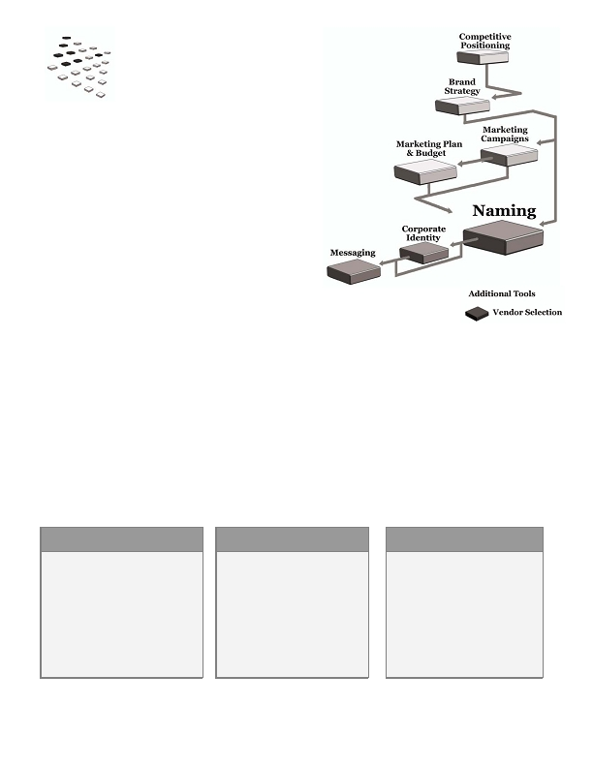
What's next?

When you've finished your plan, it's time to execute. You may need to
create new messages, literature, website or other tools and
processes for your campaigns, but after that, focus on generating
and managing your customers.
• fffiffi,-ff./0fi1230fffi00 fffiff4056ff0ff,,,78 fffi897.7
31
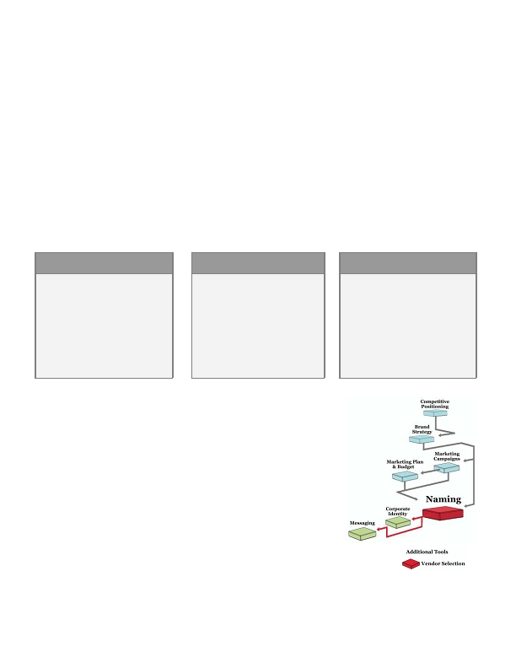
•
Naming
How important is the name of your product, service or
company? It depends on your industry, the amount of
time you've been in business, your competitors and how
you want to position yourself in the market.

Your name is an extension of your brand, and it can reinforce the value you provide or distance
you from it. When you're developing a name, you have a number of options:

• Use the founder or inventor's name (Hewlett-Packard)
• Describe what you do (Southwest Airlines)
• Describe an experience or image (Sprint)
• Take a word out of context (Apple)
• Make up a word (Google)

It's important to decide what your name should mean and represent. For example, if you're running a company
that provides naming services, your name is a sample of your work - it should be great, right?
•
Here are some companies that provide naming services:
BEST CASE

These companies appear to be more
creative and better at finding a name
that stands out from the
competition:

A Hundred Monkeys
Igor
NEUTRAL CASE

These companies all sound the
same:

The Naming Co.
BrighterNaming
Tradebrand
Catchword
Namebase
Lasting Names
Name One!
WORST CASE

A naming agency with no name:

Werner& Stevens
Kowalchek Associates

(Hypothetical examples, but there
are a lot of naming companies
named after their founders!)
All of these companies may be fantastic with many years of experience and terrific track records. And they each
could be very well-known in certain markets or industries.
..00.0,ffi fffi/0201fiffi fffi4.00,,,7,ffi fi/7.7
32
However, if you need to select three companies to bid on your naming project, which companies would you
contact? Are you more likely to call a company with a unique name, an average name, or no name?

This example shows that you have one chance to make a first impression. Many of your potential
customers know virtually nothing about your company and a great name can open doors; a poor name may shut
them.

The process is especially challenging because there are more than 24 million businesses in the United States.
U.S. trademark law protects business names, so when you find one you like, make sure you can use it. If you
infringe on a copyright, you could be forced to abandon your new name after investing a lot of time and money.

Also think about your internet marketing goals, since you may have to find a URL to match your name. There
are over 60 million domain names registered worldwide, and some experts believe that over 98% of the
dictionary is registered as a domain name.

Don't let these challenges stop you from finding the best name you can - there's a lot at stake:
BEST CASE

A great name can create buzz,
position you as a true leader and
innovator, and reinforce your value
proposition in a word or two. That's
powerful. It can convey a culture, a
position, and differentiate the
company from the rest of the
market.
NEUTRAL CASE
You look and sound like everybody
else.

You've missed an opportunity to
convey an important message, but
at least you're not hurting yourself.
WORST CASE

A poor name can neutralize or even
negate the work you do to build a
position in the market. You may
have trouble generating interest in
your company and spend more time
and money educating the market
about your value. A poor name can
also limit your opportunities if you
expand into other markets.
Key concepts & steps
•
Before you begin

Since your name is an extension of your brand, it's important to develop
your brand strategy before you start the naming process.
•
Do you need to hire someone?

With a good process and strategy, you can probably develop a good name on
your own. However, you may not have the resources or desire to handle the
project internally. While it's no guarantee that a firm or consultant will
develop a better name, they may do it more quickly and objectively.
• fffiffi,-ff./0fi1230fffi00 fffiff4056ff0ff,,,78 fffi897.7
33
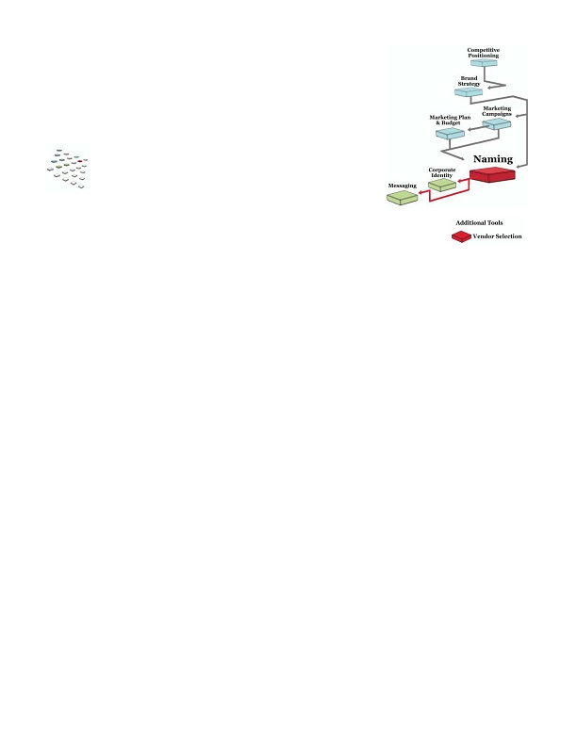
There are a number of factors to consider, including

• The stakes: If you're investing a lot of money launching a new product to a major market with
established competition, the stakes are high.
• Your confidence in your team's creative firepower or objectivity.
• The amount of time and energy you have to devote to the project.
• Whether you can afford to bring in an outside resource.
•
Develop a strategy

• Determine what your name needs to accomplish.
• Decide how it will work with existing product or service names (if applicable).
• Determine what kind of name to develop - descriptive, invented, founder's name, etc.
• Develop objective criteria to evaluate the names you generate.

Generate plenty of potential names

If you're competing beyond your local area, you may find that many of your potential names (or URLs) are
already taken, so you'll need a long list. Invite a variety of people for a brainstorming session; plan it well and
capture every idea for further evaluation.

Evaluate the list against your criteria

Your goal is to objectively find the name that meets your criteria, so be careful about asking friends and
family whether they "like" a name. For example, a name that raises eyebrows may do so because it's different -
and it may be the most memorable and powerful one in the bunch.

Also test the name to make sure it

• Sounds good over the phone (for example, when a sales rep calls a prospect)
• Won't be constantly mispronounced or misspelled, which defeats the purpose of a name
• Isn't confusing
• Conveys what you need it to convey
• Has a URL that works with it
•
Protect your name

It's important to protect your name to the appropriate degree. If you choose a name that infringes on another
company's copyright, you could receive a cease-and-desist letter and have to go to court and/or change your
name after months or even years of use.

By protecting your name, you also gain the ability to prevent future competitors from using it.
..00.0,ffi fffi/0201fiffi fffi4.00,,,7,ffi fi/7.7
34
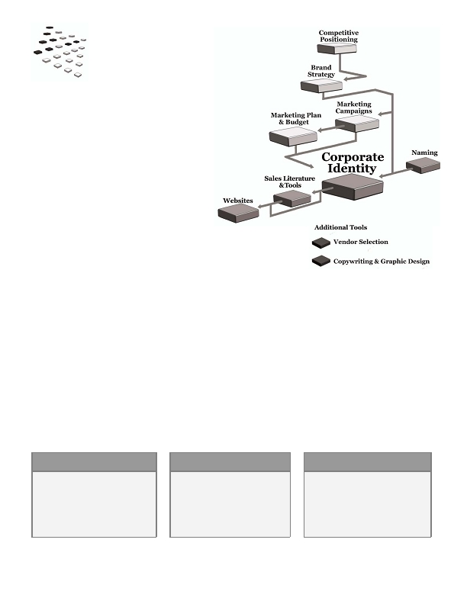
What's next?

After you select a new name, you can create your logo and corporate
identity, then begin creating the messages to use throughout your sales
materials and marketing efforts.
• fffiffi,-ff./0fi1230fffi00 fffiff4056ff0ff,,,78 fffi897.7
35
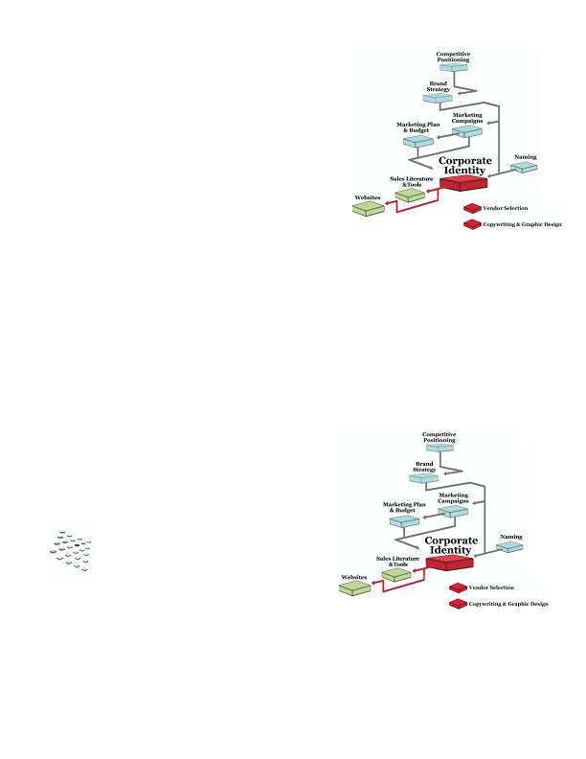
Corporate
Identity
When was the last time someone gave you a
fantastic business card? Did you turn it over
and look at it closely? Did you comment on
it? And did you generate some sort of
impression of that person and company?

Corporate identity is an extension of your brand and includes
everything with your logo or contact information:
• Business cards
• Envelopes
• Letterhead
• Mailing labels
• Email templates & signatures
• Fax covers
• Proposal/quote templates
• Invoices/statements
• Memos
• Signage
• Promotional items
Many companies spend time and money on things like business cards yet overlook proposal templates, invoices
and email signatures that prospects see more frequently. For example, when an employee customizes an email
template with unusual designs or fonts, it can contradict an expensive and serious business card - and convey a
far different impression to the customer.

Each element in your identity should use the same fonts, colors, layout, etc. The design itself may not be
incredibly important unless you're in a creative field, but consistency and professionalism make an impression.
In many cases it may be a first impression, so why not make a good one?
BEST CASE

Every touch with your prospects
and customers is consistent and
professional. They see a simple,
effective design that strengthens
your messages.
NEUTRAL CASE

Some of your identity is great and
other things, like invoices or
shipping labels, don't match up.
Prospects and customers probably
notice, but you don't think it's a
problem.
WORST CASE

Your prospects and customers see a
mismash of poorly-produced
identity. They may wonder how you
can deliver the product or service
you're selling if you can't produce a
professional-looking document.
..00.0,ffi fffi/0201fiffi fffi4.00,,,7,ffi fi/7.7
36
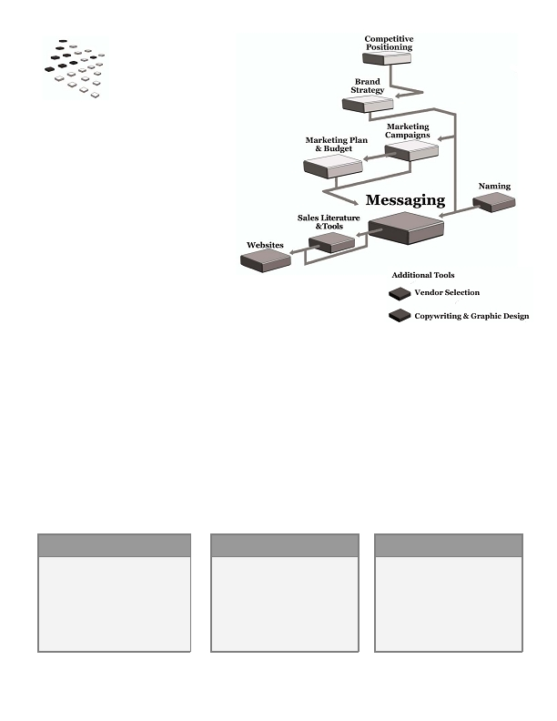
Key concepts & steps
•
Before you begin

Naturally you need a name before you can create your corporate
identity. You should also develop a brand strategy since your
identity should support it and help bring it to life.
•
If you're already in business, does all of your identity
reflect your brand?

Check everything from invoices and shipping labels to email
signatures. Make sure your logo is used correctly (sometimes
they get accidentally re-sized) and that all of your materials are consistent with your value proposition and
brand strategy. For example, if you're focusing on innovative, expensive new products but you have flimsy
business cards, you're not reinforcing your value.

Create professional, consistent templates for every touch with your market

Use a consistent style for everything your company sends out. It make take only ten minutes to create a better
template, and that template may be seen by hundreds or thousands of prospects and customers over time.

Keep inventory

Templates can be altered or misplaced; make sure team knows how to use them and check them regularly.
What's next?

Once you've finishing your identity, the typical next step is to
focus on your sales literature and your website.
• fffiffi,-ff./0fi1230fffi00 fffiff4056ff0ff,,,78 fffi897.7
37
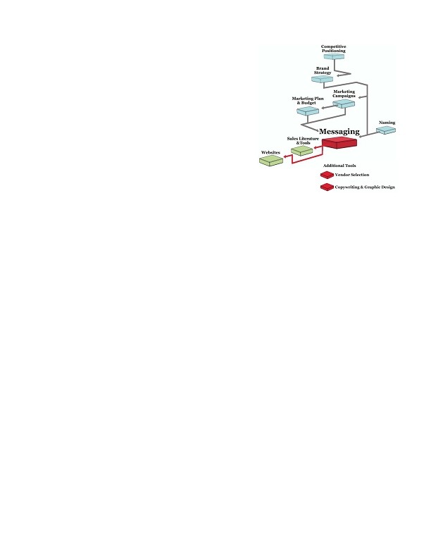
Messaging
How do you respond when someone asks
"what does your company do?" Do all your
team members answer the same way? And is your
response compelling so the listener wants to learn more, or do you sound
like everyone else?

"Messages" are written and verbal statements that quickly describe what you do and how you're
different. They're used throughout your interactions with your market:

• The "elevator pitch" - the 30-second response to "what do you do?"
• Sales & marketing materials - sales literature, websites, presentations and campaigns all use messages
of various lengths
• The introductory statement in a phone call
• Press releases - the blurb at the bottom of the release that explains what the company does
• Slogans
• Your mission statement

Good messages take your competitive positioning and brand strategy to the next level. They hone
in on what's important to your market and communicate it consistently and effectively.
BEST CASE

By carefully crafting your messages,
you can strengthen your value
proposition, your brand and the
reasons your prospects should buy.

It's easy to communicate your value.
The market "gets it" very quickly,
speeding up the sales process.
NEUTRAL CASE

Ho-hum messages don't help you
stand out, but as long as they're not
inaccurate or poorly written, they
probably won't hurt. You just miss
out on the opportunity to
strengthen your position.
WORST CASE

Without consistent messages,
individual team members do their
own authoring and the results are
rarely good, let alone consistent.
Poor messages confuse the market
and can contradict the other
strategies you've worked hard to
implement.
..00.0,ffi fffi/0201fiffi fffi4.00,,,7,ffi fi/7.7
38
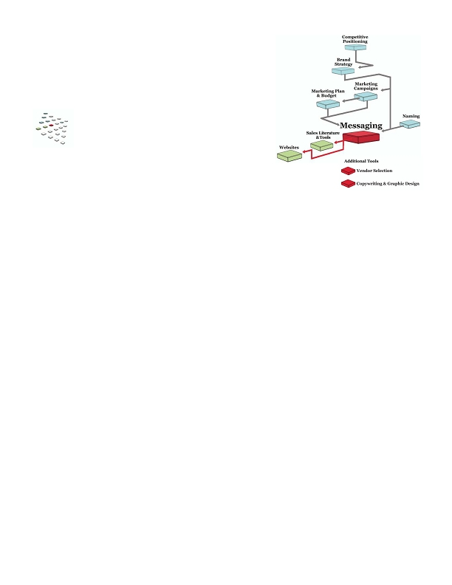
Key concepts & steps

Before you begin

Before you start writing, define your brand strategy - it will help
you identify what your messages should convey. If you need
messages for a marketing campaign or program from your
marketing plan, plan them out so you'll know exactly what kind
of messages you need. And if you haven't finalized your name,
you'll want to do that before messaging as well.

Define your writing style and requirements

Before you start writing, define your style requirements -- tone,
voice, style, vocabulary - so the writing will be consistent and match
your brand strategy.

Create an elevator pitch

The elevator pitch describes who you are, what you do, who your customers are and why they should buy from
you. When you've written it, test it to see how it sounds and how long it takes (no more than 30 seconds).

Create your positioning statements

Write statements of various lengths - 25, 50 and 100 words - so you have a message length that fits a variety of
materials. The shorter statements focus on the value and brand position; the longer ones add features and
benefits.
•
Create a tagline/slogan

Your tagline/slogan is a more succinct phrase used in campaigns. It can be one word or a short phrase and for
most business writers, it's harder to create. You may want to hire a copywriter for this one.

Create your mission statement

An average mission statement describes why you're in business. A great mission statement is compelling,
shows why you're different and conveys your company's personality.

Determine where to use the messages

Make sure to use your new messages consistently. Train your team to use the messages and audit your
materials periodically to make sure they're still working in the future.
• fffiffi,-ff./0fi1230fffi00 fffiff4056ff0ff,,,78 fffi897.7
39
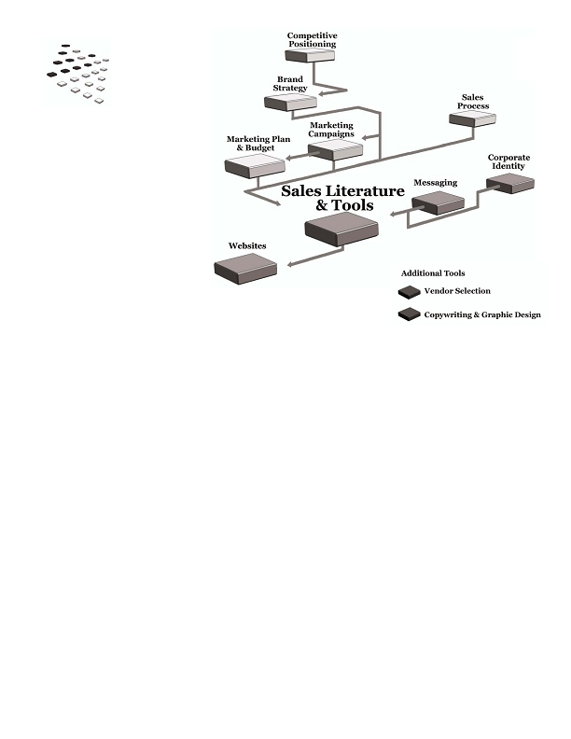
What's next?

Your messages feed all of your communication with your market.
Use them in your sales literature and tools, your website and
then all of your campaigns.
..00.0,ffi fffi/0201fiffi fffi4.00,,,7,ffi fi/7.7
40
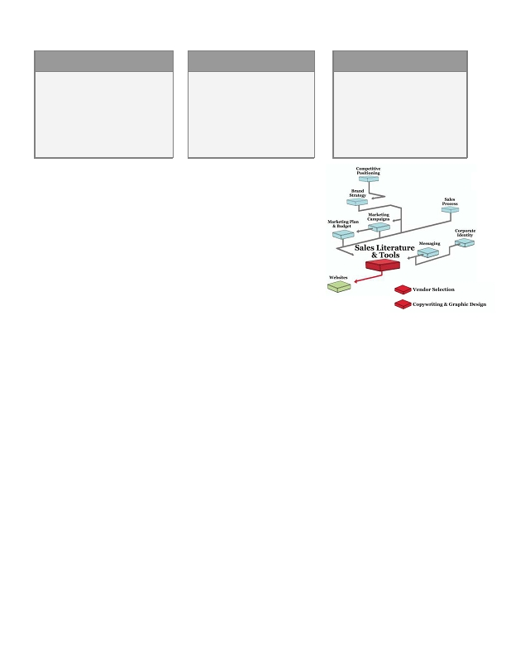
Sales Literature
& Tools
•
•
Do you know many companies that can sell their product or service without literature or other supporting
materials? It's tough to do.

Sales literature and tools help you communicate and strengthen your messages. They're also
known as "marketing communications" or "collateral" and they may include:
• Company brochures
• Product data sheets
• Case studies
• White papers
• PowerPoint presentations
• Websites
• Newsletters
• Reference lists
• Proposal templates
• Calculators
The printed word can carry a lot of credibility, so your materials are important tools in your arsenal. They
reinforce your brand and can create a lasting impression on your prospects if done well. Plus a single printed
piece can reach multiple decision-makers when your primary contact passes it along.

Good literature and tools are tightly integrated with your sales process. Rather than inundating a prospect with
all of your information at once, break that information into distinct pieces that answer a prospect's key
questions at a specific stage in the process. As a result, your prospects can quickly absorb what's most relevant,
make decisions more quickly and move to the next stage.
• fffiffi,-ff./0fi1230fffi00 fffiff4056ff0ff,,,78 fffi897.7
41
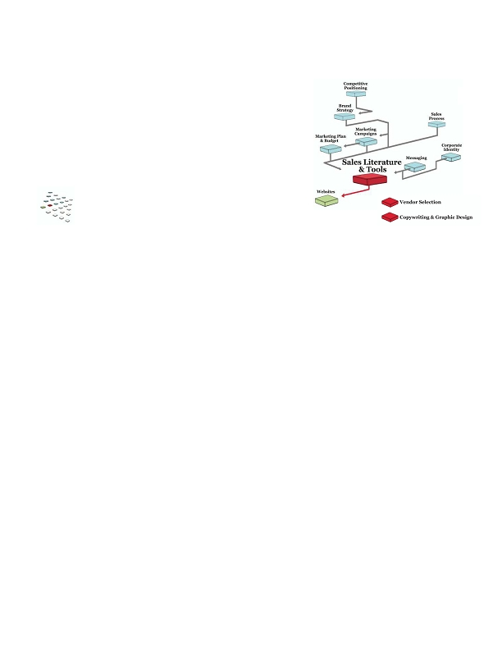
BEST CASE

Your sales literature and tools are
strong elements in your arsenal.
They convey your brand, speak
directly to your prospects, and
deliver the right amount of
information at the right time. They
truly help you move prospects
forward as quickly as possible.
NEUTRAL CASE

Your literature and tools are
typical and general. They convey
much of the information your
prospects need, but lack the
singular focus to be as effective as
they could be.
WORST CASE

Your literature and tools don't
support your brand or value
proposition - they're working
against you.
Key concepts & steps
•
Before you begin

Develop your sales tools and literature after you've created your brand
strategy, corporate identity and messages. You may also identify
the need for new materials when you write your annual marketing plan.

Analyze your current materials

If you think your existing literature and tools could be more effective, take inventory:

• Review each piece to determine its sole focus.
• Ask your sales team and others for feedback on whether the piece works.
• Make sure the piece supports your value proposition and brand strategy.
• Make sure each piece is delivered at the right time.

Determine what materials you need

List the steps of your sales process, then

• Brainstorm the materials you could use to answer a prospect's questions at each step
• Define a singular purpose for each piece of literature or tool

Write, design & print your materials

To develop your content, focus on the singular purpose of each piece.

• Outline the content that needs to be in each piece
• Hire vendors for design & writing if needed
• Research and write the content
• Develop your design requirements
• Design the piece
• Get quotes and work with your chosen printer to ensure that you're happy with the final outcome
..00.0,ffi fffi/0201fiffi fffi4.00,,,7,ffi fi/7.7
42
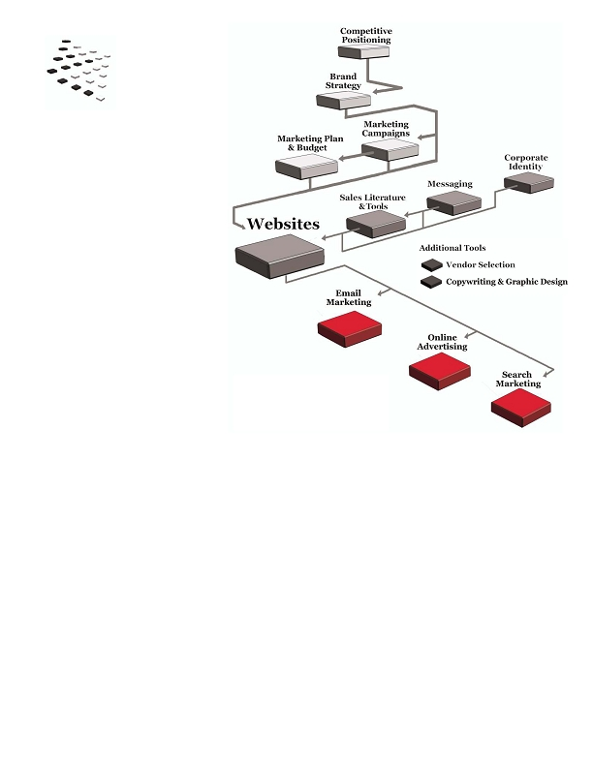
Train your team to use the materials

Make sure everyone knows the purpose of each piece and when to use it.
What's next?

If you think your website could be stronger, it's a logical next step.
Like literature, your site should support your sales process, deliver
valuable information and reinforce your brand. It can also be used for
a wide variety of marketing campaigns.
• fffiffi,-ff./0fi1230fffi00 fffiff4056ff0ff,,,78 fffi897.7
43
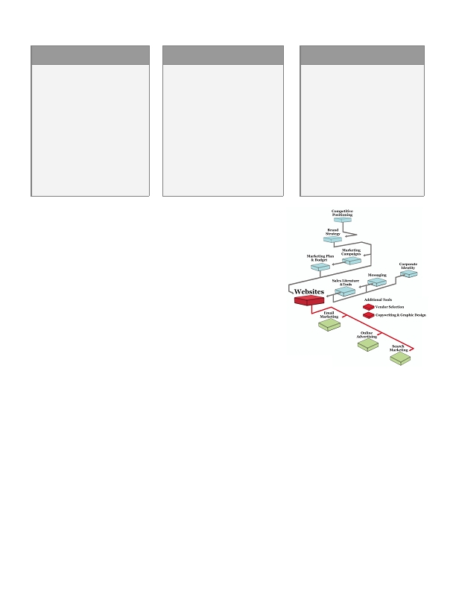
Websites
•

These days, most business buyers use
the web to read news, research solutions,
find vendors and learn about other companies.
And whether they learn about your company online
or through other means, most buyers and potential
partners will review your site before they do business with you.

Your website is potentially the most powerful sales &
marketing tool you have. A good site plays an enormous role in
your sales process and can help you:

• Generate leads
• Nurture existing leads and move them closer to purchase
• Deliver information about your products & services in a compelling way
• Process orders, cross- and up-sell, and run special promotions
• Communicate with existing customers and distribution channels
• Generate publicity

Think of your site as an interactive brochure that speaks with different groups and converts visitors into
prospects and customers. It's an extension of your brand and an example of the quality of work you do.

Although a site can be a substantial investment, it doesn't have to be expensive; it just needs to effectively
communicate with your market and support your brand. Yet when you develop your site with richer content
and some basic marketing functionality, you gain broad and potentially lucrative marketing capabilities.
..00.0,ffi fffi/0201fiffi fffi4.00,,,7,ffi fi/7.7
44

BEST CASE

Your site is more than a brochure;
it sells. You use it for a variety of
internet marketing campaigns:
Search, email, webinars, ongoing
communications, publicity and
more. Your content is relevant;
you know how many leads your
campaigns generate and what
those leads cost. You can quickly
create landing pages for campaigns
so you can convert traffic into
prospects.
NEUTRAL CASE

You have a standard site with basic
information plus a few press
releases & newsletters. You've tried
some internet marketing with
mixed results. You know your
prospects look at your site and it
could be better, but it's no different
than your competitors. There are
bigger priorities than a site
redesign, but you suspect that more
content & functionality would give
you more marketing power.
WORST CASE

Your site works against you. It may
be the design, content (or lack of),
writing, or functionality. It doesn't
support your value proposition and
you can't do any internet marketing
campaigns. You wince when
prospects ask for the URL; you know
they don't get a good impression
from your site and your competitors
look better and stronger. You can't
quantify whether you've lost any
business - but you know you
probably have.
Key concepts & steps
•
Before you begin

Make sure you've tackled your brand strategy, corporate identity,
messages and sales literature before developing your site. A site
project may also flow from your annual marketing plan, particularly
if you've decided to pursue more aggressive internet marketing
campaigns.
•
Develop your project team and timeline

• Work backward from key deadlines to create your project
timeline. Give yourself plenty of leeway since website projects
can easily hit snags.
• If you're launching a sophisticated site, make sure you've included all of the relevant departments in
your project team.
•
Define your needs

Before you hire a designer or developer, decide what your site needs to accomplish:

• Your major goals
• How the site will support online and traditional marketing campaigns
• How the site will help you generate leads, nurture prospects, communicate with your market, process
orders, etc.
• The information and functionality you believe you'll need
• Whether a basic design is fine or whether you'll need something more unique and customized
• fffiffi,-ff./0fi1230fffi00 fffiff4056ff0ff,,,78 fffi897.7
45
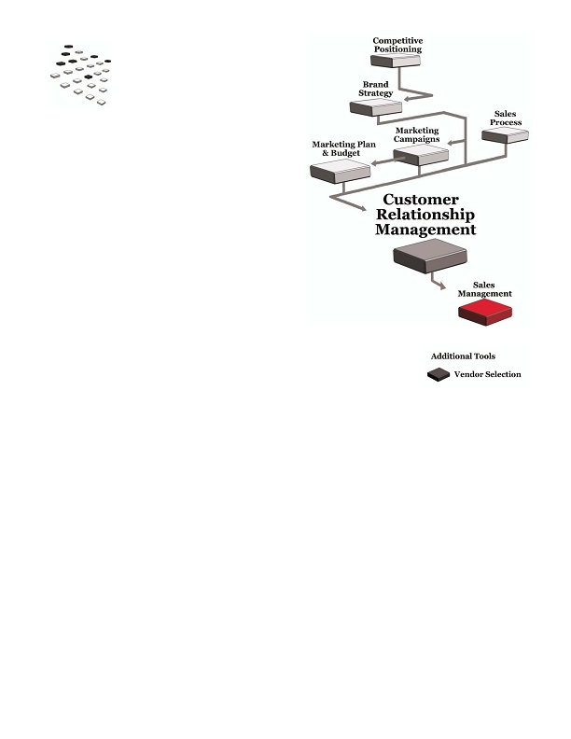
Develop your content

• Determine a preliminary game plan for your internet marketing efforts so that your site can support
them.
• List the "users" who will visit your site: new prospects, existing prospects, customers, partners, media,
job applicants, vendors, etc.
• Develop a list of the information and tools ("content") each user wants to find on your site.
• Review competitor and other industry sites for additional ideas.

Organize the content

Organize your content so users can quickly find what they need. You'll also incorporate Search Engine
Optimization ("SEO") techniques to help with search engine rankings. For example, your home page is most
important to search engines; if you don't have rich content on that page, you won't rank as highly.

Identify functionality you'll need

• You may want to display product details and process orders.
• Determine whether you want to let customers access their records on the site.
• Evaluate other functionality such as search, calculators, streaming video or other capabilities.

Develop your design requirements

Like your sales literature, your site should convey your brand. Use your regular color palette, typefaces and
personality traits as much as possible.

Identify any last requirements

• Requirements for updating and managing the content
• Programming technologies you do and don't want in the site
• Reporting requirements

Qualify and hire vendors

Unless you have an in-house web development team, hire vendor(s) for design, writing and/or programming.
Review their past work and talk with recent clients to make sure you're comfortable with their strategy and
skills.
What's next?

Once you're finished your site, use it to communicate with your market
and generate leads, especially through email, online advertising and
search marketing.
..00.0,ffi fffi/0201fiffi fffi4.00,,,7,ffi fi/7.7
46
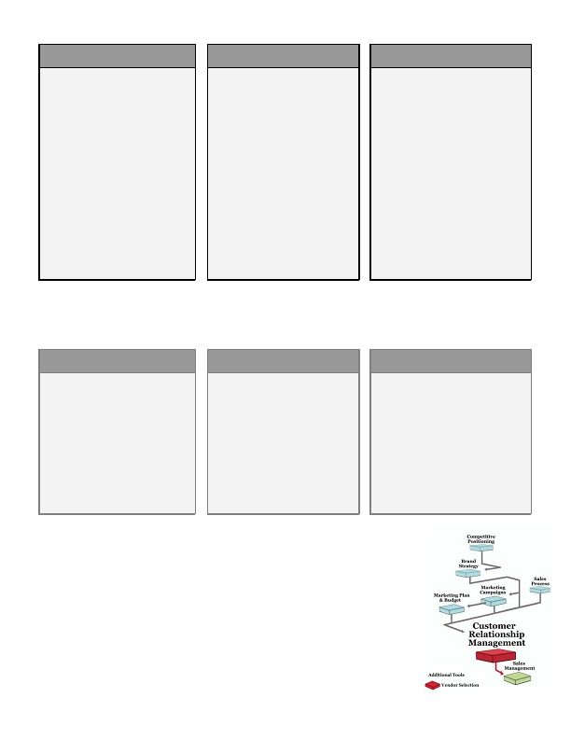
Customer
Relationship
Management
•

Customer relationship management ("CRM") is a term
that refers to two things:

• A company's strategy for managing leads and customer data
• Software that manages that data

In its simplest form, CRM is a database where sales and marketing teams store critical account
data:

• Contact & account information (contact names, emails, phone numbers, SIC code, address, etc.)
• Source of the lead
• Sales rep name and activity history (calls, emails sent, inquiries, etc)
• Purchase history
• Projected revenue by customer
• Marketing campaign data

CRM can also be an important reporting tool. For example, you can use it to:

• Generate revenue projections for a product, a sales rep, and your company as a whole
• Tie revenue to the original marketing campaign
• Pull up lists of leads and activities by sales rep
• View the number of leads you have at each step in your sales process
• Track your progress against your goals
• Manage marketing campaigns
• Capture leads from your website
• Minimize the time your team spends creating manual sales & activity reports

Here are three examples of how different companies can use CRM:
• fffiffi,-ff./0fi1230fffi00 fffiff4056ff0ff,,,78 fffi897.7
47
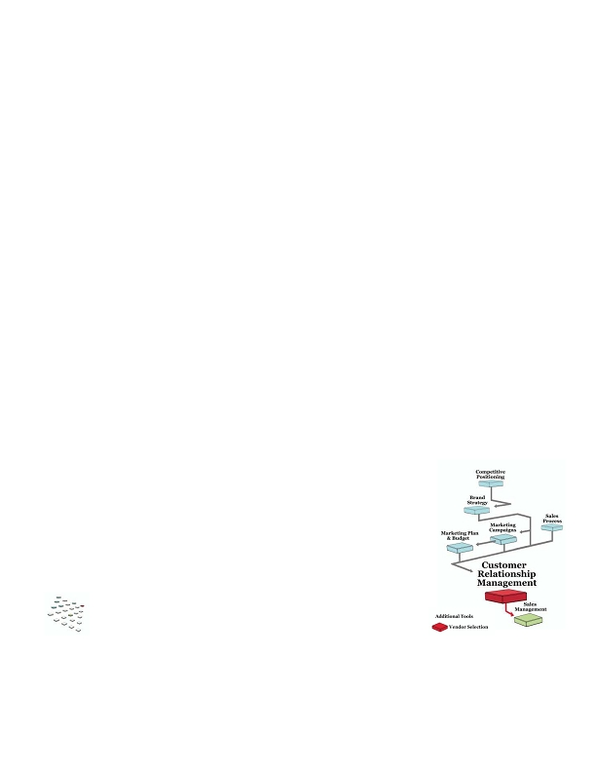
ENTERPRISE CRM
Company A is a national insurance
company that sells direct to
consumers and uses a single CRM
system. Thousands of sales reps
across the country log in, enter
prospect data and use the system to
manage their sales activities.

At regional and corporate offices,
many departments use the data to
run-real time reports - revenue
projections, sales metrics, customer
growth, customer satisfaction, and
ROI for marketing campaigns - to
effectively manage the business.
MID-MARKET CRM

Company B's 60 employees use
CRM to manage 1,200 customer
records and thousands of prospects.
The system links to the "request
information" form on the
company's website; leads are
intelligently routed directly to the
sales rep for that territory.

The CRM links to the company's
accounting software. When orders
appear in the CRM system, they
also appear in the appropriate
financial reports. The operations
team uses the system to fulfill
orders and track shipping and
service history.
SMALL COMPANY CRM

Company C has four sales reps, two
account managers and a marketing
manager. They use a web-based
system and pay per user per month.

They started with a simple version
and upgraded when they needed more
functionality.

Their system tracks leads by
campaign, assigns leads to sales reps,
tracks activity, estimates revenue,
launches and measures marketing
campaigns, and stores templates for
sales letters, emails and
presentations.
Every company needs to store this information somewhere, and there are CRM products with very simple
functionality and complex multimillion-dollar versions. When you use the right CRM system, you gain
knowledge and power to keep your team on track and measure progress against goals.
BEST CASE

Your CRM matches your marketing,
sales, customer service and retention
strategies. It's easy to use and
provides reports that eliminate the
need to generate tedious manual
reports. It may integrate with other
software like accounting and
inventory, enabling your entire team
to view important data and reports
in real time.
NEUTRAL CASE

Your CRM meets your basic needs.
Your team uses it fairly
consistently, but you have to keep
on them to update data regularly. It
doesn't have all of the reporting
capabilities you'd like, and revenue
reporting tends to be manual, so
there's some lost sales productivity.

It's fine, but it probably isn't the
best solution.
WORST CASE

You don't have a solid system for
managing customer information; it's
kept in various files or databases that
aren't linked. It's difficult and time-
consuming to create revenue
projections, sales reports and
marketing campaign reports.

The result: lost revenue, productivity
and opportunity.
Key concepts & steps
•
Before you begin

When you build your competitive positioning and brand strategies, you may
decide that you need a system that helps you better manage your customer
relationships and information, driving you to look at CRM. You may also decide to
evaluate CRM after developing marketing campaigns or a marketing plan that
will require better lead capture, reporting and other marketing capabilities.

Once you have a defined sales process, you'll enter it in the system so your reps can
track the steps each account goes through.

..00.0,ffi fffi/0201fiffi fffi4.00,,,7,ffi fi/7.7
48
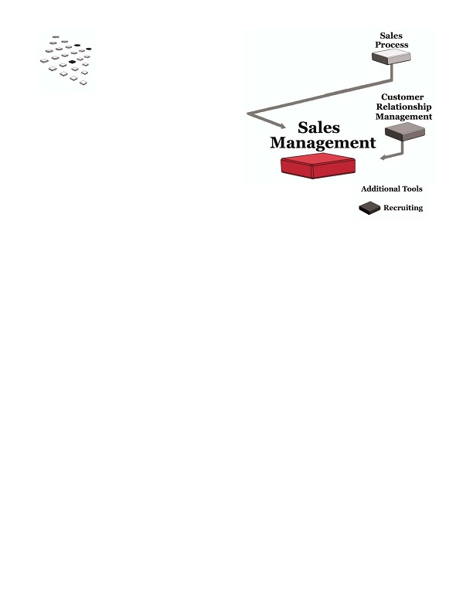
Analyze your needs

If you're new to CRM or have a system that could be improved, define what you need.

• Decide what information your team should be able to access and how they'll use it.
• Identify who needs to use the system and where they're located (i.e. in different offices).
• Determine what reports you'll want to generate, particularly your revenue and pipeline reports.
• Identify the marketing programs you'd like to be able to run and how that information can help you
better manage your accounts.

If you've outgrown your current system, you may be able to purchase add-ins to give your existing system more
power. You may also decide to evaluate new systems to give you the true functionality you need.

Evaluate and compare CRM software

Once you've defined your requirements, look for a CRM package that meets your needs. Remember that many
systems come in several versions; you can start with a basic version and upgrade as you grow, but make sure the
upgrade process is seamless.

Implement and monitor your system

When you're nearing the end of your selection process, get ready for implementation.

• Create an implementation team.
• Develop a schedule for key tasks: configuring fields, migrating data, creating reports, training users.
• Create a solid training plan.
• Launch the software.
• Do followup training to ensure that your team uses the software as planned. Most implementations fail
because employees don't use the software properly.
• Gather feedback and modify the software configuration as needed; make it as intuitive and powerful as
possible.
What's next?

CRM software can dramatically improve your sales management, so make sure
your entire team understands how to effectively use the software to make selling
easier.
• fffiffi,-ff./0fi1230fffi00 fffiff4056ff0ff,,,78 fffi897.7
49
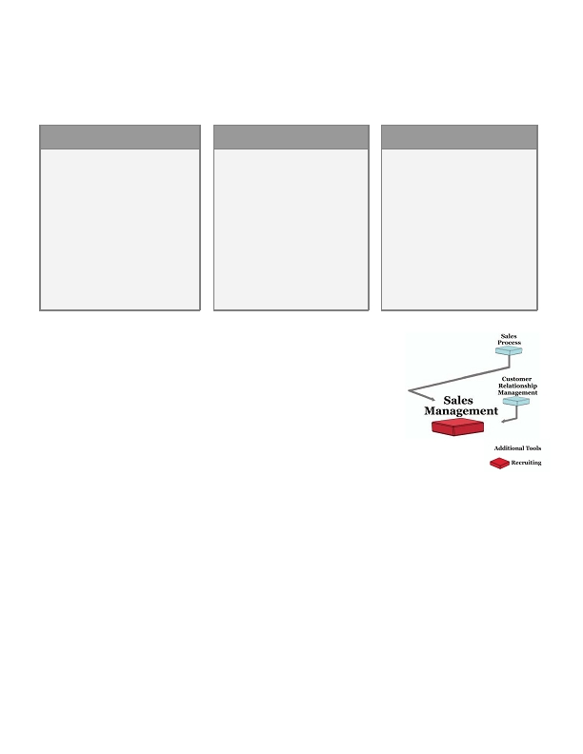
Sales Management
•
•
Good sales management is one of the simplest ways to increase your revenue and profitability.

Sales management is about leading the people and process your company uses to sell prospects
and service customers. Responsibilities include:
• Building the right sales strategy
• Hiring the right team
• Creating the right compensation plans,
territories and quotas
• Setting the right projections
• Motivating your team
• Tracking revenue against goals
• Resolving conflicts
• Training and coaching sales reps
• Managing processes
• Getting the sale!
Why is there a sales management chapter in the Strategic Marketing Process?

• Your sales team is the voice of your company. In fact, your reps may be the only people with direct
customer interaction. They may be responsible for prospecting, selling and managing existing
customers. They control the dialogue with your market, gather feedback, and deliver on your value
proposition and brand promise.

• The sales team will make or break your marketing efforts. Even if you're not personally responsible for
the sales team, it's important to understand their role and draw on that knowledge to create better
marketing programs.

• Sales and marketing serve one purpose: to generate revenue. They should be completely aligned in
their understanding of customer needs, their messages, and the process they use to identify prospects,
sell, close and manage. They should work together as a unit, providing valuable feedback to improve all
of their strategies.

• When departments aren't aligned, your company wastes time and opportunity. For example, when
salespeople rewrite literature and tools to their liking, your messages are diluted and salespeople are
doing something other than selling.
..00.0,ffi fffi/0201fiffi fffi4.00,,,7,ffi fi/7.7
50
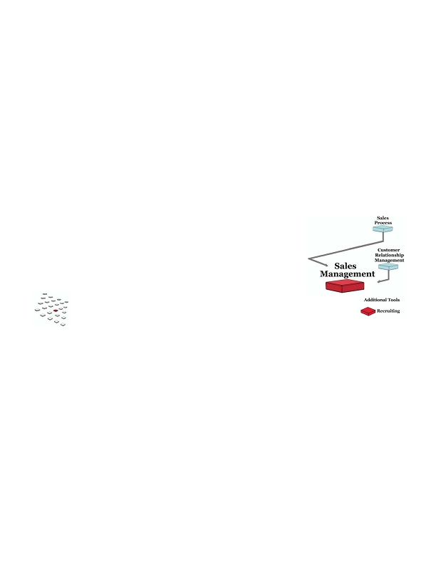
Small improvements in your team's skills and processes can often produce substantial results. Even great
salespeople can benefit from coaching; if your team is struggling, there's room for improvement. And with the
right attention to your pipeline and goals, you can make sure you're on track to hit your numbers and make
adjustments as needed.
BEST CASE

Your sales team is a revenue
machine. They have the right skills
and experience; they're motivated to
come in each day and close business.

You coach them regularly to improve
their performance. When problems
arise, they're dealt with swiftly.

The sales team does a great job
delivering the company's value
proposition, brand strategy and
messages.
NEUTRAL CASE

There are strong and weak players
on the sales team.

Some require a lot more hand-
holding than you'd like; there isn't
always time to give them the help
they need. As a result, their close
ratios are much lower. They're
probably not hitting their quotas,
but they're not a major liability to
the company.
WORST CASE

Your sales team isn't strong. They
may not have a dedicated sales
manager to help improve
performance. They may not have
enough experience, especially if
you're a small company that can't
yet afford the big hitters.

You have a pipeline but don't know
what's happening with prospects; it
takes longer than it should to close
deals. You suspect you need an
entirely new sales operation.
Key concepts & steps
•
Before you begin

It's always a good time to increase your focus on sales management. Your
sales process and CRM are important tools that can help you manage your
team, forecast results and keep your team on course.

Create the right compensation plan and tie it to your revenue goals

Great salespeople want to make money. Tie the plan to your revenue goals and make sure that you're
compensating your reps for the right things. For example, if your reps don't earn commission for managing
"house" accounts, they'll spend their time going after new business and you could lose valuable existing
customers.

Set realistic quotas

Be realistic about what a salesperson can accomplish in a set timeframe. Good salespeople can be demotivated
by unrealistic quotas, which can lead to turnover.

Hire the right people

To build a great team, start with a strong recruiting effort. Create a detailed job description so you know exactly
what you need in your candidates. Cast a wide net, use a thorough interview process, and go after the
candidates you really want.
• fffiffi,-ff./0fi1230fffi00 fffiff4056ff0ff,,,78 fffi897.7
51
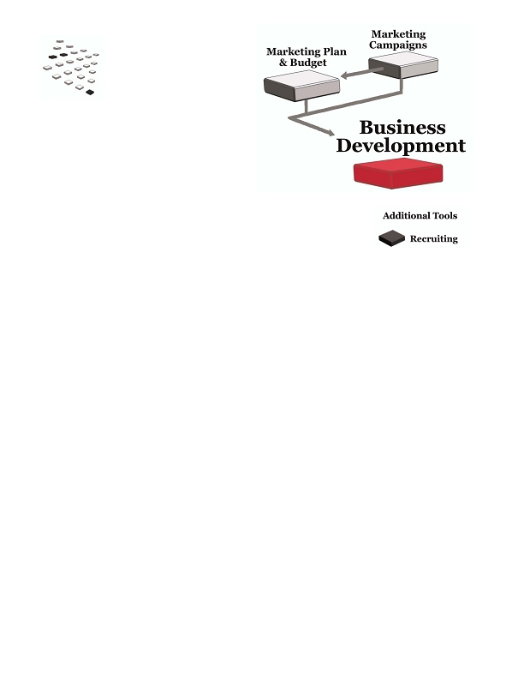
Coach and provide feedback

A good manager actively works with the sales team. Train your reps thoroughly and coach them to improve
their skills. Go on calls, establish performance measurements, and provide feedback. If a rep has trouble in a
particular area, create an action plan and measure improvement.

Generate good reports

You'll need good sales reports to measure team and individual progress. Yet you don't want your sales reps to
spend valuable sales time creating manual lists and reports. Instead, develop automated reporting processes -
for example, create reports in your CRM system. With good reports, you can see problems much earlier and
take action more quickly.

Motivate!

Good sales reps want to get better - encourage them to read, attend seminars, network, and keep refining their
skills.
What's next?

Keep working with your team, improving their skills, and adjusting as needed.
Hire the right people, manage them well, and enjoy their success!
..00.0,ffi fffi/0201fiffi fffi4.00,,,7,ffi fi/7.7
52

Business Development
Organizations apply the term "business development" (a.k.a. "biz dev") to a variety of activities.

"Business development" in the Strategic Marketing Process refers to high-level partnerships
that generate revenue, create better products and/or increase efficiency. These partnerships can
help you

• Access new markets
• Increase sales to existing markets
• Improve your access to technology
• Boost your productivity
• Gain capital (human or financial)

In a true partnership, companies collaborate to achieve a common goal. It's more than a short-term promotion
such as a special offer or marketing to each other's customers. Instead, it's an agreement to do business
together while sharing responsibilities, resources, risks and rewards.

For example, here are three examples of true partnerships:
• fffiffi,-ff./0fi1230fffi00 fffiff4056ff0ff,,,78 fffi897.7
53
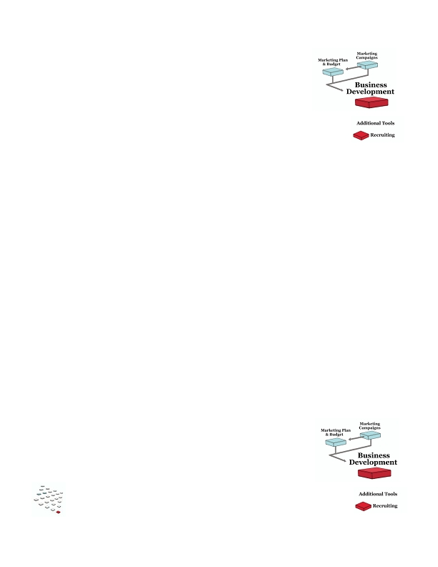
TO CREATE NEW
PRODUCTS
A computer manufacturer enters a
partnership with a fashion designer
to create a limited-edition laptop
and matching case.

They create a team of employees
from both companies to designs and
market the product. The computer
manufacturer produces the
computers, the designer creates the
bag, and they share revenue fairly
based on their cost structure.
TO INCREASE EFFICIENCY

A software company has a fantastic
new product but is inundated with
customer service calls they can't
handle. They approach a
telemarketing firm that specializes
in the software industry.

Instead of just hiring the
telemarketing firm, they create a
partnership. The telemarketing
firm provides service for a greatly
reduced fee, then receives a
substantial commission for selling
the software company's other
related software. The partners
work closely together to maximize
their revenue on the sales program.
TO CREATE NEW
PRODUCTS
A design firm partners with a direct
mail fulfillment firm to offer each
other's services to their respective
clients.

Each company promotes the
partnership to new prospects &
existing customers. They offer the
service with a single point of contact -
if a design client needs mail services,
the design firm manages the
implementation rather than just
referring the client to the mail firm.

Each company bills the other at
special rates so there's room for a fair
markup, providing each company
with additional revenue.
In these examples, each company has distinct responsibilities in the partnership. They each devote resources
(either time or money) to the program, and if it fails, they have similar levels of risk. They've also fairly divided
the rewards.

The first step in a successful partnership is structure; the right arrangement aligns both companies toward an
important common goal. The second step is execution; a partnership should be managed like any business with
careful attention to detail, solid communication and focus on the end goals.

With the right structure and management, your business development deals have the greatest potential for
success.
BEST CASE

The partnership is balanced and
productive for both parties. You share
responsibilities, resources, risks and
rewards, and the partnership delivers
substantial revenue, cost savings or
new opportunities for both
companies.
NEUTRAL CASE

Your partnership isn't balanced --
perhaps you have more
responsibilities and resources
allocated or you don't share fairly
in the rewards. It produces value,
though not what you had expected;
you hope the situation will
improve with time.
WORST CASE

You enter into a partnership and
invest substantial resources, but the
partnership goes awry. Your
"partner" isn't delivering as needed
and you don't have much recourse -
your partner isn't really providing
resources or sharing risk. As a
result, you end the partnership and
lose valuable time and money on the
deal.
Since these partnerships involve multiple departments in each company, there are usually a number of people
involved in the deal. It's often an executive or high-level "biz dev" person leading the process for each company,
although in small companies a sales or marketing executive will take the reigns. However, creating a
partnership is more complex than pure sales -- it requires a solid understanding of the business and operational
objectives of multiple organizations.
..00.0,ffi fffi/0201fiffi fffi4.00,,,7,ffi fi/7.7
54
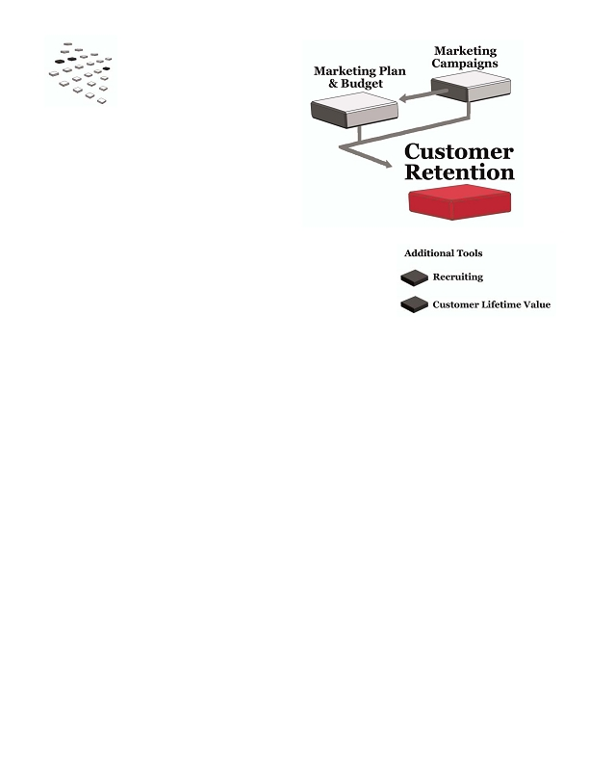
Key concepts & steps

Before you begin

You can think about business development at any time. It's common to identify
potential partnerships during annual planning time, so many companies start
pursuing deals after finishing a new marketing plan.
•
Identify potential partnerships

Brainstorm to identify partnerships that can help you meet your goals. For example, there may be related
companies with customer relationships in a different market; you may have vendors or suppliers who can help
you improve your products or firms that can help you round out your services.

Think about structure as well - the resources each party would provide, how the partnership would be managed
and what each party would invest and earn.

Identify the right "biz dev" person to lead the project

A good "biz dev" person has a broad understanding of business strategy and operations; s/he can also can
negotiate and close a complex sale. It's a different skill set than many sales reps offer, but you may have a rep or
executive on your team who can do these kinds of deals -- or you may tackle it yourself.

Pitch a partnership

Develop a strong pitch to capture the attention of your potential partners; focus on the high-level benefits for
each party. As you move through the sales process, cover all aspects of the partnership including detailed
structure and terms.

Share responsibilities, resources, risks and rewards

You have a much stronger chance of success when a partnership is balanced. As you negotiate the deal, make
sure your interests are completely aligned and that each party is contributing in all areas.
What's next?

When you set up a partnership, make sure your company manages and executes so
that you'll reap the full benefits. As part of the partnership you may launch new
marketing campaigns - treat them as you would any other marketing program.
• fffiffi,-ff./0fi1230fffi00 fffiff4056ff0ff,,,78 fffi897.7
55
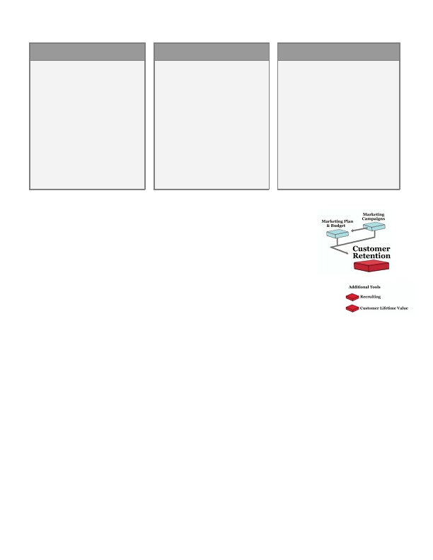
Customer Retention
How much have you invested in sales and marketing over the last few years? Thousands? Tens of thousands?
Millions? Tens of millions?

Customer retention is about keeping the customers you've spent that money to acquire. And if
you're in an industry where they make multiple purchases over the years, your entire team should be very
focused on retaining those customers:

• Delivering service that's consistent with your value proposition and brand
• Cross-selling, up-selling and asking for referrals from existing customers
• Developing programs to increase customer loyalty and decrease turnover
• Knowing the lifetime value for different segments and using that data to improve your marketing
• Prioritizing retention as a major focus in your annual marketing plan

Studies say it costs ten times more to generate a new customer than to maintain an existing one.
If you have a small number of customers, losing a few could cripple your company. Even if you have a large
number of customers, a small increase in your retention rate should dramatically increase your profits. In fact,
1
in his book The Loyalty Effect, Fred Reichheld writes that "a 5% improvement in customer retention rates will
yield between a 25 to 100% increase in profits across a wide range of industries."

With strong retention marketing, it's much easier to grow your revenue and profitability. Do you see your
company in any of these scenarios?
..00.0,ffi fffi/0201fiffi fffi4.00,,,7,ffi fi/7.7
56

•
BEST CASE

Your company is focused on
customer retention and it has paid
off. Renewals are high; you put a
lot of effort into campaigns and
service for existing customers.
Sales reps are incented to keep
customers happy, and you use
financial modeling and surveys to
identify problems and focus on
vulnerable customers. Your
revenue has grown substantially
each year because you're adding
new customers without losing
current ones.
NEUTRAL CASE

You know how important it is to
retain customers. The reps who
service existing business are good,
but you've lost some customers that
you shouldn't have. You've done
surveys but haven't done anything
major as a result. And you struggle
with the commission for current
business - some people argue that
you shouldn't pay at all because
they're house accounts.

As a result, you have to replace
current customers each year.
WORST CASE

You don't formally market to your
current customers. You know your
service could be better, but you
haven't had the time to develop an
improvement plan. You definitely
have more turnover than you'd like.

As a result, you're continually
investing to generate new customers.
Your revenue profit margins are much
lower than they could be, and the
churning takes its toll on your
organization.
Key concepts & steps

Before you begin

You can work on your customer retention strategy at any time, and marketing
campaigns may be an important part of your strategy. You may also decide to
increase your focus on retention when you're writing your annual marketing plan. But if
you're losing customers, don't hesitate to focus your energy on retention right now.
•
Determine your retention strategy

Your value proposition and brand strategy should drive your retention plan. For example, if your value
proposition is customer intimacy, your customers are counting on great service. If they're buying on price,
you'll usually focus more on automating service to minimize costs.

Build your team

In some industries, the original sales rep is the best person to manage an existing client -- for example, the
account may require ongoing selling. In other cases it's better to transition the customer to an account rep who
focuses on day-to-day management.

Once you've decided how to structure the team, determine how many people you'll need and start recruiting.

Pay commission for renewals and growing the business

Your current customers are your most valuable asset; if your sales reps don't earn commission on renewals,
they'll be incented to spend their time chasing new business instead.
• fffiffi,-ff./0fi1230fffi00 fffiff4056ff0ff,,,78 fffi897.7
57
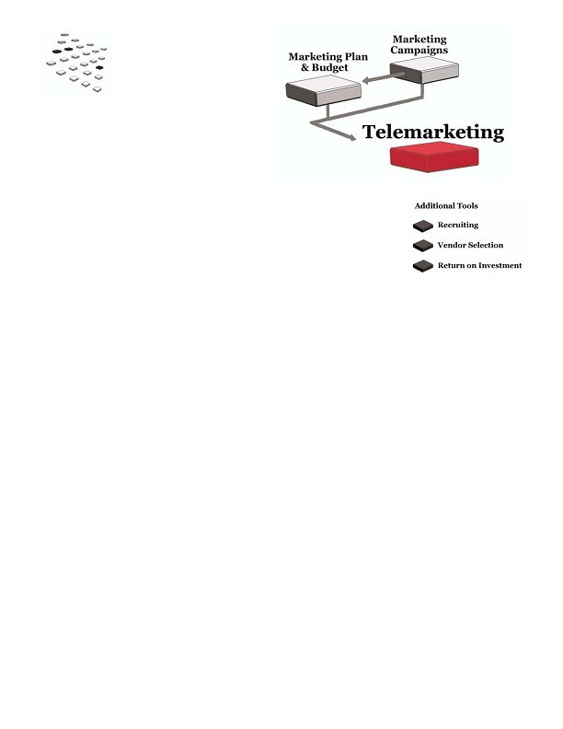
Market to existing customers

Put as much effort into your current customer campaigns as you do the rest of your marketing programs. Know
your audience, grab their attention, focus on the offer, measure your results. Use campaigns to:

• Nurture your customer relationships
• Encourage them to buy again
• Expand your relationships by cross-selling, up-selling and asking for referrals
• Identify customers who are at risk of defecting
• Continually deliver on your value proposition and brand promise

Measure purchase intent and loyalty, not "satisfaction"

Customer feedback can help you improve your products and continue your relationship. However, it's not
effective to measure "customer satisfaction" because it's so vague. "Satisfied" doesn't mean they intend to keep
buying. Instead, focus on behavior: Ask whether they intend to buy again and why or why not. Ask what three
things you can improve and whether they'll provide referrals. These questions provide more actionable insight
than "satisfaction."

Treat a survey as a marketing campaign. Give your customers a reason to respond, thank them and share the
results.

Use data to evaluate large groups of customers

If you don't have personal relationships with your customers, use data to identify customers who haven't
purchased in the normal timeframe. They may be at risk of defecting and you can launch retention campaigns
and encourage them to stay.
What's next?

Refine and improve your customer retention strategy and execution -- they may
deliver the highest ROI of all your marketing programs.
1
Frederick Reichheld, The Loyalty Effect (Harvard Business School Press, 1996)
..00.0,ffi fffi/0201fiffi fffi4.00,,,7,ffi fi/7.7
58
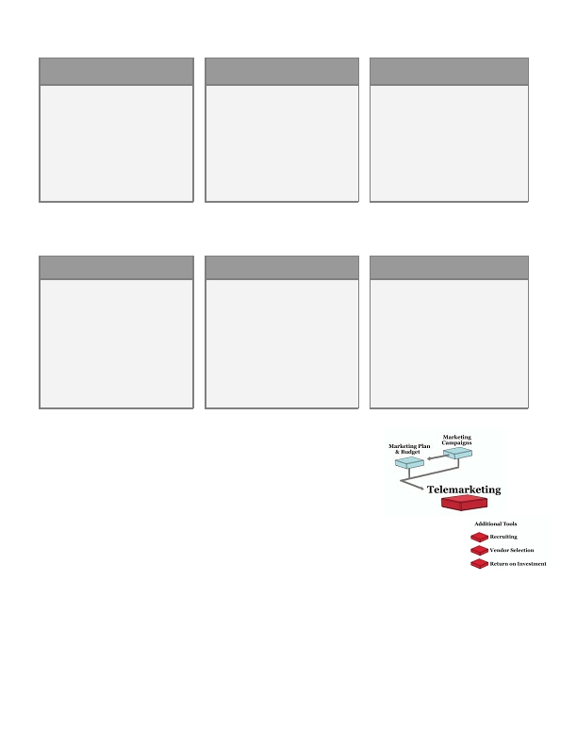
Telemarketing
•
•
The phrase "cold calling" sends chills down the spines of many businesspeople.
It's often viewed as an intimidating, difficult, and boring process … and that means
it doesn't get done as often as it should.

Telemarketing campaigns help companies reach a group of targeted prospects or customers to
communicate a message, gather feedback, and determine a next step for the relationship.
Telemarketing can be an important part of any marketing strategy - for example, you can use it to:

• Generate leads
• Qualify prospects who have downloaded information from your website or attended a webinar
• Follow up on a direct mail or email offer
• Take orders for special promotions
• Keep your marketing database current
• Conduct marketing research

In many companies, sales reps should make hundreds or thousands of cold calls every month to set
appointments and/or generate leads. But busy reps usually prefer to work on closing their existing pipeline.
Prospecting often slips on the priority list; as a result, the sales pipeline isn't always filled with new prospects.

If cold calling is an effective way to introduce your company to new prospects, don't ignore it. Instead of forcing
a sales team to devote time to prospecting, many companies use an in-house or outsourced telemarketing group
to make a high volume of calls, find decision-makers and qualify leads for the field sales group.

When telemarketers handle prospecting, salespeople can spend 100% of their time selling and closing. Your
company can produce more revenue in the same amount of time; your reps earn more commission, they're
doing what they love, and they're more satisfied with their jobs.

You can use a telemarketing team in a variety of campaigns:
• fffiffi,-ff./0fi1230fffi00 fffiff4056ff0ff,,,78 fffi897.7
59

OUTBOUND LEAD
GENERATION

Company A's telemarkers call
targeted lists. They identify the
decision-maker, ask qualifying
questions, and gauge the prospect's
needs and interest level. If a
prospect meets certain criteria, the
telemarketer sets a followup
appointment for a sales rep.
OUTBOUND CAMPAIGN
SUPPORT

Company B increases their
response rates by including a phone
call in campaigns. For example,
when they hold an event at a trade
show, they call prospects before
mailing an invite to lifts their
response rate. They also follow up
with those who don't respond.
INBOUND SALESSUPPORT

Company C makes sure that
prospects who visit their website can
call and speak with someone
immediately. They use an inbound
sales support team to answer
questions and probe callers. The
reps send followup materials and a
field sales rep follows up with the
most qualified prospects.
With the right strategy and proper management, a good telemarketing operation can produce great value for
your company.
•
BEST CASE

You have a team or vendor to
prequalify leads and handle
inbound and outbound calls for
marketing campaigns. Your team
successfully represents your brand
to your market. You have strong
management in place and can easily
report on key statistics: contacts
per hour, stats by rep, etc. You set
goals and hit them consistently.
•
•
NEUTRAL CASE

You have a vendor or in-house team
and their performance is average.
If they're in-house, you have some
statisics, but not enough, and
there's a fair amount of turnover in
the position. In fact, you're always
training someone new. You see the
value in using telemarketing and
you think your operation could
improve.
WORST CASE

You don't have a telemarketing
operation. Sales reps make their
own cold-calls but they simply don't
make enough. When prospects call
from your website, there frequently
isn't a person available to talk with
them live. And when you need to
include a phone call in a marketing
campaign, it's an enormous battle to
get reps to make calls.
Key concepts & steps
•
Before you begin

If you can immediately gain new prospects and customers, don't hesitate to
launch a telemarketing campaign right now. You may also decide to pursue
telemarketing after developing your annual marketing plan.
•
Set your goals

You can use telemarketing in many ways; brainstorm the campaigns that will work best for your company. For
example, you may need to generate leads for your sales team or use telemarketing to support other marketing
campaigns.
..00.0,ffi fffi/0201fiffi fffi4.00,,,7,ffi fi/7.7
60

Forecast and budget; determine whether to build in-house or outsource

• Estimate your call volume, then think about hours of operation, fluctuations in call volume, and the skill
set you'll need in your reps.
• Your call volume also drives your headcount, software, phone system and the office space you'll need.
• These requirements will help you decide whether to use a vendor or hire and manage a team in-house.
If you look at vendors, the requirements will make your discussions easier and faster.
• Budget for everything including headcount, software licenses, bonuses and management.

Develop good scripts

Reps will need to capture attention, build value, and close; a good script will help them do it consistently.

• Make your scripts conversational, simple, and focused on the end goal.
• It helps to make and listen to calls as you're developing and refining your script. What looks good on
paper may not work on the phone.
• Get feedback from your team as well.

Train and coach your team

Regular coaching and quality assurance is crucial.

• Engage your reps, role-play and guide them through calls.
• Listen to calls regularly, evaluate your reps and coach them to improve their performance.

Make it fun!

Telemarketing is a tough job and turnover is a big issue.

• Make things fun with contests, events, and other incentives.
• Make their space comfortable and interesting - tiny cubes, old chairs and windowless rooms don't put a
smile in anyone's voice.

Report your results

• Define the reports you'll need -- your system may not be able to provide all of the data, but you can
probably find an alternate solution.
• Use reports to consistently evaluate progress and improve your campaigns.
What's next?

It's all about execution, so manage your team and devote the resources
necessary for success. Telemarketing can be very effective and is often
underutilized in B2B marketing plans.
• fffiffi,-ff./0fi1230fffi00 fffiff4056ff0ff,,,78 fffi897.7
61
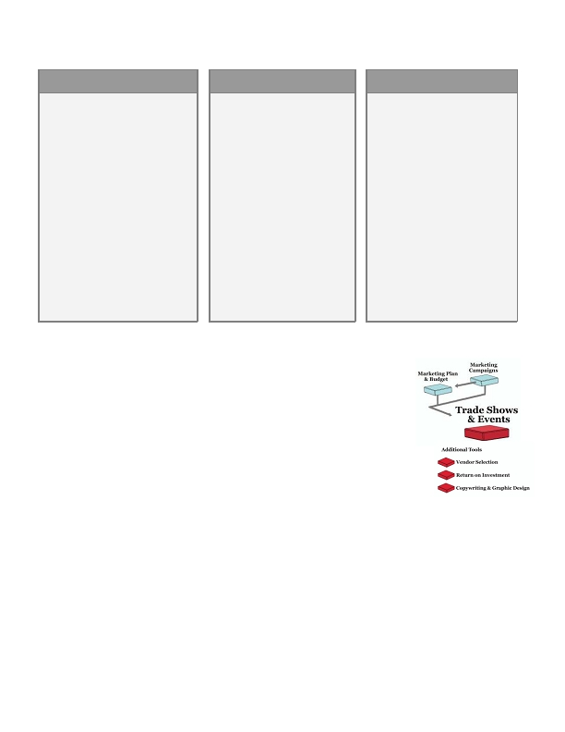
Trade Shows & Events
•

There's an old saying in business that people buy from people. If that's the case,
it's a good idea to get people together as often as possible!

Trade shows and events are gatherings for businesspeople with common interests to achieve a
goal. B2B companies use these events to generate leads, nurture prospects, build awareness, conduct training,
or enhance relationships with existing customers. Options include:

• Trade shows: You can exhibit during the exhibition, sponsor roundtable discussions or speeches,
advertise in show materials and/or host your own reception at the event hotel or a restaurant in town.
• Seminars or conferences: Sponsor an industry conference or create a seminar and market it to your
prospects.
• Networking meetings: Participate in and/or sponsor industry or local meetings; you can also create
a one-time or ongoing breakfast or lunch meeting series for your prospects to attend.
• Webinars: Webinars are online seminars with slides and audio; you can use them to generate leads
and communicate with large groups at a lower cost than a live meeting.
• Events for the arts, sports or charities: You can participate in these events as a sponsor with
advertising, blocks of tickets, promotions and a reception for your VIPs.

Many shows and events are major investments with a lot of logistics:
• Event planning
• Travel
• Shipping
• Setup
• Promotion
• Sales materials
• Sales followup
• Measurement
When executed properly, a great event could produce a large percentage of the leads a company needs to
generate over an entire year. With a halfhearted strategy, companies usually get lackluster results.
..00.0,ffi fffi/0201fiffi fffi4.00,,,7,ffi fi/7.7
62

Do you see your company in any of these scenarios?
BEST CASE

You use trade shows, special events
and/or webinars to generate new
prospects and reach out to existing
prospects and customers.

You stand out from your competitors,
deliver compelling information and
create meaningful dialog with your
market.

You set goals and measure them, and
you know your ROI is worth the
investment. You also implement
marketing programs to drive traffic
and continue dialog after the event so
leads don't fall through the cracks.
NEUTRAL CASE

You regularly attend trade shows
and you've tried a few webinars
with mixed results --there's a lot of
competition for your prospects'
attention.

At shows, your team does a decent
job of qualifying leads and
following up; you know you
generate new business but you
don't know how much. It seems
like you could be generating a lot
more business from these
programs, but you're not sure how
to do it.
WORST CASE

You exhibit at trade shows and
you're never satisfied with your
leads. It's hard to stand around for
days and you know leads fall
through the cracks in the weeks
afterward.

Your competitors are always doing
something big at the shows but you
haven't been able to afford anything
but your booth.

You haven't tried any other events
because they're an enormous effort
for very little payoff. You've never
really been able to measure the
results from the shows you attend -
you get a handful of leads and that
seems to be it.
With a solid strategy, plan, investment and measurement, events can be an exciting marketing tool to B2B
marketers.
Key concepts & steps

Before you begin

Most trade shows and events take careful planning with many details to address. It's
best to create your trade show and event strategy months in advance. Better yet, outline
your events in your marketing plan so you can build your pre-event and post-event
campaigns effectively.

Choose an event that matches your need

• Define your marketing objectives: generate leads, nurture existing leads, build relationships, train &
educate, or raise visibility/brand awareness.
• Focus on the type of events that can will help you meet your goals: Industry events and shows,
networking events, seminars and conferences, sponsored events, charity events, webinars and more.
• Brainstorm to create a list of events and themes that will fit with your goals.

Outline your event strategy

• Understand what your prospects need and how you can deliver it during the event. For example, think
about the content your prospects want and how you should structure the event.
• fffiffi,-ff./0fi1230fffi00 fffiff4056ff0ff,,,78 fffi897.7
63
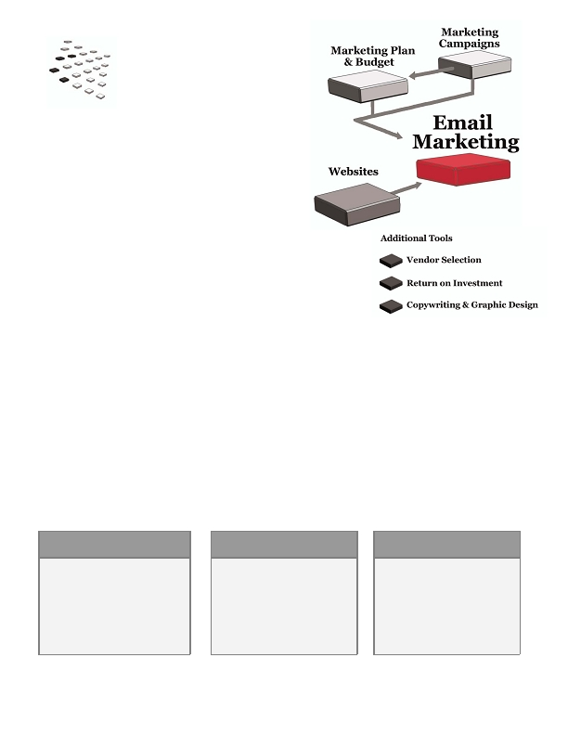
Create your event plan

• Once you have a strategy, start the planning process: time, date, location, theme, event flow, materials,
script, responsibilities and more.
• Plan for sales-related activities: what happens with new leads, how you'll prioritize leads, followup
timing, materials they should receive, etc.

Promote your event

• To drive attendance or participation, develop a thorough promotional campaign with a strong call-to-
action.
• Use multiple media to touch your market frequently and consistently.
• If you're sponsoring another company's event, be sure to promote your participation - don't leave it up
to someone else to drive your traffic.

Script your event and execute

• A good event script and plan will help you execute without problems. Create a detailed timeline;
rehearse appropriate activities with your team; make sure everyone clearly understands their
responsibilities.

Measure your event's success

• Look at your goals-to-actual and share the results with your team.
• Document everything you learned so you can use that information next time.
What's next?

Trade shows and events typically generate new relationships or foster existing
ones. It's important to set solid followup procedures with your sales team so
valuable leads don't fall through the cracks.
..00.0,ffi fffi/0201fiffi fffi4.00,,,7,ffi fi/7.7
64
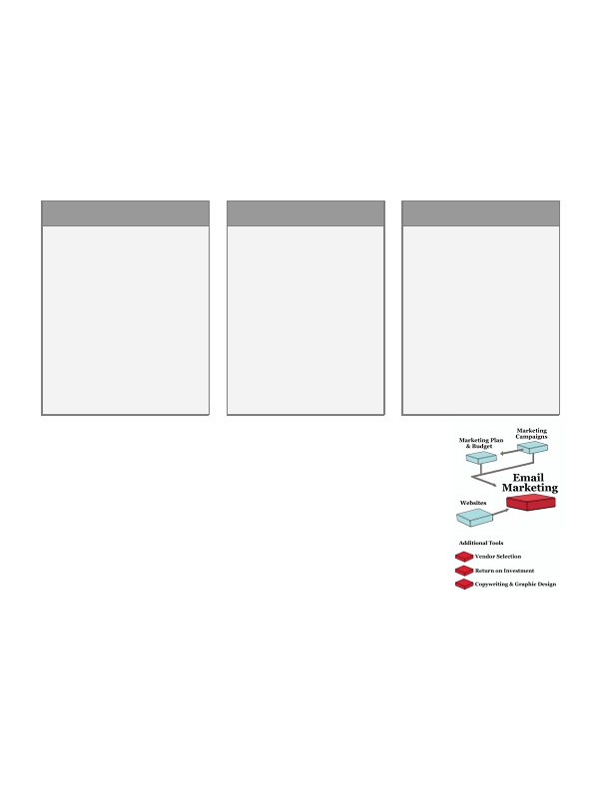
Email Marketing
•
•
Email marketing has been a staple for consumer marketers since
the mid-90s. A few years later, B2B marketers discovered its
value, and email campaigns have become an important tool for
businesses in all stages and industries.

Email marketing enables you to cost-effectively communicate with your market in a way that's
immediate and relevant. With email, you can:

• Nurture leads
• Build brand awareness
• Obtain prospects
• Build customer loyalty
• Generate sales

You can usually launch a campaign and measure your results fairly quickly, making email a great option for
time-sensitive programs. It's easy and inexpensive to test different aspects of your campaign on a segment of
your list, so you can hone your creative and your offer to generate the best possible results.

Here are three sample email campaigns:
GENERATE NEW LEADS

Buy or rent a list and send a short,
compelling message to generate
interest in your product. Drive
prospects to a special page on your
website to download a white paper,
a demo or other offer. Capture
basic information and follow up via
phone several days later.
DIRECT SALES

Buy or rent a subscriber list or
send the campaign to your current
prospects and customers; compel
them to click to your website to
learn and buy.
BUILD BRAND
AWARENESS
Use email to keep in touch with
prospects and customers. Deliver
timely, valuable information that
makes them want to read your
messages. Add news about your
company, special offers, etc., but
focus on content and information
rather than pure sales.
• fffiffi,-ff./0fi1230fffi00 fffiff4056ff0ff,,,78 fffi897.7
65
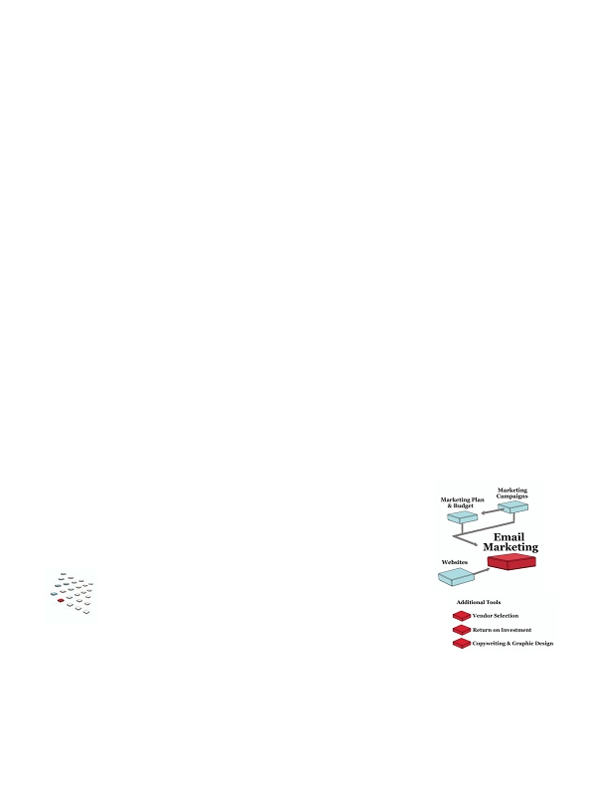
Email is more editorial than advertising, and it's powerful because it can support and even drive a sales process.
Yet like any medium, it has its challenges. Businesspeople get hundreds of emails (or more) each day, so you'll
need to get your message past spam filters and give them a reason to read. You'll also need a strong offer,
valuable editorial content, appropriate design and a good fulfillment and measurement process.

You can reach a wide audience with email, but that doesn't mean you should. It's most effective when you really
target so you can speak to specific needs. Think of it as a one-to-one communication - personalized, relevant,
timely - not a blast.

If you've used email in the past, do you see your company in one of these scenarios?
BEST CASE
You have a strong email program
with very specific goals.
You use technology to deliver your
messages effectively. Your
campaigns offer strong content and
messages; you create custom landing
pages to convert clicks to prospects.

You continually test your designs,
copy, list and offer to improve your
response. As a result, you usually
meet your ROI and business goals.
NEUTRAL CASE

You do some email marketing and
are generally satisfied with the
results. You send announcements
about products and offers; you
occasionally use email to generate
leads or keep your name in front of
existing ones.

You occasionally test a campaign
before launch, but it isn't a major
priority. You know your
campaigns could be stronger, but
you haven't had time to learn
more.
WORST CASE
You use email as a quick-fix -
when you're low on leads, you do a
blast message; if you haven't
reached out to customers, you
create a quick newsletter.

You generally don't target your
prospects - you blast one message
to your entire list. You don't test
your campaigns , and you don't
know how many of your messages
are actually delivered.
Key concepts & steps

Before you begin

Use email to meet the goals you set in your annual marketing plan; you can also
use them as part of a broader marketing campaign. You'll also need to make sure
your website is strong enough to support your campaign.

Develop your campaign around specific goals

Take the time to strategize and plan your campaign:

• Develop a tangible objective - for example, to generate a specific number of leads, demo requests,
meetings, or purchases.
• Profile and target your audience. You can reach a large audience through email, but that doesn't mean
you should - narrow targeting means you can speak more directly to their needs.
• Create a good offer and compelling call-to-action, and present it early in your message - readers skim.
• Plan a series of emails to create an ongoing campaign - it takes multiple touches to generate response.
• Don't forget fulfillment - if your prospects expect a phone call or email, deliver it quickly or you could
lose their interest.
..00.0,ffi fffi/0201fiffi fffi4.00,,,7,ffi fi/7.7
66
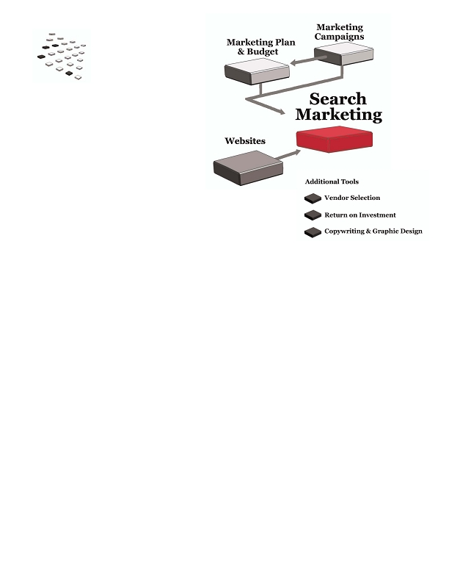
Invest in good content

Few people want to read emails that look and feel like ads. Instead, offer information that's relevant to your
recipients. It's an investment to develop that content, but it's the content that gets people to open your
messages and continue to read them over time.

Choose the right technology

If you've never launched an email campaign, you'll probably need to use an email service provider (ESP),
typically a web-based service. Choose a reputable ESP to help you stay compliant with spam legislation and get
your messages to your prospects' inboxes - a major issue in email marketing. A good ESP can raise your
delivery rate, manage your opt-in and opt-out process, keep your email list clean and provide reports that can
help you improve your results.

Be respectful and follow industry practices

Make sure you're following accepted industry practices - you'll improve your probability of success.

• Mail to your house list regularly - even corporate emails change rapidly. The more time between
campaigns, the higher your rate of bad addresses - and those "bounces" could trigger spam alerts.
• Make sure your recipients can easily opt-out of future communications.
• If you're buying or renting a list, make sure it's an "opt-in" list.

Continually test, refine and improve

It's always wise to test before launching a campaign. If you're working with a new ESP or list, evaluate your
delivery and response rate before you roll out. Keep testing and improving your subject lines, headlines and
copy, design, offer, landing pages, even the delivery timing. You'll improve all your campaigns in the process.
What's next?

As email becomes more important in your overall strategy, keep learning about
the subject and improving your campaigns.
• fffiffi,-ff./0fi1230fffi00 fffiff4056ff0ff,,,78 fffi897.7
67
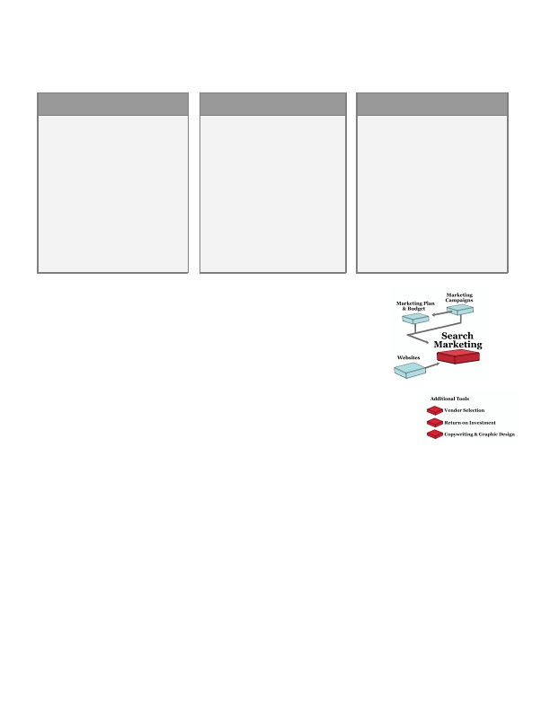
Search Marketing
•

What's "search marketing" and why is everyone talking about it?

Search marketing is about gaining visibility on search engines when users search for terms that
relate to your business. For most companies, ranking highly in search results isn't luck - it's a result of
solid effort in one or both categories of search marketing:

• Organic search: When you enter a keyword or phrase into a search engine like Google or Yahoo!, the
organic results are displayed in the main body of the page.

When your prospects search for information about your products and services, you want to rank highly
in search engine results. By "optimizing" your site, you can improve your ranking for important search
terms and phrases ("keywords"). You can also improve your rank by getting other important sites to
link to yours.

• Paid search enables you to buy listings in the "sponsored" area of a search engine. There are a variety
of paid search programs, but the most common is called pay-per-click (PPC), meaning you only pay for
a listing when a prospect clicks your ad.

In search marketing, companies focus on driving more traffic to targeted areas of their website. They use search
to:

• Generate new leads
• Sell products
• Build their brand
• Divert traffic from their competitors

Studies show that most businesspeople research their problems, potential purchases and vendors online and
use a search engine in the process. And the higher the price of the product/service, the earlier they search.
..00.0,ffi fffi/0201fiffi fffi4.00,,,7,ffi fi/7.7
68
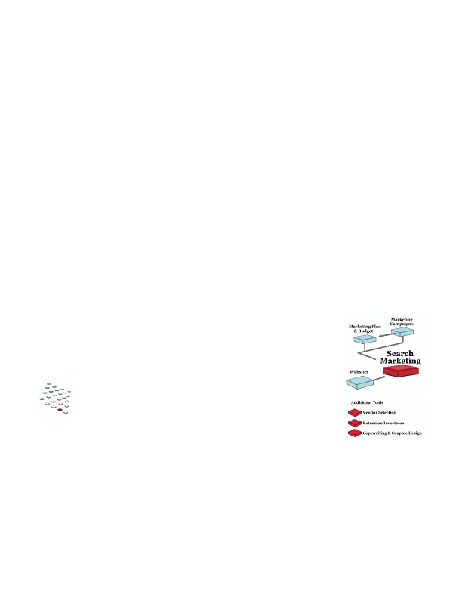
For many businesses, generating only a handful of additional serious prospects can make a substantial
difference in revenue. Using search marketing may efficiently produce these additional prospects.
BEST CASE
You're generating very targeted
prospects through your search
marketing programs. Your site is
optimized and you've built a lot of
important incoming links, so you
rank well in organic results for
targeted searches. You use paid
search to supplement that traffic and
you create custom landing pages for
your campaigns to convert visitors
into prospects.
NEUTRAL CASE

You've built a new website and it's
been optimized for search, but you
don't rank in the top 10 for
anything but your company name.
You've tried some paid search with
good success; your conversion rates
on the traffic are okay but could be
better.

You know that search marketing is
a solid opportunity - you're just
figuring out how to improve your
results.
WORST CASE

Your website isn't optimized for
search and you're nowhere to be
found on search engines, even for
very targeted terms. In fact, you may
not even rank for searches on your
company name. Unfortunately, your
competitors show up on the first and
second pages for the terms your
prospects use; as a result, your
competitors are winning new
business and furthering their lead in
the market.
Key concepts & steps
•
Before you begin

Depending on your search strategy, you may need to make major or minor
improvements to your website.
•
Create your search strategy

Look at your short- and long-term goals to choose whether to focus on organic or paid
search (or both). It takes time to improve your organic search rankings, but you can
launch a paid search campaign tomorrow. However, there are other considerations: the amount of traffic you
need, your budget, and your marketing objectives. Once you've reviewed the pros and cons, you can select the
search strategy that's right for you.

Generate a list of keywords

Before you can optimize your site or launch a paid campaign, generate a list of keywords - terms your prospects
use when looking for information you can deliver. You can brainstorm, copy keywords from competitors, or use
online tools to generate a list and traffic estimates.

Optimize your website

• Rewrite your content so it's rich with the keywords you've chosen.
• Make sure the content is organized in the best possible manner.
• Eliminate any technologies that prevent search engines from reading your content (for example, search
engines can't read graphics or Flash content).
• Register your site in important directories that play a vital role in search engine results.
• fffiffi,-ff./0fi1230fffi00 fffiff4056ff0ff,,,78 fffi897.7
69
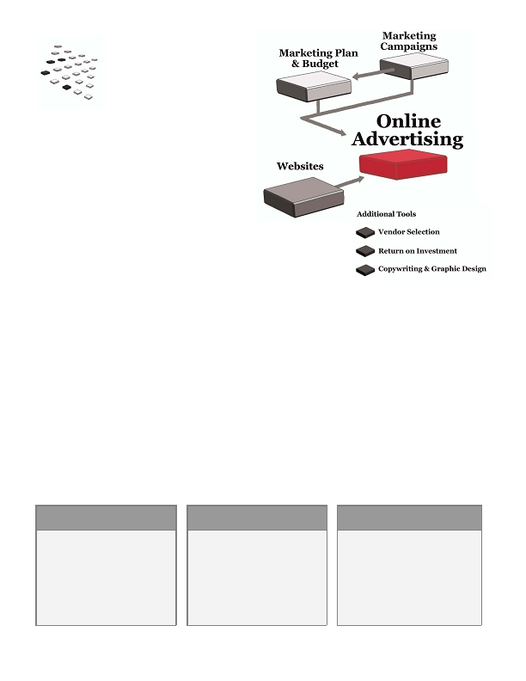
Generate inbound links

Search engines reward you when sites link to yours - they assume that your site must be valuable and you'll
rank higher in search results. And the higher the "rank" of the sites that link to you, the more they count in your
own ranking. You want links from popular industry authorities, recognized directories, and reputable
companies and organizations.

Implement additional internet campaigns

These programs can improve your search results:

• Creating RSS feeds to distribute updated content from your site to other websites
• Including a blog on your site
• Distributing search-optimized press releases on the web

Start testing paid search

To begin using paid search, you'll

• Develop targeted landing pages for each campaign
• Write your ad(s)
• Create an account with a search network that's important to business users (i.e. Google)
• Set up your campaign with the network
• Start tracking your results
What's next?

Focus on converting your new prospects to customers, then keep the cycle going.
..00.0,ffi fffi/0201fiffi fffi4.00,,,7,ffi fi/7.7
70
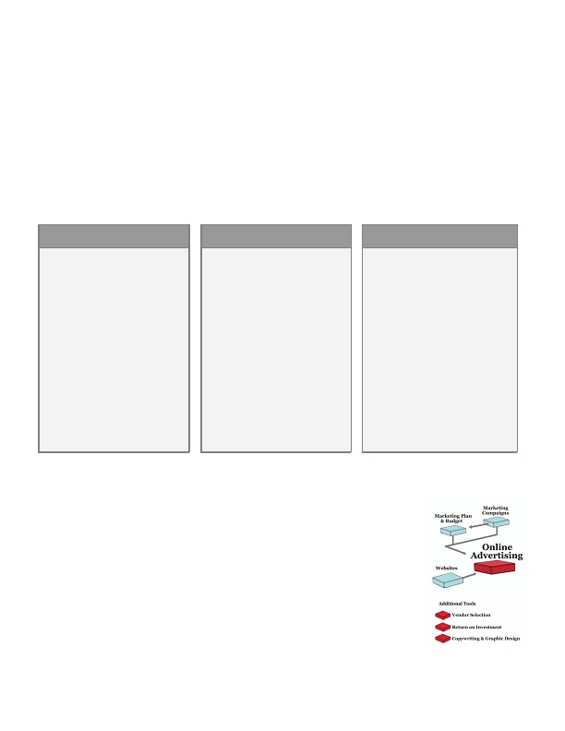
Online Advertising
•

Internet marketing isn't just for consumer marketers or large B2B firms - it's a powerful vehicle for companies
of all sizes.

Online advertising offers B2B marketers an opportunity to reach very broad or very targeted
prospects to generate leads, communicate a message and raise visibility. In the Strategic Marketing
Process, the term "online advertising" refers to three general types of campaigns:

• Banner ad campaigns on B2B websites
• Ads or sponsored content on targeted email newsletters
• Affiliate programs that enable other companies to put your ads on their sites in return for commission
on clicks or sales

While a B2B marketer has a smaller universe of prospects than a consumer marketer, the value of each prospect
is typically far greater. With a targeted campaign and a good offer, you may only need to generate a handful of
highly qualified prospects to generate substantial revenue.

Here are three different online ad campaigns:
GENERATE NEW LEADS

Promote a white paper, webinar or
demo that can help prospects who
are in the early phases of their
research. Drive them to a special
landing page; provide details about
the offer and capture key pieces of
data so you can follow up when the
prospect is ready.
DIRECT SALES

Run ads to sell a particular product
or service. Drive prospects to a
special landing page that describes
your offer in detail; if you need to
provide additional information,
create supplemental pages as
needed. Really focus on converting
those prospects into sales.
INCREASE YOUR
VISIBILITY
Run a campaign to share a message,
promote an event or offer, or raise
awareness about your products.
Your goal is twofold: Drive click-
throughs and generate awareness.
Use landing pages designed to
convert a visitor into a prospect or
customer.
• fffiffi,-ff./0fi1230fffi00 fffiff4056ff0ff,,,78 fffi897.7
71
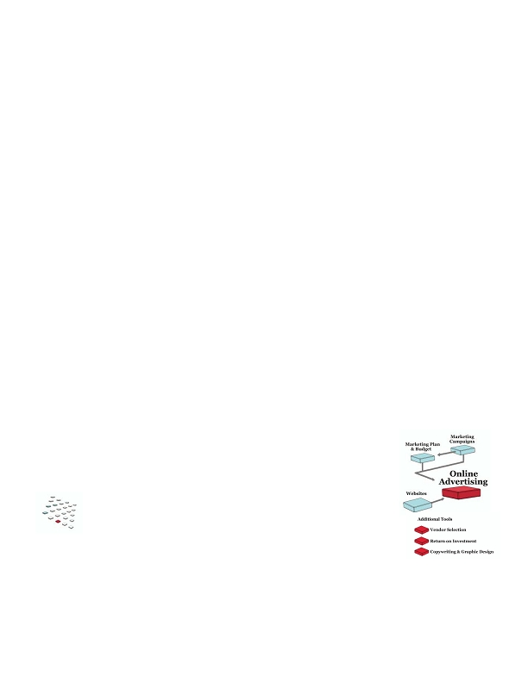
What are the benefits of online advertising?

• Timing: Reach businesspeople when they're actively looking for information, vendors and solutions.
• Immediacy: You can test and launch very quickly and generate response almost immediately.
• Targeting: You can deliver your message to very specific audiences.
• Lead generation and nurturing: You can capture prospects early, provide valuable information,
and nurture them throughout the sales process.
• Cost: You can reach a large audience quickly and at a lower cost than many other media.
• Scalability: You can run campaigns of any size at any budget level.

As with any marketing program, it's important to develop a good strategy, target your audience, test, measure
and improve - especially because it's easy and inexpensive to test different aspects of your campaigns to
generate the best possible results.
BEST CASE

Your online ad campaigns are a
strong element in your marketing
mix.

You use them to generate prospects
and customers, but gaining visibility
is also important. You calculate
ROI so you can compare the return
of these investments versus your
other programs.

You continually test your ads and
landing pages to maximize your
response rates.
NEUTRAL CASE

You run campaigns periodically and
they're moderately successful.
Prices are high, but you reach a
targeted audience.

You occasionally test and tweak
your ads, but it isn't a priority.
Since you use cost per click to
measure success, you can't
accurately calculate ROI, but you're
satisfied with what you're paying
for traffic.

You think you can generate even
more traffic, but without better
metrics, you can't divert more funds
to these campaigns.
WORST CASE

You've advertised on a few sites and
generated some traffic, but you don't
have data to indicate whether your
campaigns are successful beyond
initial visits.

You don't create special landing
pages - you drive visitors to your
home page, and you rarely test your
ads.

You cringe at the prices for the sites
you'd really like to use, and you think
you're wasting money since you're
paying for impressions not clicks.
•

Key concepts & steps

Before you begin

Before you launch an online campaign, it's important to have a good website that can
measure your traffic and convert visitors to prospects or customers. It's also helpful to
address your online campaigns in your annual marketing plan and budget.
..00.0,ffi fffi/0201fiffi fffi4.00,,,7,ffi fi/7.7
72
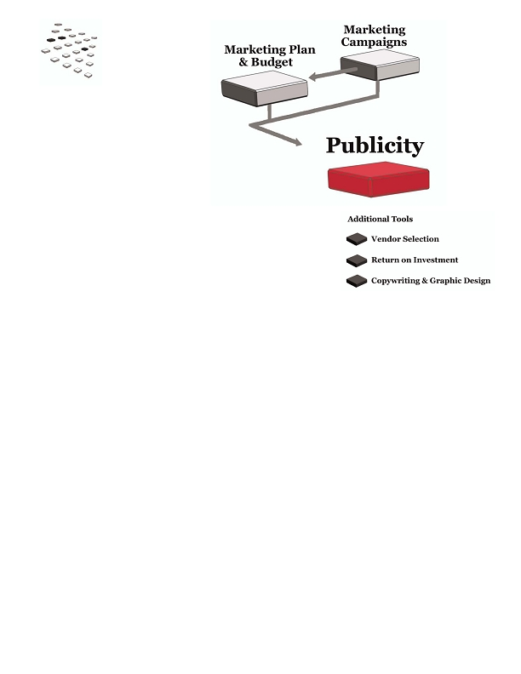
Develop a tangible goal

For example, determine how many click-throughs or leads you need to generate, then estimate your response
rates to figure out how many impressions you'll need. Make sure you know how you'll measure your campaign
as well.

Target your audience

Profile and target your audience. You can reach a large audience with your ad, but that doesn't mean you
should - narrow targeting means you can speak more directly to their needs.

Create a good offer and compelling call-to-action

Your ad needs to generate interest and get people to click through to your website to learn more - give them a
reason, a benefit. Keep your message simple and clear.

Focus on conversion

When you run a great ad, continue the message and momentum on your website. Don't drive prospects to your
home page; instead, create unique landing pages that focus on the topic you used to generate their interest.
Focus and sell!

Continually test, refine and improve

It's easy and inexpensive to test your online campaigns. You can test the offer, the design of your ad, the size
and location of the ad, or the sites you choose. Start with the element that's most important - for example, the
offer - and create two versions of the ad. Then run them against each other to see which performs best.

When you keep testing in this way, you can greatly increase your response over time - and that can mean a
substantial increase in the number of qualified leads and new customers you generate.
What's next?

Keep refining your online campaigns and your website to drive and convert traffic.
• fffiffi,-ff./0fi1230fffi00 fffiff4056ff0ff,,,78 fffi897.7
73
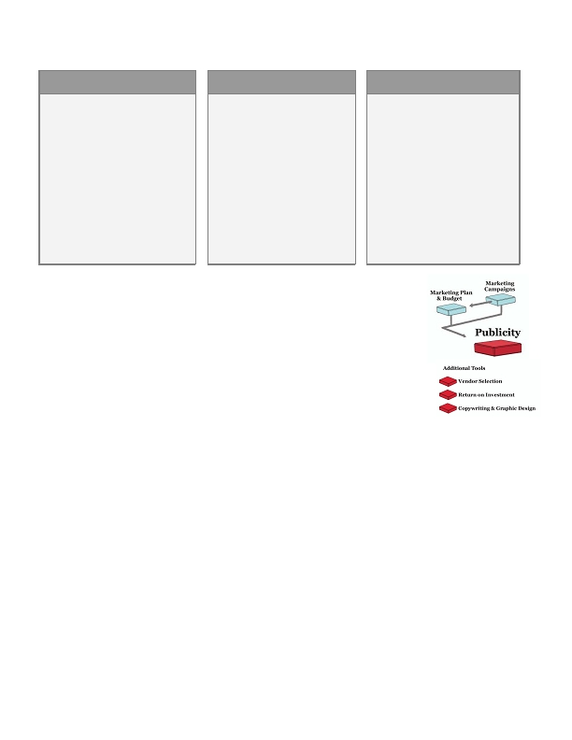
Publicity
•
•
Have you ever read a story about a company and then contacted them to learn more about their product or
service? Or perhaps you've heard a CEO's speech and found yourself researching the company later on?

Publicity in the media can be extremely valuable in building credibility and awareness for your
company. For example, a legitimate news story is an endorsement that can reach a wide audience for very
little cost beyond your own creativity and time. There are many forms of publicity including

• News stories/interviews in trade journals, industry sites, newspapers, magazines, etc.
• "Expert" quotes in a story written by a journalist or blogger
• Self-authored stories published on websites or in industry publications
• Speaking engagements

Publicity is a highly cost-effective strategy that can

• Build awareness about your products/services, expertise and people
• Drive prospects to your website
• Drive participation in a promotion or event
• Educate the market about problems your company can solve
• Create an ongoing dialogue with the market

The key to success: create newsworthy stories. They should be interesting, relevant, timely, and offer new
information or insight to your prospects.

Even if you don't think you have newsworthy content to share with the world, you can benefit by implementing
small programs to raise your visibility. At the very least, you should include news releases on your website and
home page; they help in search engine rankings and enable prospects to see what you've been doing.
..00.0,ffi fffi/0201fiffi fffi4.00,,,7,ffi fi/7.7
74
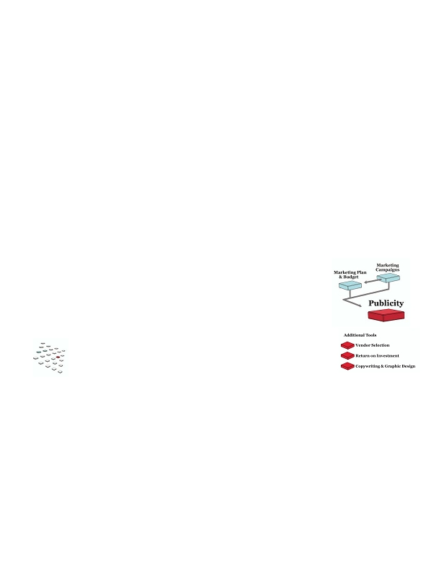
Publicity isn't about luck. It's about investing in a good PR program, and it can really pay off over time.
BEST CASE

Your company is very well-known in
your industry. When you launch a
product or have a newsworthy story,
important publications write about
you, and you're often quoted in
industry articles.

You capitalize on the role the
internet plays in publicity -- your
press releases drive prospects and
customers to your website. You also
use blogs or other online publicity
techniques to create a strong
presence on the internet.
•
•
NEUTRAL CASE

You use PR sporadically with
mixed results - an occasional
blurb in an industry journal, a
miscellaneous quote as an expert.
You put press releases on your
website and distribute them
online; you know they make your
site more interesting to prospects,
but you're not sure whether you're
gaining the full benefit from your
efforts.
WORST CASE

You don't use any form of PR. You
may be a startup or an established
company, but you're not known by
your industry press. You see your
competitors featured in industry
publications even when your
solution may be better; your
company doesn't seem to have that
level of credibility, and you're not
sure how to get it.
Key concepts & steps
•
Before you begin

Tie your publicity strategy to goals you've identified in your annual marketing plan.
•
Create a publicity strategy

Don't just "shotgun" press releases when you need to drum up some attention. Plan
your publicity strategy as you would any marketing campaign:

• Develop a calendar that ties story ideas to key events and spreads your storytelling out over the year.
• List events that may offer good speaking opportunities.
• Identify publications, reporters and bloggers who cover subjects that are relevant for your company.
• Create traditional and online press materials to give reporters support materials for their stories.
• Know the audience for each story and carefully target your media.

Develop newsworthy story ideas

Every day, journalists are bombarded with press releases touting new product releases, business alliances,
research discoveries, etc. But journalists don't just make announcements -- they need to tell compelling stories
that their readers will find interesting and useful. A trade journal may run one-paragraph blurbs about new
products, but to get headlines, photos, interviews and pages, you need to develop real stories.

Like movies, good news stories are often about conflict. An endless stream of positive information is boring.
Instead, develop stories with substance: Good vs Evil, Nature vs Nurture, Race Against Time, Company A vs
Company B, Employee Against the World, Company vs the System.

In addition, good stories can be extremely "viral" when you distribute them on the web.
• fffiffi,-ff./0fi1230fffi00 fffiff4056ff0ff,,,78 fffi897.7
75
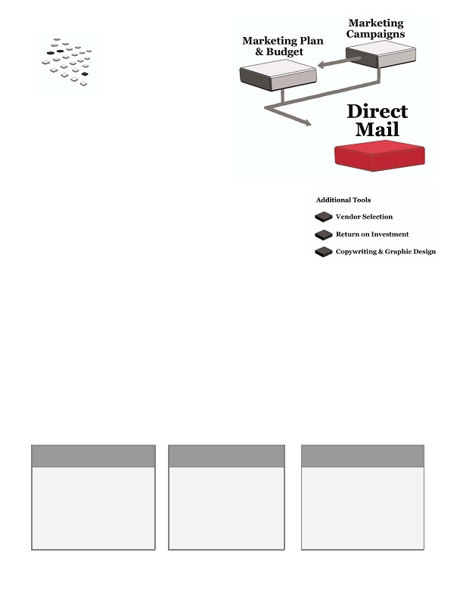
Market your stories and expertise

Journalists need stories; when you have a story, you have something to offer. With a quick, courteous phone
call and a simple pitch, you may get a journalist to say, "Yes, I'm interested in that story, send me your
material." That three-minute phone call could potentially make a substantial difference in your campaign
success.

Reach out when you identify a potential speaking engagement or find a journalist or blogger who may want to
quote an expert from your company. Be sure to prepare a short pitch and support materials as well.

Use the internet

Many PR experts say the traditional press release is dead. These days, a worthwhile PR strategy has to
capitalize on the internet.

• Write a second version of your normal releases with rich keywords and a format that helps search
engines find the release.
• Post your search-friendly releases on your site - they should be an actual page on the site, not a PDF.
• Send your release to internet news distribution services.
• Consider adding an RSS feed to your site - it will send updated content to other publishers.
What's next?

It's difficult to measure the return on publicity, but if you're really focused on creating
stories and reaching out, you have strong potential for success. One big story or
important speaking engagement could generate fantastic results, so keep at it!
..00.0,ffi fffi/0201fiffi fffi4.00,,,7,ffi fi/7.7
76
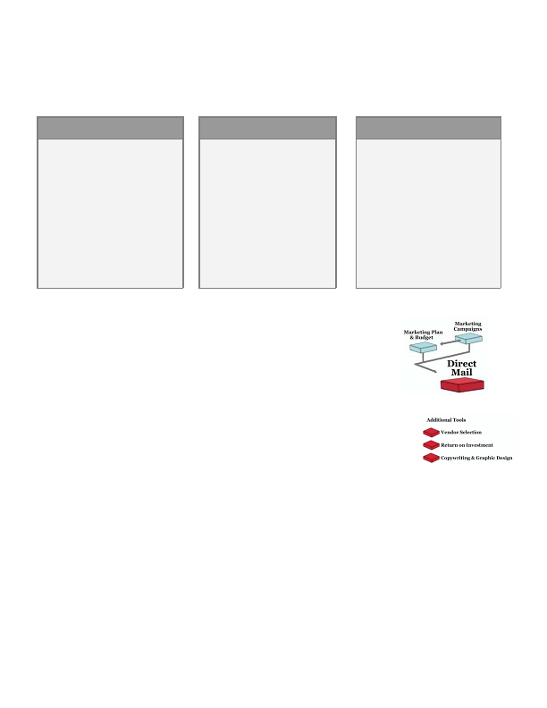
Direct Mail
•
•
For many years, direct mail has been an important
marketing vehicle. Even though many companies
have turned to email and internet marketing, a targeted and well-produced
mail campaign can still be highly effective.

Direct mail campaigns can generate leads, promote special
offers, support other campaigns, communicate with customers
and raise your visibility in your market. You can be very simple or
wildly creative depending on your goals - for example, you can use

• A handwritten note
• A simple but effective sales letter
• A postcard with a four-color image on one side and a printed message on the back
• A digitally-printed brochure with the prospect's name printed in the headline and body copy
• A custom piece that you develop for a specific purpose

Direct mail can be an efficient vehicle for your company if you focus on strategic, targeted mailings instead of
large bulk mail campaigns, which draw very low response rates at much higher costs than online marketing.
Instead, consider using mail for small campaigns:

• Invite current customers and top prospects to an event you're holding at a trade show
• Send product literature with the prospect's name and custom specifications printed into the brochure
itself (via digital printing)
• Announce a compelling sale

Here are three sample mail campaigns:
GENERATE NEW LEADS

Mail a personalized, hand-signed
letter to targeted prospects. Quickly
introduce your value proposition;
invite prospects to call or visit your
website to view a demo, download a
special report, or request a quote.
Follow up with a phone call a week
later.
NURTURE EXISTING
LEADS

Mail a quarterly "industry
update" or case study with graphs
and reference info - more than
you'd be able to provide in an
email newsletter. Focus the piece
on a typical objection prospects
have before they buy.
CROSS-SELL CURRENT
CUSTOMERS

Develop a piece that delivers a
compelling case for your current
customers to buy related products
and services. Include a strong call-
to-action; encourage customers to
call or visit your website to learn
more and buy.
• fffiffi,-ff./0fi1230fffi00 fffiff4056ff0ff,,,78 fffi897.7
77
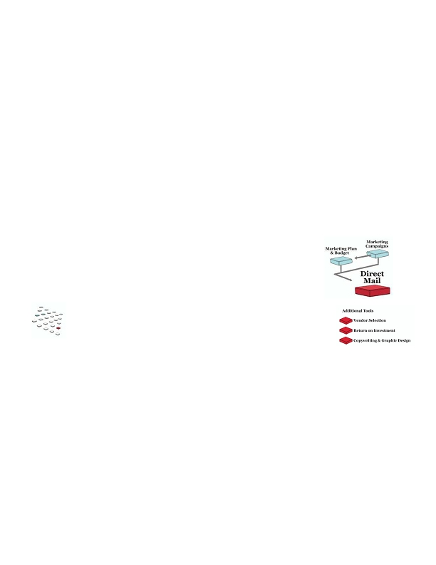
In B2B, it's better to think about mail as an integral part of a larger campaign. Don't just mail and wait for the
phone to ring. Instead, plan a campaign that starts with an introduction via mail, then perhaps a followup
phone call from a sales rep and a demo delivered via email.

When you use the right strategy and execution, direct mail can be a strong addition to your marketing arsenal.
•
BEST CASE

You're happy with the ROI on your
mail campaigns.

You design each piece to grab
attention, convey a simple message
and move the prospect toward
action.

You test your mailings and tweak
the headlines, envelopes or offers to
increase response, and you use
targeted and current lists.
•
NEUTRAL CASE

You've had some success with
mail campaigns. Sometimes
they're spur-of-the moment; you
know you could do a better job of
planning ahead and focusing your
message. You typically use mail
in conjunction with a phone call.

You don't really test your
campaigns and try to improve
results, but your response rates
are acceptable.
WORST CASE

You've used mail but feel it was a
waste of money. The list was
expensive and didn't necessarily
have the right contact name. The
mailpiece and postage was
expensive and contained a lot of
information, yet it didn't generate
the response you planned.

You had counted on it generating a
lot of leads that you ended up
having to find elsewhere.
Key concepts & steps

Before you begin

Make sure your direct mail campaign is tied to the goals you've set out in your
marketing plan.

Define your goals

Tie your campaign to a specific objective - for example, the number of responses you
need or the number of customers you want to generate. Then design your campaign to
meet your specific goal.

Target your audience

Narrow your audience as much as you can - you'll be able to speak more directly to your prospects with better
results. You'll also save on postage and production.

Focus on the offer

Don't overwhelm your audience with every detail about your product and company. Focus on the offer itself -
the purpose for the mailing, the call-to-action. For example, if you're promoting a software demo, explain what
the demo will help them learn and why they should request it now. Touch on the key benefits, but don't muddy
your message by including every detail about the software and the history of your company.
..00.0,ffi fffi/0201fiffi fffi4.00,,,7,ffi fi/7.7
78
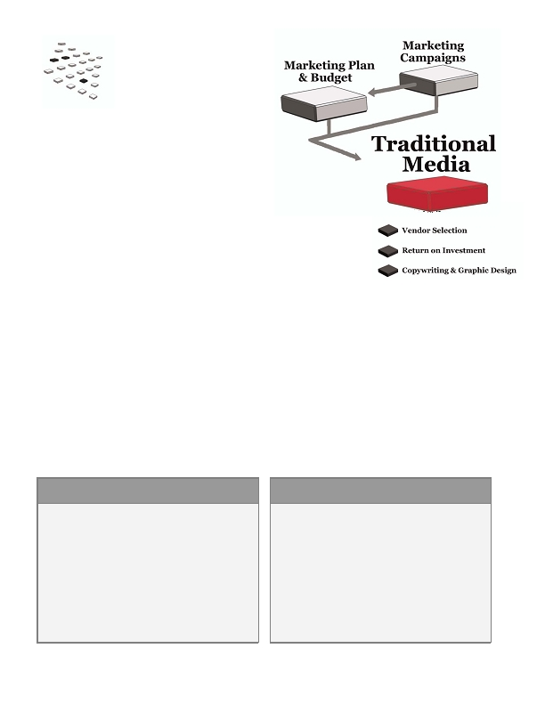
Develop your content, then your creative

First determine how much copy you'll need, what kind of graphics or photography you'll include, how to
promote the offer, etc. Once you've defined the content you'll need to achieve your goals, start the design
process. If you're working with a design and/or writing team, explain your requirements in a "creative brief" so
you're all on the same page.

Tackle the campaign logistics

Make sure you plan how your piece will be folded, stuffed, addressed, stamped, mailed, etc. If you're running
large campaigns, you may want to hire a vendor to handle this step.

Test, measure and continually improve

Mail is a terrific media for testing - you can select a random set of records from your list, send your mailing,
measure your response, then tweak the mailing and send it to another subset. You can improve the list
targeting, your offer, the envelope design, the copy and the design itself. Commit to continuous improvement
and use what you learn in all future campaigns.
What's next?

Measure your ROI and compare it against your ROI for other media. Mail can be a
substantial investment and it should produce a return that is as great or better than
your other media.
• fffiffi,-ff./0fi1230fffi00 fffiff4056ff0ff,,,78 fffi897.7
79
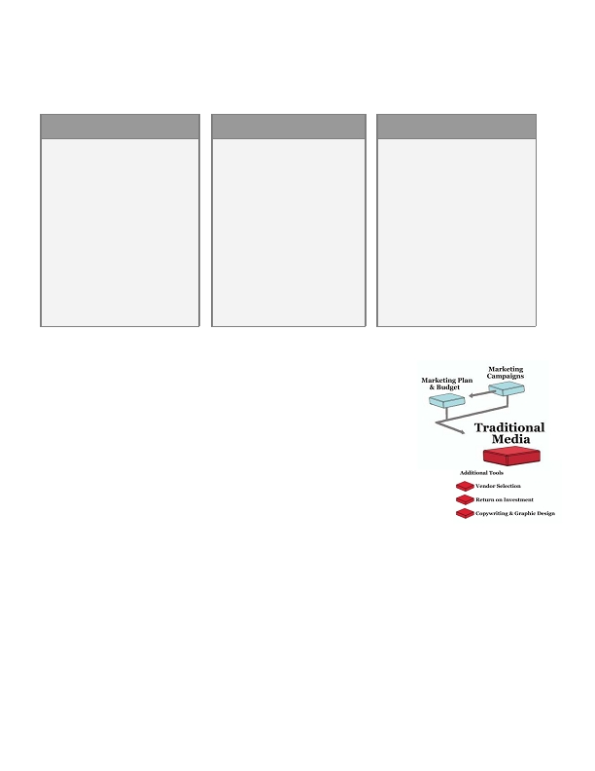
Traditional Media
Marketers have used traditional media such as print, radio, TV, yellow pages
and even outdoor ads to reach consumer markets for the last 50 to 100 years.

Traditional media can also play a role in the marketing mix for
many B2B companies. These media often reach a broad audience and thus
can be relatively expensive. Yet in your industry or region, they may be very
effective in helping you reach your market. For example:

• In many industries, print ads in monthly trade journals are an important vehicle to reach decision-
makers.
• If your company sells to a certain geographic region, directory listings and ads may be crucial for
reaching buyers when they're searching for solutions.
• You may need to reach a wide variety of prospects in different industries, so you may advertise in a
regional or national business publication, newspaper or radio program.

You can use these media to generate leads, build visibility, share your message and/or drive specific
promotions. They're especially helpful when you use them in conjunction with other media in a larger
campaign.

Here are two sample campaigns that incorporate traditional media:
USE PRINT & ONLINE TO GENERATE
LEADS
To generate leads, you run a print ad in an industry
journal and a banner on the publication's website and
monthly subscriber email.

The prospect calls to take advantage of your offer or
visits a unique landing page on your website, then fills
out a form.

A sales rep calls and sets up an in-person presentation.
USE RADIO TO GENERATE
LEADS& AWARENESS
You run a schedule of :30 ads on a talk radio show that
reaches a broad base of businesspeople in your industry
or region.

As part of your package, you buy exclusive sponsorship
of the show. You receive special mentions throughout
the show, and you use the entire campaign to drive
traffic to a specific landing page on your website. The
page continues your message, captures the prospect's
information or encourages a phone call. Your
telemarketing team qualifies leads and transfers hot
prospects to your sales team.
..00.0,ffi fffi/0201fiffi fffi4.00,,,7,ffi fi/7.7
80
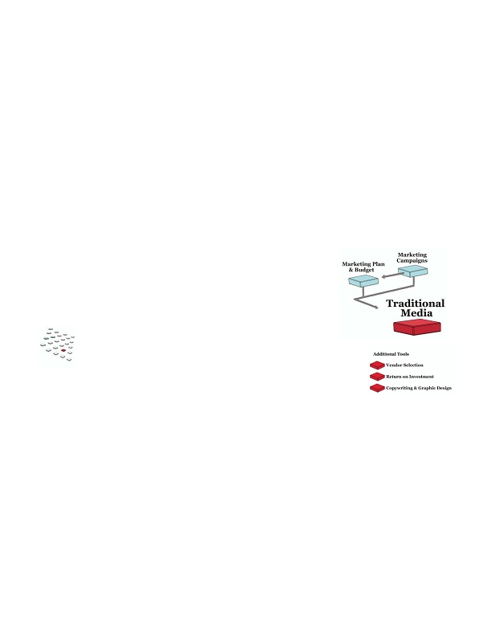
It's important to treat these programs as longer-term investments because responses tend to come in gradually
-- they aren't as immediate or measurable as internet marketing, telemarketing or direct mail. Targeting may
be an issue and you may not be able to measure the branding impact of your campaign, but they're solid
vehicles when they're in line with your goals or used in a larger campaign.
BEST CASE

You understand the strengths and
limitations of traditional media, and
you use them effectively in
campaigns to drive awareness and
response.

You test your campaigns to improve
over time and you measure the
campaigns to the best of your
ability. While you don't measure
the value of your brand-building,
you do adjust your ROI calculations
to incorporate an allowance for that
value.
NEUTRAL CASE

You run a sprinkling of traditional
media campaigns and track the
number of calls they generate.
You know they work to some
degree, but you can't quantify the
results that well. The ads
themselves are about average but
you rarely test them to improve.

You know it's important to be in
the vehicles you choose, and you
stick with the same tactics because
your competitors are doing the
same thing.
WORST CASE

You don't evaluate your buys very
carefully; you don't have specific
goals and thus can't measure
whether you're successful or not.
You don't really test your ads either
- they offer a lot of information and
you can't really say whether they
work either for branding or direct
response.

You're wasting your budget and
time on programs that could be
vastly improved.
Key concepts & steps
•
Before you begin

Make sure your campaigns are tied to the goals in your marketing plan.
•
Develop a strong strategy

First, determine what you need to accomplish. For example, you may need to generate a
specific number of leads, raise your visibility in a certain industry or geography, or
communicate a key message across different media. Set tangible goals for your media
plan.

Each media has benefits and drawbacks. When you've defined your goals, you can decide which vehicle will
work best. Make sure you know how to measure your campaign as well.

Decide whether to buy media in-house or through an agency

Media buying can be a tricky and time-consuming process. If you have a lot of media to buy, you may want to
hire an agency. You'll pay for their services, but they may also have more buying power to negotiate better
deals and find ways to reach your target market more cost-effectively.
• fffiffi,-ff./0fi1230fffi00 fffiff4056ff0ff,,,78 fffi897.7
81
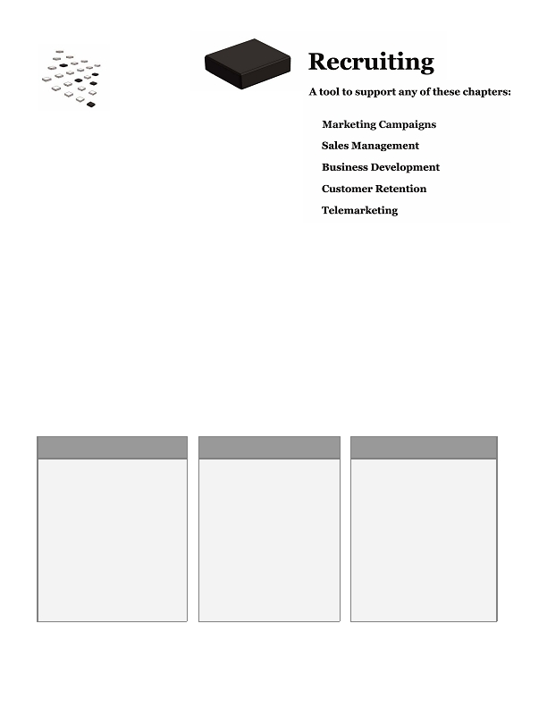
Consider targeting when comparing costs

Media sales reps may quote you a flat rate for a particular ad or they may quote a cost per thousand (CPM)
impressions. You may pay a higher CPM for a more targeted media than a general one, but if you calculate
your cost per targeted impression instead, you can truly compare apples to apples.

Create a compelling ad and call-to-action

Your ad needs to grab the attention of your market - be creative, but keep your message simple and clear.
Include a call-to-action: Encourage prospects to call or visit a special landing page to learn more about a
particular offer or program.

Continually test, refine and improve

It's wise to test any campaign before spending your entire budget. If you're considering multiple publications,
run the same ad in two different ones to see which generates the best response. Or test different headlines and
offers. Your goal is to find the ads and publications that generate the best response, then run them for the
remainder of your campaign.
What's next?

Keep testing and refining your campaigns so they deliver on your goals.
..00.0,ffi fffi/0201fiffi fffi4.00,,,7,ffi fi/7.7
82
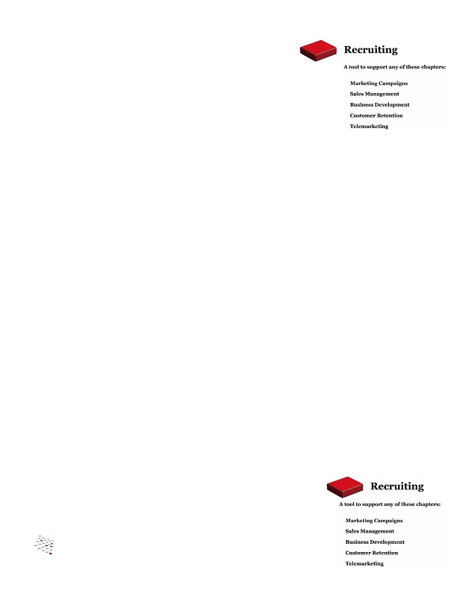
Recruiting
•

What's the difference between a great company that outperforms the market and an average company? Great
products, services, strategies and execution … and your employees are responsible for those successes. A
company can accomplish far more with a strong team in place than it can with an average team.

Recruiting is essential for building a strong sales and marketing function. And like marketing,
recruiting is both an art and a science:

• Art: getting to know a candidate to understand whether s/he is the best fit for the job
• Science: defining detailed job requirements so you can search for the right candidates; conducting a
wide search; using a process for moving candidates through the process; measuring results

It's time-consuming to recruit marketers, sales reps, telemarketers and account managers. Yet these positions
are the heart of your success, so give your recruiting efforts the time they deserve.
BEST CASE

You have a strong team with the skill
sets you need for success. Before
each hire, you develop a solid job
description, compensation plan and
profile so you're sure about the
qualifications and personality type
for the position.

You screen and interview your
candidates efficiently and when you
hire someone, s/he's excited about
the job. You have little turnover and
your employees are truly a valuable
asset to the company.
•
NEUTRAL CASE

You create job descriptions before
you recruit and you usually get an
acceptable number of resumes.
Sometimes the process drags out
longer than it should, and you've
made some offers to candidates
that weren't a great fit. You do
have some average performers on
your team, but there are no major
issues.
WORST CASE

In the worst case, you have team
members who aren't qualified for
their roles. They require a great
deal of management and you're
concerned about the time it takes to
replace them.

It's difficult to find qualified
candidates, especially because
experience is expensive. Morale
isn't great and people view their
jobs as tedious - there isn't a lot of
excitement and positive energy in
your team.
• fffiffi,-ff./0fi1230fffi00 fffiff4056ff0ff,,,78 fffi897.7
83
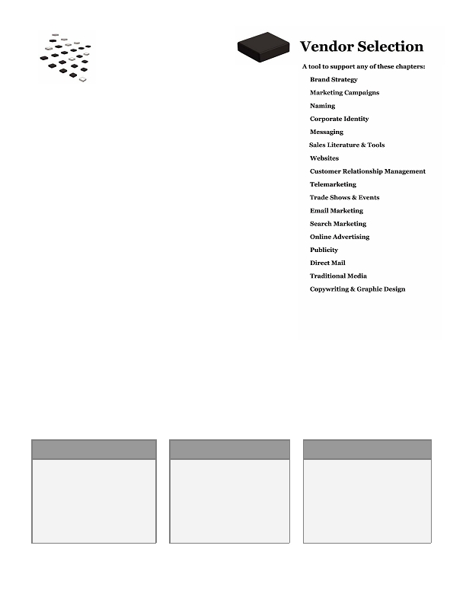
Key concepts & steps
•
Before you begin

You may need to recruit to meet a variety of goals: grow your sales team, hire a
business development executive, create an account management team, build a
telemarketing operation, or add resources to another area of your company. Strive to
recruit the best employees for all areas of your business at all times.
•
Define the position

• Evaluate the job responsibilities; prioritize the skills and experience your candidates will need.
• Develop specific criteria you'll use to evaluate your candidates.

Write a compelling ad

• A good ad inspires qualified candidates to apply for the position. It needs to stand out among the ads
they'll be reviewing, and it needs to convey credibility, your brand and message.
• Think of your ad as a sales pitch to a prospect and write it carefully with your applicant in mind.

Cast a wide net

• Referrals are a great source for qualified candidates. Encourage everyone in your company to contact
vendors, customers, friends and family about open positions. Create a job description they can pass
around.
• Advertise in appropriate publications and websites. If you're concerned about cost, measure your cost
per applicant and per hire, then use the best-performing sources the next time around.
• If you're not finding qualified candidates, keep investing … don't settle for mediocre applicants just
because you don't want to spend more money looking.
• If you're doing a lot of hiring, make sure to post open jobs on your website and include content that
speaks to applicants. Good candidates will look at your site to learn about the company.

Follow your process

• Create a process and follow it: Resume review, phone screen, interview, maybe a second interview,
reference check, offer. A good process saves time -- for example, don't invite a candidate for live
interviews if you haven't done a good phone screen; you may find that they're not a good fit during the
phone call.
• Respect the time and talent of all your candidates. Thank them for interviewing and let them know
when you've extended an offer to someone else. You never know when you'll cross paths again.

What's next?

After you bring aboard new marketing and sales employees, make sure they
understand your competitive positioning, brand strategy and messaging so they can
deliver on those strategies every day.
..00.0,ffi fffi/0201fiffi fffi4.00,,,7,ffi fi/7.7
84
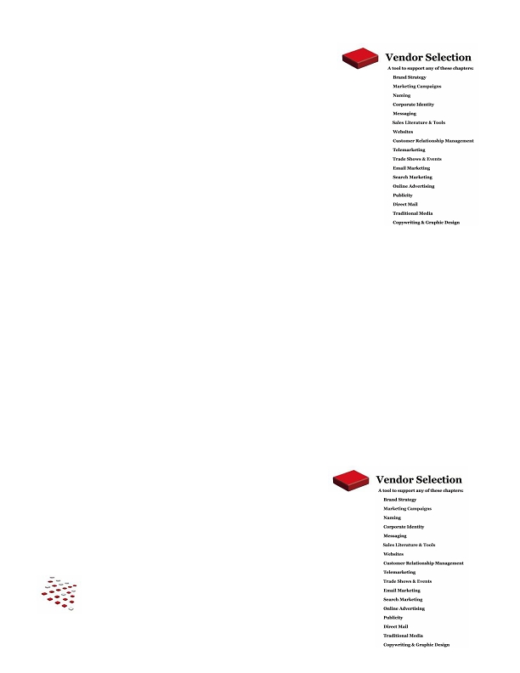
Vendor Selection
Have you ever had a difficult time hiring a vendor? Even with years of
experience in a particular area, it can be a time-consuming process. It's
even more difficult if you're hiring a vendor for a function you don't
know very well.

Vendor selection is an important part of the marketing
process because few companies have the resources to
complete every project in-house. For example, you may need a
vendor's expertise and resources to

• Write, design or produce sales literature, ads or other creative
materials
• Design, write or develop your website or online campaigns
• Run a telemarketing campaign
• Develop your media plans and buy media
• Provide email or search marketing services
• Manage the print and fulfillment process for a mail campaign
• Handle publicity
• Write messages and slogans

There are many benefits to outsourcing; you can gain deep industry experience, access new technologies, or
save money thanks to efficiencies a vendor can provide. But it's important to carefully evaluate and manage
your vendors to reap those rewards.

Do you see your company in any of these scenarios?
BEST CASE

Your vendor delivers great results
on time and on a fair budget. The
vendor is easy to work with and
enables you to focus on other
things, making you more
productive. A great vendor
relationship can truly enhance your
business.
NEUTRAL CASE

Your vendor delivers acceptable
results at the price you expect.
You probably need to keep on top
of the vendors to make sure
deadlines are met, and you devote
time to properly manage the
relationship.
WORST CASE

Your vendor provides poor work, is
overpriced, doesn't meet important
deadlines, and/or is difficult to work
with. In the worst case, you lose time
and money trying to manage the
vendor; you may have to fire the
vendor and start from scratch.
• fffiffi,-ff./0fi1230fffi00 fffiff4056ff0ff,,,78 fffi897.7
85
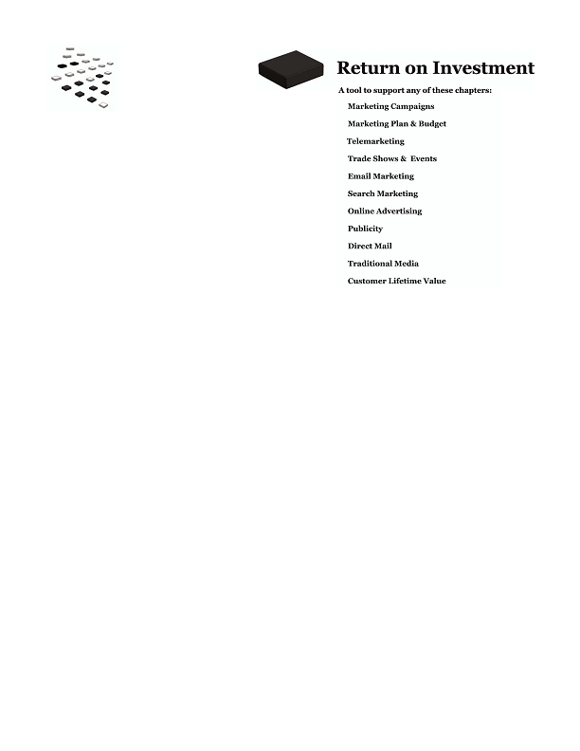
Key concepts & steps
•
Before you begin

Next time you need a vendor for one of your projects, use this process to find,
evaluate and select the best person or company for the job.

Define your needs and timeline

If possible, determine what you're looking for before you start your search. You may
want to set an initial budget, then develop a timeline for your search, especially if you
have important dates to hit.

Identify and analyze vendors

Use the web and ask for referrals to find a list of qualified vendors. Develop a list of
qualifying questions and narrow the field to a handful of companies.

Create your RFP

If you're looking for very simple, straightforward services, you can ask bidders to provide a proposal and quote.
For more complex or intangible projects, it's better to create a Request for Proposal (RFP) that asks bidders to
respond to very specific questions in a consistent fashion. A standard RFP is especially helpful when

• The vendor is providing a comprehensive service
• The project is intangible or has many elements, such as a website
• You have very specific evaluation criteria and need to compare "apples to apples"
• You're evaluating a large number of bidders (more than four)

Evaluate, negotiate and award project

• Rate your bidders on the important criteria and narrow the field.
• Negotiate pricing and terms with your finalists, but remember the adage "You get what you pay for."
Don't just choose the lowest bid - choose the vendor that best meets your criteria for success.
What's next?

Continue to improve your vendor research, RFPs, and vendor management. Most
companies use a variety of vendors over time, and good vendor selection and
management will help you improve results.
..00.0,ffi fffi/0201fiffi fffi4.00,,,7,ffi fi/7.7
86
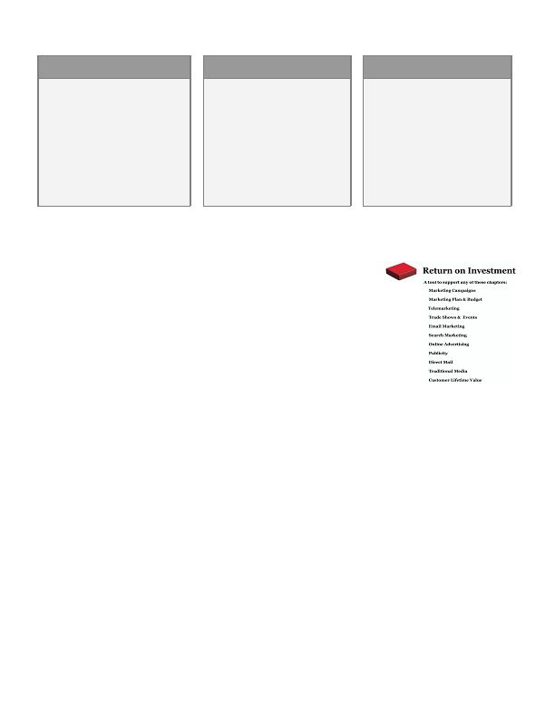
Return on Investment
•

Marketing campaigns are investments. And like any smart
investment, they need to be measured, monitored and
compared to other investments to ensure you're spending your
money wisely.

Return on investment (ROI) is a measure of the profit earned from each investment. Like the
"return" you earn on your portfolio or bank account, it's calculated as a percentage. In simple terms, the
calculation is
(Profit - Investment)
Investment

ROI calculations for marketing campaigns can be complex -- you may have many variables on both the profit
side and the investment (cost) side. But understanding the formula is essential if you need to produce the best
possible results with your marketing investments.

With solid ROI calculations, you can focus on campaigns that deliver the greatest return. For example, if one
campaign generates a 15% ROI and the other 50%, where will you invest your marketing budget next time? And
if your entire marketing budget only returns 6% and the stock market returns 12%, your company can earn
more profit by investing in the stock market.

ROI helps you improve your ongoing campaigns. When you tweak your offer or launch a campaign to a
different list, you can compare ROI and focus on the version with the best performance.

Finally, ROI helps you justify marketing investments. In tough times, companies often slash their marketing
budgets - a dangerous move since marketing is an investment to produce revenue. By focusing on ROI, you can
help your company move away from the idea that marketing is a fluffy expense that can be cut when times get
tough.
• fffiffi,-ff./0fi1230fffi00 fffiff4056ff0ff,,,78 fffi897.7
87

BEST CASE

You measure and track the ROI of all
of your marketing investments. Your
campaigns deliver the highest
possible return and you're able to
improve them over time.

Your organization understands and
agrees with the choices you make
because there's solid data to support
your investments.
NEUTRAL CASE

You calculate ROI on some
investments, but because it can get
complex, you don't attempt to
measure it at all times.
You have a general idea of how your
investments perform relative to
each other, but you can't pinpoint
the exact return you're generating.
And in tough times, your budget is
cut.
WORST CASE

You don't measure the performance
of any of your investments.

In fact, marketing is viewed as a
cost, not an investment at all.

Your company isn't sure what works
and what doesn't, and it's a struggle
to meet goals.
Key concepts & steps
•
Before you begin

It's a good idea to measure ROI on all of your marketing investments - after all, you're
in business to earn a profit. If your sales process is long and complex, you may choose
to modify or simplify your ROI calculations, but a simple calculation is more useful
than none at all.
•
Confirm your formulas

There are several figures you'll need for your ROI calculations:

• Cost of goods sold (COGS): The cost to physically produce a product or service.
• Marketing investment: Typically you'd include just the cost of the media, not production costs or time
invested by certain employees; however, in certain cases it may be better to include all of those figures.
• Revenue: It can be tricky to tie revenue to a particular campaign, especially when you run a variety of
campaigns and have a long sales process. Your finance team may have some suggestions for estimating
this figure.

Companies calculate these figures differently, so confirm the formulas your company uses -- your finance team
or accountant can guide you.

Establish an ROI threshold

Set an ROI goal for your entire budget and individual campaigns; set a floor as well. By doing so, you gain more
power over your budget. If you project that a campaign won't hit the threshold, don't run it; if you can't get an
ongoing campaign over the threshold, cut it and put your money elsewhere.
..00.0,ffi fffi/0201fiffi fffi4.00,,,7,ffi fi/7.7
88
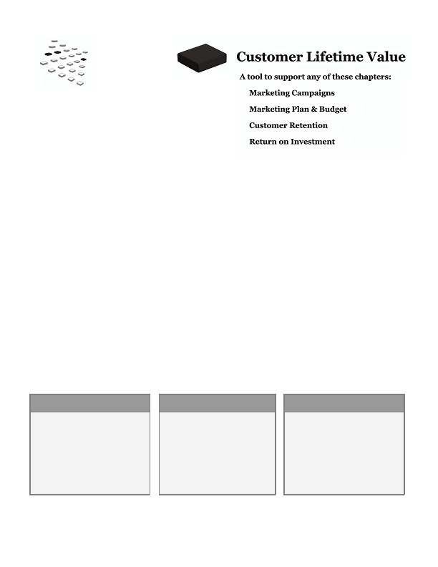
Set your marketing budget

When you have an ROI goal and annual revenue/profit goals, you can calculate the amount of money you
should spend on marketing - just solve the ROI formula for the "investment" figure. You'll be more confident
that you're spending the right amount of money to meet your goals.

Calculate ROI on campaigns; track and improve your results

Tracking ROI can get difficult with complex marketing campaigns, but with a commitment and good reporting
processes, you can build solid measurements, even if you have to use some estimates in the process.

Use your ROI calculations to continually improve your campaigns; test new ways to raise your ROI and spend
your money on the campaigns that produce the greatest return for your company.
What's next?

The more you understand ROI, the more power you have over your investments. Continue
to learn, improve your reporting capabilities and use ROI to improve your campaigns and
generate more profit for your company.
• fffiffi,-ff./0fi1230fffi00 fffiff4056ff0ff,,,78 fffi897.7
89

Customer Lifetime Value
Do you know what an average customer is truly worth to your company? By calculating your Customer Lifetime
Value (CLV), you'll be able to answer that question.

CLV is the amount of profit a customer delivers to your company for as long as the customer is
buying from you. It's typically calculated as the net present value (the value in today's dollars) of the profit
you'll earn from all of a customer's purchases over time. When you know your CLV, you have an extremely
powerful tool that helps with:

• Acquisition: You'll have a better understanding of what you can spend to acquire customers.
• Targeting: You'll know which customer segment delivers the most profit to your company and you
can focus more marketing efforts toward that segment.
• Return on investment: By using CLV in your ROI calculations for marketing campaigns, you'll have
a much more accurate measure of campaign performance.
• Customer retention: You can determine how much you can spend to profitably retain customers.
• Single-customer profitability: You can calculate the profitability of an individual customer.

CLV becomes more important as your marketing budget rises and your customer base grows. Yet even an early-
stage company can benefit with a simple CLV estimate.
BEST CASE
You know how much an average
customer in each of your segments is
worth to you. You focus your
acquisition efforts on your most
valuable segments, and you know
how much you can spend to
profitably retain your customers.
NEUTRAL CASE

You have an idea of who your most
valuable customers are, but you're
not really sure how much you
should spend to acquire or retain
them. Your ROI measurements for
your marketing campaigns are
probably very general, though still
helpful.
WORST CASE
You don't know how much a
customer is worth or how much you
should spend on acquisition or
retention. You're not sure what your
marketing budget should be, and
you're not confident in the quality of
the investments you're making.
..00.0,ffi fffi/0201fiffi fffi4.00,,,7,ffi fi/7.7
90

Key concepts & steps

Before you begin

You'll want to look at CLV for different groups of customers, so make sure
you've defined those segments. CLV is a valuable tool to improve your
marketing campaigns and budget; it's also used when you're working on
customer retention and ROI.

Confirm your formulas

There are several figures you'll need for your CLV calculations:

• Cost of goods sold (COGS): the cost to physically produce a product or service
• Gross profit: the difference between the price of your product and the COGS

Companies calculate these figures differently, so your first step is to confirm the formulas your company uses.

Determine your customer segments

The CLV calculation is most valuable when you measure it by customer segment - similar groups of customers
who use your products/services in a similar way.

For each segment, determine how long an average customer stays with you -- the "lifetime"

Look at your customers' buying patterns and calculate the total number of purchases they make and the time
between those purchases.

Calculate your CLV for each segment

Once you know the average lifetime, you'll calculate

• The total profit you earn on all of their purchases
• The probability that they'll make successive purchases
• The value of future revenue if you had the cash today

Use CLV to improve your acquisition and retention marketing

Once you have a CLV for each customer segment, you can

• Set a maximum budget to acquire a particular type of customer.
• Calculate whether a particular deal will be profitable.
• Look at current customers who haven't purchased according to the pattern you estimated in the
calculation. They're more likely to defect, so launch a retention campaign to those customers.
• Plug it into your ROI projections. It's more accurate to calculate your return on a campaign when you
use the total profit the customer represents over time, not just the profit you earn on the first sale.
• fffiffi,-ff./0fi1230fffi00 fffiff4056ff0ff,,,78 fffi897.7
91
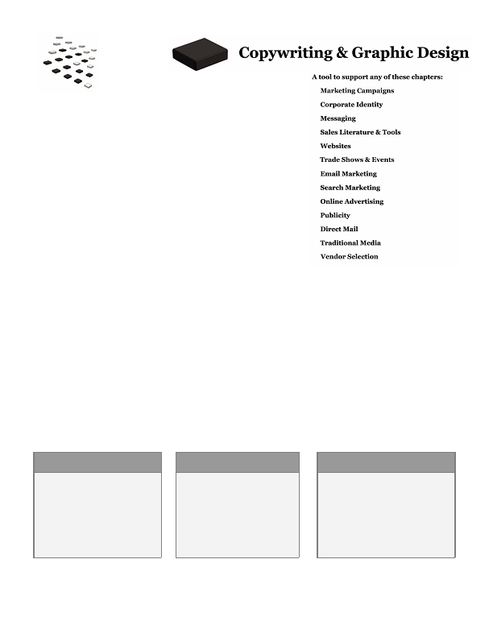
What's next?

Keep applying CLV and using it in your marketing strategies and
plans. When you use CLV and ROI in all of your campaigns, you have
powerful tools to help you grow your company's revenue and profit.
..00.0,ffi fffi/0201fiffi fffi4.00,,,7,ffi fi/7.7
92
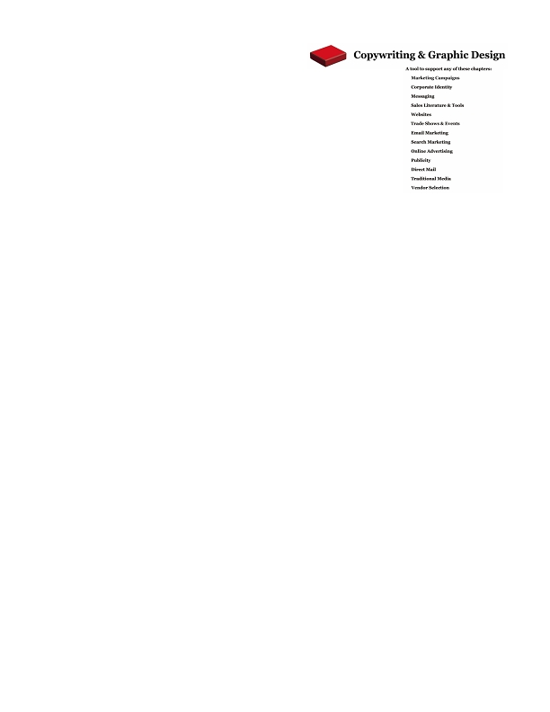
Copywriting &
Graphic Design
•
•
You've probably seen quite a few marketing materials such as
brochures, websites and ads that are dull, uninspiring, and worst of
all, confusing.

Good copywriting and graphic design create powerful
communications with your market. They help a creative vision and message resonate with your audience.
Good copywriting and graphic design will

• Reinforce your value proposition
• Evoke your brand
• Convey your messages in a meaningful, memorable way
• Improve response and ROI for your campaign

Writers and designers can have broad or very focused skill sets. For example, a writer may specialize in web
copy, technical writing, advertising copy or sales letters. Graphic designers may focus on web design, logos,
flash design for online campaigns or print design. Agencies may offer a variety of services, but they can also be
just as specialized.

When you create literature or other creative projects, you're making a substantial investment. By using the
right people and managing your project effectively, you'll maximize your chance for success.
BEST CASE

Your copy and design are
powerful; they communicate your
objectives simply and in a
memorable way. Your prospects
"get it" quickly and are eager to
learn more, creating more
opportunity for your company.
NEUTRAL CASE

Your copy and design are
average. They may be wordy or
not that exiting, but they're not
substantially different than what
your competitors create. They
accomplish what they need to but
could be better.
WORST CASE
Naturally the worst case scenario is
that your copy is poorly written and
your design unappealing. These
materials give a negative impression
of your company and your prospects
choose your competitors over you.
• fffiffi,-ff./0fi1230fffi00 fffiff4056ff0ff,,,78 fffi897.7
93
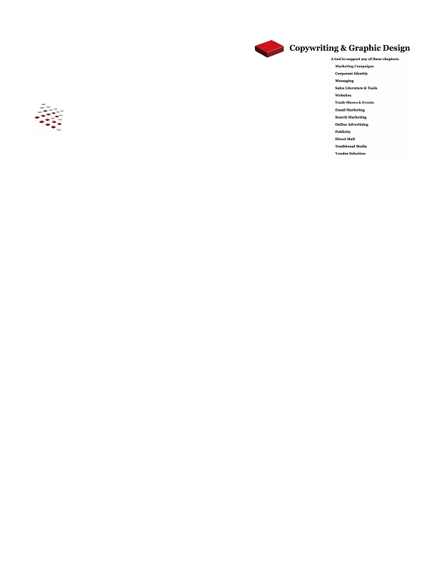
Key concepts & steps
•
Before you begin

You'll need your brand strategy and messages for any creative project. If you're
creating sales literature, you'll need to understand how it fits with your sales
process; if the project is part of a marketing campaign, make sure you've finished
your strategy and goals so the piece can support them.
•
Create a project timeline

Provide a reasonable amount of time between each step so each team member can
deliver on schedule. The earlier you get started, the better your results.

Determine what content will be in the piece

Content should drive the design, not the reverse. If you start with design and try to fill in content later, the
piece may not be nearly as effective. Identify the copy, graphics, photos or charts you'll need in your piece
before starting the design process.

Use a creative brief

A creative brief is an overview for a project. It can be simple or lengthy depending on the complexity of the
project and the amount of background information your team needs. A good creative brief defines

• Deadlines
• Goals including the action you want the recipients to take after seeing the piece
• Audience
• Content
• Background information about the product, service, audience, company, etc.
• Branding requirements including the desired color palette, logo usage, fonts, etc.

Establish criteria for the designs

It's much easier to evaluate design concepts when you have specific criteria to measure against. Establish that
criteria upfront so your design team understands what they need to deliver, then use that criteria to choose
concepts and provide feedback.

Pay attention to proofs and the press check

Make sure you have a very thorough review process in place - a typo in an ad or brochure can be an expensive
and embarrassing error. And conduct a thorough press check so your printed materials completely match your
requirements and vision; you wouldn't want your brochure printed on the wrong paper or your colors to be
mismatched.
•
•
..00.0,ffi fffi/0201fiffi fffi4.00,,,7,ffi fi/7.7
94

What's next?

Keep looking for good copywriters and graphic designers. With
a good team of resources, you'll have someone to call no matter what type of project
you dream up.
• fffiffi,-ff./0fi1230fffi00 fffiff4056ff0ff,,,78 fffi897.7
95
•
•
•
•
•
•
•
•
What's next?
•

Hopefully you've gained a solid framework for the entire marketing process; perhaps you've already put this
information into practice.

Now keep using the Strategic Marketing Process to build expertise and drive your revenue and profit each year.
Continue to improve all of your marketing programs; strive to land in the "best case" scenarios used throughout
this guidebook.

Feel free to visit www.MarketingMO.com for free how-to articles and marketing tips based on the process.

If you'd like to dig deeper, visit www.GrowthPanel.com to see if our complete set of tools and software based on
the process might be a fit for your company or practice.

Good luck!
..00.0,ffi fffi/0201fiffi fffi4.00,,,7,ffi fi/7.7
96

