AMERICAN COLLEGE OF TECHNOLOGY

Online MBA
Module for Entrepreneurship
Course Code:

Prepared by: Buzeye Zegeye (Ph.D.)

Edited by: Meaza Moges

February 2024
Addis Ababa, Ethiopia

Contents
Chapter One: Basics of Entrepreneurship 5
1.0. Introduction 5
1.2 Historical Origin of Entrepreneurship 5
1.3 Definitions of Entrepreneurship and Entrepreneur 6
1.4 Role of Entrepreneurs in Economic Development 10
1.5 Entrepreneurial Competence 12
Chapter Two: Entrepreneurship Ecosystem 26
2.0. Introduction 26
2.2. Concepts 27
2.3. Entrepreneurship and Ecosystem 29
2.4. Factors Influencing Entrepreneurial Ecosystem 30
2.5. Ecosystem Challenges 32
2.6. Development of Conducive Ecosystem 33
2.7. Chapter Summary 34
2.8. Chapter Summary Review Questions 35
Chapter Three: Business Plan 36
3.0. Introduction 36
3.1. Necessity of planning 36
3.2. What is a Business Plan? 37
3.3. Users of a Business Plan 39
3.4. Internal Users of the Business Plan 39
3.5. External Users of the Business Plan 40
3.6. Essentials of a sound business plan 42
3.7. Basic types of business plans 43
3.8. Short business plan 43
3.9. Extended business plan 44
3.10. Operational business plan 44
3.11. Importance of the Business Plan 44
3.12. Preparing the Business Plan 46
3.13. MAJOR COMPONENTS OF A BUSINESS PLAN 46
3.14. Why Some Business Plans Fail 54
3.15. Chapter Summary 55
3.16. Chapter Summary Review Questions 56
Chapter Four: Micro and Small Business 57
4.0. Introductions 57
4.1. The Concept of Small Business Development 57
4.2. Forms of Business (A Short Explanation) 58
4.3. Definition and Role/Importance of MSEs in Developing Countries 60
4.4. Role/Importance of MSEs in Developing Countries 62
4.5. Classification of Micro and Small Enterprises 66
4.6. Priority Sectors and Sub-Sectors for MSEs Engagement In Ethiopia 67
4.7. Levels of MSEs in Ethiopia 67
4.8. Setting up Small Scale Business 68
4.9. Small Business Failure and Success Factors 73
4.10. Small Business Success Factors 77
4.11. Main Supporting Packages for MSEs Development in Ethiopia 80
4.12. Problems of Small Scale Business in Ethiopia 80
4.13. Chapter Summary 82
4.14. Questions for Review and Discussions 83
Chapter Six: CRM 84
6.0. Introduction 84
6.1. Defining CRM 85
6.2. Misunderstandings about CRM 85
6.3. Benefits of CRM 88
6.4. MODELS OF CRM 89
6.5. CRM Success Factors 92
6.6. Chapter Summary 94
6.7. Chapter Summary Review Questions 95
Chapter Seven: Innovation 96
7.0. Introduction 96
7.1. Basic Concepts and Definitions 96
7.1.1. Invention 97
7.1.2. Creativity 97
7.1.3. Innovation 98
7.2. Difference between Innovation–Invention 99
7.3. Characteristics of Innovation 101
7.4. The Concept of Technological Innovation 105
7.5. Innovation Measurement 106
7.6. Common Frameworks and Typologies to Characterize Innovations 107
7.8. GENERATIONS OF INNOVATION MODELS 109
7.9. Chapter Summary 113
7.10. Chapter Review Questions 114
Reference 115

Chapter One: Basics of Entrepreneurship

Introduction

Chapter Objectives
This chapter is concerned with developing a predominant and integrated perspective of the entrepreneur and entrepreneurship. It reviews the great variety of definitions given for the word entrepreneurship and also the different activities performed by the entrepreneur.
After completing this chapter, students will be able to:
- Define the term entrepreneurship and entrepreneur
- Understand the historical development of entrepreneurship in the world
- Recognize the role of entrepreneurship in the economy
- Analyze the personal entrepreneurial competences

1.2 Historical Origin of Entrepreneurship
Warm up questions!
Dear online student, have you ever read about the history of entrepreneurship? When did you think the practice as well as the literature about entrepreneurship begin? Who are entrepreneurs? What is entrepreneurship? Do you think that there is a significant difference between simply merchant and entrepreneurs? Is entrepreneurship is job creation? Well you may not get a complete answer for these and other questions for this document, but you must read other supporting materials to widen your knowledge scope.

Dear online student, during the ancient period the word entrepreneur was used to refer to a person managing large commercial projects through the resources provided to him.
In the 17th Century a person who has signed a contractual agreement with the government to provide stipulated products or to perform service was considered as entrepreneur. In this case the contract price is fixed so any resulting profit or loss reflects the effort of the entrepreneur. In the 18th Century the first theory of entrepreneur has been developed by Richard Cantillon. He said that an entrepreneur is a risk taker. If we consider the merchant, farmers and /or the professionals they all operate at risk. For example, the merchants buy products at a known price and sell it at unknown price and this shows that they are operating at risk. The other development during the 18th Century is the differentiation of the entrepreneurial role from capital providing role. The later role is the base for today’s venture capitalist.

In the late 19th and early 20th Century, an entrepreneur was viewed from economic perspectives.
The entrepreneur organizes and operates an enterprise for personal gain. In the middle of the 20th
Century the notion of an entrepreneur as an inventor as established. “The function of the entrepreneur is to reform or revolutionize the pattern of production by exploiting an invention or more generally untried technological possibility for producing new commodities or producing an old one in a new way or opening a new outlet for products by reorganizing a new industry.”
The concept of innovation and newness are at the heart of the above definition. From the historical development it is possible to understand the fact that the perception of the word entrepreneur was evolved from managing commercial project to the application of innovation (creativity) in the business idea.

1.3 Definitions of Entrepreneurship and Entrepreneur
Now let’s study some popular definitions on the word entrepreneurship and entrepreneur. Intuitively, it is know that entrepreneurship is the process and entrepreneur is the person undertaking entrepreneurial activity such as undertaking own business. Finally we will see the common attributes of the definitions of entrepreneurship and entrepreneur.
Entrepreneurship is the process of identifying opportunities in the market place, arranging the resources required to pursue these opportunities and investing the resources to exploit the opportunities for long term gains. It involves creating incremental wealth by bringing together resources in new ways to start and operate an enterprise.
Entrepreneurship is a ship on a voyage that has on board, innovative and creative men and women, who like to do all those constructive things which nobody could lay his/her hands on before. They make a fortune out of ideas. Success never goes to their heads and each setback makes them bold enough to carve their future, aiming for excellence.
Entrepreneurship is the freedom to do what one likes to do, with all its attendant profits and risks. Entrepreneurship is defined by results and not by attributes. It is a passion and all about commercial risks.
Entrepreneurship is the processes through which individuals become aware of business ownership then develop ideas for, and initiate a business.
Entrepreneurship can also be defined as the process of creating something different and better with value by devoting the necessary time and effort by assuming the accompanying financial, psychic and social risks and receiving the resulting monetary reward and personal satisfaction. In this case an individual should come up with something different and better in order to the named as entrepreneur.
Entrepreneurship is the art of identifying viable business opportunities and mobilizing resources to convert those opportunities into a successful enterprise through creativity, innovation, risk taking and progressive imagination.
Entrepreneurship is a practice and a process that results in creativity, innovation and enterprise development and growth.
Most of what you hear about entrepreneurship, says America’s leading management thinker, is all wrong. It is not magic; it is not mysterious, and it has no nothing to do with genes. It is a discipline and, like any discipline, it can be learned. Peter F. Drucker
Dear student, I hope you have captured what entrepreneurship is? Based on the above entrepreneurship concept, now let’s study some of the definitions about entrepreneur. In the late 1700s, as the modern world started developing, a major transition took place in human activity. The workplace began to change from one of nature to one of artificial environment. Seasons were replaced with work shifts; the sun replaced with artificial lights; the outside ambient replaced with factory-controlled weather, and work activity changed from agrarian to shop assembly. Out of these major dynamic transitions and moves in the human activity, a new sociological distinct individual emerged and this individual was an entrepreneur.
Entrepreneurs are change agents; the figure for economic development; a panacea for unemployment, and drivers of innovation.
An entrepreneur is any person who creates and develops a business idea and takes the risk of setting up an enterprise to produce a product or service which satisfies customer needs.
An entrepreneur can also be defined as a professional who discovers a business opportunity to produce improved or new goods and services and identifies a way in which resources required can be mobilized.
An entrepreneur is an individual who: has the ability to identify and pursue a business opportunity; undertakes a business venture; raises the capital to finance it; gathers the necessary physical, financial and human resources needed to operate the business venture; sets goals for him/herself and others; initiates appropriate action to ensure success; and assumes all or a major portion of the risk!
Entrepreneurs have different souls from others below the sky, they are not people who put their hands in other organizations, work for others and receive payment of checks. They want a job; they create jobs. Entrepreneurs do not follow the market; they define the market. They attribute their success and failure only to themselves-take personal responsibility for their action and behavior.
An entrepreneur is the one who always searches for change, responds to it and exploits it as an opportunity.
Peter F. Drucker
An entrepreneur is a person who: create the job not a job-seeker; has a dream, has a vision; willing to take the risk and makes something out of nothing.
The entrepreneur,” said the French economist J. B. Say around 1800, “shifts economic resources out of an area of lower and into an area of higher productivity and greater yield.”
Other definition, views the term entrepreneur from three perspectives; i.e. from the economist, psychologist and capitalist philosopher’s point of view.
- To an economist an entrepreneur is one who brings resource, labor, materials, and other assets into combination that makes their value greater than before and also one who introduces changes innovations.
- To a psychologist an entrepreneur is a person typically driven by certain forces need to obtain or attain something, to experiment, to accomplish or perhaps to escape the authority of others.
- For the capitalist philosopher an entrepreneur is one who creates wealth for others as well, who finds better way to utilize resources and reduce waste and who produce job others are glad to get.
In general, entrepreneur refers to the person and entrepreneurship defines the process. Both men and women can be successful entrepreneurs; it has nothing to do with gender. All entrepreneurs are business persons, but not all business persons are entrepreneurs.
Think of a person who sits by the roadside leading to your home and who has been selling the same type of food, from the same size of saucepan or pot, from the same tabletop, and may not have been able to change their standard of living to any appreciable extent. Is the person a businessperson or an entrepreneur?

An entrepreneur is therefore a business-minded person who always finds ways to improve and grow in business. An entrepreneur can also be defined as a professional who discovers a business opportunity to produce improved or new goods and services and identifies a way in which resources required can be mobilized. Finally, an entrepreneur is someone who constantly scans the environment looking for changes that can provide opportunities for creating new growth-oriented businesses. Entrepreneurs assume significant accountability for the risk and the outcomes of new enterprises, ventures or business ideas. An effective and successful entrepreneur shows creativity and innovation in business and is an example for other people.

1.4 Role of Entrepreneurs in Economic Development
Brain warm up questions

Do you think that Ethiopia is developing country and USA is developed to entrepreneurship? If you say “yes” how?

- Improvement in per capita Income/Wealth Generation: Entrepreneurs play a vital role in the economic development of a region. From the fall of Rome (AD 476) to the eighteenth century, there was virtually no increase in per capita wealth generation in the West. With the advent of entrepreneurship, however, per capita wealth generation and income in the west grew exponentially by 20 Percent in the 1700s, 200 percent in the 1800s, 740 percent in the 1900 (Drayton, 2004).
- Generation of Employment Opportunities: By creating a new business enterprise, entrepreneurs generate employment opportunities for others. Unemployment is a major issue, especially in the context of developing economies like Ethiopia. Educated youth often are unable to get to get a suitable employment themselves. Thus, entrepreneurs not only self-employ themselves, but also create jobs for others.
- Inspire others Towards Entrepreneurship: The team created by an entrepreneur for his new undertaking often provides the opportunity for the employees to have a first-hand experience of getting involved in an entrepreneurial Venture. An existing venture provides a number of entrepreneurial opportunities through forward and backward linkages, to these employees even to become entrepreneurs themselves. Thus, this process helps in forming a chain reaction of entrepreneurial activity which directly contributes to the health of the economy.
- Balanced Regional Development: Entrepreneurs help to remove regional disparities in economic development. They set up the industries in the backward areas to avail various subsidies and incentives offered by the Central and State Governments, thereby balancing the economic growth in different regions in the country.
- Enhance the Number of Enterprise: When new firms are created by entrepreneurs, the number of enterprises based upon new ideas/ concepts/ products in a region increases. Not only does an increase in the number of firms enhance the competition for new ideas, but greater competition across firms also facilitates the entry of new firms specializing in a particular new product or service. This is because the necessary complementary inputs are more likely available from small specialist niche firms than from large vertically integrated products (Jacobs, 1969).
- Provide Diversity in Firms: Entrepreneurial activity often results into creation of a variety of firms in a region. These firms operate into diverse activities and it has been found that it is this diversity in firms which fosters economic development and growth rather than homogeneity. According to Jacobs (1969), it is the exchange of complementary knowledge across diverse firms and economic agents that yield an important return on new economic knowledge.
- Economic Independence: Entrepreneurship is essential for self-reliance for a country. Entrepreneurs create industries that manufacture indigenous substitutes, thereby reducing the dependence on imports. Also, the goods are exported to other countries to earn foreign exchange. This import substitution and export promotion results in more economic independence to the country.
- Combine Economic factors: All the products bought and sold in an economy are a mix of three primary economic factors (the raw materials, nature offers up, the physical and mental labor people provide and capital (money). Now value is created by combining these three things together in a way which satisfies human needs.
- Provide Market efficiency: Efficient means resources are distributed in an optimal way that is the satisfaction that people can gain from them is maximized. An economic system can only reach this state if there is competition between different suppliers. If a supplier is not using competition then they will tend to demand profit in excess of what the market would allow and reduce the overall efficiency of the system.
- Accepting Risk: Risk is the potential variation in terms of future outcomes. We do not know exactly what the future will bring. This lack of knowledge creates uncertainty. No matter how we plan there is always a possibility of adverse deviation from what we expect or hoped for. Here the primary function of the entrepreneur is to accept risk on behalf of other people.
- Maximize Investor’s Return: Entrepreneurs create and run organizations which maximize long-term profit on behalf of the investors which in turn generates overall economic efficiency.

1.5 Entrepreneurial Competence
An entrepreneurial mind-set is important not only for people engaged in business but also for those who are in nation leadership positions.
Job, employment, occupation, and career are all different terms for the same thing - work! Finding a job that one thinks is right for her/ him might take some time and effort.
Job opportunities emanate from either by self-employment or/and by wage employment, the effort of the government as well as development partners and the private sector is engaging the youth to employment opportunities in either way.

Goal setting
A Goal - is a general direction or long-term aim that you want to accomplish. It is not specific enough to be measured. It is large in scope, not necessarily time-bound, and is something that people strive for by meeting certain objectives, that hopefully add up to eventually, achieving the goal.
Successful people think about their goals most of the time. As a result, they are continually moving toward their goals, and their goals are continually moving toward them. Whatever you think about most of the time grows and increases in your life. If you are thinking about, talking about, and visualizing your goals, you tend to accomplish far, far more than the average person, who is usually thinking and talking about his or her worries and problems most of the time.
Here is a simple seven-step formula for setting and achieving goals that you can use to become a millionaire: First, decide exactly what you want in each area of your life, especially in your financial life. Most people never do this. Second, write down your goals clearly and specifically. Something amazing happens between your head and your hand when you put your goals in writing. Third, set a deadline for each goal. Set sub deadlines if a goal is big enough. Give yourself a target to aim at. Fourth, make a list of everything you can think of that you will have to do to achieve each goal. As you think of new ideas, add them to your list until it is complete.
Fifth, organize your list into a plan of action. Determine what you are going to do first and what you will do later. Decide what is more important and what is less important. Sixth, take action on your plan immediately. It is amazing how many splendid goals and plans are never realized because of procrastination and delay. Seventh, and perhaps most important, do something every day that moves you at least one-step closer to your most important goal. This commitment to daily action will make you a big success in anything you decide to accomplish.

Exercise
Take a sheet of paper and write the word “Goals” at the top of the page with today’s date. Then, make a list of 10 goals that you would like to achieve over the next 12 months. Write your goals in the present tense, as though a year has passed and you have already achieved them. Begin each goal with the word “I” to make it personal to you. By making out a list of 10 goals for yourself for the next year, you will move into an exclusive group consisting of only 3 percent of adults in our society. The sad fact is that 97 percent of adults have never made a list of goals in their entire lives. Once you have your list of 10 goals, go over the list and ask this key question: Which one goal on this list, if I were to achieve it, would have the greatest positive impact on my life?
Whatever your answer to that question, circle that goal and make that your number one, most important goal for the future. Set a deadline, make a plan, take action on your plan, and do something every day that moves you toward that goal.
From now on, think and talk about that goal all the time. Think and talk about how you can achieve that goal. Think and talk about all the different steps that you can take to make that goal a reality. This exercise will stimulate your creativity, increase your energy, and unlock more and more of your potential.

“A person with a clear purpose will make progress on even the roughest road. A person with no purpose will make no progress on even the smoothest road.
THOMAS CARLYLE
Planning
Planning is making a decision about the future in terms of what to do, when to do it, where to do it, how to do it, by whom to do and using what resources. Planning is the systematic process of establishing a need and then working out the best way to meet the need, within a strategic framework that enables you to identify priorities and determines your operational principles. Planning means thinking about the future so that you can do something about it now.
Question: Why Plan?
- Provides a clear understanding of what you need to do in order to achieve your development goals;
- Guides you in prioritizing and making decisions;
- Allows you to focus possibly limited resources on the actions that will benefit your work the most;
- Keeps you in touch with your context – global, national and local;
- Provides a tool to help you communicate your intentions to others;
- Provides a coherent guide for day-to-day implementation.

Opportunity seeking
Dear student, what is opportunity seeking?
An opportunity is a favorable set of circumstances that creates a need for a new product, service, or business. It includes access to credit, working premises, education, training, etc. An entrepreneur always seeks out and identifies opportunities. He/she seizes an opportunity and converts it into a realistic and achievable goal or plan. Dear student, to succeed in your business, you must always watch out your environment, scan the market, seek for market information, open your eye to see the problems and underutilized resources, develop plan to convert to business opportunities. Successful entrepreneurs erect their ear as antenna to collect the information and have the eagle eye to scan their environment. An entrepreneurial mind typically is opportunity focused. It has an uncanny ability to identify opportunities quickly in any given environment. Call it art or science-an entrepreneurial mind is always identifying opportunities. An opportunity exists in the ecosystem, outside the entrepreneurial mind at that particular point in consideration. It can also be safely assumed that an opportunity that can be capitalized for business purposes needs to exist where customers exist or at least where potential customers exist.

Exercise (the Nine Dots Puzzle)
Instruction: Write or draw Nine dots on your exercises or piece of paper as it is indicated below. The objective of this puzzle is to connect all 9 dots using four straight lines or fewer, without lifting the pen and without tracing the same line more than once.

I hope, you have tried to connect the dots. Very good!
Did you get the solution? I hope most of you did not! Look at the solution on the next page. Let me ask you for those who did not get the solution: why you did not connect the dots while keeping the instruction into account? Most of the time people may answer the following reasons
- The instruction was not clear
- I did not think that going outside the square is possible
- No idea what the solution looks like
- etc
Solution 
The notion of something outside a perceived "box" is related to a traditional topographical puzzle called the nine dots puzzle. The origins of the phrase "thinking outside the box" are obscure; but it was popularized in part because of a nine-dot puzzle, which John Adair claims to have introduced in 1969. Management consultant Mike Vance has claimed that the use of the nine-dot puzzle in consultancy circles stems from the corporate culture of the Walt Disney Company, where the puzzle was used in-house.
The puzzle proposed an intellectual challenge—to connect the dots by drawing four straight, continuous lines that pass through each of the nine dots, and never lifting the pencil from the paper. The conundrum is easily resolved, but only by drawing the lines outside the confines of the square area defined by the nine dots themselves. The phrase "thinking outside the box" is a restatement of the solution strategy. The puzzle only seems difficult because people commonly imagine a boundary around the edge of the dot array. The heart of the matter is the unspecified barrier that people typically perceive.
Ironically, telling people to "think outside the box" does not help them think outside the box, at least not with the 9-dot problem. This is due to the distinction between procedural knowledge (implicit or tacit knowledge) and declarative knowledge (book knowledge). For example, a non-verbal cue such as drawing a square outside the 9 dots does allow people to solve the 9-dot problem better than average.
The nine-dot problem is a well-defined problem. It has a clearly stated goal, and all necessary information to solve the problem is included (connect all of the dots using four straight lines). Furthermore, well-defined problems have a clear ending (you know when you have reached the solution). Although the solution is "outside the box" and not easy to see at first, once it has been found, it seems obvious. After you explain the lesson of the 9 points challenge and how and why this puzzle is developed, now drive your participant to “Think outside the box”

Persistence
PERSISTENCE IS THE iron quality of character. Persistence is to the character of man as carbon is to steel. The indispensable quality goes hand in hand with all great success in life. The courage to persist in the face of adversity and disappointment is the one quality that, more than anything, will guarantee your success. Your greatest personal asset can be your willingness to persevere longer than anyone else. In fact, your persistence is a true measure of your belief in yourself and your ability to succeed. Remember, all of life is a test. For you to have great success, you must pass the “persistence test.” And this test is often a pop quiz. It can come at any time, usually totally unexpectedly and out of left field. You take the persistence test whenever you are confronted with an unexpected difficulty, disappointment, setback, failure, or crisis in life. This is where you show yourself, and everyone around you, what you are truly made of.
Activity
Instructions: Read the story of Thomas Edison carefully and answer the questions
The story of Thomas Edison (please adapt to the context) When he was young, Thomas Edison’s parents took him out of school after his teachers declared that he was “stupid” and “unteachable.” Edison spent his early years working and being fired from various jobs, culminating in his firing from a telegraph company at the age of 21. Despite these numerous setbacks, Edison was never discouraged from his true calling in life: inventing! Throughout his career, Edison obtained more than one thousand patents. In addition, although several of these inventions such as the light bulb, stock printer, phonograph, and alkaline battery -- were groundbreaking innovations, the vast majority of them could be fairly described as failures. Edison is now famous for saying that genius is “1% inspiration and 99% perspiration.
One of Edison’s best examples of perseverance occurred after he was already a successful man. After inventing the light bulb, he began seeking an inexpensive light bulb filament. At the time, ore was mined in the Midwest of the United States, and shipping costs were very high. In order to minimize his costs with ore, Edison established his own ore-mining plant in Ogdensburg, New Jersey. For nearly ten years, he devoted his time and money to the enterprise. Edison also obtained 47 patents for innovations that helped make the plant run more smoothly. In addition, even despite those inventions, Edison’s core project failed because of the low quality of ore on the East Coast. However, despite that failure, one of those 47 inventions (the crushing machine) revolutionized the cement industry, and actually earned Edison back almost all of the money he had lost. Later, Henry Ford would credit Edison’s Ogdensburg project as the main inspiration for his Model T Ford assembly line. In addition, in fact, many believe that Edison paved the way for modern-day industrial laboratories. Edison’s foray into mining demonstrates that dedication can pay off even in a losing venture.
Reflection questions:
• What are the major challenges that Thomas Edison faced?
• What were his achievements?
• What are the causes for his success?
• What do we learn from the story of Thomas Edison?

Efficiency and Quality
What do you know about efficiency and quality?
Efficiency
• Being efficient means producing results with little wasted effort.
Quality refers to:
- The most common definition of quality is “the standard of something as measured against other things of a similar kind” or “general excellence”
- The ongoing process of education, communication, evaluation and constant improvement of goods/services to meet the customer’s need in a way that exceeds the customer’s expectations;
- A characteristic of the product or service that makes it fit to use. It makes a product, process, or service desirable.
- The ability of a product or service to meet a customer’s expectations for that product or service. The importance of quality management in entrepreneurship is reflected in the income statement of the business. There is always a demand for quality products and efficient services.
After the definition, ask them if they are clear on the definition and then show the slide “Relation between Quality and Efficiency” and ask the participant to reflect on. After some reflection, explain the following to them.
Quality is the guarantee of efficiency, quality is the first. Efficiency without quality is like dead wood without vitality. It also attaches great importance to improving the efficiency and quantity to obtain profits, and constantly increases the research and development cost to the creative products, so that the number of different types of products, namely the cost, can be reduced to obtain benefits. So, efficiency is also a source of cost reduction. When the enterprise’s efficiency is improved to a critical value, it will generate profits or even high profits, which enables the enterprise to have current assets to increase the income and bonus of employees and fixed capital to increase the equipment update and purchase as well as certain R&D expenses to maintain the vitality of the enterprise. Therefore, efficiency to a certain extent solves the urgent need of capital and medium-and-long-term capital of the company. The same is true of today’s automobile industry, where the number of cars leads to lower costs and thus higher profits. This gives the car companies a valuable source of capital to inject new energy into their research and reinvestment. This virtuous circle keeps the enterprise growing.
Now display “why quality” and ask them. After you extract some answers from the participants and then show the slide and explain the importance of quality.
Quality plays an important role in this new era of globalization because it confers certain benefits that include:
• Reduction of waste: Striving to maintain quality means examining all processes that contribute to the creation of a product, to remove non-productive processes and waste. If businesses keep to their standard of maintaining the quality of the product, the number of defective products will be reduced. Consumers prefer to buy quality products. Hence, the quality products/services help in increasing the share in the market and ensure that they will not be returned.
• Cost-effectiveness: Striving to ensure quality helps businesses to minimize the chances that they will make mistakes. As a result, the costs of re-doing work or changing the product after it has been sold are greatly reduced.
• An increase in market share: Customers prefer to buy the same product repeatedly if they are satisfied with the quality. If they are satisfied with the quality of a product, then they will not only purchase the product/services more than once, but they will also recommend it to their friends. As a result, this contributes to an increase in the company’s market share
- Better profitability: better quality of product satisfies customers. Increased customers mean increased sales, increased shares in the market, and consequently increased profits
• Social responsibility: By providing quality products and services, a company is more likely to be able to fulfill its responsibility to the community and meet standards set by the government.
• Reputation: Quality of goods and services improves the reputation of the business for competition in the market and growth.
Information-seeking
Information seeking is an activity or process of trying to get information in both human and technological contexts. This is to look for any information that is required in order to make decisions. This is for the concerned person to seek and obtain information regarding suppliers, customers, competitors and any other relevant information that enable the entrepreneur make decisions and improve knowledge on their business.
Persuasion and networking
Persuasion is
• A way of convincing someone to get something or make a decision in your favor
• Inducing or taking a course of action or embracing a point of view by means of argument, reasoning, or entreaty, to convince
• To succeed in causing a person to do or consent to something; to win someone over, as by reasoning or personal forcefulness
• To cause to believe, to induce, urge, or prevail upon successfully
Importance of Persuasion in Business
- We purchase goods from people
• We sell goods to people
• We need support from people
• We work with people.
• Without people be they suppliers, workers, and most importantly customers, there is no business.
Networking is an extended group of people with similar interests or concerns who interact and remain in informal contact for mutual assistance or support. Business Networks In a business environment where we are in, we network with customers, suppliers, competitors, various firms, different organizations, government offices and family, etc Factors that affect persuasion and networking • Socio-cultural background and perceptions
• Communication skills (both verbal and non-verbal).
• Negotiation skills
Building self-confidence
Self-confidence is the state of being certain that a chosen course of action is the best or most effective given the circumstances. Confidence can be described as a subjective, emotional state of mind, but is also represented statistically as a confidence level within which one may be certain that a hypothesis will either be rejected or deemed plausible. Self-confidence is having confidence in oneself when considering a capability. Overconfidence is having unmerited confidence believing something or someone is capable when they are not.
Characteristics of a self-confident person
A person with self-confidence may exhibit some of the following characteristics:
• Risk-taking: willing to take risks and go the extra mile to achieve better things.
• Independent: entrepreneurs like to be their own masters and want to be responsible for their own decisions.
• Perseverance: Ability to endure and survive setbacks and continue to build confidence in whatever you do in your business.
• Able to learn to live with failure. Entrepreneurs are going to make mistakes. They are human. However, they learn from these mistakes and then move on.
• Ability to find happiness and contentment in work.
• Doing what you believe to be right, even if others mock or criticize you for it.
• Admitting mistakes and learning from them
1.6. Chapter Summary
Dear student, in this chapter we have studied about the definition, meaning and concept of entrepreneurship and entrepreneurs. Furthermore, we have also seen the role of entrepreneurship in economic development of the country. Finally, we have learned more in depth on personal entrepreneurial competencies.
1.7. Chapter Review Questions
1. List personal entrepreneurial competencies
_____________________________________________________________________________________________________________________________________________________________________________________________________________________________________________________________________________________________________________________________________________________________________________________________________________________
2. List basis for the classifications of an entrepreneur
____________________________________________________________________________________________________________________________________________________________________________________________________________________________________________________________________________________________________________________________________
3. Explain the role of entrepreneurship in economic development
______________________________________________________________________________________________________________________________________________________________________________________________________________________________________________________________________________________________________________________________________________________________________________________________________________________________________________________________________________________________________

Chapter Two: Entrepreneurship Ecosystem

Introduction
Micro-, small- and medium-sized enterprises (MSMEs) are known to be a main driver of economic growth and job creation in high-income countries and, especially, in countries with developing economies. The World Bank estimates that formal small- and medium-sized enterprises (SMEs) constitute roughly 90 percent of all businesses worldwide, they provide nearly 50 percent of employment and contribute around 40 percent of GDP in emerging economies. A recent ILO study using data from 99 countries reveals that self-employed individuals, micro and small businesses, also considering the informal sector, contribute to roughly 70 percent of total employment6 in those countries.
Many development efforts and policies have therefore focused on promoting MSME development in countries with developing economies. As a subset of the many development approaches used to promote self-employment and MSMEs, entrepreneurship support is broadly aimed at aiding the startup and expansion of these businesses.
Business creation is a key avenue to sustain innovation, economic growth and, ultimately, job creation. As a result, entrepreneurship promotion, that is, facilitating the creation of sustainable and growing businesses, has become a core component of most economic development agendas. Given the uncertainty and costs associated with starting and sustaining successful businesses, the international community has increasingly recognized the need to adopt more systemic approaches to sustain well-functioning entrepreneurial ecosystems.
Objectives
After you study this chapter you will be able to:
- Define what is ecosystem and entrepreneurship ecosystem
- Identify the domains of entrepreneurship ecosystem
- Understand the impact of entrepreneurship ecosystem on startups and business growth

2.2. Concepts
The concept of entrepreneurial ecosystems has gained popularity in recent years due to mainstream business books such as Feld’s (2012) Startup Communities and work by Isenberg (2010) in the Harvard Business Review. These works have popularized the idea amongst entrepreneurial leaders and policymakers that a place’s community and culture can have a significant impact on the entrepreneurship process. But despite its popularity, there is not yet a widely shared definition of entrepreneurial ecosystems amongst researchers or practitioners.
The entrepreneurial ecosystem approach often narrows this entrepreneurship down to ‘high-growth start-ups’ or ‘scale ups’, claiming that this type of entrepreneurship is an important source of innovation, productivity growth, and employment.
The term is ecosystem associated with the biological interpretation of this concept in which the interaction of living organisms with their physical environment is at the center is obviously not to be taken too literally.
The term ecosystem was introduced by Tansley (1935) in a biological context. He describes it as the whole of living and nonliving organisms interacting with one other and with their environment. Of course, this biological interpretation should not be taken too literally. Nonetheless, it has some similarities when comparing it with its economic counterpart. Moore (1993) was the first one to use it in an economic context. He argued that entrepreneurship does not exist in a vacuum, hereby emphasizing the importance of its environment.
‘A set of interconnected entrepreneurial actors (both potential and existing), entrepreneurial organizations (e.g. firms, venture capitalists, business angels, banks), institutions (universities, public sector agencies, financial bodies) and entrepreneurial processes (e.g. the business birth rate, numbers of high growth firms, levels of ‘blockbuster entrepreneurship’, number of serial entrepreneurs, degree of sellout mentality within firms and levels of entrepreneurial ambition) which formally and informally coalesce to connect, mediate and govern the performance within the local entrepreneurial environment’.
The ecosystem relevant to context of economic entities can be seen as whole set of stakeholders, resources and processes with their interdependencies, at varied stages of lifecycles. The lifecycles may consist of all matters of interest in the relevant space, characterized by intrinsic and extrinsic factors which influence stakeholder in focus. The ecosystem is characterized by internal and external factors which have interdependency and has been responsible for dynamic nature of the ecosystem evolution. For example, resource limitations affect the growth and behavior of organisms in a habitat which over time can affect the resources in the external environment. The goals of ecosystem approach and ecosystem management has been to achieve sustainability of the focus entities or the stakeholders within the ecosystem. The ecosystem approach or systems view can be used from a locational perspective or process perspective. There is more inclination among researchers to use the process view in a specific context to demarcate stakeholders of interest.
The Entrepreneurship Ecosystem means various constituents like entrepreneurs, organizational stakeholders, employees and other individuals, and organizations etc., which facilitate or limit the development of entrepreneurs in a location / region of interest.
These constituents of the system like institutions, individuals aspiring to be entrepreneurs, entrepreneur’s groups/associations, other complementary factors etc. these factors may influence the progress of current entrepreneurs, individuals aspiring to be entrepreneurs, individuals who could be candidates for entrepreneurship in future etc., are called stakeholders. There can be other stakeholders like policy institutions, educational set ups, financial institutions and investors, R & D centers, civil society outfits, industry associations, unions, legal institutions, multinationals, etc.
Activity
Dear student
Discuss the actors/pillars of entrepreneurship ecosystem

2.3. Components of Entrepreneurship Ecosystem
Entrepreneurship ecosystem is the social and economic environment that affects entrepreneurship. It is an interaction amongst the set of independent actors and factors that lead to encourage, nurture and promote entrepreneurship in any area.
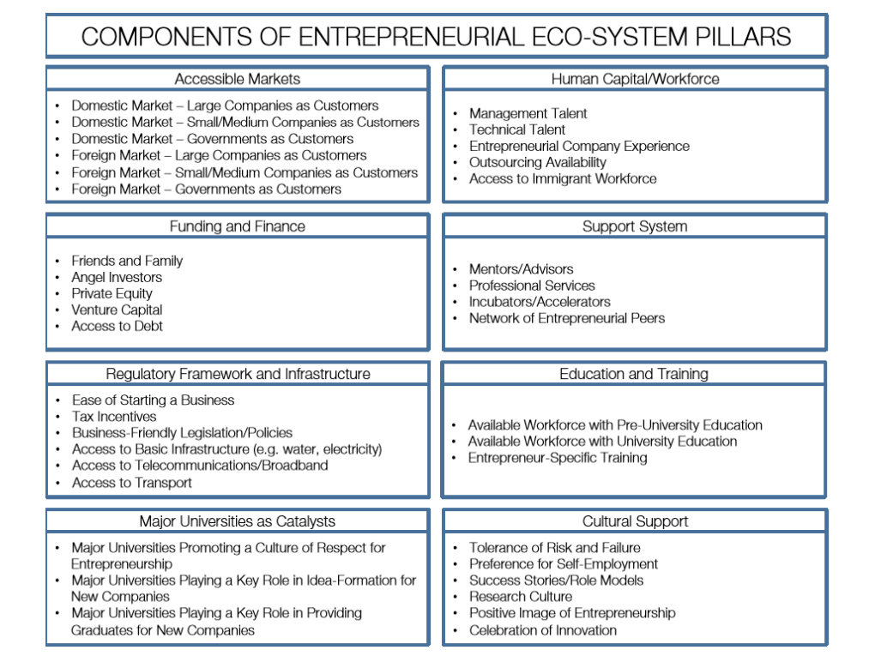
In his ‘Relational Organization of Entrepreneurial Ecosystems’, Spigel (2015) refers to all these previously cited components.
Daniel Isenberg (2011a) identifies the same elements as Spilling but categorizes them differently. He stated that a region needs leadership, government, funding, cultural norms, success stories, human capital, universities, entrepreneurship organizations, infrastructure, support services, networks, and early customers in order to have self-sustaining entrepreneurship which is, according to him, only possible if there exists an entire entrepreneurial ecosystem. As shown in figure XIII, these participants can be consolidated into six domains: policy, finance, culture, supports, human capital and markets.
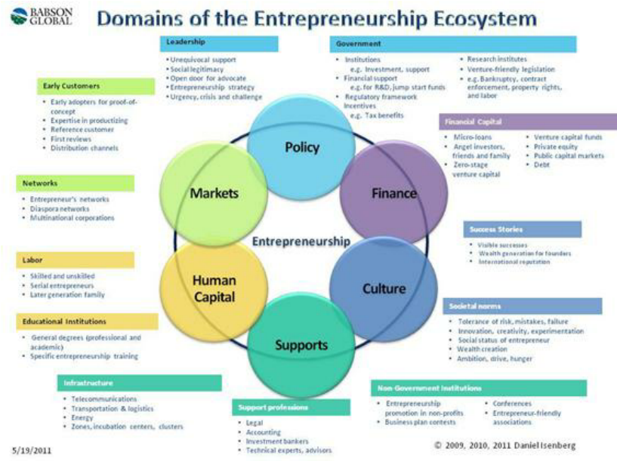
Another case-based conceptual framework, is developed by Suresh and Ramraj (2012). It identifies eight systems of support that influence an individual to become (or not to become) an entrepreneur: moral support (friends, family, and society at large..), financial support, network support, government support, technology support (e.g. from universities, incubators, human capital, etc.), market support (i.e. opportunities in the market), social support (e.g. acceptance of failure, exposure by media, etc., which is the same as the so-called ‘culture’) and environmental support (which are the local conditions: available resources, climatic condition,…). The attentive reader can infer that most of these ‘supports’ are already mentioned in the above literature. Only the notion of moral support is completely new.

2.4. Factors Influencing Entrepreneurial Ecosystem
From getting the idea to opportunity identification, solution development, its evaluation and final implementation, successful entrepreneurship requires host of skills. These can be summed up as technical skills, commercial competencies, communication skills, opportunity identification, problem solving ability, planning skills, organizing skills, operational management, financial management, human resource mobilization, governance skills, innovation and networking skills, with the ability to take calculated risks.
According to the “Entrepreneurial ecosystems around the globe and company growth dynamics” report by World Economic Forum (2013), three areas of entrepreneurial ecosystems matter most for entrepreneurs and they are access to markets, human capital/workforce and finance. Though there are major differences in entrepreneurial ecosystems that exist from one part of the world to another, there are also similarities in the issues facing entrepreneurs around the globe – particularly when it comes to early-stage companies. There is a potential alignment issue among these early stage companies with governments who often adopt a strong country/regional focus in their entrepreneurial ecosystem policies.
Isenberg (2011) has categorized these various elements into six main activities. These activities are: policy, finance, culture, institutional and infrastructural supports, human capital and markets. Let us learn them in detail:
- Policy: The government regulatory domain plays a pivotal role in deciding the structure of the entrepreneurial ecosystem to the extent that governmental policy can make or break the ecosystem. The regulatory policy framework element consisting of components such as the ease to start a new business with respect to licenses and registrations required, tax incentives including tax holidays available to new start-ups, laws that are conducive to business growth, determines the ability to open and expand new businesses. The government policy helps in attracting the entrepreneurs to initiate the venture. If ease of doing business is favorable, the entrepreneur may be encouraged to start the new venture.
- Finance: The supply and accessibility of financial reserves for entrepreneurs is crucial not only at the initial incubation stage but also help in maintaining their growth trajectory. Finance is required when the entrepreneurs need to acquire more resources like recruiting people, or buying or leasing capital assets as well as raw materials, or investing in marketing and sales. These financial reserves can range from the traditional sources like friends and family to the relatively modern forms like angel investors, private equity partners or venture capital as well as access to debt from banks/FIs or open markets. Needless to add that a wider and greater availability of financial resources accelerates the scaling up of the business growth.
- Culture: The culture of any region is the soul of the entrepreneurial ecosystem that takes form in the region. It is said that an entrepreneurial ecosystem without a strong cultural support for entrepreneurship lacks the impetus to carry ahead for long. Cultural aspects like cultivating a positive image of entrepreneurship, having an inherent spirit of self-reliance with a preference for self-employment, tolerance of failure of entrepreneurship by developing adequate risk-appetite, culture of research and innovativeness and celebrating the success stories of role models provide the support system for the entrepreneurial ecosystem to prosper.
- Institutional and Infrastructural Supports: The institutional and infrastructural supports consist of the various formal and informal agencies that help in business creation and their expansion. These may be physical infrastructures like transportation in the form of roadways, railways and air connectivity which provide the requisite accessibility. Similarly the internet connectivity to the World Wide Web which serves as the medium for information exchange. Besides this the support system consists of agents providing professional services like financial planning, accounting, human resources, legal advisers etc. which team up to form the entrepreneurial networks.
- Human Capital: The human capital represents the quality and quantity of the workforce available at the disposal of the entrepreneur. Human capital is a multifaceted element and depending on the specific skill set that the workforce possess, gives shape to the type of working environment that it can generate. The various components of this domain are the management and technical talent pool available, the level of education and training especially technical education and training that the workforce holds, the experience the entrepreneurs possess, ease of access to immigrant workforce etc. Nurturing of the human capital is essential to sustenance of the ecosystem.
- Markets: A receptive market setup consisting of customers who create the requisite demand is essential for the businesses to grow. Entrepreneurial ecosystems need access to such markets with the presence of the appropriate customers who are willing to pay for the entrepreneur’s products and services. These markets can be domestic as well as foreign markets, wholesale or niche markets, small, medium or large markets where individuals, businesses as well as institutional market participants can interact and transact.

2.5. Ecosystem Challenges
Though entrepreneurship and entrepreneurial ecosystem are a necessity for the growth of trade and economy and the overall progress of the nation, yet there are many barriers that hamper their growth. The challenges are:
- Policy Barriers: The area of concern include regulatory or policy barriers, identified by bureaucratic red tape, tax compliance burdens, regulatory requirements and policy indecisiveness and weaknesses in the overall business environment.
- Access to technology and Intellectual Property Rights issues: Access to technology, patent and copyright issues, are some of the other problems plaguing entrepreneurs, in addition to problems caused by lack of access to markets, effective transport, communication and supply chain and distribution systems, cultural and social barriers and weak or inefficient judicial process.
- Intrinsic challenges: The challenges can also be categorized as intrinsic and extrinsic. The intrinsic reasons consist of factors like societal bias towards specific groups/communities, illiteracy and lack of capability, limited family backing, etc.
- Extrinsic Challenges: The extrinsic factors include organizational challenges such as access to financing and investment, natural resources, limited market or access to potential market, human resource etc. There are also environmental factors that form part of the extrinsic factors and they can be categorized into socio-cultural factors like beliefs, attitudes and values of a society towards the subject of entrepreneurship are known as the entrepreneurial culture of that society. In addition to this are regulatory factors and government licensing and policies and associated factors like bribery, corruption etc.

2.6. Development of Conducive Ecosystem
There are multiple ways and responses to overcome above challenges and make ecosystem conducive for enterprise development. The features of development of conducive ecosystem are:
- Infrastructure
- Finance
- Ancillary Industry
- Single window operations and approval
- Ease of doing business
- Development of clusters of industries
- Development of MSMEs
- Favorable Government Policies
- Incentives

2.7. Chapter Summary
Entrepreneurship is the process which an entrepreneur goes through to fructify ideas, competencies and commitment of entrepreneurs into an enterprise. Entrepreneurship is the process influenced by Factors like social economic, economic, psychological and other factors. The process involves visioning, mobilization of resources and setting up of an enterprise by an entrepreneur or entrepreneurs which is meant to leverage the identified opportunity and capture value. There is increased interest in ecosystems as an approach for understanding the climate for growth of entrepreneurship. The understanding of this interdependency helps entrepreneurs and other stakeholders especially policy makers understand process modalities in the whole context. Important buckets of influence include policy, finance, culture, institutional and infrastructural supports, human capital and markets. Innovation is the key factor for effective entrepreneurial success and its sources and acceptability lies in the better understanding of the whole system or ecosystem. There are challenges in managing and making this ecosystem conducive as the goals of the stakeholders are varied, opportunities have a window and resources are mostly limited. Hence states should effectively monitor ecosystems for their strengths and weaknesses so that it helps in assessment and taking suitable corrective measure, including all necessary stakeholders, on a dynamic basis.

2.8. Chapter Summary Review Questions
- Discuss the entrepreneurial ecosystem in context of Ethiopia SMEs
____________________________________________________________________________________________________________________________________________________________________________________________________________________________________________________________________________________________________________________________________________________________________________________________________________________________________________________________________________________________________________________________________
- What are the challenges for the policy makers to make the ecosystem conducive for startups in Ethiopia?
____________________________________________________________________________________________________________________________________________________________________________________________________________________________________________________________________________________________________________________________________________________________________________________________________
- What are six buckets to comprehend the role of entrepreneurial ecosystem?
_________________________________________________________________________________________________________________________________________________________________________________________________________________________________________________________________________________________________________________________________________________________________________________________________________________________

Chapter Three: Business Plan

Introduction
When we run a business, we get so caught up in our daily tasks, problems, and issues that we lose sight the bigger picture. This can happen when we don’t have a business plan. Business plan is an essential document for starting, building and running a successful business. It is also an effective tool for raising (raising) the necessary operating funds and attracting (retaining) business partners. A business plan is a tool that outlines the goals and objectives of the business in a clear and concise manner and indicates the strategy for its success. Also, a business plan is an excellent communication tool for manufacturers, service providers, interested business partners and suppliers for business goals. Many businesses fail or go bankrupt due to lack of planning. Therefore, this training will show you how to develop a proper plan and enable you to run a successful business.
Upon completion of this course, trainees will be able to:
  - Have a good understanding of why planning is an important part of running a business;
  - Be able to define business plan, understand its essence and identify the major users of a company’s business plan;
  - Comprehend the essentials of business plan preparation;
  - Have better information about the importance of a business plan;
  - Identify the different types of business plan;
  - Identify the essential components of a business plan;
  - Develop a business plan, and use the plan to start and/ or improve their business;

Necessity of planning
Before we go into the details part of business plan, it is important that every individual understand the importance of planning for the success of any venture. Planning is the process of setting objectives and devising actions to achieve those objectives, answers the questions such as:
- What business am I in?
- What finances do I need?
- What is my sales strategy?
- Where can I find needed personnel?
- How much profit can I expect?
Planning is a process that never ends for a business. It is extremely important in the early stages of any new venture when the entrepreneur will need to prepare a preliminary business plan. The plan will be finalized as the entrepreneur has a better sense of the market, the product or services to be marketed, the management team, and the financial needs of the venture. As the venture evolves from an early start-up to a mature business, planning will continue as management seeks to meet its short term or long-term business goals.
For any given organization, it is possible to find financial plans, marketing plans, human resource plans, production plans, and sales plans. Plans may be short-term or long-term, or they may be strategic or operational. Plans will also differ in scope depending on the type of business or the anticipated size of the startup operation.
Discussion question:
Why is planning necessary in running a business organization? What do you think is a business plan? What kind of information do you think does it provide to stakeholders? Discuss.

What is a Business Plan?
The business plan is the formal written expression of the entrepreneurial vision, describing the strategy and operation of the proposed venture. It is also a loan proposal, venture plan, or investment prospectus. A business plan is a written document that sets out the basic idea underlying a business and related start-up considerations. However, not all business plans are the same because businesses are different, products are different, they are prepared for different reasons and they vary in importance.
For the entrepreneur starting a new venture, a business plan has four basic objectives:
- It identifies the nature and the context of the business opportunity why does such an opportunity exist.
- It presents the approach the entrepreneur plans to take to exploit the opportunity.
- It identifies the factors that will most likely determine the success of the venture.
- It serves as a tool to raise financial capital.
A business plan can be viewed as an entrepreneur's game plan; it crystallizes the dreams and hopes that motivates the entrepreneur to start the business. The business plan will represent your vision and goals for the firm and it will reflect what actually happens.
The business plan should:
- layout basic idea of the venture,
- describe where you are now,
- indicate where you want to go,
- outline how you propose to get there
- explain the key variables of success or failure,
The business plan is a bridge between an idea and reality. Without first mentally visualizing the desired end result, the entrepreneur is not likely to see the venture become a reality. The role of the business plan is to provide a clear visualization of what the Entrepreneur intends to do. A business plan may also address major expansion of an existing firm. A business plan can be a response to some changes in the external environment that presents new opportunities. Therefore, writing a business plan should be thought of as ongoing process and as the means to an end product.
A business plan, in principle, can be seen as a document that commercializes your business idea as a whole towards potential investors and stakeholders. Business plans are assumed to be successful if business owners/ promoters succeed in conveying to the reader the most significant opportunities and growth capacities of their company realistically. It should justify and describe your business idea and further business development in a clear and adequate manner. It should not merely aim at emphasizing the strengths of the company, but rather at presenting a realistic portrait of its problems, risks and obstacles. In addition to this, appropriate solutions should be proposed and discussed in detail.
Basically a successful business plan has three important features:
- The short- and long-term objectives are clearly depicted,
- a careful description is given of how the objectives can be achieved in realistic general conditions and,
- A description is given of how the realization of the plan will meet the expectations of the investors.

Discussion question:
- Given the discussion provided earlier, who do you think are the main users of a business plan document? How would it serve those who use it? Discuss.

Users of a Business Plan
A business plan has two primary functions: first, to provide a clearly articulated statement of goals and strategies for internal use and second, to serve as a selling document to be shared with outsiders. Figure provides an overview of those who might have an interest in a business plan for a new venture.
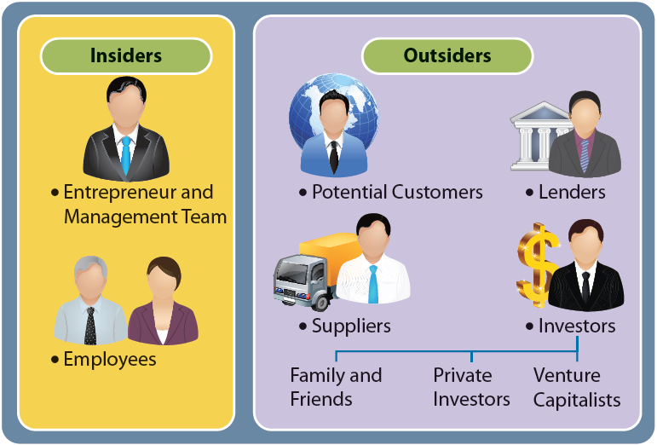

One main group of users consists of outsiders who are critical to the firm's success: customers, suppliers and investors. The other major group is the internal users of the business plan: the new firm's management and its employees.

Internal Users of the Business Plan
A written plan is essential to ensure systematic coverage of all the important features of a new business. By identifying the variables that can affect the success of the business, the business plan, becomes a model that helps the entrepreneur focus on important issues and activities of the new venture. A business plan should also be effective in selling the new venture to those within the company. It provides a structure for communicating the entrepreneur's mission to current and prospective employees of the firm.

External Users of the Business Plan
By enhancing a firm's credibility, the business plan can serve as an effective selling tool to use with prospective customers and suppliers, as well as investors. Suppliers, for example, extend trade credit, which is often an important part of a new firm's financial plan. A well-prepared business plan may be helpful in gaining a supplier's trust and securing favorable credit terms. Occasionally, a business plan can improve sales prospects. Both investors and lenders use the business plan to better understand the new venture, the type of product or service it offers, the nature of the market, and the qualifications of the entrepreneur and the management team. A venture capital firm or other sophisticated investor would not consider investing in a new business before reviewing a properly prepared business plan. The plan can also be extremely helpful in establishing a good relationship for a new firm with banks. External use of a business plan is detailed as follows with reference to the type of financing and stakeholder relations.
- Venture-capital financing
As a rule, venture-capital and private-equity investors nowadays only consider business cases which are well represented by a business plan. When reading a business plan, the investors are primarily interested in good and relevant arguments that promise business growth. Furthermore, investors attach great importance to how and in which period of time a return on investment will be realized, for instance:
- through operating profit or
- by going public or
- by merger and acquisition or
- through a repurchase by the management
In order to guarantee a high return on investment, investors pay great attention to:
- the company’s success on the market,
- the feasibility of the plan in order to achieve its business objectives,
- the unique selling proposition of the products and services and
- the quality and experience of the management team
- Financing by bank credits
When granting credits, investment banks focus on one main question: when and how the repayment of the credits and interests will be made. In order to minimize risks, banks usually ask for securities. That is why credit applications addressed to banks should provide more than a list of current and past annual accounts. Moreover, banks will also ask to what extent the companies are prepared for possible setbacks, and how they will be able to overcome such critical situations.
For these reasons banks more and more often demand professional business plans when considering applications for credits. Banks expect business plans to give qualified insight into: the enterprise strategy, the management, the organization, the market, the competitors, the products and the current and future financial and profit situation of the enterprise.
- Forming strategic alliances
The formation of strategic alliances by young and growing companies within the framework of research projects, product design, marketing, etc. is gaining increasingly in importance. A strategic alliance is usually the consequence of:
- financial backing or
- access to well-established distribution channels
Such an alliance may well succeed over several years for the benefit of all parties. The majority of companies, however, request a business plan before consenting to any long-term business relations or obligations within the framework of a strategic alliance.
- Completing mergers and acquisitions
Acquisitions present an alternative for company expansion, while selling a company may be seen as the way out of a solvency crisis. Companies that are looking for acquisition candidates usually request a detailed business plan that will support their evaluation and selection of the candidates. Similarly, the acquisition candidate himself will also be interested in the long-term plans of any acquiring company, in order to ensure and protect his own interests for the future. This information is also the subject-matter of a business plan.

- Building customer and marketing relations
Winning a major customer or an agreement with a wholesaler is a particularly crucial step towards success for many growth companies. Most big companies, however, are very reserved and precautious before starting negotiations with rather small and unknown companies. In such cases, a convincing business plan may clear doubts and prove decisive for inspiring confidence, opening negotiations and making further decisions. Hence, business plans effectively help to open doors to potential customers, markets and suppliers.

Essentials of a sound business plan
To make persuasive your business plan consider the following points:
- Comprehensive: the business plan has to fully and completely treat all the major issues facing the new venture. The comprehensiveness enables the entrepreneur to see where trouble might come from and to develop contingent strategies to reduce the effect of problems.
- Communicative: the business plan is a document for communicating to various audiences the business’s concept and potential.
- Guidance: the business plan sets goals and milestones for the new venture. It layouts the intention of the entrepreneurial team and the values of the founders wish to preserve in their organization. It describes what business we will do, how and where it will be started. Therefore, the business plan can be referred repeatedly to guide decisions of the firm’s managers and employees. The business plan should serve as guideline for taking any major decisions.
- The planning process/flexible: the process of putting together a business plan, consulting it frequently, and reviewing and revising it periodically can improve the venture’s performance even through some aspects of the plan may become obsolete before the ink dry. The improvement is brought about collecting information, sharing analysis, developing norms for decision making within the organization, publicity enunciating the values of the organization’s leaders, reviewing objectives, and linking theses with actions-all elements of highly effective organizations.
Discussion question:
- How do you think are business plans categorized? What are the most common types of business plans used by different entrepreneurs for different purposes? Discuss with relevant examples.

Basic types of business plans
For the majority of authors writing their first business plan, the question arises “How detailed should the business plan be?” To this question there is, unfortunately, no standard answer and no formula. It is entirely up to you how detailed your business plan should be, and depends solely on the purpose and necessity behind it, as well as on the complexity of your specific business. In general, one distinguishes between three basic types of business plans:
- the short business plan,
- the extended business plan and
- the operational business plan
In the following these three types are described.

Short business plan
A short business plan is usually about 10 to 15 pages long. It is most suitable for young companies in an early stage of their development when, there still do not exist complex interrelations.
For a well-established company, a short business plan only makes sense if certain investment opportunities are to be roughly approved in advance, in order to prepare an extended business plan on the base of the short version later on. Even if it is a “short” business plan, the required information should be conveyed in a complete and appropriate manner. The final goal is to convince potential investors that you understand your entrepreneurial business and the market extremely well.

Extended business plan
The extended business plan is usually about 20 to 40 pages long. This type of business plan describes the business issues of the company much more profoundly and more detailed than a short business plan would do. The higher the required capital, the more interesting this type of business plan becomes. If, for example, you require 5 million Euros outside capital for the construction of a new and innovative industrial plant, i.e. you are striving for long-term credits, the preparation of an extended business plan would be advisable. Such a business plan should contain a thorough market analysis and a revenue, cost and financial planning for a 5-year period.

Operational business plan
For well-established companies a business plan can serve the management team as an important operative tool, say a business guideline. Such a plan not only serves as a draft for the entire business organization, but also ensures a consistent appreciation on the part of the entire management with respect to the strategic objectives. Indeed, operational business plans are very long and detailed, usually comprising over 40 pages, in some cases even exceeding 100 pages.
Discussion question:
Explain the importance of a business plan. What benefits would preparing a business plan provide for entrepreneurs? Discuss with relevant examples.

Importance of the Business Plan
A business plan is the most essential for starting, building and making business successful. It allows the entrepreneur to exploit the opportunities that arise in the life of business from a start-up to maturity. The major benefits of a sound business plan are discussed below.
- Arranging strategic alliance: strategic alliances are arrangements between large and small companies to carryout joint research, marketing, and other activities. Hence, developing sound business plan will enable an entrepreneur to build a strategic alliance with a larger company then to gain the advantage or benefits from the financial and managerial experience of the larger company.
- Seeking investment funds: venture capitalists and investors require a business plan from any company that wants to be taken seriously for funding the venture. Well-designed business plan is the best way to secure finance from different sources.
- It reduces the anxieties and tension of the entrepreneur. By projecting the risk of the new venture into the future, the entrepreneur comes to grasps with potential negative outcomes and the possibility of failure. The knowledge that comes from this experience can reduce fear of falling unknown future.
- Obtaining bank financing: Banks require a business plan to deserve bank funds for entrepreneurs. Because more business are seeking bank financing than banks have money available, only those business that make the best business plan will receive funds.
- It helps to obtaining large contract.
- Completing mergers and acquisitions: Whether you want to sell your company or acquire one, a business plan is very important. Your business plan can inspire the confidence essential to complete the deal, i.e. to sell your company or to acquire the other companies.
- Attracting key employees: Usually, people doubt about the sustainability of companies during their inspection. Hence, sometimes, it becomes difficult to attract qualified employees into the small business venture. But developing sound business plan will remove the doubts from the mind of potential candidates.
- Motivating the management team: A written business plan that is based on input from all members of the company’s management team and/or distributed to all managers ensures that everyone understands where the company is headed. The plan serves as a motivational tool by laying out the company’s financial, marketing and producing goals.
- It provides self-assessment of the entrepreneur. A well-prepared business plan enables an entrepreneur to see whether the business is assured of success. The planning process forces the entrepreneur to bring the objectivity to the idea. The entrepreneur is required to play out various scenarios and consider obstacles that might prevent the venture from succeeding. The act of these scenarios allows the entrepreneur to confront these obstacles and play ways to avoid them.

Discussion question:
What kinds of elements do you think shall be incorporated in to a comprehensive business plan document? Explain the subjects that should be considered while preparing a business plan.

Preparing the Business Plan
In preparing the business plan the entrepreneur, himself must sit still long enough to do it. Hiring someone to write the business plan is not acceptable substitute; entrepreneurs should undertake the task personally. Although outsider consultants, accountants and lawyers should be tapped for their advice and expertise, the founder or the initial management team should be responsible for the preparation of the business plan.
Developing and writing the business plan take money, time, and energy. A business plan could take many hours to prepare, depending on the experience and knowledge of the entrepreneur as well as the purpose it is intended to serve. It should be comprehensive enough to give any potential investor a complete understanding of the new venture. Many entrepreneurs incorrectly estimate the length of time that an effective plan will take to prepare. Once the process has begun, however, the entrepreneur will realize that it is invaluable in sorting out the business functions of a new venture. Although all business plans contains certain key elements, the content and the organization (format) varies greatly on the nature of the business, the goal of the plan and the business plan preparation norms in different countries.

MAJOR COMPONENTS OF A BUSINESS PLAN
- Introductory Page
This is the title or cover page that provides a brief summary of the business plan's contents. The introductory page should contain the following:
  - The name and address of the company.
  - The name of the entrepreneur(s) and a telephone number.
  - A paragraph describing the company and the nature of the business.
  - The amount' of financing needed: The entrepreneur may offer a package that is stock, debt, and so on. However, many venture capitalists prefer to structure this package in their own way.
  - A statement of the confidentiality of the report: This is for security purposes and is important for the entrepreneur.
This title page sets out the basic concept that the entrepreneur is attempting to develop. Investors consider it important because they can determine the amount of investment needed without having to read the entire plan.
- Executive Summary
This section of the business plan is prepared after the total plan is written. About three to four pages in length, the executive summary should stimulate the interest of the potential investor. The investor uses the summary to determine if the business plan is worth reading in total. Thus, it would highlight concisely and convincingly the key points in the business plan, that is, the nature of the venture, financing needed, market potential, and support as to why it will succeed.
XYZ Procurement Service
DebremarkosTown
Kebele 6, Mender Sosit
Coowners:
Mr. X, Mrs. Y & Mr. Z
Tel.______, ______,______
Description of Business
This business will provide purchasing and procurement service of fast moving items on a contract basis to small and medium sized businesses. Services include collecting pro forma invoice, screening out potential vendors and awarding the winning bidder and purchasing the products in accordance with the description in the purchase order. Contracts will be for one year and will specify the specific services and scheduling for completion of services. Financing Initial financing requested is a 150,000 Birr loan to be paid off over 5 years. This debt will cover office space, office equipment and supplies, one leased van, advertising and selling costs.
Statement of Confidentiality
This report is confidential and is the property of the co-owners listed above. The persons to whom it is transmitted and any reproduction or disclosure of any of its contents without the prior written consent of the company is prohibited intend it only for use.

- Industry Analysis
It is important to put the new venture in a proper context. In particular, the potential investor, while assessing the venture on a number of criteria, needs to do an industry analysis in order to know which industry the entrepreneur will be competing in. Discussion of the industry outlook, including future trends and historical achievements, should be included. The entrepreneur should also provide insight on new product developments in this industry. Competitive analysis is also an important part of this section. Each major competitor should be identified, with appropriate strengths and weaknesses described particularly as to how they might affect the new venture's potential success in the market.
Who is the customer? The market should be segmented and the target market for the entrepreneur identified. Most new ventures are likely to compete effectively in only one or a few of the market segments. This strategy may be a function of the competition. Any forecasts made by the industry or by the government should be noted. The potential investor may view a high growth market more favorably.
Some key questions the entrepreneur should consider in this part include:
- What are total industry sales over the past few years?
- What is the anticipated growth in the industry?
- How many new firms have entered this industry in the past few years?
- What new products have been recently introduced in this industry?
- Who are the nearest competitors?
- How will your business operation be better than this?
- Is each of your major competitor’s sales growing, declining, or steady?
- What are the strengths and weaknesses of each of your competitors?
- What is the profile of your customers?
- How does your customer profile differ from that of your competitors?
- Description of the Venture
The description of the venture should be detailed in this section of the business plan. This will enable the investor to ascertain the size and scope of the business. Key elements are the product(s), the location and size of the business, the personnel and office equipment that will be needed, the background of the entrepreneur(s), and the history of the venture.
Some of the important questions the entrepreneur needs to answer when preparing this section of the business plan include:
- What are the product(s)?
- Describe the product(s), including patent, Copyright or trademark status
- Where will the business be located?
- Is the building new or old? In need of renovations (If renovation needed, state costs)
- Is the building leased or owned? (State the term)
- Why are these building and location right for your business?
- What additional skills or personnel will be needed to operate the business?
- What office equipment is needed?
- Will equipment be purchased or leased?
- What is your business background?
- What management experience do you have?
- Describe personal data such as education, age, special abilities and interests
- What are your reasons for going into business?
- Why will you be successful in this venture?
- What development work has been completed to date?
- Production Plan
If the new venture is a manufacturing operation, a production plan is necessary. This plan should describe the complete manufacturing process. If some or all of the manufacturing process is to be subcontracted, the plan should describe the subcontractor(s), including location, reasons for selection, costs, and any contracts that have been completed. If the manufacturing is to be carried out in whole or in part by the entrepreneur, he/she will need to describe the physical plant layout; the machinery and equipment needed to perform the manufacturing operations; raw materials and suppliers' names, addresses, and terms; costs of manufacturing; and any further capital equipment -needs. In a manufacturing operation, the discussion of these items will be important to any potential investor in assessing financial needs.
If the venture is not a manufacturing - operation but a retail store or service, this section would be titled "merchandising plan" and purchase of merchandise, inventory control system, and storage needs should be described. Some of the key questions for this section of the business plan are the following:
- Will you be responsible for all or part of the manufacturing operation?
- If some manufacturing is subcontracted, who will be the subcontractor(s)? Give names and addresses.
- Why were these subcontractors selected?
- What are the costs of the subcontracted manufacturing? Include copies of any written contracts.
- What will be the layout of the production process? Illustrate the steps if possible.
- What equipment will be needed immediately for manufacturing?
- What raw materials will be needed for manufacturing?
- Who are the suppliers of new materials and appropriate costs?
- What are the costs of manufacturing the product?
- What are the future capital equipment needs of the venture?
If a retail operation or service:
- From whom will merchandise be purchased?
- How will the inventory control system operate?
- What are storage needs of the venture - and how will they be promoted?
- Marketing Plan
The marketing plan is an important part of the business plan since it describes how the product(s) will be priced, promoted and distributed. Specific forecasts for product(s) are indicated in order to project profitability of the venture. The budget and appropriate controls needed for marketing strategy decision should be discussed.
Potential investors regard the marketing plan as critical to the success of the new venture. Thus, the entrepreneur should make every effort to prepare as comprehensive and detailed plan as possible so that investors can be clear as to the goals and strategies of the venture. Marketing planning will be an annual requirement (with careful monitoring and changes made on a weekly or monthly basis) for the entrepreneur and should be regarded as the road map for short-term decision-making.

- Organizational Plan
The organizational plan describes the venture's form of ownership - that is, proprietorship, partnership, or corporation. For instance, if the venture is a partnership, the terms of the partnership should be included. If the venture is a corporation, it is important to detail the shares of stock authorized, share options, names and addresses and resumes of the directors and officers of the corporation. It is also helpful to provide an organization chart indicating the line of authority and the responsibilities of the members of the organization. This information provides the potential investor with a clear understanding of who controls the organization and how other members will interact in performing their management functions.
Some of the key questions the entrepreneur needs to answer in preparing this section of the business plan are summarized below.
- What is the form of ownership of the organization?
- If a partnership, who are the partners and what the terms of agreement?
- If a corporate, who are the principal shareholders and how much stock do they own?
- What type and how many shares of voting or non-voting stock have been issued?
- Who are the members of board of directors?
- Who has check-signing authority or control?
- What are the roles and responsibilities of each member of the management team?
- What are the salaries, bonuses, or other forms of payment for each member of the management team?
- Assessment of Risk
Every new venture will be faced with some potential hazards, given the particular industry and competitive environment. It is important that the entrepreneur makes an assessment of risk and prepares an effective strategy to deal with them.
Major risks for a new venture could result from a competitor's reaction; weaknesses in the marketing or production, and new advances in technology that might render the new product obsolete. Even if these factors present no risks to the new venture, the business plan should discuss why that is the case. It is also useful for the entrepreneur to provide alternative strategies should any of the above risk factors occur. These contingency plans and strategies illustrate to the potential investor that the entrepreneur is sensitive to important risks and is prepared should any occur.
- Financial Plan
Determines the potential investment commitment needed for the new venture and indicates whether the business plan is commercially feasible. Three financial areas are covered in this section of the business plan. First, the entrepreneur should summarize the forecasted sales and appropriate expenses for some years. It includes the forecasted sales, cost of goods sold, and the general and administrative expenses. Second, cash flow figures must be presented for some years. Third, the projected balance sheet should be presented. It shows the financial condition of the business at a specific time. It also summarizes the assets of the business, its liabilities, the investment of the entrepreneur and any partners, and retained earnings or cumulative loses.
- Appendix:
This part generally contains any back up material that is not necessary in the text of the document. Letters from customers, distributors, or subcontractors are examples of the information that should be included in the appendix.
Discussion question:
Use the business plan preparation outline specified above and /or summarized below, and prepare a comprehensive business plan report for a business you are contemplating to get involved in.

A SUMMARY OF BUSINESS PLAN OUTLINE
I. Introductory Page
A. Name and address of business
B. Name(s) and address(s) of principals
C. Nature of business
D. Statement of financing needed
E. Statement of confidentiality of report
II. Executive Summary
III. Industry Analysis
A. Future outlook and trends
B. Analysis of competitors
C. Market segmentation
D. Industry forecasts
IV. Description of Venture
A. Product (S)
B. Size of business
C. Office equipment and personnel
D. Background of entrepreneur
V. Production Plan
A. Manufacturing process (amount sub contracted)
B. Physical plant
C. Machinery and equipment

D. Names of suppliers of raw materials
VI. Marketing Plan
A. Pricing
B. Distribution
C. Promotion
D. Product forecasts
E. SWOT analysis
VII. Organizational Plan
A. Form of ownership
B. Identification of partners or principal share holders
C. Authority of principals
D. Management-team background
E. Roles and responsibility of members of organization
VIII. Assessment of Risk
A. Evaluation of weakness of business
B. New technologies
C. Contingency plans
IX. Financial Plan
A. Pro forma income statement
B. Cash flow projections
C. Pro forma balance sheet
D. Break-even analysis
E. Sources and applications of funds
X. Appendix
A. Letters
B. Market research data
C. Leases or contracts

D. Price lists from suppliers

Note:
Please check out the different sample formats of business plan entries in the appendices part of this manuscript.

Why Some Business Plans Fail
Generally, a poorly prepared business plan can be blamed on one or more of the following factors:
  - Goals set by the entrepreneur are unreasonable and not measurable
  - The entrepreneur has not made a total commitment to the business.
  - The entrepreneur does not have experience in the planned business.
  - No customer need was established for the proposed threats or weaknesses of the business.
Setting goals requires the entrepreneur to be well informed about the type of business and the environment. Goals should be specific and not so vague as to lack any basis of control. For example, the entrepreneur may target a specific market share, units sold, or revenue. These goals are measurable and can be monitored over time.
In addition, the entrepreneur and must make a total commitment to the business in order to be able to meet the demands of a new venture. For example, it is difficult to operate a new venture on a part-time basis while still holding onto a full-time position. Lenders or investors will not be favorably inclined toward a venture that does not have full-time commitment. Moreover, they will expect the entrepreneur to make a significant financial commitment to the business even if it means a second mortgage or a depletion of savings.
Generally, a lack of experience will result in failure unless the entrepreneur can either attain the necessary knowledge or team up with someone who already has it. For example, an entrepreneur trying to start a new restaurant without any experience or knowledge of the restaurant business would be disastrous. The entrepreneur should also document customer needs before preparing the plan. Customer needs can be identified from direct experience, letters from customers, or from market research. A clear understanding of these needs and how the entrepreneur's business will effectively meet them is vital to the success of the new venture.

Chapter Summary
Business plans help companies identify their goals and objectives and provide them with tactics and strategies to reach those goals. It is not historical document; rather, they embody a set of management decisions about necessary steps for the business to reach its objectives and perform in accordance with its capabilities. Business plans have several major uses. These include internal planning and forecasting, obtaining funding for ongoing operations or expansion, planned divestiture and spinoffs, and restructuring or reorganizing. While business plans have elements common to all uses, most business plans are tailored according to their specific use and intended audience.

Chapter Summary Review Questions
- List and explain components of business plan
_____________________________________________________________________________________________________________________________________________________________________________________________________________________________________________________________________________________________________________________________________________________________________________________________________________________________________________________________________________
- Define Business plan
________________________________________________________________________________________________________________________________________________________________________________________________________________________________________
- Explain the importance of business plan
_____________________________________________________________________________________________________________________________________________________________________________________________________________________________________________________________________________________________________________________________________________________________________________________________________
- List users of business plan
____________________________________________________________________________________________________________________________________________________________________________________________________________________________________________________________________________________________________________________________________________________________________

Chapter Four: Micro and Small Business

Introductions
Chapter Objectives
After completing this chapter, students will be able to:
- Explain the Concept of Business Development;
- Identify the Forms of Business Ownership;
- Analyze the Importance/Role of MSEs;
- Set Up Small Scale Business;
- Distinguish the Failure and Success Factors of MSEs;
- Identify the Problems of Small Scale Business in Ethiopia; and
- Develop Organizational Culture

The Concept of Small Business Development
Specifying size and standard to define small business is necessarily arbitrary, because people adopt different standards for different purposes. Based on socio- economic conditions, countries define small business differently. But all may use size and economic criteria as a base to define small business. Size criteria include number of employees and the startup capital. Size does not always reflect the true nature of an enterprise; in addition, qualitative characteristics are used to differentiate small business from other business. The economic/control definition covers market share, independence and personalized management.
Micro and small enterprises (MSEs) cover a wider spectrum of industries and play an important role in both developed and developing economies. Ethiopia is no exception and MSEs occupy a prominent position in the development of the Ethiopian economy. While the small entrepreneurs can set up a unit even with less capital, enjoy quick returns and have the flexibility to handle the vagaries(change) of the market, they have to face many problems like lack of finance, poor operations management, lack of experience, poor financial management, etc,. The process of setting up a venture begins with searching for an opportunity. Identifying a good opportunity is a difficult task and involves scanning the environment and the use of creativity and innovation.

Forms of Business (A Short Explanation)
There are three basic legal forms of business formation with some variations available depending on the entrepreneurs’ needs.
The three basic legal forms are:-
1) Proprietorship,
2) Partnership, and
3) Corporation, with variations particularly in partnerships and corporations.
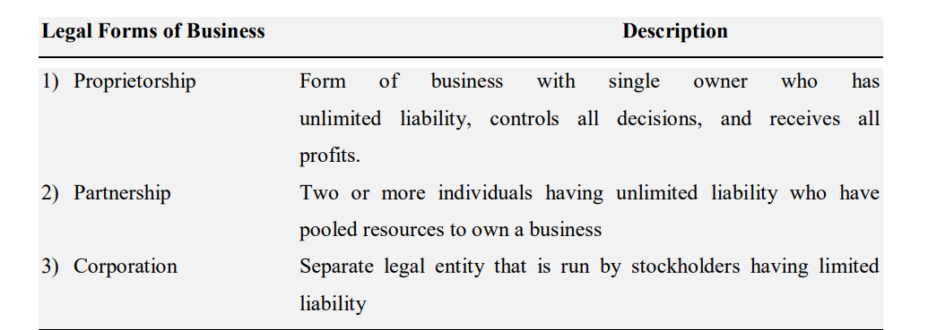
These three basic legal forms are compared with regard to ownership, liability, start-up costs, continuity, transferability of interest, capital requirements, management control, distribution of profits, and attractiveness for raising capital. It is very important that the entrepreneur carefully evaluate the pros and cons of the various legal forms of organizing the new venture. This decision should be made before the submission of a business plan and request for venture capital. The comparison for the three basic legal forms against the aforementioned factors is briefly presented in the table below:-
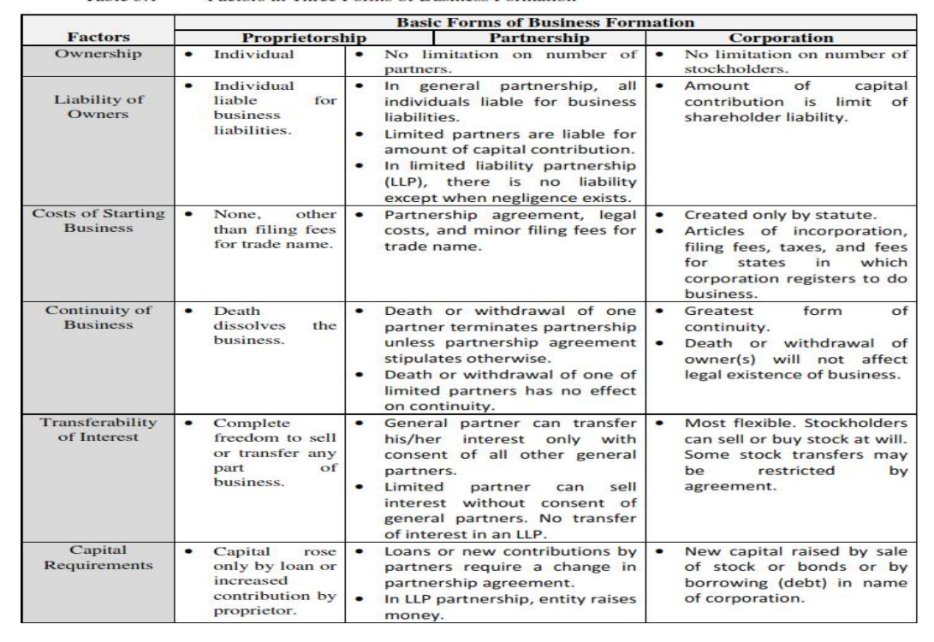
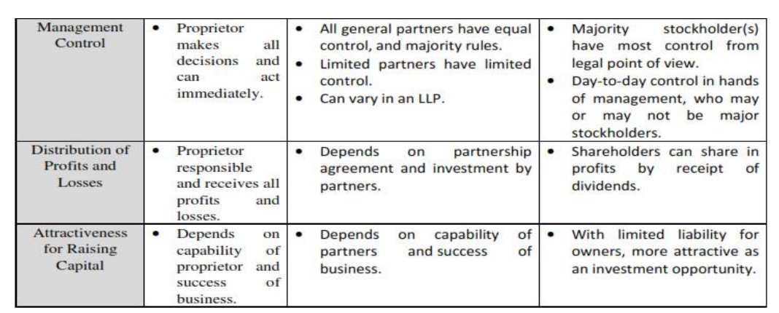

Definition and Role/Importance of MSEs in Developing Countries
Definition of MSEs
Small businesses are playing an important role in the industrial economy of the world. These are particularly important in the developing economies. Small business is predominant even in developed countries such as USA, Japan etc.
There is a difference between small business owners and entrepreneurial ventures as well. An entrepreneurial venture often is a growth-oriented innovative company with product or service offerings that are new to the market. Small businesses could be entrepreneurial ventures. Most entrepreneurial ventures start as a small business.
However, some discernible characteristics still differ them. Most small businesses’ owners work with known products and services aimed at incremental growth, and their innovation is focused on sales, marketing, and market expansion. Entrepreneurial ventures incorporate a different set of strategies. These entities are aimed at rapid growth and apply innovation and creativity at every node of the business process. They work with new offerings, and they face a lot more uncertainties; hence, their strategy calls for continuous work on mitigating uncertainty and risk reduction Specifying size and standard to define small business is necessary because people adopt different standards for different purposes. For example, legislators may exclude small firms from certain regulations and specify ten employees as the cut-off point. Moreover, a business may be described as “small” when compared to larger firms, but “large” when compared to smaller ones. For example, most people would classify independently owned gasoline stations, neighborhood restaurants, and locally owned retail stores as small business.
Similarly, most would agree that the major automobile manufacturers are big businesses. And firms of in-between sizes would be classified as medium on the basis of individual viewpoints. There are two approaches to define small business. They are: Size Criteria, and Economic/control criteria.
Size Criteria
Even the criteria used to measure the size of businesses vary; size refers to the scale of operation. Some criteria are applicable to all industrial areas, while others are relevant only to certain types of business. For instance, some of the criteria used to measure size are: number of employees; volume, and value of sales turnover, asset size, and volume of deposits, total capital investment, volume/value of production, and a combination of the stated factors.
Even though the number of employees-is the most widely used yardstick, the best criterion in any given case depends upon the user’s purpose. To provide a clearer image of the small firms, the following general criteria for defining a small business are suggested by Small Business Administration (SBA).
Financing of the business is supplied by one individual or a small group. Only in a rare case would the business have more than 15 or 20 owners.
• Except for its marketing function, the firm’s operations are geographically localized.
• Compared to the biggest firms in the industry, the business is small.
• The number of employees in the business is usually fewer than 100.
This size criteria based definition of MSEs varies from country to country. All over the world, number of employees or capital investment or both has been used as the basis for defining MSEs.
Economic/Control Criteria
Size does not always reflect the true nature of an enterprise. In addition, qualitative characteristics may be used to differentiate small business from other business. The economic/control definition covers:
    - Market Share,
    - Independence
- Personalized Management
    - Geographical Area of Operation
All four of these characteristics must be satisfied if the business is to rank as a small business.
- Market Share: - The characteristic of a small firm’s share of the market is that it is not large enough to enable it to influence the prices of national quantities of goods sold to any significant extent.
- Independence: - Independence means that the owner has control of the business himself/herself. It, therefore, rules out those small subsidiaries which though in many ways fairly autonomous, nevertheless have to refer to major decisions (e.g., on capital investment) to a higher level of authority.
- Personalized Management: - It is the most characteristics factor of all. It implies that the owner actively participates in all aspects of the management of the business, and in all major decision-making process. There is little delegation of authority and one person is involved when anything material is involved.
- Technology: - Small business is generally labor intensive and only few are technology intensive.
- Geographical Area of Operation: - The area of operation of a small firm is often local. Generally, small business is a business that is privately owned and operated, with a small number of employees and relatively low volume of sales.

Role/Importance of MSEs in Developing Countries
Micro and Small Enterprises (MSEs) cover a wider spectrum of industries and play an important role in both developed and developing economies. Ethiopia is no exception and MSEs occupy a prominent position in the development of the Ethiopian economy. Over the years, the number of MSEs is growing from time to time and they need a strong support on Scio- economic and political ground. Some of the contributions are hereunder.
1) Large Employment Opportunities: MSEs are generally labor-intensive. For every fixed amount of investment, MSE sector provides employment for more persons as against few persons in the large scale sector. Thus in a country like Ethiopia where capital is scarce and labor is abundant, MSEs are especially important.
2) Economical Use of Capital: MSEs need relatively small amount of capital. Hence it is suitable to a country like Ethiopia where capital is deficient.
3) Balanced Regional Development/ Removing Regional Imbalance/: Generally small enterprises are located in village and small towns. Therefore it is possible to have a balanced regional growth of industries. Ethiopia is a land of villages.
Another problem is the continuous shifting of people from rural to urban areas which causes over-crowding in cities with slum conditions due to lack of social and medical amenities which require heavy investments. This problem can be solved by inducing people to set up micro and small firms in rural areas. Large scale industries have the tendency to concentrate in big cities. As a result, semi urban and rural areas remain deprived of the benefits of industrialization. Moreover, undue concentration of large industries in urban areas creates several problems, e.g., pollution, shortage of civic facilities, etc. Due to lack of employment opportunities in the country side, people migrate in large numbers to big cities. Micro and small-scale units can be located in rural and semi urban areas to reduce regional disparities.
4) Equitable Distribution of Wealth and Decentralization of Economic Power: It removes the drawbacks of capitalism, abnormal profiteering, concentration of wealth and economic power in the hands of few etc.
5) Unregulated Growth of Large-scale industries results in concentration of economic· power in the hands of a few; and consequently, gross inequalities in the distribution of income and wealth will occur. On the other hand; income generated in a large number of small enterprises is dispersed more widely and its benefit is derived by the large segments of the society. This is due to wide spread ownership and decentralized location of small scale enterprises. In this way, small & medium scale enterprises bring about greater equality of income distribution. It is also argued that most of the micro and small scale units are either proprietary or partnership concerns. As a result, relations between workers and employers are more harmonious in micro and small enterprises than in large enterprises. Micro and small enterprises also encourage competitive spirit and generate the impetus to self-development.
6) Dispersal over Wide Areas- MSEs has a tendency to disperse over wider areas and they play a key role in the industrialization of a developing country.
7) Higher Standard of Living: MSEs bring higher national income, higher purchasing power of people in rural and semi-urban areas.
8) Mobilization of Locals Resources/Symbols of National Identity: The spreading of industries even in small towns and villages would encourage the habit of thrift and investment among the people of rural areas. Small scale businesses are locally owned and controlled, and can strengthen family and other social systems and cultural traditions. They are perceived as valuable in their own right as well as symbols of national identity.
9) Innovative and Productive /Simple Technology: New but simple techniques of production can be adopted more easily by MSEs without much investment. Small businesses are highly innovative though they do not maintain their own research and development.
10) Less Dependence on Foreign Capital/ Export Promotion: MSEs use relatively low proportion of imported equipment and materials. The machinery needed for these industries can be manufactured within the country. Micro and small scale enterprises are opening up fresh avenues in the export market in our world. Realizing the importance of the small and medium- scale sectors in the economy; the Ethiopian government has adopted several measures to speed up the growth of micro and small size enterprises.
11) Promotion of Self Employment: MSEs foster individual skill and initiative and promote self-employment particularly among the educated and professional class.
12) Protection of Environment: MSEs help to protect the environment by reducing the problem of pollution.
13) Shorter Gestation Period: In these enterprises the time-lag between the execution of the investment project and the start of flow of consumable goods is relatively short.
14) Facilitate Development of Large Scale Enterprises: MSEs support the development of large enterprises by meeting their requirements of inputs of raw materials, intermediate goods, spare parts etc. and by utilizing their output for further production.
15)Individual Tastes, Fashions, and Personalized Services: Small businesses have the flexibility to adapt quickly to changes in the business or technological environment.
16) More Employment Creation Capacity: Economic planners have realized the necessity of encouraging micro and small enterprises because they require less capital but generate more employment. The micro and small scale sectors have the capacity to generate a much higher degree of employment than the large-scale sector. This is because micro and small scale enterprises are labor intensive and thus create more employment with a given level of capital. More production needs more capital in such a situation. The micro and small firms will stand in good position because they are less capital intensive and more labor intensive.

4.5. Classification of Micro and Small Enterprises
1. In Case of Manufacturing Enterprise (Manufacturing, Construction and Mining):
a) A Micro Enterprise is one in which the investment in plant and machinery (total asset) does not exceed birr100, 000 (one hundred thousand); and operates with 5 people including the owner.
b) Small Enterprises is one in which the investment in plant and machinery (a paid up capital of total asset) of birr100, 000 (one hundred thousand) and not more than Birr 1.5 million; and operates with 6-30 persons.
2. In Case of Service Enterprise (Retailing, Transport, Hotel and Tourism, ICT and Maintenance):
a) A micro enterprise is one with the values of total asset is not exceeding Birr 50,000(fifty thousands); and operates with 5 persons including the owner of the enterprise.
b) Small Enterprises is one in which the total asset value or a paid up capital of birr100, 000 (one hundred thousand) and not more than Birr 1.5 million; and operates with 6-30 persons.
When ambiguity is encountered between manpower and total assets as explained above, total asset is taken as primary yardstick.
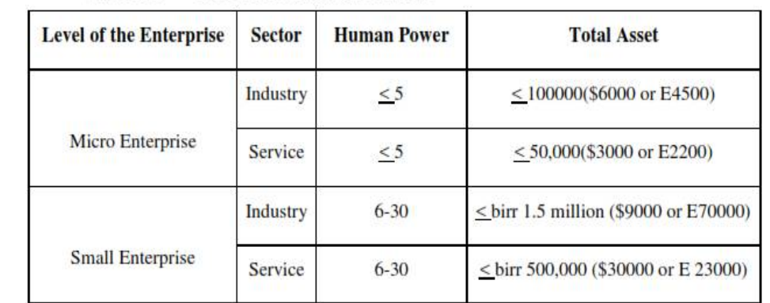

4.6. Priority Sectors and Sub-Sectors for MSEs Engagement In Ethiopia
1. Manufacturing Sector- This is the one which comprises textile and garment; leather and leather products; food processing and beverage; metal works and engineering wood works including furniture and ornaments service; and agro-processing.
2. Construction Sectors- This is the one which comprises sub-contracting; building materials; traditional mining works; cobble stone; infrastructure sub-contract; and prestigious goods.
3. Trade Sectors- This is the one which comprises whole sale of domestic products; retail sale of domestic products and raw materials supply.
4. Service Sectors- This is the one which comprises small and rural transport service; café and restaurants; store service; tourism service; canning/packing service; management service; municipality service; project engineering service; product design & development service; maintenance service; beauty salon; and electronics software development; decoration and internet café.
5. Agriculture Sector (Urban Agriculture) - This is the one which comprises modern livestock raring; bee production; poultry; modern forest development; vegetables and fruits; modern irrigation; and animal food processing.

4.7. Levels of MSEs in Ethiopia
Start-up:- Start up level refers to enterprises that incorporate people who are interested to establish MSE and those who completed the required profession/skill from various institutions and innovated by legally either in the form of association or private. It is a level where an enterprise begins production and service under legal framework or legal entity.
Growth Level: - An enterprise is said to be at growth level when an enterprise become competent in price, quality and supply and profitable using the support provided. At this level, the enterprise man power and total asset is larger than at startup level; and use book keeping system.
Maturity Level: - Maturity level means when an enterprise able to be profitable and invest further by fulfilling the definition given to the sector and using the support provided.
Growth- Medium Level:- An enterprise is said to be transformed from small to medium level of growth is when it enabled to be competent in price, quality and supply using the support given to the level.

Setting up Small Scale Business
Steps for Setting up the Entrepreneurial Venture
Once an individual decides to take up entrepreneurship as a career path, to be a job provider instead of a job seeker, s/he has to establish an enterprise. However, setting up of a small new enterprise is a very challenging as well as a rewarding task. Several problems are involved in this task. It is extremely important to take utmost care in identifying the product or service to be launched by the entrepreneur; otherwise it might prove to be a costly mistake. After tentatively identifying four to five ideas, s/he should go in for detailed assessment and feasibility study. This will help the entrepreneur to crystallize one idea in an objective and systematic manner, which will greatly enhance his/ her chances of success. The entrepreneurial process of launching a new venture can be divided into three key stages of: Discovery; Evaluation; and Implementation.
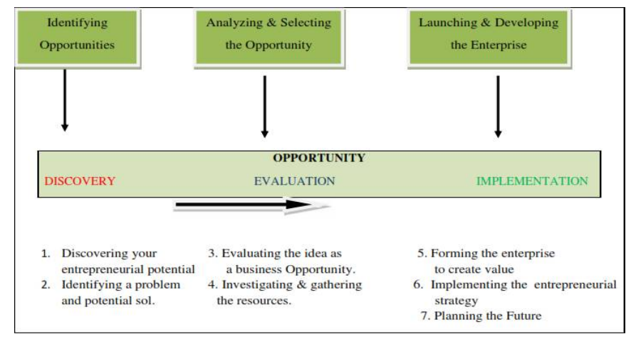
Discovery: The first stage of discovery is to identify opportunities that may form the basis of an entrepreneurial venture. It requires creative thinking to identify issues that can benefit from an entrepreneurial vision. This stage can be divided into two steps:
Step 1 Discovering your entrepreneurial potential - the first step is to know more about your personal resources and attributes through some self-evaluation– what will you bring to the venture? What are your strengths and challenges? These will affect the type of venture you choose.
Step 2 Identifying a problem and potential solution – a new venture has to solve a problem and meet a genuine need.
Evaluation: By the end of first stage of discovery, you should have selected an idea worthy of further detailed investigation. The next stage evaluates if this all adds up to a feasible business in two further steps:
Step 3 Evaluating the idea as a business opportunity– find out information about the market need. Is the solution to this problem really wanted by enough customers? Investigate the feasibility of the proposed solution (technically, economically, socially, and legally).
Step 4 Investigating and gathering the resources – How will the product/service get to market? How will it make money? What resources are required?
Exploitation: By the end of the second stage of evaluation, you should have identified an opportunity that has reasonable prospects of success, and analyzed what is required to launch it. The next stage is to make the final preparations and launch it into the market. It can be developed in three further steps:
Step 5 Forming the enterprise to create value – set up a business entity and protect any intellectual property. Get ready to launch the venture in a way that minimizes risk and maximizes returns.
Step 6 Implementing the entrepreneurial strategy – activate the marketing, operating, and financial plans.
Step 7 Planning the future – look ahead and visualize where you want to go.
Environmental Analysis: Entrepreneurship does not exist in a vacuum. It is affected by and affects the environment. Relationship between entrepreneurship and environment is shown in the figure below.
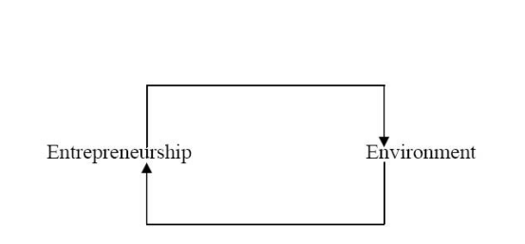
As the economies are getting internationally integrated, for an analysis of the environment of entrepreneurship you would be required to develop an understanding of macroeconomic, and industry/sector specific factors.
- Macro Environment
The macro environment of an entrepreneur consists of the political, technological, social, legal and economic environments. All of these are not immediate part of the entrepreneur’s venture yet they have an impact on his/her enterprise.
- Sectoral Analysis
After having understood the general environment in which the business has to take birth, it is important to study the sector or industry conditions in which the entrepreneur proposes to launch a venture. This will help to put the proposed venture in the proper context. The purpose of industry analysis is to determine what makes an industry attractive- this is usually indicated either by above normal profits or high growth rates. For such analysis one should study the history of the industry, the future trends, new products developed in the industry, forecasts made by the government or the industry. It is also advisable to study the existing or potential competition, threat of substitutes and entry barriers. Sometimes there might be bilateral agreements between countries regarding some sectors or government policy that is sector specific or some event that throw up challenges. There might be certain constraints regarding availability of technology, manpower or raw materials, which are industry specific. Similarly, there might be certain strengths of a particular sector, which might outweigh some negative general trends. For instance, currently the cement and steel sector are on an upward swing with a favorable climate in the housing sector as well as government’s thrust on the construction sector.

SWOT Analysis
At this stage, conducting a SWOT analysis will help the entrepreneur to clearly identify his/her own strengths and weaknesses as well as the opportunities and threats in the environment. Strengths are positive internal factors that contribute to an individual’s ability to accomplish his/her mission, goals and objectives. Weaknesses are negative internal factors that inhibit an individual’s ability to accomplish his/her mission, goals and objectives. An entrepreneur should try to magnify his strengths and overcome or compensate for his/her weaknesses.
Opportunities are positive external options that an individual could exploit to accomplish his/her mission, goals and objectives. Threats are negative external forces that hinder an individual from accomplishing his/her mission, goals and objectives. These could arise due to competition, change in government policy, economic recession, technological advances etc. Threats in the environment can arise from competition, technological breakthroughs, change in government policies etc. S/he might possess certain unique skills or abilities, which along with his/ her knowledge and experience can provide him/ her cutting edge.
An analysis of the above can give the entrepreneur a more realistic perspective of the business, pointing out foundations on which s/he can build future strengths and remove obstacles.
The entrepreneur has to use the opportunities provided by the environment, combine these with his/her unique strengths in terms of knowledge, skills, experience etc. and then take a decision to launch a particular product or service. The proposed product / service should be compatible with the capability of the entrepreneur, resources available in the environment and the need of the society.

Small Business Failure and Success Factors
Small Business Failure Factors
What Is Business Failure?
Even though business owners launch their ventures with the best of intentions and work long, hard hours, some businesses inevitably fail. Dun & Bradstreet, a financial research firm, defines a business failure as a business that closes as a result of either (1) actions such as bankruptcy, foreclosure, or voluntary withdrawal from the business with a financial loss to a creditor; or (2) a court action such as receivership (taken over involuntarily) or reorganization (receiving protection from creditors).
Causes of Business Failure The rates of business failure vary greatly by industry and are affected by factors such as type of ownership, size of the business, and expertise of the owner. The causes of business failure are many and complex; however, the most common causes are inadequate management and financing.
Although financial problems are listed as the most common cause of business failure, consider management’s role in controlling them. Could business failure due to industry weakness be linked to poor management? Yes, if the owner tried to enter an industry or market with no room for another competitor or responded only slowly to industry changes. High operating expenses and insufficient profit margins also reflect ineffective management. Finally, business failure due to insufficient capital suggests inexperienced management.
Inadequate Management: - Business management is the efficient and effective use of resources. For small business owners, management skills are especially desirable—and often especially difficult to obtain. Lack of experience is one of their most pressing problems. Small business owners must be generalists; they do not have the luxury of specialized management. On the one hand, they may not be able to afford to hire the full-time experts who could help avert costly mistakes. On the other hand, their limited resources will not permit them to make many mistakes and stay in business. As a small business manager, you will probably have to make decisions in areas in which you have little expertise.
Entrepreneurs are generally correct in pointing to internal factors as the reason for the failure of their businesses; these factors are the cause of 89 percent of such failures. Internal problems are those more directly under the control of the manager, such as adequate capital, cash flow, facilities/equipment inventory control, human resources, leadership, organizational structure, and accounting systems.
The manager of a small business must be a leader, a planner, and a worker. You may be a “top gun” in sales, but that skill could work against you. You might be tempted to concentrate on sales while ignoring other equally important areas of the business, such as record keeping, inventory, and customer service.
Inadequate Financing: - Business failure due to inadequate financing can be caused by improper managerial control as well as shortage of capital. On the one hand, if you don’t have adequate funds to begin with, you will not be able to afford the facilities or personnel you need to start up the business correctly. On the other hand, if you do possess adequate capital but do not manage your resources wisely, you may be unable to maintain adequate inventory or keep the balance needed to run the business.
There are a lot of ways to fail in business. You can extend too much credit. You can fail to plan for the future or not have strategic direction. You can overinvest in fixed assets or hire the wrong people. Identifying mistakes that can be made is merely one component of the problem. Figuring out how to avoid them is the hard part.
Other common causes of business failure include Neglect, Fraud, and Disaster.
• Neglect occurs whenever an owner does not pay a due attention to the enterprise. The owner who has someone else managing the business while s/he goes fishing often finds the business failing because of neglect.
• Fraud involves intentional misrepresentation or deception. If one of the people responsible for keeping the business’s books begins purchasing materials or goods for himself or herself using the business's money, the business might find itself bankrupt before too long.
• Disaster refers to some unforeseen happening. If a hurricane hits the area and destroys the property in the company's yard, the loss may require the firm to declare bankruptcy. The same is true for fires, burglaries, robberies, or extended strikes.
Business Termination versus Failure
There is a difference between a business termination and a business failure. A termination occurs when a business no longer exists for any reason. A failure occurs when a business closes with a financial loss to a creditor.
Reasons for a termination abound. The owner may have an opportunity to sell her business to someone else for a healthy profit, or be ready to move on to a new business or to retire, or s/he may have simply lost interest in the business. The market for the business’s product may have changed or become saturated. Perhaps the owner has decided it would be more appealing to work for someone else. In other cases, businesses may change form. A partnership may be restructured as a corporation, or a business may move to a new location. Businesses that undergo such changes are considered terminated even though they continue in another form.
Mistakes Leading to Business Failure
No one likes to think about failing, yet many small business owners invite failure by ignoring basic rules for success. One of the most common mistakes is to neglect to plan for the future because planning seems too hard or time-consuming. Planning what you want to do with your business, where you want it to go, and how you’re going to get there are prerequisites for a sound business. Of course, that doesn’t mean you can’t change your plans as circumstances dictate. Your plan should provide a road map for your business, showing you both the expressways and the scenic routes and the detours.
Another common mistake is failing to understand the commitment and hard work that are required for turning a business into a success. Having to work long hours and do things you don’t enjoy because no one else is available to do them are part and parcel of owning a small business. Yet, when you have the freedom of being your own boss, the hard work and long hours often don’t seem so demanding!
Still another mistake that small business owners make, particularly with rapidly growing businesses, is not hiring additional employees soon enough or not using existing employees effectively. There comes a point in the growth of a business when it is no longer possible for the manager to do it all, but s/he resists delegation in the belief that it means s/he is giving up control. It is important to recognize that delegating tasks to others isn’t giving up control—it’s giving up the execution of details.
The last type of mistake involves with finances. Inaccurate estimates of cash flow and capital requirements can swamp a business quickly. Figuring the correct amount of money needed for starting a business is a tough balancing act: Asking for too little may hinder growth and actually jeopardize survival, whereas asking for too much might cause lenders or investors to hesitate. An important rule to remember in terms of arranging financing or calculating cash-flow projections is to figure the unexpected into your financial plans. In this way, you can have more of a cushion to fall back on if things don’t go exactly according to plan. After all, without the right amount of capital, it’s impossible to succeed.
Business failure, then, is a serious reality. How can a small business owner avoid it? Difficult changes may be needed, and change requires leaders to overcome all sorts of human dynamics, like inertia, tradition, and head-in-the-sand hoping that things will get better. Strategic moments require courage, or at least a lack of sentimentality, which is rare.
It is in these moments that the best leaders find a mirror and ask themselves the defining question that the late, great Peter Drucker posed nearly 40 years ago: “If you weren’t already in your business, would you enter it today?” If the answer is no, Drucker said, you need to face a second tough question: “What are you going to do about it?” Every leader should heed this good advice and, if need be, follow it through to its conclusion, whether that will be to fix, sell, or close the business.

Small Business Success Factors
When large and small businesses compete directly against one another, it might seem that large businesses would always have a better chance of winning. In reality, small businesses have certain inherent factors that work in their favor. You will improve your chances of achieving success in running a small business if you identify your competitive advantage, remain flexible and innovative, cultivate a close relationship with your customers, and strive for quality.
It may come as a surprise, but big businesses need small businesses a symbiotic relationship exists between them. For instance, John Deere relies on hundreds of vendors, many of which are small, to produce component parts for its farm equipment. Deere’s extensive network of 3,400 independent dealers comprising small businesses provides sales and service for its equipment. These relationships enable Deere, the world’s largest manufacturer of farm equipment, to focus on what it does best, while at the same time creating economic opportunity for hundreds of individual entrepreneurs.
Small businesses perform more efficiently than larger ones in several areas. For example, although large manufacturers tend to enjoy a higher profit margin due to their economies of scale, small businesses are often better at distribution. Most wholesale and retail businesses are small, which serves to link large manufacturers more efficiently with millions of consumers spread all over the world.
Small business success factors can be seen the same as the efforts exerted in reversing the factors of failure. There are several positive steps in addition to planning that business owners can take to improve a firm’s chance for success.
From the discussion about factors of failure, we can conclude that a proper attitude is important to ensure a customer orientation for quality and service; the owner must have a purpose for being in business and want to provide customers with value for their money; and having a variety of basic business skill is important (such as the ability to keep accounting records.) So, by understanding why business fail, entrepreneurs can discover ways to tilt the scales towards success. These success factors are categorized as:-
1. Conducive Environment;
2. Adequate Credit Assistance;
3. Markets and Marketing Support.
1. Conducive Environment
Successful small enterprises do not emerge, and thereafter survive and grow unless the environment is conductive. Political, economic, technological and socio-cultural factors in the environment impinge upon the life of the small enterprises and generate much of the needs required for their existence. Political Climate: - The overall political climate in a country is important for the small scale entrepreneur to consider. Small scale entrepreneur will need positive and encouraging measures by government and political constituencies to establish private investment. Such measures could include liberal or nonrestrictive investment policy, creation of promotional agencies, creation of industrial estates and free trade zones and availability of low-cost loan capital for private investors.
The Economic Environment: - An analysis of the economic environment is particularly helpful in investment decision, market measurement and in forecasting. The general state of the economy dictates what the small enterprise will need especially since it is handicapped in obtaining capital and credit owning to greater unit costs of small transactions, greater risks involved, etc.
Technology: -Technological advances in the environment create new needs for the small entrepreneur as far as adaptation and adjustment is concerned. Small scale entrepreneur needs to learn how to adjust to the new technological environment surrounding him/her, or needs to take a set of advance technologies and bring these to his/her own level in the small enterprise. Either way, constant reexamination is needed for possible utilization and improvement of existing technologies.
Socio-Cultural Environment: - Finally, the socio-cultural environment also creates a very important climate for the survival of the enterprises.
2. Adequate Credit Assistance
Small enterprise development cannot be ensured without arrangement for financing. Adequate and timely supply of credit is critical for new entrepreneurs to emerge especially from a wide base. A great majority of micro and small business activities have come about because of special financing programs offered to them. Thus, requirements are less strict in terms of lower interest rates than the prevailing commercial rates; less collateral requirements and lower equity ratio; various assistance schemes such as preparing the project study; etc.
3. Markets and Marketing Support
Market for a small enterprise in a developing country can be quite a problem. The small business entrepreneur will be in competition not only with locally mass-produced goods but even imports. Small enterprises can brand together and sell their products as one body through closely-knit associations or organizations. The government too can take an active part in marketing specific products or assisting small groups of entrepreneurs in selling their products.

Main Supporting Packages for MSEs Development in Ethiopia
When entrepreneurs are deciding to involve and develop MSEs in Ethiopia, they are more likely entitled with some supporting packages which include awareness creation about the sector; provision of legal services, to form legal business enterprises; providing Technical and business management training; financial support based on personal saving, 20/80 (the beneficiaries are save 20% and the MFIs provide Loan 80% of the projects); facilitate working premises; industry extinction services and BDS provision; bookkeeping and audit services.

Problems of Small Scale Business in Ethiopia
Small-scale businesses have not been able to contribute substantially to the economic development, particularly because of financial, production, and marketing problems. These problems are still major handicaps to their development. Lack of adequate finance and credit has always been a major problem of the Ethiopian small business.
Small-scale units do not have easy access to the capital because they mostly organized on proprietary and partnership basis and are of very small size. They do not have easy access to industrial sources of finance partly because of their size and partly because of the fact that their surpluses which can be utilized to repay loans are relatively small. Because of their size and partly because of the limited profit, they search for funds for investment purposes. Consequently, they approach traditional money lenders who charge extra high rate of interest hence small enterprise continue to be financially weak.
Small scale enterprises find it difficult to get raw materials of good quality at reasonable prices in the field of production. Furthermore, the techniques of production, which the enterprises have adopted, are usually outdated. Because of their poor financial position they are not able to buy new equipment, consequently their productivity suffers.
Small business’s owner can avoid some of the common pitfalls that lead to business failure by knowing the business in depth; developing a solid business plan; managing financial resources; understanding financial statements; and learning to manage people effectively.

Chapter Summary
Launching a new venture and becoming an entrepreneur is an exciting and challenging task. Can you learn how to be an entrepreneur or are some people just born that way? Some have argued that great entrepreneurs like Anita Roddick and Mohammed Yunis are simply born with different qualities to the rest of us – and it is these qualities that explain their success as entrepreneurs. But we know that a key human quality is the ability to change and develop over time. This is good news for anyone who wants to become an entrepreneur because it will require you to adapt and change with the enterprise you are founding as it develops and faces challenges. Becoming an entrepreneur is a never ending lesson as new challenges arise that offer experiences in how to do and not to do things. Small businesses include a wide variety of business types that are independently owned, operated, and financed. By itself, each individual small business has relatively little impact in its industry. Small businesses provided the economic foundation on which the country’s economy was built. Today these businesses are creating new jobs even as large businesses continue eliminating jobs. Small businesses are more flexible than large ones in the products and services they offer. Most real product innovations come from small businesses. As the population becomes more diverse, the owners and employees of small businesses are likewise becoming more diverse. Businesses owned by women and minorities are growing at a faster rate than the overall rate of business growth. Diversity is important in small business because a wide range of viewpoints and personal backgrounds can improve problem solving. Small and large businesses need each other to survive—they have a symbiotic relationship. This relationship provides opportunities to small businesses in that they can supply needed parts to large manufacturers and can distribute manufactured goods. Moreover, small businesses often pick up functions that large businesses outsource. Other opportunities exist for small businesses where they enjoy the advantage of being able to profitably serve smaller niches than can their larger counter-parts. For all these reasons, small businesses are rapidly becoming important players in international trade.

Questions for Review and Discussions
- How would you define small business?
________________________________________________________________________________________________________________________________________________
- Name a company that seems large but might be classified as small because it has relatively little impact on its industry.
______________________________________________________________________________________________________________________________________________________
- Why are small businesses more likely than large businesses to be innovative?
________________________________________________________________________________________________________________________________________________________________________________________________________________________________
- How would you show that small business is becoming a more important part of the economy?
________________________________________________________________________________________________________________________________________________________________________________________________________________________________
- We compared the failure rate for small businesses with the divorce rate in marriage and the student failure rate in college. Are these fair comparisons?
______________________________________________________________________________________________________________________________________________________
- Describe four causes of small business failure.
______________________________________________________________________________________________________________________________________________________

Chapter Six: CRM

Introduction
Customer Relationship Management (CRM) is to create a competitive advantage by being the best at understanding, communicating, delivering, and developing existing customer relationships, in addition to creating and keeping new customers. It has emerged as one of the largest management buzzword. Popularized by the business press and marketed by the aggressive CRM vendors as a panacea for all the ills facing the firms and managers, it means different things to different people. CRM, for some, means one to one marketing while for others a call center. Some call database marketing as CRM. There are many others who refer to technology solutions as CRM. If so, what is CRM?
Merchants and traders have been practicing customer relationship for centuries. Their business was built on trust. They could customize the products and all aspects of delivery and payment to suit the requirements of their customers. They paid personal attention to their customers, knew details regarding their customers’ tastes and preferences, and had a personal rapport with most of them.
In many cases, the interaction transcended the commercial transaction and involved social interactions. Even today, this kind of a relationship exists between customers and retailers, craftsmen, artisans – essentially in markets that are traditional, small and classified as pre-industries markets.
These relationship oriented practices have changed due to industrial revolution.. Businesses adopted mass production, mass communication and mass distribution to achieve economies of scale. Manufactures started focusing on manufacturing and efficient operations to cut costs. Intermediaries like distributors, wholesalers and retailers took on the responsibilities of warehousing, transportation, distribution and sale to final customers. This resulted in greater efficiencies and lower costs to manufacturers but brought in many layers between them and the customers. The resulting gap reduced direct contacts and had a negative impact on their relationships.

Defining CRM
CRM is the process of managing all aspects of interaction a company has with its customers, including prospecting, sales and service. CRM applications attempt to provide insight into and improve the company/customer relationship by combining all these views of customer interaction into one picture.
CRM is an integrated approach to identifying, acquiring and retaining customers. By enabling organizations to manage and coordinate customer interactions across multiple channels, departments, lines of business and geographies, CRM helps organizations maximize the value of every customer interaction and drive superior corporate performance.
CRM is an integrated information system that is used to plan, schedule and control the pre-sales and post-sales activities in an organization. CRM embraces all aspects of dealing with prospects and customers, including the call center, sales force, marketing, technical support and field service. The primary goal of CRM is to improve long-term growth and profitability through a better understanding of customer behavior. CRM aims to provide more effective feedback and improved integration to better gauge the return on investment (ROI) in these areas.
CRM is a business strategy that maximizes profitability, revenue and customer satisfaction by organizing around customer segments, fostering behavior that satisfies customers, and implementing customer-centric processes.

Misunderstandings about CRM
Misunderstanding 1: CRM is merely database marketing Database marketing is concerned with building and exploiting high-quality customer data - bases for marketing purposes. Companies collect data from a number of sources. These data are verified, cleaned, integrated and stored on computers, often in data warehouses or data-marts. They are then used for marketing purposes such as market segmentation, targeting, offer development and customer communication. Whereas most large and medium-sized companies do indeed build and exploit customer databases, CRM is much wider in scope than database marketing. A lot of what we have described above as analytical CRM has the appearance of database marketing. However, database marketing is less evident in strategic and operational CRM.
Misunderstanding 2: CRM is a marketing process CRM software applications are used for many marketing activities: market segmentation, customer acquisition, customer retention and customer development (cross-selling and upselling), for example. However, operational CRM extends into selling and service functions. The deployment of CRM software to support a company’s mission to become more customer-centric often means that customer-related data are shared more widely throughout the enterprise than the marketing function alone. Operations management can use customer related data to produce customized products and services. People management (HR) can use customer preference data to help recruit and train staff for the front-line jobs that interface with customers. Research and development management can use customer-related data to focus new product development. Customer data can not only be used to integrate various internal departments but can also be shared across the extended enterprise with outside suppliers and partners.
Misunderstanding 3: CRM is an IT issue. In the authors’ experience, this is the most serious of the misunderstandings. There is no doubt that IT is a necessary enabler of CRM in most organizations, given the need to store, analyze and distribute huge amounts of data quickly throughout the organization and its business partners. CRM technology keeps advancing and can be costly (see discussion above on social CRM). It is therefore too easy for senior management to look to the IT function for CRM leadership. Too many CRM implementations are framed at the outset as IT initiatives, rather than broader strategic initiatives.
Misunderstanding 4: CRM is about loyalty schemes Loyalty schemes are commonplace in many industries: car hire, airlines, food retail and hotels, for example. Customers accumulate credits, such as air miles, from purchases. These are then redeemed at some future point. Most loyalty schemes require new members to complete an application form when they join the program. This demographic information is typically used together with purchasing data to help companies become more effective at customer communication and offer development. Whereas some CRM implementations are linked to loyalty schemes, not all are. Loyalty schemes may play two roles in CRM implementations. First, they generate data that can be used to guide customer acquisition, retention and development. Second, loyalty schemes may serve as an exit barrier. Customers who have accumulated credits in a scheme may be reluctant to exit the relationship. The credits accumulated reflect the value of the investment that the customer has made in the scheme, and therefore in the relationship.
Misunderstanding 5: CRM can be implemented by any company Strategic CRM can, indeed, be implemented in any company. Every organization can be driven by a desire to be more customer-centric. Chief executives can establish a vision, mission and set of values that bring the customer into the heart of the business. CRM technology may play a role in that transformation. Some companies are certainly more successful than others. The banking industry has implemented CRM very widely, yet there are significant differences between the customer satisfaction ratings and customer retention rates of different banks. Any company can also try to implement operational CRM. Any company with a sales force can automate its selling, lead management and contact management processes. The same is true for marketing and service processes. CRM technology can be used to support marketing campaigns, service requests and complaints management. Analytical CRM is a different matter, being based on customer-related data. At the very least, data are needed to identify which customers are likely to generate most value in the future, and to identify within the customer base the segments or customers that have different requirements. Only then can different offers be communicated to each customer group to optimize company and customer value over the long term. If these data are missing then analytical CRM cannot be implemented.

Benefits of CRM
- Customers are Profitable over a period of time
Studies by the US-based Bain and Company have shown that a customer becomes more profitable with time because the initial acquisition cost exceeds gross margin while the retention costs are much lower. When an organization retains the customer, it gets a larger share of the customers wallet at a higher profit-one percent increase in sale to existing customer increase profits by 17 per cent while the same amount of sale to new customer increased profit by only 3 per cent. This huge different is explained by the fact that for most companies the cost of acquiring the customer is very high. It costs six to eight times more to sell to a new customer than to sell to an existing one. The same study also highlighted that a company can boost its profit up 85 per cent by increasing its annual customer retention by only 5 per cent.
Similarly, studies have shown that the probability of selling a product to a prospect is 15 per cent while it is 50 per cent to an existing customer. Thus, the time, the effort and the costs of selling are much lower for an existing customer.
- Customer Probability is Skewed
An analysis of the revenue and profit contribution of customer base of banks in the US, Europe and Australia showed the following:
➢➢The top 20 per cent of the customers contribute to 150 per cent of the profits while the bottom 20 per cent drain 50 per cent of the profits and the rest 60 per cent just break even.
The implication of such a skew in customer profitability and revenue contribution are startling for organizations, which use to conventionally treat ‘all customers are equal’. Competitors have to just lure these top customers and the organization would face serious problems. It also highlights the fact that one has to adopt different strategies for different customer groups:
➢➢Programs have to be developed to retain and build stronger bonds with the top ‘gold standard’ customers so that they do not get ‘poached’
➢➢Activity-Based Costing analysis has to be done with the middle group of ‘potentials’ so that the cost of serving this customers are reduced. In addition, cross-selling and up selling should be done to increase the profitability of these customers.
➢➢An analysis of the bottom growth has to be done to identify those customers who can be shifted to the ‘potential’ group. For the remaining, the cost of service has to reduce by encouraging them to use lower cost channels. In extreme cases, some of these customers will be encouraged to defect to competitors. Outsourcing of loss making customers to specialized low overhead agencies is an emerging trend.

MODELS OF CRM
A number of comprehensive CRM models have been developed. We introduce four of them here.
The IDIC model
The IDIC model was developed by Don Peppers and Martha Rogers, of the Peppers & Rogers Group, and has featured in a number of their books.20 The IDIC model suggests that companies should take four actions in order to build closer one-to-one relationships with customers:
• Identify who your customers are and build a deep understanding of them.
• Differentiate your customers to identify which customers have most value now and which offer most for the future.
• Interact with customers to ensure that you understand customer expectations and their relationships with other suppliers or brands.
• Customize the offer and communications to ensure that the expectations of customers are met.
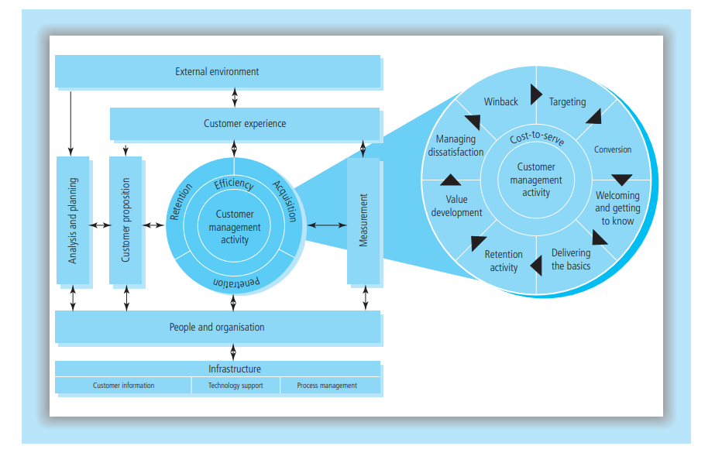
The CRM Value Chain
Francis Buttle’s model, shown in Figure 1.1, consists of five primary stages and four supporting conditions leading towards the end goal of enhanced customer profitability.21 The primary stages of customer portfolio analysis, customer intimacy, network development, value proposition development and managing the customer lifecycle are sequenced to ensure that a company, with the support of its network of suppliers, partners and employees, creates and delivers value propositions that acquire and retain profitable customers. The supporting conditions of leadership and culture, data and IT, people and processes enable the CRM strategy to function effectively and efficiently.
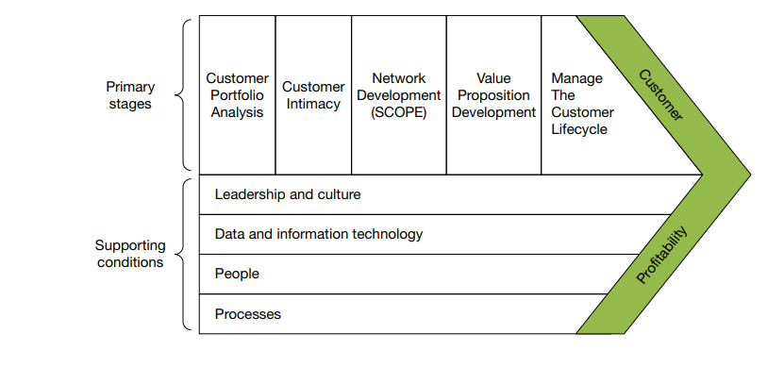
Payne and Frow’s 5-process model
Adrian Payne and Pennie Frow developed the 5-process model of CRM.22 This model (Figure 1.2) clearly identifies five core processes in CRM: the strategy development process, the value creation process, the multi-channel integration process, the performance assessment process and the information management process. The first two represent strategic CRM; the multi-channel integration process represents operational CRM; the information management process is analytical CRM.

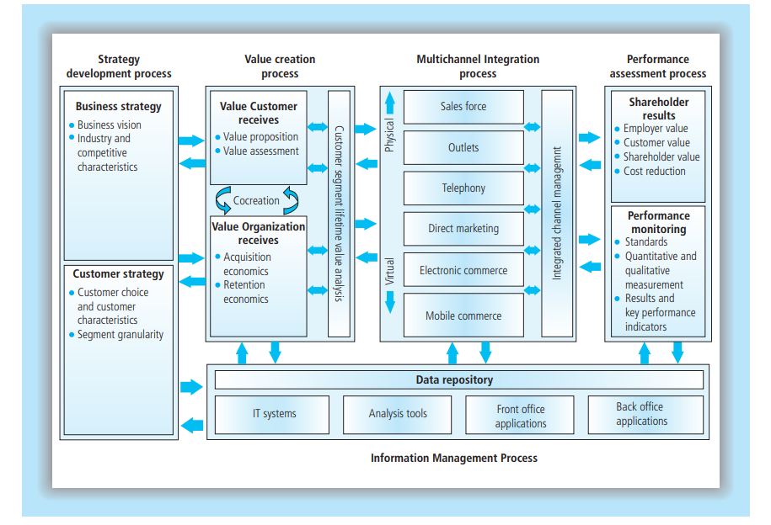
The Gartner competency model
The final comprehensive CRM model comes from Gartner Inc. Gartner Inc. is a leading IT research and advisory company that employs some 1,450 research analysts and consultants in 85 countries, and has a significant place in CRM research. Figure 1.3 presents Gartner’s CRM competency model. The model suggests that companies need competencies in eight areas for CRM to be successful. These include building a CRM vision, developing CRM strategies, designing valued customer experiences, intra- and extra-organizational collaboration, managing customer lifecycle processes, information management, technology implementation and developing measures indicative of CRM success or failure.
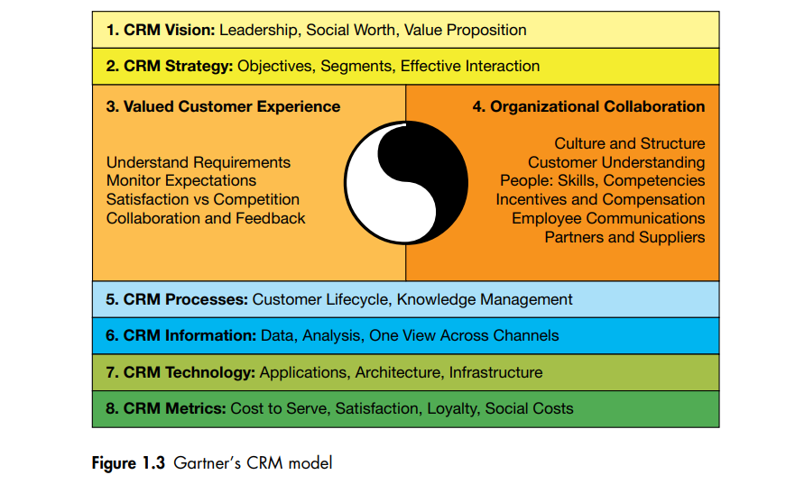

CRM Success Factors
While clear intention fuels the power of CRM, there are several other success factors to consider. We will focus on five of the most important here. Organizations that implements CRM with a strong return on investment share these characteristics.
- Strong internal partnership around the CRM strategy. We said earlier that CRM is a way of doing business that touches all areas of your organization. This means that you and your management peers need to firm strong internal partnerships around CRM. If you and your organization are early on the road to CRM implementation, now is the time to bring your CRM needs to the table, and to be open to listening to the CRM needs of the other areas. You may find that you have requirements that are, atleast potentially, in conflict. Resist the temptation to go to the war for what you need.
- Employees at all levels and all areas accurately collect information for the CRM system. Employees are most likely to comply appropriately with your CRM system when they understand what information is to be capture and why it is important, they are also more likely to trust and use CRM data when they know how and why it was collected.
- CRM tools are customer – and employee – friendly. CRM tools should be integrated into your systems as seamlessly as possible, making them a natural part of the customer service interaction. A major manufacturer of specialty pet foods redesigned the pop – up screens for its toll – free consumer phone line. In the original design, the final pop-up screen prompted the representative to ask the caller’s name and address. Yet, representatives had found that it was easier and felt more natural to 26 ask, “What’s your name?” and “Where are you calling from?” and “What’s your pet’s name?” at the start of the call.
- Report out only the data you use, and use a data you report. Just because your CRM tool can run a report doesn’t mean it should. Refer back to your CRM strategy, and then run the data you will actually use. And share that data with your team.
- Don’t go high – tech when low – tech will do. At Harley – Davidson outside of Milwaukee, WI during the summer they often leave open the big metal doors to the manufacturing facility to let in any breeze and the cooler evening air. Unfortunately, open doors occasionally let in other things, including skunks. A team met to consider the problem and possible solutions. After discussing the pros and cons of screens, half-doors, or keeping the doors shut, they came upon ideal solution. When a skunk wanders in, just leave it alone and wait till it wanders back out. Skunks may be Harley fans, but they never stay long.

Chapter Summary
In this chapter you have learned that the expression CRM has a variety of meanings. Although CRM is generally thought of as a business practice, it is also applied in the not-for-profit context. A number of different constituencies have an interest in CRM, including CRM consultancies, CRM software vendors, CRM application service providers, CRM hardware and infrastructure vendors, companies that are implementing CRM and their customers. A number of different models of CRM have been developed. Finally, we have produced a definition that underpins the rest of this book. We define CRM as the core business strategy that integrates internal processes and functions, and external networks, to create and deliver value to targeted customers at a profit. It is grounded on high quality customer-related data and enabled by information technology.

Chapter Summary Review Questions

- Define customer relation
_____________________________________________________________________________________________________________________________________________________________________________________________________________________________________________________________
- Discuss CRM Models
_________________________________________________________________________________________________________________________________________________________________________________________________________________________________________________________________________________________________________________________________________________________________________________________________________________________________________
- Discuss the importance of CRM
________________________________________________________________________________________________________________________________________________________________________________________________________________________________________________________________________________________________________________________________________________________________________________________________________________________________________
Chapter Seven: Innovation

7.0. Introduction
At present, the life cycle of products, i.e the time span from a product launch in the market until it becomes mature, is constantly shrinking. In fact, in some sectors, such as personal computers, the technological ageing of products takes place within just a few months. Therefore, the capacity to introduce new products in the market anticipating their competitors, earning in this way significant shares of sales, constitutes a big competitive advantage for companies. Companies, hence, should be in a position to constantly ‘innovate’ in order to preserve and improve their market position. Many would define innovation as ‘something new, an invention, and a new idea’. In reality though, innovation does not only constitute the birth of a new product or process-related idea; it does include all stages, from the design and the evaluation of the way this idea is translated into action effectively. An innovation takes effect with the first commercial transaction regarding a new or improved accessory, product, process or system. On the contrary, the invention is an idea, a design or a model of an improved or new accessory that in most of the times does not result in any commercial transaction, although it could lead to a patent. Many researches have shown that innovative enterprises, namely the ones that constantly innovate, present on average double profit compared to the rest. However, innovation management is particularly difficult, hence the failure of many new ideas to result in successful new products or services. For this reason, various innovation management models have been developed.
Objectives
- Define creativity, invention and innovation
- Explain the type of innovation
- Understand the importance of innovation in entrepreneurship
- Recognize innovation generations

7.1. Basic Concepts and Definitions
‘Imagination is more important than knowledge. To raise new questions, new possibilities, to regard old problems from a new angle, require creative imagination and marks real advance in science’. Albert Einstein

7.1.1. Invention
Understanding the term of invention should take precedence over the definition of innovation. Florida considers invention as breakthrough and innovation as an actualization. Hindle defines invention as the creative origin of new process and the enabler of innovation. Therefore, invention is defined as creative process or progress, while innovation is defined as the actualization and impact of all processes–progresses on societies and markets.

7.1.2. Creativity
Starting from the individual level, creativity may be defined as the capacity to ‘think out of the box’, think laterally, observe, conceive and construct ideas and models that outweigh or outstrip existing items and ways of thought and perception. Creativity is associated with the capacity to imagine in the sense that it requires the creator to perceive future perspectives, not being obvious under the current circumstances. Therefore, creativity is the capacity to observe new interactions between objects and ideas. Creative types, such as artists, scientists and businessmen usually present features of ‘obsessed maniacs’ and ‘clairvoyant oracles’.
When, Why and How Creativity Arises
The problem with ‘creativity’ is that it is indeterminate. While we generally know when something is creative, we usually don’t know why. It seems particularly challenging to give a precise definition on the matter. Aristotle for example argued that inspiration involves a form of insanity giving birth to great ideas as a result of a person’s thoughts, evolving through forms of cooperation. Freud believed creative ability was a personality trait that tends to become fixed by experiences in the first five years of life. During the first half of the twentieth century, B. F. Skinner and other behaviorists considered creative production to be strictly the result of ‘random mutation’ and of appropriate society’s reinforcing factors.
Kneller (1965) argues that ‘an act or idea is creative not only because it is novel but because it achieves something that is appropriate to a given situation’. We create when we discover and express being new to us. The functional phrase ‘it’s new to us’, even if an individual has discovered something, is still creativity if we rediscover it by ourselves.

7.1.3. Innovation
Innovation is a word deriving from Latin and means the introduction of something new to the existing world and the order of things or the improvement of resources productivity as mentioned by J. B. Say, quoted in Drucker (Drucker 1985). Many definitions of innovation are found in the literature. We report some of them:
Chris Freeman and Soete (1982) reports: “The industrial innovation involves technical design, manufacturing, administrative and commercial activities related to the marketing of few (or improved) products or with the first commercial use of a new (or improved) process or equipment”
Paul Gardiner (1985) highlights the following: “…innovation does not only mean commercialization of a significant advantage at the highest technical level (radical innovation), but it also includes taking advantage of small scale changes in the know-how (improvement or incremental innovation)…”
Peter Drucker (1985) stresses that: “innovation is the special tool of businessmen to utilize change as an opportunity for a different activity or service. It is possible to appear as a discipline, to be learned, to be practiced”.
Paul Michael Porter (1990): “enterprises acquire a competitive advantage through acts of innovation. They approach innovation in its broader sense, including new technologies and the new way to do things”
The term Innovation may refer to the process-conversion of an idea into a merchandised product or service, a new form of business organization, a new or improved functional production method, a new product presentation way (design, marketing) or even to a new service rendering method. It may also refer to the design and construction of new industrial equipment, the implementation of a project with a new management or may refer to a new way of thinking to deal with a situation or a problem. (Green Paper of the E.U. on innovation).
Innovation regards every aspect of economic or productive process. At the level of an enterprise or an organization, innovation is mainly realized either by developing new products and services or by restructuring production–operation processes.
The continuous innovative effort for new products-services or new productive processes create a competitive advantage in three critical areas:
- Evaluation of the resources involving research and development activities, application of a new technology, sales productivity, production etc, new productive investments and expansion into new markets or broadening of the customer base.
- Development and renewal of the entity with investments and growth, professional evolution opportunities for human resources, new recruitments and optimism, high morale and spirit.
- Business success building on the reputation and attracting new customers, image of a dynamic business, products that distinguish from the competition, ongoing development and making hard for the competition to gather pace.

7.2. Difference between Innovation–Invention
There is a clear difference between the concepts of invention and innovation. The famous economist Joseph Schumpeter (1942) was the first to have observed and defined this difference: the ‘invention’ is the outflow of an applied research, while ‘innovation’ is the successful introduction of an invention in the market as a functional solution (product or service). Scientific discovery is also assessed on the basis of whether it has contributed to understanding natural phenomena. Due to the fact that innovation includes specialized knowledge and the latter’s main attribute is its being a public good, the state enshrines legally the intellectual rights of an inventor–innovator by awarding him/her a patent, safeguarding thus for the benefit of the inventor–innovator the economic exploitation of the new product in a specific geographical region and for a specific period of time.
One of the most successful, innovative inventors was the American Thomas Alva Edison, who managed to be granted exclusive rights over more than 1,000 patents throughout his life. Three of them were the light bulb, the cinema tape-fi lm of 35 mm and the electric chair. His capacity to innovate, and not simply invent, i.e. his capacity not only to have ideas but convert them into products being sold successively in the market, helped to create a large enterprise (General Electric), with its worth standing at circa 21.6 bn $ in 1920. In other words, Edison understood correctly the two-way character of innovation requiring mobilization and coordination of two forces, the technology promise and the market demand.
As regards invention in contrast to innovation, some of the most important inventions of the nineteenth century were invented by persons whose name was forgotten. The names we still remember are the names of entrepreneurs who transformed inventions into a commercial value. For example, the vacuum cleaner was invented by J. Murrey Spengler. However, it was W.H. Hoover, leatherwear manufacturer, who launched it in the market. Similarly, the sewing machine was invented by Elias Howe in Boston in 1846, who failed to promote it commercially, though he traveled to England for that purpose. Returning to the USA, he found Isaac Singer to have stolen his patent and having set up a thriving business of sewing machines.
Innovation is therefore the product of the nineteenth century, not of the twentieth century, while invention has existed since primitive times. The driving force was to envisage the opportunity to create new industries, such as the electric railway by Edison. In the twentieth century innovation became the heart of technological effort through systematic organization and institutionalization of applied research in laboratories of Research and Technological Development.

7.3. Characteristics of Innovation
The characteristics of innovation are classified in three axes.
- Product Axis: Product innovation is in place when a new or improved product is launched in the market. The parameters examined under this axis are the following:
- Market demand: Demand and acceptance of the product in the market is one of the key criteria for product innovation. It is directly linked to the company’s market share and to profit margin.
- Level of resonance: It is the level of target-customers locally, nationally or internationally; it is the product acceptance and market penetration yardstick.
- Optimal use of existing condition: It is examined whether the existing technology is used in an optimal way relevant to the product and its production. It relates to updating procedures and technology forecast.
- Price/Value: The price and value of a product is compared with the prices of corresponding competitive products in the market.
- Compliance with the regulations: Compliance with the safety, health, environmental regulations, etc. It is a characteristic of innovation because compliance with the regulations could often lead to qualitative innovative changes on the product.
- Originality: It is examined whether the product is a new solution or encompasses changes compared to competitive products. These changes may concern the product, its package, the way it is distributed or its use. It is also a way to evaluate an enterprise’s approach to innovation.
- Offer of improvements: The product as an evolution of an existing technology, in the sense of using new materials, the existence of new functions, the use of the product in new applications. It defines whether the product brings about changes on the basic design or its architecture.
- Coverage of operational needs: Coverage rate of specific operational needs, customer needs, including over-coverage offering additional functions not fully determined by customer demands. It relates to customer requirements analysis.
- Aesthetic: The product’s outward appeal is a criterion of innovation often underestimated; it constitutes though a key success factor.
- Process Axis: Process innovation is the introduction of new processes in product development or the improvement thereof. The parameters examined under this axis are the following:
- Market research: Market research may disclose alternative solutions regarding design, price, distribution and product promotion and offers an estimate of product acceptance and image in the market.
  - Connection to target-customers: Frequency of contact between the company and target-customers at local, national or international level. The main objective is to establish a long lasting relation mainly with large customers.
  - Access to new technology: Frequency of the company’s contact with the current technological evolutions regarding production of product. It relates directly with departments of R&D, design, cooperation with technological bodies, participation in exhibitions, etc.
  - Costing Methodology: Costing methodology in all stages of the product development process. Analysis and accurate costing methodology is required to cut the total product production cost.
  - Compliance with the regulations: Compliance of the product development process with the safety, health and environmental regulations, in parallel with the procedures to verify all the above. Compliance of the development process with the regulations often contributes to qualitative upgrading of the product.
  - Technique of ideas development: The existence of specific techniques and approaches for the elaboration of new ideas is examined; such ideas affect significantly the development of a successful innovative product.
  - Improvement techniques: The effort and the techniques to integrate new technologies and uses in the product are assessed.
  - Emphasis on fulfilling operational needs: Focus of product development process on the specific operational need the product addresses. It involves conversion of requirements to product specifications and relates to the way the trade mark participates in product development process.
  - Focus on aesthetics in the design: The success of products using a fixed technology and with fixed target-customers depends directly on their attractiveness and their visual diversification vis-à-vis competitive products. The aesthetic aspect of a product in combination with the analysis of its ergonomic is one of the main targets of industrial design. The use of systems and design engineers is assessed.
  - Formal procedures to protect copyright: It is examined whether the required actions are taken to protect copyright. It is assessed whether an enterprise is geared towards protecting patents and designs and whether the above methodology constitutes its policy.
- Management (organization) Axis: The introduction of changes in administration and organization constitutes the administrative innovation that completes the first axis. The parameters examined under this axis are the following:
- Feasibility study: It is the base (technical, economic, commercial) to decide upon an investment.
- Formal procedures to ensure communication with target-customers: Such procedures may include participation in exhibitions, sample distribution, meetings with groups of customers, etc.
- Formal procedures to apply the best technology: One of the key indications of innovation is systematic follow up of current technological evolution, the assessment of the technological level of competitors, the identification of new technologies and the correct selection of the best technology.
- Cost control: Control is a systematic review process applied during the design phase, in order to cut production cost, preserving at the same time the value and the required operation specifications (value/price) and ensuring the product’s sustainability and competitive price.
- Quality control: Formal control procedures during the design phase that include use of methods to analyze and improve innovation process quality and processes to safeguard rules applying to date.
- Organizational culture: Emphasis of organizational culture on innovation. It has been evidenced that organizational culture relates directly to a company’s innovativeness. Some elements of organizational culture placing emphasis on innovation is the encouragement to create new ideas, the clarification of the enterprise’s innovation policy to all employees, the determination of performance measurement systems, personnel training etc.
- Quantitative controls with criteria to assess improvement of technology, new materials, functions and uses: Introduction of controls with quantitative data and minimum acceptance values to assess improvement of technology, new materials, functions and uses. Processes for the integration and evaluation of new technologies and methods by the company.
- Quantitative controls with criteria on the satisfaction rate of functional needs: Introduction of controls with quantitative data and minimum acceptance values to fulfill specific functional needs.
- Marketing and quality control processes for the aesthetic aspect of the product: Introduction of marketing and quality control processes to assess and ensure good product aesthetic appeal. It relates directly to production and testing of originalities.
- Formal control to protect copyright: Formal control procedures to protect copyright are examined.

7.4. The Concept of Technological Innovation
Innovation is often associated with the creation of a sustainable market around the launching of a new and superior product or process. In particular, in the literature of technology management, technological innovation is characterized by the introduction of a new technological product in the market:
‘Technological innovation is defined here as a situationally new development through which people extend their control over the environment. Essentially, technology is a tool of some kind that allows an individual to do something new. So, technology transfer amounts to communication of information, usually from one organization to another’ (Tornatzky and Fleischer 1990).
In particular, technological innovation is defined as: ‘Introduction in the market of a technologically new or significantly improved product or the application of a technologically new or significantly improved productive process, successfully responding to market demand. It is the outcome of the interplay of market conditions on the one hand and of the possibilities to utilize the stock of technological and scientific knowledge’ (Schumpeter 1934).
Technological innovation is a new technology that creates new products, hence new opportunities for the industry. This is the basic meaning of innovation and the reason it is important for economic growth as it creates business opportunities. Technology was and will be the key incentive to drive changes in our society.
Technological innovation has turned into the largest driving force paving the way for society since 1980s. There is a constant flow of products and processes, from power engines in cars, airplanes, telecommunications and pharmaceutical preparations. All enterprises owe their existence and long standing presence to the successful application of technology in the creation of new products and improved manufacturing processes.
Traditionally, innovation has been linked to R&D activities and the use of technological knowledge. This could be explained by the fact that all examples outlined in the literature of businesses are taken from the pharmaceutical industry, the chemical industry or electronics, where basic research has brought about the innovation that changed the world (penicillin, nylon and microprocessors). Any industrial application of scientific knowledge is a technological innovation. It should be stressed at this point that all sectors, of high or low technology, can use technology for innovation. A case in point is EUROPASTRYFRIPAN, a company set up in Barberà del Vallès, that managed to innovate in an existing bakery industry developing frozen bread. The possibility to have hot bread at any time of the day carrying out a simple task not requiring specialized staff at the sale point seemed impossible to many people. The company almost took a leading position in the Spanish market and set out a revolution in what was seen as a particularly traditional sector. A broader interpretation of the term ‘innovation’ refers to innovation as an ‘idea, practice or material artifact’ (Rogers and Shoemaker 1971) adopted by a person or an organization, where the artifact is ‘considered new by the relevant unit of adoption’ (Zaltman et al. 1973). For this reason, innovation tends to change the perceptions and the relations at organizational level but its influence is not limited at this level. Innovation in the broader socio-technical, economic and political framework could significantly affect, shape and modify the ways and the means people live, businesses are structured, compete, succeed and fail and nations prosper or decay.

7.5. Innovation Measurement
Input indicators measure the available resources in the innovation process. Such inputs include the intellectual, human and technological capital.
Process indicators depict the organizational systems and the management systems of innovation processes. They also integrate a company’s innovation system design as well as its innovativeness.
Output indicators determine the results of organizational innovation. Output indicators represent the realized short-term success of innovative activity. Indicators in this group count the numbers and rates of patents, patents reports, the number of new products, innovation-related sales rate etc. They also represent the realized, short-term success of innovative activity, e.g. profit margins or the company’s medium-term and long-term market shares, the company’s growth rate, the dominant designs or the technological standards formulated by business innovations, the innovations of second stage and advanced stages deriving from an initial innovation, degree of disruptiveness.
Activity
Can you mention some activity from any company as creativity, invention and innovation?_____________________________________________________________________________________________________________________________________________________________________________________________________________________________________________________________________________________________________

7.6. Common Frameworks and Typologies to Characterize Innovations
Innovations can be classified in three general categories, in content innovations, process innovations and administrative innovations while others distinguish innovation in incremental, generational, radical and architectural.
Process innovations regard the change in the methods adopted by a company to offer products and services. A case in point is the use of the internet to manage the supply chain, whereby ordering, pricing and monitoring are carried out through the internet.
Product Innovation reflect the changes in the final products and in a company’s services. Such an example is the addition of a new characteristic, i.e. remote control in TV sets to facilitate users.
Administrative innovations refer to the changes in the characteristics of an organization or an institution. Such examples are the changes in policy, structure and distribution of sources.
Incremental innovations exploit the potential of established designs and usually reinforce the dominance of already existing enterprises. They also enhance current operational capabilities of a technology through small scale improvements on the value of technology, adding attributes such as performance, safety, quality and cost.
Generational innovations are incremental innovations resulting in the creation of a new system that does not present radical changes.
Radical innovations introduce new concepts that diverge significantly from the practices of the past and contribute to the creation of products and services based on different engineering or scientific principles and usually pave the way for new markets and possible applications. They also offer a ‘new operational capacity that constitutes a discontinuity in the current technological capabilities in effect’.
Architectural innovations serve to broaden the classification of radical and incremental innovations introducing the concept of changes in the way the constituent parts of a product or system are linked together.
Another common classification is evolutionary innovations whereby changes seem to follow the process of ‘natural selection’ (technical improvements are the result of the ‘survival of the fittest’) and revolutionary innovations, whereby changes appear as disruption or non-continuing change in the course of technology.

7.8. GENERATIONS OF INNOVATION MODELS
Rothwell (1994) presents five generations using the US environment as a reference. The linear model, or technology push, is regarded as the first by most authors who study this subject. Its origin is the report from scientist Vannevar Bush, entitled Science: the endless frontier, in which basic scientific research is given as the fundamental source for industrial development, which could stagnate if neglected for a long period (Bush, 1945). This model focuses on intensive innovations based on the scientific knowledge produced in public and private R&D centers or units.
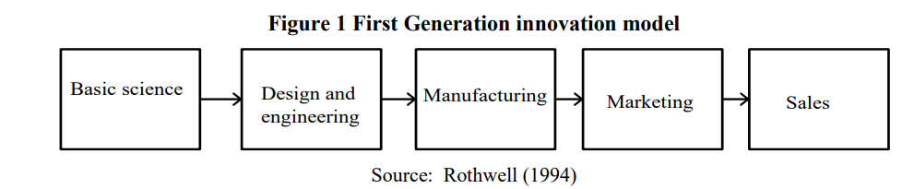
The second generation of models was developed in the mid-1960s and 1970s, a period in which an intensification of competition in the US economy can be seen and investments began to migrate to new products and related technologies. This is diametrically opposed to the first generation, which is why it was called reverse linear, as shown in Figure 2. The market is the source of ideas that drive R&D operations, thus the expression “market pull” or “demand pull”.
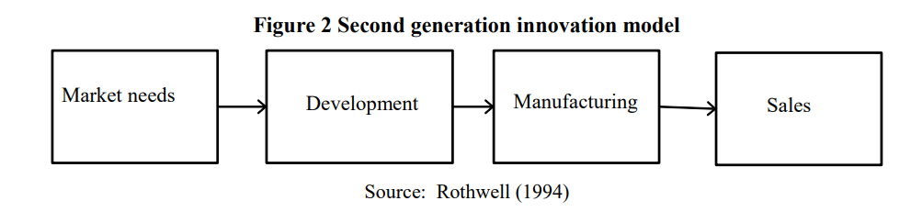
The push vs pull debate has excited authors on the topic for decades but several empirical studies showed that the technology push and need‐pull models were extreme or atypical cases of a more general model of interaction between technological capabilities on the one hand and market needs on the other. This interaction model would be the third generation, the origin of which can be attributed to Rothwell and Zegveld (1985), who called it the coupling model, or combined model (Figure 4). According to Rothwell (1994), the third generation began early in the 1970s but as from the mid-1980s began to be regarded as best practice by the majority of large western companies.
The third generation in the Bochm & Frederick (2010) design, called portfolio management (Chart 1), is just a different name for the coupled model, since one of its basic distinctions is the convergence of technological capacity and market needs. As in prior model generations, innovation is also conceived as a linear process, the operations sequence of which is similar to the second generation model, although including some interactions and feedback between them, as represented by the two-way arrows.
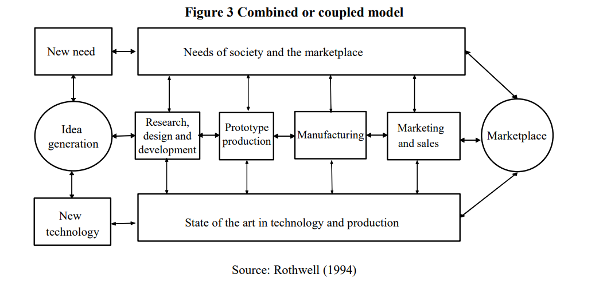
Even after the rise of other model generations, the concept of reverse linear flow with different variations remained popular among companies and textbook authors from the production, marketing and product development areas. One example is the seven stage business plan model (Figure 4-A), developed by Cooper (1994) and afterward replaced by the model entitled stage gate, today a registered trademark R.G Cooper & Associates Consultants Inc (Figure 4-B). To finalize a stage, an assessment is made on the basis of criteria established by the company management to decide whether the innovation process can pass through the gate to begin another stage. The assessments are of the go/no-go type and the project can be abandoned forever, put off for another time or receive reinforcements to be carried forward.
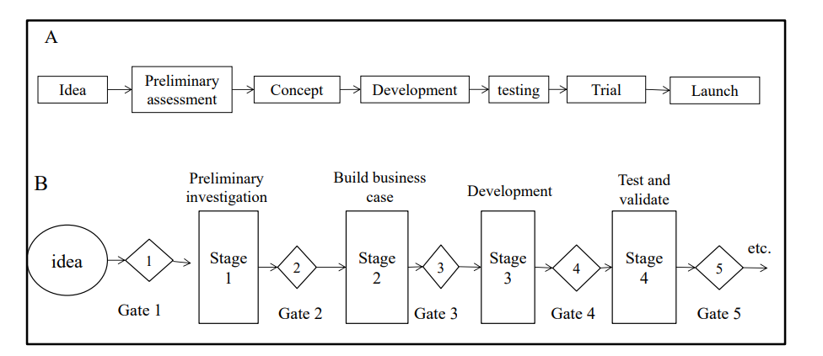
The fourth generation ranges from the early 1980s to the beginning of the 1990s, a period in which US manufacturing companies underwent stiff competition from the Japanese on the global market (ROTHWELL, 1994). This generation presents the two most outstanding characteristics of the leading Japanese companies in terms of innovation: integration and parallelism. According to Bochm & Frederick (2010), the fourth innovation generation was driven by Simultaneous Engineering or New Product Simultaneous Engineering and the skill with which Japanese companies were using these processes to generate disruptive innovations, for example, automobile manufacturers’ ability to introduce new cars within 30 months, while their rivals took from 48-60 months.
The fifth generation innovation models, which were being incubated at the time when Rothwell wrote his article, are bases for the intensive and flexible use of integrated networks and systems for implementing innovations quickly and continually. According to Rothwell, the fifth generation is essentially the fourth generation (parallel and integrated) in which the technology of technological change is itself changing. The fifth generation is an evolutionary model inspired in the concept of Darwin´s evolution by natural selection. In this model, innovation is the same as a mutation in the field of biology, a way of producing varieties of species.
The sixth generation requires interaction networks and innovations systems, which is in conformity with but goes further by inserting the innovative milieu, such as the model’s central element. The innovative milieu is a creative combination of generic knowledge and specific competencies, as well as a territorial organization and an essential component of the technical and economic creative process. Among its important features is the ease of contact and trust between partners and social, cultural and natural conditions, such as the leisure, education, health, and climate and quality of life options for the residents.

7.9. Chapter Summary
In this chapter you have studied about the concepts of creativity, invention and innovation. So that you have identified the difference between the three concepts. You have also learned about the characteristics of innovation. Furthermore, you have studied in-depth about the different typologies of innovation, generations of innovation and the importance of innovation.

7.10. Chapter Review Questions
- Define creativity, invention and innovation
_______________________________________________________________________________________________________________________________________________________________________________________________________________________________________________________________
- List and explain innovation generation
______________________________________________________________________________________________________________________________________________________________________________________________________________________________________________________________________________________________________________________________________________________________________________________________________________________________________________________________________________________________________________________________
- Explain the associations between innovation and entrepreneurship
_________________________________________________________________________________________________________________________________________________________________________________________________________________________________________________________________________________________________________________________________________________________________________________________________________________________________________
- Explain the characteristics of innovation
______________________________________________________________________________________________________________________________________________________________________________________________________________________________________________________________________________________________________________________________________________________________________________________________________________________________________________________________________________________________________________________________

Reference
Drucker, P. (2014). Innovation and entrepreneurship. Routledge.
Hisrich, R., Peters, M., & Shepherd, D. (2017). Entrepreneurship (10th ed.). McGraw-Hill Education.
Isenberg, D. J. (2011). The Entrepreneurship Ecosystem Strategy as a New Paradigm for Economic Policy: Principles for Cultivating Entrepreneurships. The Babson Entrepreneurship Ecosystem Project, 1(781), 1–13. http://www.innovationamerica.us/images/stories/2011/ The-entrepreneurship-ecosystem-strategy-for-economic-growth-policy20110620183915.pdf
Kotler , P. ( 2000 ) Marketing management: the millennium edition . Englewood Cliffs, NJ : Prentice-Hall International .

