

Online MBA
Module for Operations Management
Course Code:

Prepared by: Dr. Dagim Woldie

Edited by: Dr. Buzeye Zegeye

March, 2024
Addis Ababa, Ethiop

Table of Contents
CHAPTER ONE 1
NATURE OF OPERATIONS MANAGEMENT 1
1.1. Definition of Operations Management 2
1.2. Historical Evolution of Production and Operations Management 3
1.3. Manufacturing Operations and Service Operations 5
1.3.1. Manufacturing operations 7
1.3.2. Operations in the service sector 8
1.3.3. Difference between goods and services 9
1.4. Operations Decision Making 11
1.5. Productivity and Productivity Measurement 14
1.5.1. Productivity 14
1.5.2. Productivity measurement 14
1.5.3. Productivity and the Service Sector 15
SUMMARY 15
CHAPTER TWO 19
OPERATIONS STRATEGY AND COMPETITIVENESS 19
2.1. Introduction to operations strategy 19
2.2. The process of operations strategy 21
2.3. Operations Management Strategy in Manufacturing and Services 22
2.3.1. Operations Management Strategy in Manufacturing 22
2.3.2. Developing missions and strategy 23
2.3.3. Strategies for Competitive Advantage 24
2.4. The 10 strategic OM decisions 26
2.5. Issues in Operations Strategy 27
2.6. Strategy development and implementation 28
2.6. Global operations strategy options 30
2.7. Service operations strategies 31
CHAPTER THREE 36
DESIGN OF THE OPERATION SYSTEM 36
3.1. PRODUCT AND SERVICE DESIGN 36
3.1.1. Concepts of product and service design 37
3.1.2. Manufacturing and Service Systems 38
3.1.3. Phases in Product Development Process 39
3.1.4. Basic principles of designing products for production 40
3.1.4. Product design tools 41
3.1.5. Factors Impacting Product Design 42
3.1.6. Design of services and flexible manufacturing systems 46
3.2. PROCESS SELECTION 48
3.3. CAPACITY PLANNING 52
3.3.1. Meaning 52
3.3.2. Measuring Capacity 52
3.3.3. Process of Capacity Planning 55
3.4. FACILITY LOCATION AND LAYOUT 56
3.4.1. Facility Location 56
3.4.2. Facility Layout 63
3.5. JOB DESIGN AND WORK MEASUREMENT 71
3.5.1. Job Design 71
3.5.2. Work Measurement 74
SUMMARY 79
CHAPTER FOUR 90
OPERATION PLANNING AND CONTROL 90
4.1. AGGREGATE PRODUCTION PLANNING 92
4.2. OPERATIONS SCHEDULING 101
SUMMARY 120
CHAPTER FIVE 125
QUALITY MANAGEMENT AND CONTROL 125
5.1. Meaning and Nature of Quality 125
5.2. Overview of Total Quality Management (TQM) 127
Statistical Process Control 129
SUMMARY 143

The keys below are used throughout the material and will make your learning faster and easier.
 | This tells there is an introduction of the unit or an overview of a section and what the unit or section is about.
 | Refers to Take Note. It helps to highlight significant points that you need to keep in mind. When making your study notes, take down these points as well.
 | Refers to Checklist. These are questions given at the end of the unit, in order to check whether you have mastered the whole content of the unit or not.
 | Refers to Activity. The activities are also interspersed throughout the lectures to encourage group discussions, open-ended learning, project work, et cetera. Please endeavor to carry out all the suggested activities individually and in groups, as required. This will help you to master what you are learning.
 | Refers to Further Reading. It is vital for you to study the additional materials cited in the Further Reading section. This will broaden and deepen your understanding of the subject under discussion.
 | Refers to In-text Question(s). These are questions that are interspersed within the text of the lecture to help you review and master small chunks of knowledge, skills and values.
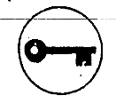 | This is the key to self-check exercises.

CHAPTER ONE


NATURE OF OPERATIONS MANAGEMENT
Operations management (OM) is the administration of business practices to create the highest level of efficiency possible within an organization. It is the activity of managing the resources which are devoted to the production and delivery of products and services. Production/operations management is the process, which combines and transforms various resources used in the production/operations subsystem of the organization into value added product/services in a controlled manner as per the policies of the organization. Therefore, it is that part of an organization, which is concerned with the transformation of a range of inputs into the required (products/services) having the requisite quality level. The operations function is central to the organization because it produces the goods and services which are its reason for existing, but it is neither the only nor necessarily the most important function. It is, however, one of the three core functions of any organization. These are: the marketing (including sales) function, the product/service development function, and the operations function. In addition, there are the support functions which enable the core functions to operate effectively. These include, for example: the accounting and finance function and the human resource’s function.
Dear learners, remember that different organizations will call their various functions by different names and will have a different set of support functions. Almost all organizations, however, will have the three core functions because all organizations have a fundamental need to sell their services, satisfy their customers and create the means to satisfy customers in the future. In practice, there is not always a clear division between the three core functions or between core and support functions.
Objectives
After reading this chapter, you will be able to:
- Define management and operations management
- Gain the areas covered by operations decision making
- Gain insight in to how operations management has developed over time.
- Elucidate the main differences between operations in service and manufacturing organizations.
- Comprehend the nature of productivity and productivity measures.

Definition of Operations Management
Activity
What do you mean by ‘operations management’?
_____________________________________________________________________________________________________________________________.
Dear learners, having reviewed the introduction of operations management, we now turn to the meaning of the term "management" and define "operations management" in a precise way. Over the years, several approaches have been developed to explain what management is all about.
Management (managing) is the administration of organizations, whether they are a business, a nonprofit organization, or a government body through business administration, nonprofit management, or the political science sub-field of public administration respectively. It is the process of managing the resources of businesses, governments, and other organizations.
Having considered management in general, let us now define operations management.
Operations management is the process whereby resources, flowing within a defined system, are combined and transformed in a controlled manner to add value in accordance with policies communicated by management.
From this definition, operations management contains some key terms which merit further consideration: (1) resources, (2) systems, and (3) transformation and value-adding activities.

Operations management (OM): is the business function that plans, organizes, coordinates, and controls the resources needed to produce a company’s goods and services. Operations management is a management function. It involves managing people, equipment, technology, information, and many other resources.
Operations management is the central core function of every company. This is true whether the company is large or small, provides a physical good or a service, is for-profit or not-for-profit. Without operations, there would be no goods or services to sell. Consider a retailer such as The Gap, which sells casual apparel. The marketing function provides promotions for the merchandise, and the finance function provides the needed capital. It is the operations function, however, that plans and coordinates all the resources needed to design, produce, and deliver the merchandise to the various retail locations.
The set of interrelated management activities, which are involved in manufacturing certain products, is called as production management. If the same concept is extended to services management, then the corresponding set of management activities is called as operations management. The operations function can be described as that part of the organization devoted to the production or delivery of goods and services. This means all organizations undertake operations activities because every organization produces goods and/or services.
Within organizations, operations management describes the functional area responsible for managing the operations that produce the organization’s goods and services for internal or external customers or clients. Operations management gives us a way of thinking about operations that helps us design, manage and improve the organization’s operations in an orderly fashion.

Historical Evolution of Production and Operations Management
Dear learners, before we consider the issues that will be covered in this topic, it is useful to understand how operations and the study of operations management have developed, and where they are today. Operations management has made many contributions to the development of modern management theory, beginning with scientific management and industrial engineering early in the twentieth century, through to the influence of Japanese management at the end of the century. Over time, the set of operations practices used in organizations has become more complex. Operations, broadly defined, may be argued to have existed as long ago as the Pyramids and other great works projects, but the academic study of operations management only took off after World War II. However, many influential managers and scholars who shaped the modern practice of management have been associated with either the practice of operations or the study of operations management. On the other hand, as products or services and the organizations and processes required to produce them have changed, the way in which organizations and operations are organized has become larger and more complex. Most of the goods and services that we consume, as well as the goods and services used by the organizations that produce them, are routinely mass-produced.
Dear learners, in this section we will provide an overview of how the study of operations management has evolved, although over a much shorter time period. The traditional view of manufacturing management began in eighteenth century when Adam Smith recognized the economic benefits of specialization of labor. He recommended breaking of jobs down into subtasks and recognizes workers to specialized tasks in which they would become highly skilled and efficient. In the early twentieth century, F.W. Taylor implemented Smith’s theories and developed scientific management. From then till 1930, many techniques were developed prevailing the traditional view. Brief information about the contributions to manufacturing management is shown in the Table below.
TABLE 1.1 Historical summary of operations management
Date | Contribution | Contributor
1776 | Specialization of labour in manufacturing | Adam Smith
1799 | Interchangeable parts, cost accounting | Eli Whitney & others
1832 | Division of labour by skill; assignment of jobs by Skill; basics of time study | Charles Babbage
1900 | Scientific management time study and work study Developed; dividing planning and doing of work | Frederick W.Taylor
1900 | Motion of study of jobs | Frank B. Gilbreth
1901 | Scheduling techniques for employees, machines Jobs in manufacturing | Henry L. Gantt
1915 | Economic lot sizes for inventory control | F.W. Harris
1927 | Human relations; the Hawthorne studies | Elton Mayo
1931 | Statistical inference applied to product quality: quality control charts | W.A. Shewart
1935 | Statistical Sampling applied to quality control: inspection sampling plans | H.F.Dodge&H.G.Roming
1940 | Operations research applications in World War II | P.M.Blacker& others
1946 | Digital Computer | John Mauchlly and J.P.Eckert
1947 | Linear Programming | G.B.Dantzig, Williams & others
1950 | Mathematical programming, on-linear and stochastic processes | A.Charnes, W.W.Cooper& others
1951 | Commercial digital computer: large-scale computations available | Sperry Univac
1960 | Organizational behavior: continued study of people at work | L.Cummings, L.Porter
1970 | Integrating operations into overall strategy and policy Computer applications to manufacturing, scheduling, and control, Material Requirement Planning (MRP) | W.SkinnerJ.Orlicky& G. Wright
1980 | Quality and productivity applications from Japan: robotics, CAD-CAM | W.E. Deming &J.Juran
Production management becomes the acceptable term from 1930s to 1950s. As F.W.Taylor’s works become more widely known, managers developed techniques that focused on economic efficiency in manufacturing. Workers were studied in great detail to eliminate wasteful efforts and achieve greater efficiency. With the 1970s emerge two distinct changes in our views. The most obvious of these, reflected in the new name operations management was a shift in the service and manufacturing sectors of the economy. As service sector became more prominent, the change from ‘production’ to ‘operations’ emphasized the broadening of our field to service organizations. The second, more suitable change was the beginning of an emphasis on synthesis, rather than just analysis, in management practices.

Manufacturing Operations and Service Operations
Manufacturing organizations produce physical, tangible items which can be stored as inventory before delivery to the customer. Service organization produces intangible items that cannot be produced ahead of time. One of the key developments in operations is the increasing competence of service operations as service industry accounts for an increasing proportion of the output of industrialized economies. Because a service cannot be stored its production and consumption will occur at the same time that implies that the producer of the service will come into contact with the customer.

Operations in an organization can be categorized into manufacturing operations and service operations. Manufacturing operations is a conversion process that includes manufacturing yields a tangible output: a product, whereas, Service Operations is a conversion process that includes service yields an intangible output: a deed, a performance, an effort.
Dear students, in fact the customer will be involved to a greater or lesser extent in the actual delivery of the operation. For instance, a supermarket requires the customer to choose and transport the goods around the store and queue at an appropriate checkout till. However, it should not be assumed that all employees in a service operation have to deal directly with a customer. Manufacturing operations will often compensate for fluctuations in demand by fulfilling demand from finished goods inventory produced during a slack period. This option is not open to service operations and they must focus on trying to alter the demand pattern to meet capacity by such strategies as discounting the price of the service during periods of low demand. Because the output of a service is intangible it is more difficult to assess performance by such measures as productivity or output. For example, a manufacturer can simply count the volume of output of its product range, but an administration service for example will have more difficulty in measuring the productivity of their employees.

The following characteristics can be considered for distinguishing manufacturing operations with service operations:
1. Tangible/Intangible nature of output
2. Consumption of output
3. Nature of work (job)
4. Degree of customer contact
5. Customer participation in conversion
6. Measurement of performance.
Manufacturing is characterized by tangible outputs (products), outputs that customers consume overtime, jobs that use less labor and more equipment, little customer contact, no customer participation in the conversion process (in production), and sophisticated methods for measuring production activities and resource consumption as product are made. Service is characterized by intangible outputs, outputs that customers consume immediately, jobs that use more labor and less equipment, direct consumer contact, frequent customer participation in the conversion process, and elementary methods for measuring conversion activities and resource consumption. Some services are equipment based namely rail-road services, telephone services and some are people based namely tax consultant services, hair styling.

Manufacturing operations
Dear students for a manufacturing firm, the transformation process is more obvious. Materials are processed, changing their form. The materials may take a number of forms and determine the nature of the transformation process. Typically, an operation may be a raw material producer, a user of raw materials, combining or changing them into parts, which are then assembled by another operation into assemblies or finished goods. Examples of each of these are given in Table 1.2.
Table 1.2
Table 1.3

Operations in the service sector
A service is an act or performance offered by one party to another. Although the process may be tied to a physical product, the performance is essentially intangible and does not normally result in ownership of any of the factors of production. Services are economic activities that create value and provide benefits for customers at specific times and places, as a result of bringing about a desired change in—or on behalf of-—the recipient of the service. More humorously, service has also been described as "something that may be bought and sold, but which cannot be dropped on your foot." In general, we define services as including repair and maintenance, government, food and lodging, transportation, insurance, trade, financial, real estate, education, legal, medical, entertainment, and other professional occupations.
Dear learners, Service operations generally transform information, people or animals, physical items or ownership. Examples of each of these transformations are given in Table 1.3.

Difference between goods and services
Services are usually intangible (for example, your purchase of a ride in an empty airlines seat between two cities) as opposed to a tangible good.
Services are often produced and consumed simultaneously; there is no stored inventory. For instance, the beauty salon produces a haircut that is ―consumed simultaneously, or the doctor produces an operation that is consumed as is produced. We have not yet figured out how to inventory haircuts or appendectomies.
Services are unique. Your mix of financial coverage, such as investment and insurance policies, may not be the same as anyone else ‘s, just as the medical procedure or a haircut produced for you is not exactly like anyone else‘s.
Services are high customer instruction. Services are often difficult to standardize, automate and make as efficient as we would like because customer interaction demands uniqueness. In fact it may cases the uniqueness is the customer is paying for; therefore, the operation manager must ensure that the product is designed (i.e., customized) so that it can be delivered in the required unique manner.
Service has inconsistence product definition. Product definition may be rigorous, as in the case of an auto insurance policy, but inconsistent because policyholders change cars and mature.
Services are often knowledge based, as in the case of educational, medical, and legal services, and therefore hard to automate. Services are frequently dispersed. Dispersion occurs because services are frequently brought to the clients/customers through a local office, a retail outlet, or even a house call.

Attributes of Goods (Tangible Product)
- Can be resold
- Can be inventoried
- Some aspects of quality
- Measurable
- Selling is distinct from production
- Product is transportable
- Site of facility important for cost
- Often easy to automate
- Revenue generated primarily from tangible product

Attributes of service (Intangible Product)
- Reselling unusual
- Difficult to inventory
- Quality
- difficult to measure
- Selling is part of service
- Provider, not product, often transportable
- Site of facility important for customer contact
- Often difficult to automate
- Revenue generated primarily from the intangible service

Dear learners, although service products are different from goods, the operation function continues to transform resources in to products. Indeed, the activities of the operations function are often very similar for goods and services. For instance, both goods and services must have quality standards established, and both must be designed and processed on a schedule in a facility where human resources are employed. Having made the distinction between goods and services, we should point out that in many cases, the distinction is not clear-cut. In reality almost all services and almost all goods are a mixture of a service and tangible product. When a tangible product is not included in the service, we may call it a pure service.

Operations Decision Making
Operations decision range from simple judgments to complex analyses, which also involves judgment. Judgment typically incorporates basic knowledge, experience, and common sense. They enable to blend objectives and sub-objective data to arrive at a choice.
The appropriateness of a given type of analysis depends on
- The significant or long-lasting decisions,
- The time availability and the cost of analysis, and
- The degree of complexity of the decision.
The significant or long-lasting decisions deserve more considerations than routine ones. Plant investment, which is a long-range decision, may deserve more thorough analysis. The time availability and the cost of analysis also influence the amount of analysis. The degree of complexity of the decision increases when many variables are involved, variables are highly independent and the data describing the variables are uncertain.
Business decision-makers have always had to work with incomplete and uncertain data. The figure below depicts the information environment of decisions. In some situations, a decision- maker has complete information about the decision variables; at the other extremes, no information is available. Operations management decisions are made all along this continuum. Complete certainty in decision-making requires data on all elements in the population. If such data are not available, large samples lend more certainty than do small ones. Beyond this, subjective information is likely to be better than no data at all.
Dear learners, the following figure illustrates some useful quantitative methods that are classified according to the amount of certainty that exists with respect to the decision variables and possible outcomes. These analytical techniques often serve as the basis for formulating models, which help to reach operational decisions.

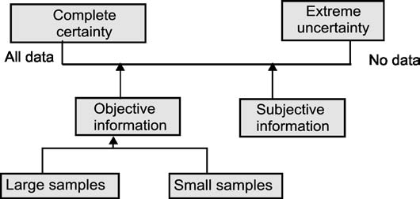
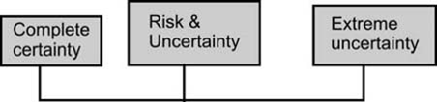
(All information)  Algebra: | (Some information)  Statistical analysis: | (No information)  Game theory
Break-even | - Objective and subjective probabilities | Flip coin
Benefit/cost | - Estimation and tests of hypothesis
Calculus | - Bayesian statistics
Mathematical programming: | - Decision theory
Linear | - Correlation and regression
Non-linear | - Analysis of variance
Integer | - Non-parametric methods
Dynamic | Queuing theory
 | Simulation
 | Heuristic methods
 | Network analysis techniques:
Decision trees PERT and CPM
Utility theory
Dear learners, by having the above models the following are the activities which are listed under production and operations management functions:
Location of Facilities: Location of facilities for operations is a long-term capacity decision which involves a long-term commitment about the geographically static factors that affect a business organization. It is an important strategic level decision-making for an organization.
Plant Layout and Material Handling: Plant layout refers to the physical arrangement of facilities. It is the configuration of departments, work centers and equipment in the conversion process, while Material Handling refers to the moving of materials from the store room to the machine and from one machine to the next during the process of manufacture.
Product Design: Product design deals with conversion of ideas into reality. Product development translates the needs of customers given by marketing into technical specifications and designing the various features into the product to these specifications. Product design and development provides link between marketing, customer needs and expectations and the activities required to manufacture the product.
Process Design: Process design is a macroscopic decision-making of an overall process route for converting the raw material into finished goods.
Production Planning and Control: Production planning and control can be defined as the process of planning the production in advance, setting the exact route of each item, fixing the starting and finishing dates for each item, to give production orders to shops and to follow up the progress of products according to orders.
Quality Control: Quality Control (QC) may be defined as ‘a system that is used to maintain a desired level of quality in a product or service’.
Materials Management: Materials management is that aspect of management function which is primarily concerned with the acquisition, control and use of materials needed and flow of goods and services connected with the production process having some predetermined objectives in view.
Maintenance Management: In modern industry, equipment and machinery are a very important part of the total productive effort. Therefore, their idleness or downtime becomes are very expensive. Hence, it is very important that the plant machinery should be properly maintained.
Explain the scope of operations decision making.
__________________________________________________________________________________________________________________________________________________________________________________________________________________.

Productivity and Productivity Measurement

Productivity
Productivity is the creation of goods and services requires changing resources into goods and services. The more efficiently we make this change, the more productive we are and the more value is added to the good or service provided.

Productivity is the ratio of outputs (good and service) divided by the inputs (resource such as labor and capital).
The operations manager‘s job is to enhance (improve) this ratio of outputs to inputs. Improving productivity means improving efficiency. The improvement can be achieved in two ways: reducing inputs while keeping output constant or increasing output while keeping inputs constant. Both represent an improvement in productivity. In an economies sense, inputs are labor, capital and management, which are integrated into a production system. Management creates this production system, which provides the conversion of inputs to outputs.

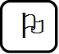
Productivity measurement
Activity
Dear students, can you define productivity? How productivity is measured?
______________________________________________________________________________
The measurement of productivity can be quite direct. Such is the case when productivity is measured by labor hours per ton of a specific type of steel. Although labor hours in a common measure of input, other measures such as capital (dollar invested), materials (tons of ore), or energy (kilowatts of electricity) can be used. An example of this can be summarized in the following equation:
Partial = Output, Output , Output , Output
measures Labor Machine Capital Energy
Multifactor measures = Output , Output
Labor + Machine Labor + Capital + Energy
Total measure = Goods or Services Produced
All inputs used to produce them
Example: 10000 Units Produced and Sold for $5/unit
Cost of labor of $1500
Cost of materials: $1400
Cost of overhead: $2000
- Calculate the overall productivity.
Solution
Overall productivity = Output
Labor + Materials + Overhead
MFP = (10000 units) *($ 5)
$1500 + $1400 + $2000
= 10.20
Visit any organization in your locality and get information for the following questions.
- Identify the type of production system followed by the organization.
- Check how production system is managed.
- Discovery the company’s utilization of the resources particularly manpower, capacity and material.
- Examine how the customer service is rendered?

Productivity and the Service Sector
The service sector a special challenge to the accurate measurement of productivity and productivity improvement. Productivity of the service sector has proven difficult to improve because service- sector work is:
- Typically, labor-intensive (for example, counseling, teaching).
- Frequently focused on unique individual attributes or desires (for example, investment advice).
- Often an intellectual task performed by professionals (for example, medical diagnosis)
- Often difficult to mechanize and automate (for example, a haircut)
- Often difficult to evaluate for quality (for example, performance of a law firm)

SUMMARY
The operations function is central to the organization because it produces the goods and services. Operations management is the central core function of every company since it has made many contributions to the development of modern management theory, beginning with scientific management and industrial engineering early in the twentieth century, through to the influence of Japanese management at the end of the century. Later many influential managers and scholars shaped the practice of operations or the study of operations management. Operations in an organization can be categorized into manufacturing operations and service operations. Manufacturing organizations produce physical, tangible items which can be stored as inventory before delivery to the customer. Service organization produces intangible items that cannot be produced ahead of time. Operations decision range from simple judgments to complex analyses, which also involves judgment. Because of this, business decision-makers have always had to work with incomplete and uncertain data. Given this, the operations manager ‘s job is to enhance productivity, because improving productivity means improving efficiency.
 Check list
Part I: Say True if the Statement is Correct and False if it is Incorrect.
- All organizations, including service firms such as banks and hospitals, have a production function.
- The operations manager performs the management activities of planning, organizing, staffing, leading, and controlling of the OM function.
- Frederick W. Taylor is generally credited with inventing and establishing standards for the moving assembly line.
- It is easier to measure productivity for an operation that provides services than for one that produces goods since there is no material used in services.
- Productivity is the ratio of input to output, with input limited to material and labor.
Part II: Please Select the Alternative that Best Answers the Question.
- Operations management is applicable

- Mostly to the service sector
- To services exclusively
- Mostly to the manufacturing sector
- To all firms, whether manufacturing and service
- To manufacturing sector exclusively

- Henry Ford is noted for his contributions to

- Standardization of parts
- Statistical quality control
- Assembly line operations
- Scientific management
- Time and motion studies

- Which of the following statements is true?
- The person most responsible for initiating use of interchangeable parts in manufacturing was Eli Whitney.
- The origins of management by exception are generally credited to Frederick W. Taylor.
- The person most responsible for initiating use of interchangeable parts in manufacturing was Walter Shewhart.
- The origins of the scientific management movement are generally credited to Henry Ford.
- The person most responsible for initiating use of interchangeable parts in manufacturing was Henry Ford.
- Typical differences between goods and services do not include

- Cost per unit
- Ability to inventory items
- timing of production & consumption
- Customer interaction
- Knowledge content

- A foundry produces circular utility access hatches (manhole covers). Currently, 120 covers are produced in a 10-hour shift. If labor productivity can be increased by 20%, it would then be

- 14.4 covers/hr
- 24 covers/hr
- 240 valves/hr
- 1200 covers/hr
- None of the above

- The total of all outputs produced by the transformation process divided by the total of the inputs is

- Utilization
- Greater in manufacturing than in services
- defined only for manufacturing firms
- Multifactor productivity
- None of the above

- Productivity can be improved by
- Increasing inputs while holding outputs steady
- Decreasing outputs while holding inputs steady
- Increasing inputs and outputs in the same proportion
- Decreasing inputs while holding outputs steady
- None of the above
- Which of the following is not true when explaining why productivity tends to be lower in the service sector than in the manufacturing sector?
- Services are typically labor-intensive.
- Services are often difficult to evaluate for quality.
- Services are often an intellectual task performed by professionals.
- Services are difficult to automate.
- Service operations are typically capital intensive.
- The major difference between goods and services is:
- It is difficult to inventory services
- Services lack the profitability that goods enjoy
- Goods production usually requires more labor than services
- Goods are always customized, services are always standardized
- An organization offering goods cannot also offer services
Part III: Write Short Answer for the Following Questions
- Define operations management.
- How do services differ from goods? Identify five ways.
Part IV: Solve the Following Work out questions
- Susan has a part-time "cottage industry" producing seasonal plywood yard ornaments for resale at local craft fairs and bazaars. She currently works 8 hours per day to produce 16 ornaments.
- What is her productivity?
- She thinks that by redesigning the ornaments and switching from use of a wood glue to a hot-glue gun she can increase her total production to 20 ornaments per day. What is her new productivity?
- What is her percentage increase in productivity?
- The Dulac Box plant produces wooden packing boxes to be used in the local seafood industry. Current operations allow the company to make 500 boxes per day, in two 8-hour shifts (250 boxes per shift). The company has introduced some moderate changes in equipment, and conducted appropriate job training, so that production levels have risen to 300 boxes per shift. Labor costs average $10 per hour for each of the 5 full-time workers on each shift. Capital costs were previously $3,000 per day, and rose to $3,200 per day with the equipment modifications. Energy costs were unchanged by the modifications, at $400 per day. What is the firm's multifactor productivity before and after the changes?

CHAPTER TWO

OPERATIONS STRATEGY AND COMPETITIVENESS
No organization can plan in detail every aspect of its current or future actions, but all organizations need some strategic direction and so can benefit from some idea of where they are heading and how they could get there. Once the operations function has understood its role in the business and after it has articulated its performance objectives, it needs to formulate a set of general principles which will guide its decision making. This is the operations strategy of the company. It is important to bear in mind that operation managers have responsibilities that go beyond management of assets, costs and human resources in the transformation process. In the current business environment, operations must be managed in a way that will enable the firm to compete against extensive and increasing competition from around the world.
Dear learners, in this chapter we will expand upon a number of key issues faced by operations managers in both manufacturing and service environments that we discussed in Chapter 1. We will develop the theme of how operations management must be seen in terms of strategic importance and how strategies have to be in place if the organization wants to be able to compete.
objectives
After reading this chapter, you will be able to:
- Define the strategy and operations strategy
- Explain the key developments in operations strategy in both service and manufacturing contexts.
- Understand the nature and importance of strategy in dealing with competitive conditions.
- Appreciate why some organizations struggle with devising and implementing operations strategies.
- Understand global operations strategy and issues in operations strategy

Introduction to operations strategy
Most companies now face increasingly turbulent, complex, and threatening environments. In the past, many firms could apparently succeed by focusing management efforts on internal functions and on running their day-to-day affairs as efficiently as possible. Of course, efficient internal operations remain important. However, a company’s adapting to changing environmental conditions has become an essential ingredient for success.
Activity
What is operation strategy? Can you differentiate between business strategy and operations strategy? How can an operations strategy be put together?
______________________________________________________________________________
The long-range plan of a business, designed to provide and sustain shareholder value, is called the business strategy. For a company to succeed, the business strategy must be supported by each of the individual business functions, such as operations, finance, and marketing.

Operations strategy is a long-range plan for the operations function that specifies the design and use of resources to support the business strategy. Just as the players on a football team support the team’s strategy, the role of everyone in the company is to do his or her job in a way that supports the business strategy.
Operations strategy concerns the pattern of strategic decisions and actions which set the role, objectives and activities of the operation. The term ‘operations strategy’ sounds at first like a contradiction. How can ‘operations’, a subject that is generally concerned with the day to day creation and delivery of goods and services, be strategic? ‘Strategy’ is usually regarded as the opposite of those day-to-day routine activities. Nor is there universal agreement on how an operations strategy should be described. Different authors have slightly different views and definitions of the subject. Between them, four ‘perspectives’ emerge:
- Operation strategy is a top-down reflection of what the whole group or business wants to do;
- Operations strategy is a bottom-up activity where operations improvements cumulatively build strategy;
- Operations strategy involves translating market requirements into operations decisions;
- Operations strategy involves exploiting the capabilities of operations resources in chosen markets.
Dear learners, none of these four perspectives alone gives the full picture of what operations strategy is. But together they provide some idea of the pressures which go to form the content of operations strategy. There is no one best way to formulate strategy and the debate on whether strategy should be internal, resource-based or fully externally market-driven may be seen as of intellectual interest only. In practice, many organizations will combine both internal and external considerations in the same way that they tend to innovate as a result of both ‘push technology’ (from internal developments) and ‘pull demand’ (from market requirements). Every firm must be aware of external issues, including macro-economic factors, social and technological changes. The PEST model (Political, Economic, Social and Technical elements) is a convenient – but hardly exhaustive – approach to scanning external issues. However, the firm must also pay great attention to internal capabilities and to link these with opportunities and threats that may influence the firm.
What are the links between operations strategy and business strategy?
______________________________________________________________________

The process of operations strategy
The process of operations strategy refers to the procedures which are, or can be, used to formulate those operations strategies which the organization should adopt. Most consultancy companies have developed their own frameworks, as have several academics. Typically, many of these formulation processes include the following elements:
- A process which formally links the total organization’s strategic objectives (usually a business strategy) to resource-level objectives;
- The use of competitive factors (called various things such as order winners, critical success factors, etc.) as the translation device between business strategy and operations strategy;
- A step which involves judging the relative importance of the various competitive factors in terms of customers’ preferences;
- A step which includes assessing current achieved performance, usually as compared against competitor performance levels;
- An emphasis on operations strategy formulation as an iterative process;
- The concept of an ‘ideal’ or ‘green-field’ operation against which to compare current operations. Very often the question asked is: ‘If you were starting from scratch on a green-field site, how, ideally, would you design your operation to meet the needs of the market?’ This can then be used to identify the differences between current operations and this ideal state;
- A ‘gap-based’ approach. This is a well-tried approach in all strategy formulation which involves comparing what is required of the operation by the marketplace against the levels of performance the operation is currently achieving.

Operations Management Strategy in Manufacturing and Services
Operations strategy can be vitally important to achieving business goals and gaining competitive advantage in at least two ways. First, it can be central to the implementation of an already devised business strategy, which, as we have already noted, operations personnel may or may not have helped to formulate. In this approach, operations’ role is important in providing ‘strategic fit’ in focusing efforts and resources so that operations strategy is consistent with, and helps to support, the already devised business strategy. Second, operations strategy can be used in a more proactive approach. Here, operational capabilities would be viewed as part of the core capabilities/competencies, which can be exploited and used to create new opportunities and to target new areas. In this approach, operations’ contribution would be central to the planning stages of business strategy and is not restricted to the implementation of an already devised strategy. This resource, competence-based approach to strategy has become an important feature in the literature on strategy.
Activity
Dear learners, could you explain the key developments in operations strategy in both service and manufacturing contexts?
______________________________________________________________________________

Operations Management Strategy in Manufacturing
Manufacturing strategy was the forerunner of the wider aspects of operations strategy.
Dear students, the discussion on the role and purpose of manufacturing strategy has been broad and includes many frameworks for identifying key manufacturing decisions. Manufacturing strategy consists of a sequence of decisions that, over time, enables a business unit to achieve a desired manufacturing structure, infrastructure and set of specific capabilities. Manufacturing strategy is concerned with combining responsibility for resource management (internal factors) as well as achieving business (external) requirements. For manufacturing strategy to be useful, it needs to have consistency among decisions that affect business-level strategy, competitive priorities and manufacturing. Much of the degree to which manufacturing strategy will be effective relies on the internal consistency of manufacturing strategy, manufacturing capabilities, marketing – manufacturing congruence, and their effects on manufacturing performance. Although applied to manufacturing, the above analysis is equally relevant to services. Hence, we can refer to an ‘operations strategy’ applicable to any business organization.

Developing missions and strategy
The organization strategy provides the overall direction for the organization. It is broad in scope, covering the entire organization. Operations strategy is narrower in scope, dealing primarily with the operations aspect of the organization. An operations strategy involves decisions that relate to the design of a process and the infrastructure needed to support process. An effective operation management effort must have a mission so it knows where it is going and a strategy so it knows how to get there.
- Mission
Economic success, indeed survive, is the result of identifying missions to satisfy a customer’s needs and wants. Mission statements provide boundaries and focus for organizations and the concept around which the firm can rally. The mission states the rationale for the organization’s existence.

Mission is statement defining what business an organization is in, who its customers are, and how its core beliefs shape its business.
Once an organization’s mission has been decided, each functional area within the firm determines supporting mission. By functional area we mean the major disciplines required the firm, such as marketing, finance/accounting, productions/operations.
- Strategy
Strategy is an organization’s action plan to achieve the mission. Each functional area has a strategy for achieving its mission and for helping the organization reach the overall mission. These strategies exploit opportunities and strengths, neutralize threats, and avoid weaknesses.
Strategy is the direction and scope of an organization over the long term, which achieves advantage in a changing environment through its configuration of resources and competence with the aim of fulfilling stakeholder expectations

The success of operations strategy has nothing to do with how long the planning process has taken, nor has it to do with how nicely or how wonderfully articulately the strategy is presented to the firm’s employees – if indeed strategy is articulated to employees.

- Environmental Scanning
To remain competitive, companies have to continuously monitor their environment and be prepared to change their business strategy, or long-range plan, in light of environmental changes.

Environmental scanning is the process of monitoring the external environment
The external business environment is always changing. Environmental scanning looks at economic, political, and social trends that can affect the business. Economic trends include recession, inflation, interest rates, and general economic conditions. Political trends include changes in the political climate—local, national, and international—that could affect a company. Finally, social trends are changes in society that can have an impact on a business.
- Core Competencies
The third factor that helps define a business strategy is an understanding of the company’s strengths. These are called core competencies. In order to formulate a long-term plan, the company’s managers must know the competencies of their organization. Core competencies could include special skills of workers, such as expertise in providing customized services or knowledge of information technology.
Three inputs in developing a business strategy

Strategies for Competitive Advantage
Production is the key area for forming competitive advantage for a company. Therefore the aim of strategic production management is to provide competitive advantage by creating an optimal co-ordination between competitive strategy and production strategy. More recently, the potential that such operations strategies can offer to mainstream strategy, particularly resource-based approaches, has emerged as an important contribution.
Activity
What are the strategies for competitive advantage?
______________________________________________________________________________
Dear students, operations strategy viewed as having a key role in the competence-based approaches to strategy and one that can nullify any notions of competitive trade-offs in strategy formulation. Generally, firms compete on differentiation (concerned with providing uniqueness), cost, and response.
Order Winners and Qualifiers
Activity
Differentiate between order winners and order qualifiers?
______________________________________________________________________________
Dear learners, a particularly useful way of determining the relative importance of competitive factors is to distinguish between ‘order-winning’ and ‘qualifying’ factors. It is also important to distinguish between order winners and order qualifiers, to help a company decide which competitive priorities to focus on. Order-winning factors are those things which directly and significantly contribute to winning business. Qualifying factors may not be the major competitive determinants of success but are important in another way. They are those aspects of competitiveness where the operation’s performance has to be above a particular level just to be considered by the customer.
Order qualifiers are those competitive priorities that a company has to meet if it wants to do business in a particular market. Order winners, on the other hand, are the competitive priorities that help a company win orders in the market.

Dear learners let us consider a simple restaurant that makes and delivers pizzas. Order qualifiers might be low price (say, less than $10.00) and quick delivery (say, less than 15 minutes) because this is a standard that has been set by competing pizza restaurants. The order winners may be “fresh ingredients” and “home-made taste.” These characteristics may differentiate the restaurant from all the other pizza restaurants. However, regardless of how good the pizza, the restaurant will not succeed if it does not meet the minimum standard for order qualifiers. Knowing the order winners and order qualifiers in a particular market is critical to focusing on the right competitive priorities.
Mass customization: Some companies have developed their flexibility in such a way that products and services are customized for each individual customer. Yet they manage to produce them in a high volume, mass production manner which keeps costs down. This approach is called mass customization. Sometimes this is achieved through flexibility in design. For example, Dell is the world’s largest volume producer of personal computers yet allows each customer to „design‟ (albeit in a limited sense) their own configuration. Sometimes flexible technology is used to achieve the same effect.
Agility: Judging operations in terms of their agility has become popular. Agility is really a combination of all the five performance objectives but particularly flexibility and speed. In addition, agility implies that an operation and the supply chain of which it is a part can respond to the uncertainty in the market. Agility means responding to market requirements by producing new and existing products and services fast and flexibly.

The 10 strategic OM decisions
Differentiation, low cost, and response can be achieved when managers make effective decisions in 10 areas of OM. These are collectively known as operation decisions. The 10 decision of OM that support missions and implement strategies follow:
1. Goods and service design: designing goods and services define much of the transformation process. Costs, quality, and human resource decisions are often determined by design decisions. Designs usually determine the lower limits of costs and the upper limits of quality.
2. Quality: the customer’s quality expectations must be determined and policies and procedures established to identify and achieve that quality.
3. Process and capacity design: process options are available for products and services. Process decision commits management to specific technology, quality, human resource use, and maintenance. These expense and capital commitments determine much of the firm’s basic cost structure.
4. Location selection: facility location decisions for both manufacturing and service organizations may determine the firm’s ultimate success. Errors made at this juncture may over whelm other efficiencies.
5. Layout design: materials flows, capacity needs, personal levels, technology decisions, and inventory requirements influence layout.
6. Human resources and job design: people are an integral part and expensive part of the total system design. Therefore, the quality of work life provided, the talent and skills required, and their costs must be determined.
7. Supply chain management: These decisions determine what is to be made and what is to be purchased. Consideration is also given to quality, delivery, and innovation, all at a satisfactory price. Mutual trust between buyer and supplier is necessary for effective purchasing.
8. Inventory: inventory decision can be optimized only when customer satisfaction, suppliers, production schedules, and human resource planning are considered.
9. Scheduling: feasible and efficient schedules of production must be developed; the demands on human resources and facilities must be determined and controlled.
10. Maintenance: decisions must be made regarding desired levels of reliability and stability, and system must be established to maintain the reliability and stability.
Dear learners, operation managers implement these 10 decisions by identifying key tasks and the staffing needed to achieve them. However, the implementation of the decision is influenced by a variety of issues, including a product’s proportion of goods and services. Few products are either all goods or all services. Although the 10 decisions remain the same for goods and services, their relative importance and method of implementation depend on this ratio of goods and services.

Issues in Operations Strategy
Once a firm has formed a mission, developing and implementing a specific strategy requires that the operations manager consider a number of issues. Generally, this issue summarize in to three ways.
1. Research: Strategic insight has been provided by the findings of the strategic planning institute. PIMS (profit impact of market strategy) has been able to identify some characteristics of high-ROI firms. Among those characteristics that affect strategic OM decisions are: High product quality (relative to the competition), High-capacity utilization, High operating efficiency (the ratio of expected to actual employee productivity), Low investment intensity (the amount of capital required to produce a dollar of sales), and Low direct cost per unit (relative to the competition). These five findings support a high ROI and should therefore be considered as an organization develops a strategy. In the analysis of a firm’s relative strength and weaknesses, these characteristics can be measured and evaluated.
2. Preconditions: before establishing and attempting to implement a strategy, the operations manager needs to understand that the firm is operating in an open system in which a multitude of factors exists. These factors influence strategy development and execution. The more thorough the analysis and understanding of both the external and internal factors, the more the likelihood of success.
3. Dynamics: strategies change for two reasons. First, strategy is dynamic because of a change within the organization. All areas of the firm are subject to change. Changes may occur in a variety of areas, including personnel, finance, technology, and product life. All may make a difference in an organization’s strength and weaknesses and therefore its strategy. Strategy is also dynamic because of changes in the environments.

2.6. Strategy development and implementation
Once firms understand the issues involved in developing an effective strategy, they evaluate their internal strength and weaknesses as well as the opportunities and threats of the environment. This is known as SWOT analysis. Beginning with SWOT analysis, firms position themselves, through their strategy, to have a competitive advantage. The firm may have excellent design skill or great talent at identifying outstanding locations. However, the firm may recognize limitations of its manufacturing process or in finding good suppliers. The idea is to maximize opportunities and minimize threats in the environment while maximizing the advantage of the organization’s strength and minimizing the weaknesses. Any preconceived ideas about mission are then reevaluated to ensure they are consistent with the SWOT analysis. Subsequently, a strategy for achieving the mission is developed. This strategy is continually evaluated against the value provided customers and competitive realities.

1. Critical success factors and core competencies
Because no firm does everything exceptionally well, a successful strategy requires determining the firm’s critical success factors and core competencies. Critical success factors (CSFs) are those activities that are necessary for a firm to achieve its goals. CSFs can be so significant that a firm must get them right to survive in the industry. CSFs are often necessary, but not sufficient for competitive advantage. On the other hand, core competencies are the set of unique skills, talents, and capabilities that a firm does at a world class standard. They allow a firm to set it apart and develop a competitive advantage. Organizations that prosper identify their core competencies and nurture them. The idea is to build CSFs and core competencies that provide a competitive advantage and support a successful strategy and mission. A core competence may be a subset of CSFs or a combination of CSFs. The 10 OM decisions provide an excellent initial checklist for determining CSFs and identifying core Competencies within the operations function. For instance, the 10 decisions related CSFs, and core competence can allow a firm to differentiate its product or service.
2. Build and staff the organizations
One of the operations manager jobs is to staff it with personnel who will get the job done. The manager works with subordinate managers to build plans, budgets, and programs that will successfully implement strategies that achieve missions. The firms tackle this organization of the operations function in a variety of way.
3. Integrated OM with other activities
The organization of the operations function and its relationship to other parts of the organization vary with the OM mission. Moreover, the operations function is most likely to be successful when the operations strategy it integrated with other functional areas of the firm, such as marketing, finance, information technology, and human resources. In this way, all of the areas support the company’s objectives. The operations managers provide a means of transforming inputs into outputs. The transformations may be in terms of storage, transportation, manufacturing, dissemination of information, and utility of the product or service. The operations manager’s job is to implement an OM strategy, provide competitive advantage, and increase productivity.

Global operations strategy options
Many operations strategies now require an international dimension. We tend call a firm with an international dimension an international business or a multinational corporation. An international business is any firm that engages in international trade or investment. A multinational corporation (MNC) is a firm with extensive international business involvement. The term Multinational Corporation applies to most of the world’s large, well-known businesses. Certainly IBM is a good example of an MNC. It imports electronics components to the U.S. From over 50 countries, export computers to over 130 countries, has facilities in 45 countries, and earns more than half its sale and profits abroad. Operations managers of the international and multinational firms approach global opportunities with one of four operations strategies: international, multinational, global, and transnational. Let us briefly examine each of the four strategies.
1. International strategy
An international strategy uses exports and licenses to penetrate the global arena. The international strategy is the least advantageous, with little local responsiveness and little cost advantage. There is little responsiveness because we are exporting or licensing a good from the home country.
2. multi-domestic strategy
The multi-domestic strategy has decentralized authority with substantial autonomy at each business. Organizationally these are typically subsidiaries, franchises, and joint ventures with substantial independence. The advantage of the strategy is maximizing a competitive response for the local market; however, the strategy has little or no cost advantage. Many food producers, such as Heinz, use a multi-domestic strategy to accommodate local tastes because global integration of the production process is not critical.
3. Global strategy
A global strategy has a high degree of centralization, with headquarters coordinating the organization to seek out standardization and learning between plants, thus generating economies of scale. This strategy is appropriate when the strategic focus is cost reduction but has little to recommend it when the demand for local representativeness is high. Caterpillar, the world leader in earth-moving equipment, and Texas instruments, a world leader in semiconductors.
4. Transnational strategy
Transnational strategy exploit the economies of scale and learning, as well as pressure for responsiveness, by recognizing that core competence does not reside in just the “home “ country but can exist anywhere in the organization. Transnational describes a condition in which material, people, and ideas cross-or transgress-national boundaries. Key activities in a transnational company are neither centralized in the parent company not decentralized so that each subsidiary can carry out its own tasks on a local basis. Instead, the resources and activities are dispersed, but specialized, so as to be both efficient and flexible in an interdependent network. Nestle is a good example of such company. Although it is legally Swiss, 95% of its assets are held and 98% of its sales are made outside Switzerland. Fewer than 10% of its workers are Swiss.
Why is operations strategy vitally important in modern-day operations management?
______________________________________________________________________________

Service operations strategies
Activity
What makes different service operation strategy from manufacturing operation strategy?
______________________________________________________________________________
Service sector firms face some of the same challenges as manufacturing firms, and some unique challenges of their own. First, services are increasingly either managed or traded internationally, and so service firms need to devise plans for how this will be accomplished. Where services and manufacturing are closely linked in the overall provision to customers, the role of services can be vital. In the past, companies often located manufacturing facilities in different countries to take advantage of local resources and wage rates and the emphasis was on the manufacturing element. However, today multinational corporations are locating services where they can access highly trained workers at reasonable costs - for example in India and in Eire. Such effects can also be observed at the regional level within countries. For example, in the UK many call centers have located in Yorkshire, where local accents have been judged to be the „most friendly‟ and to come across well over the telephone; others have located in isolated rural areas of Scotland, where there are large untapped resources of an educated workforce without much competing local employment.
Service organizations may choose one of three generic strategies:
- Customer-oriented focus - providing a wide range of services to a limited range of customers, using a customer-centered database and developing new offerings to existing customers
- Service-oriented focus - providing a focused, „limited menu‟ of services to a wide range of customers, usually through specialization in a narrow range of services
- Customer- and service-oriented focus - providing a limited range of services to a highly targeted set of customers. Ensuring service quality is a key competitive objective for most service organizations.
Unlike manufacturing, customer contact in services means that both front-line employees and customers influence the quality and perception of the service. Service failures occur when the service is unavailable, too slow, or does not meet organizational or customer standards. Two ways that companies can mitigate service failures are service guarantees and service recovery.
In becoming part of the production process, making the client productive can take place in four ways. The first way to make clients productive is to involve them in the specification of custom-tailored services. There are many familiar services that rely on customer specification, such as kitchen design. A second way is to include customers in the production of the service, thus turning them into „involuntary unpaid labor‟. Most of us have become accustomed to eating at least occasionally in fast-food restaurants, where we (instead of employees) are responsible for clearing tables, etc. In return, these offer (at least in theory) faster service and lower costs, since employees have less work to perform. A third way is to make the customer responsible for quality control. A popular restaurant trend has been restaurants such as the „Mongolian Wok‟ chain, where customers select their own ingredients from a buffet, and then hand them over to a chef for stir-frying - they can include their favorite ingredients and exclude those they dislike, rather than accepting a standard range.

SUMMARY
Strategy matters, because without it a firm does not have direction. Consequently, any successes that it may gain will be by fluke. For sure, there are success stories that appear to have been achieved by pure chance – or so the stories would have us believe. Operations strategy can be vitally important to achieving business goals and gaining competitive advantage both in manufacturing and service organizations. Therefore, the aim of strategic operations management is to provide competitive advantage by creating an optimal co-ordination between competitive strategy and production strategy. Differentiation, low cost, and response can be achieved when managers make effective decisions in 10 areas of OM that is operation decisions. These 10 decisions of OM support missions and implement strategies. Once a firm has formed a mission, developing and implementing a specific strategy requires that the operations manager consider a number of issues such as Research, Preconditions, and Dynamics. Many operations strategies now require an international dimension. Operations managers of the international and multinational firms approach global opportunities with one of four operations strategies: international, multinational, global, and transnational. Generally, CEOs in the modern era will be judged on their ability to understand, develop and utilize world-class operations in a manner that creates advantage – in other words, to use strategic operations.
Checklist
Part I: Say True if the Statement is Correct and False if it is Incorrect.
- Operations strategies are implemented in the same way in all types of organizations.
- An organization's ability to generate unique advantages over competitors is central to a successful strategy implementation.
- Low-cost leadership is the ability to distinguish the offerings of the organization in any way that the customer perceives as adding value.
- Critical Success Factors are those activities that are key to achieving competitive advantage.
- The mission of a firm should be designed to support each of the firm's functional strategies.
Part II: Please Select the Alternative that Best Answers the Question.
- Which of the following represent reasons for globalizing operations?

- To gain improvements in the supply chain
- To improve operations
- To expand a product's life cycle
- To attract and retain global talent
- All of the above are valid.

- Which of the following statements about organizational missions is false?
- They reflect a company's purpose.
- They indicate what a company intends to contribute to society.
- They are formulated after strategies are known.
- They define a company's reason for existence.
- They provide guidance for functional area missions.
- A firm can effectively use its operations function to yield competitive advantage via all of the following except

- Customization of the product
- Setting equipment utilization goals below the industry average
- Speed of delivery
- Constant innovation of new products
- Maintain a variety of product options

- A strategy is a(n)
- Set of opportunities in the marketplace
- Broad statement of purpose
- Simulation used to test various product line options
- Plan for cost reduction
- Action plan to achieve the mission
- Which of the following is not an operations strategic decision?

- Maintenance
- Price
- Layout design
- Quality
- Inventory

- Which of the following OM strategic decisions pertains to sensible location of processes and materials in relation to each other?

- Layout design
- Goods and service design
- Supply chain management
- Inventory
- Scheduling

- The PIMS program has identified the
- Operations decisions all organizations must make
- Distinctive competencies any company needs
- Characteristics of firms with high "ROI"
- Corporate decisions any company needs to make
- All of the above
- Which of the international operations strategies involves high-cost reductions and high local responsiveness?

- International strategy
- Global strategy
- Transnational strategy
- Multi domestic strategy
- none of the above

- An operations strategy is developed using many sources of input - which is the least likely to have input?

- Quality
- Planning
- Suppliers
- Top management
- Production

Part III: Write Short Answer for the Following Questions
- What is the difference between a firm's mission and its strategy?
- Define core competencies.
- Are strategies static or dynamic? What are the forces that lead to this result?
- Identify and explain the four basic global operations strategies. Give an example of each strategy.

CHAPTER THREE

DESIGN OF THE OPERATION SYSTEM
Before products can flow into a market, someone must design and invest in the facilities and organization to produce them. This chapter concerns the planning of the systems needed to produce goods and services.
Dear students, from this lecture onwards we will be embarking on the journey to learn about Design of operation Systems. This journey would require us to complete various milestones like product and service design, capacity planning, Facilities Layout, Design of Work systems and Locations. Please pay special attention to all examples you will cover through the following lectures and try to keep two important things in mind: -
1. Design aspect requires strategic planning and may fall under the domain of Organizational strategy and senior management, also
2. Design aspect requires the existing system to be improved or replaced by a better system for this you should always focus on the word Productive. This word reflects the idea of adding value either to the manufacturing or the services System or to be more precise improving the operation system.
Learning Objectives
After reading this lesson you will be able to understand;
- Product development and design process
- Service design and Flexible manufacturing systems
- Product design tools and basic principles of designing products
- Capacity decision and capacity planning
- How to measure capacity
- How to make location decision
- Different types of plant layout and designing product layout

PRODUCT AND SERVICE DESIGN

Product design and process selection affect product quality, product cost, and customer satisfaction. If the product is not well designed or if the manufacturing process is not true to the product design the quality of the product may suffer. Product and Service Design together form the very basis of design aspect of operations. The fact is that we cannot leave out services from products or exclude products from service. They both complement and supplement each other. We have to respect this concept and pay attention in identifying how products and services are present in tandem everywhere. For example, if Virtual University is providing students with an education service, it also supplements the services side by providing products like books, compact discs, handouts, and power point slides. The point we are trying to focus upon is that products and services are found in combination and a service organization can also provide products or a manufacturing organization can also provide a service.

Concepts of product and service design
Activity
Define product design and service design
______________________________________________________________________________
Students, most of us might think that the design of a product is not that interesting. After all, it probably involves materials, measurements, dimensions, and blueprints. When we think of design, we usually think of car design or computer design and envision engineers working on diagrams. However, product design is much more than that. Product design brings together marketing analysts, art directors, sales forecasters, engineers, finance experts, and other members of a company to think and plan strategically. It is exciting and creative, and it can spell success or disaster for a company.
Dear friends, yet another fascinating aspect of the entire process concerns with the defining and documenting the product and service design. Design is the process of defining all the features and characteristics of just about anything you can think of.

Product design is defining a product’s characteristics, such as its appearance, the materials it is made of, its dimensions and tolerances, and its performance standards.
Developing and designing great products are keys to success in business. Anything less than an excellent product strategy can be destructive to a firm. Top companies’ focus on few products and concentrate on maintaining a high level of quality for those products to maximize the potential for success.

Manufacturing and Service Systems
Manufacturing and service systems are arrangements of facilities, equipment, and people to produce goods and services under controlled conditions. Manufacturing systems produce standardized products in large volumes. Service systems present more uncertainty with respect to both capacity and costs. Services are produced and consumed in the presence of the customer and there is little or no opportunity to store value, as in a finished goods inventory. As a result, capacity of service systems like hospitals, restaurants and many other services must be sufficiently flexible to accommodate a highly variable demand. In addition, many services such as legal and medical involves professional or intellectual services judgments that are not easily standardized. This makes more difficult to accumulate costs and measure the productivity of the services. For service industries, where the product is intangible, the design elements are equally important, but they have an added dimension. The service design adds the aesthetic and psychological benefits of the product. These are the service elements of the operation, such as promptness and friendliness. They also include the ambiance, image, and “feel- good” elements of the service. As with a tangible product, the preference for a service is based on its product design. Service design defines the characteristics of a service, such as its physical elements, and the aesthetic and psychological benefits it provides.
Degree of Standardization
Standardization: Extent to which there is an absence of variety in a product, service or process. Standardized products are immediately available to customers
Advantages of Standardization
- Fewer parts to deal with in inventory & manufacturing
- Design costs are generally lower
- Reduced training costs and time
- More routine purchasing, handling, and inspection procedures
- Orders fillable from inventory
- Opportunities for long production runs and automation
- Need for fewer parts justify increased expenditures on perfecting designs and improving quality control procedures.

Disadvantages of Standardization
- It may reduce innovation and differentiation among products or services.
- It may not account for differences in equipment, culture, or preferences across countries or regions.
- It may delay the adoption of new technologies or processes that could improve quality or efficiency.
- It may limit the responsiveness and flexibility of a business to meet customer needs or market changes.
- It may stifle the creativity and motivation of employees or stakeholders.

Phases in Product Development Process
Dear learners, product development goes through nine stages, starting with ideas and ending with delivery to market and then final evaluation.
1. Idea Generation: comes from various sources: To remain competitive, companies must be innovative and bring out new products regularly and generate ideas from Customers, Competitors, and Suppliers. Reverse Engineering is a way of using competitors’ ideas is to buy a competitor’s new product and study its design features. Using a process called reverse engineering; a company’s engineers carefully disassemble the product and analyze its parts and features. Product design ideas are also generated by a company’s R & D (research and development) department, whose role is to develop product and process innovation.
2. Feasibility Analysis: includes Market analysis (demand), Economic analysis (development cost and production cost, profit potential), technical analysis (capacity requirements and availability, & skills needed), and collaboration among marketing, finance, accounting, engineering and operations.
3. Product Specification: Detailed descriptions of what is needed to meet (exceed) customer wants and requires collaboration among legal, marketing and operations
4. Process Specification: Alternative process specifications must be weighed in terms of cost, availability of resources, profit potential and quality. It involves collaboration between accounting and operations.
5. Prototype Development: One (few) unit are made to see if there are any problems with the product or process specifications.
6. Design Review: Make any necessary changes or abandon. Involves collaboration among marketing, finance, engineering, design and operations
7. Market Test: Used to determine the extent of consumer acceptance. If unsuccessful, return to the design review phase; this phase is handled by marketing
8. Product Introduction: Promote the product; Handled by marketing
9. Follow-up Evaluation: Determines if changes are needed & refine forecasts; handled by marketing.

3.1.4. Basic principles of designing products for production
Dear learners, attention to production, CE, and team design is important in obtaining compatibility between the product and the production process. But this is not enough. The overriding principle of product design is “make it simple!” simplicity of design and simplicity of production process can be promoted by using the following principles:
- Minimize the number of parts
- Use common components and processes
- Use standard components and tools
- Simplify assembly
- Use modularity to obtain variety
- Make product specifications and tolerances reasonable
- Design products to be robust
In the case of an airplane, as in most manufactured items, a component is typically defined by a drawing, usually referred to as an engineering drawing. An engineering drawing shows the dimensions, tolerances, materials, and finishes of a component. The engineering drawing will be an item on a bill-of-material.
One way to ensure that product design is compatible with and promote efficient, high-quality production is to design and test the production process while the product is being designed; this method is called concurrent design or concurrent engineering (CE). As the product is being designed, production personnel develop the actual production system or a prototype system (either in physical or computer simulated form) to determine how the product will be made.
Dear learners, quality robust design is an important term. Let’s attempt to define it.

Quality robust design means that the product is designed so that small variations in production or assembly do not adversely affect the product.
Product development teams, design for manufacturability teams, and value engineering teams may be the best-cost avoidance technique available to operations management. Value engineering takes place when the product is selected and designed. Value analysis however, takes place during the production process when it is clear that a new product is a success.

Product design tools
Several tools and methods have been developed to help product designers make products of higher quality at lower cost. These are:
1. Quality function deployment: An important aspect of product design is to identify customers’ preferences with respect to product features and to convert them into appropriate technical or design attributes. The method is based on completing a series of matrices and then combining them into a comprehensive table referred to as the house of quality.
2. Value analysis (or value engineering) is a design methodology developed by Lawrence Miles in the late 1940s that focuses on the function of the product, rather than on its structure or form, and tries to maximize the economic value of a product or component relative to its cost. Three important aspects of value analysis are (i) the use of multidisciplinary teams, (ii) a systematic procedure for evaluating product functionality and value, and (iii) a focus on product simplification.
3. The Taguchi method is one of the most popular tools use in robust design. Taguchi’s approach is based on three principles: (i) when the value of a product attribute, such as shape or length, deviates from its target value, the cost to society (consumers and producers) in terms of lower quality increases more than linearly (increases at an increasing rate). (ii) The design features of the product and the production process together determine the amount of variation in the product attributes. (iii) Using experimentation, those product and process characteristics that affect product attributes can be determined, and by manipulating these characteristics, products can be designed to reduce the attribute variations that result from normal production variations.
4. Computer aided design. Product design is greatly enforced through the use of computer-aided design (CAD). Where CAD is used, a design engineer starts by developing a rough sketch, or, conceivably, just an idea. The designer then utilizes a graphic display as a drafting board to construct the geometry of a design. As a geometric definition is completed, a sophisticated CAD system will allow the designer to determine various kinds of engineering data, such as strength or heat transfer. CAD will also allow the designer to ensure that parts fit together. So there will be no interferences when parts are subsequently assembled. Current CAD technology has branched out to provide tooling departments with data and to produce a computer program for numerically controlled machines. Thus, we have the integration of CAD and CAM, resulting in CAD/CAM. In this manner the initial programming generated at the design stage can be used to create a computer program that will be used not only by drafting departments, but also in tooling and manufacturing departments.
Describe the benefits associated with value engineering.
______________________________________________________________________________

Factors Impacting Product Design
Dear students, let’s now move over to the factors affecting product design. Here are some additional factors that need to be considered during the product design stage.
Design for Manufacture (DFM): is a series of guidelines that we should follow to produce a product easily and profitably. DFM guidelines focus on two issues:
- Design simplification means reducing the number of parts and features of the product whenever possible. A simpler product is easier to make, costs less, and gives higher quality.
- Design standardization refers to the use of common and interchangeable parts. By using interchangeable parts, we can make a greater variety of products with less inventory and significantly lower cost and provide greater flexibility.
Product Life Cycle: Products are born, they live, and they die. Most products go through a series of stages of changing product demand called the product life cycle. There are typically four stages of the product life cycle: introduction, growth, maturity, and decline. Understanding the stages of the product life cycle is important for product design purposes, such as knowing at which stage to focus on design changes. Also, when considering a new product, the expected length of the life cycle is critical in order to estimate future profitability relative to the initial investment. The product life cycle can be quite short for certain products, as seen in the computer industry. For other products it can be extremely long, as in the aircraft industry. A few products, such as paper, pencils, nails, milk, sugar, and flour, do not go through a life cycle. However, almost all products do, and some may spend a long time in one stage.
Activity
Why does an organization need new products?
______________________________________________________________________________
Well, a very logical question. Let me attempt an answer.
An organization cannot survive without introducing new products. Older products are maturing and others in periods of decline must be replaced. This requires a constant successful introduction of new products and active participation by the operations manager. Successful firms have learned how to turn opportunities into successful products.
Product by value: Product-by-value analysis lists products in descending order of their individual birrs contribution to the firm. Product-by-value analysis also lists the total annual Birr’s contribution of the product. Low contribution on a per-unit basis by a particular product may look substantially different if it represents a large portion of the company’s sales.
A product-by-value report allows management to evaluate possible strategies for each product. These might include: -increasing cash flow (for example, increasing contribution by raising selling price or lowering cost), Increasing market penetration (for example, improving quality and / or reducing cost or price), or reducing costs (for example, improving the production process).
Concurrent Engineering: is an approach that brings many people together in the early phase of product design in order to simultaneously design the product and the process. This type of approach has been found to achieve a smooth transition from the design stage to actual production in a shorter amount of development time with improved quality results. The old approach to product and process design was to first have the designers of the idea come up with the exact product characteristics. Once their design was complete, they would pass it on to operations, who would then design the production process needed to produce the product. This was called the “over-the-wall” approach because the designers would throw their design “over-the-wall” to operations, which then had to decide how to produce the product. There are many problems with the old approach.
Dear learners, the following illustration shows the difference between the “over-the-wall” approach and concurrent engineering. The first illustration shows sequential design with walls between functional areas. The second illustration shows concurrent design with walls broken down.
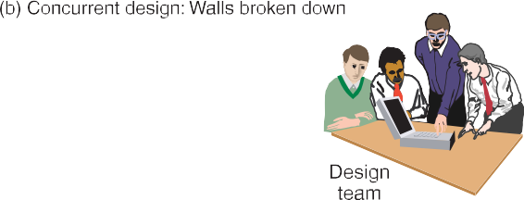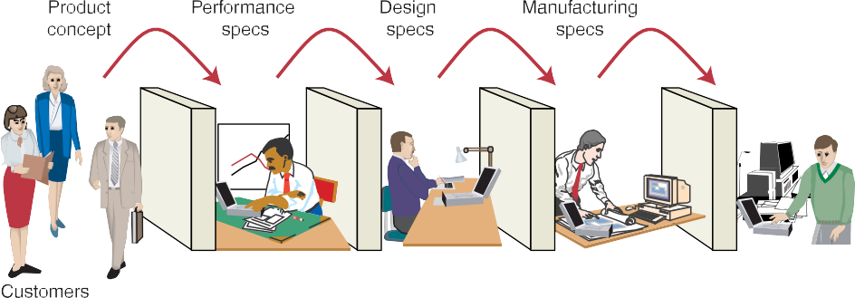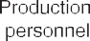
Figure 3.1: Difference between the “over-the-wall” approach and concurrent engineering
Remanufacturing: is a concept that has been gaining increasing importance as our society becomes more environmentally conscious and focuses on recycling and eliminating waste. Remanufacturing uses components of old products in the production of new ones.
Quality function deployment: The key purpose of quality function deployment is to try to ensure that the eventual design of a product or service actually meets the needs of its customers. Customers may not have been considered explicitly since the concept generation stage and therefore it is appropriate to check that what is being proposed for the design of the product or service will meet their needs. Defining the relationship is the first step in building a world-class production system. To build the house of quality, we perform seven basic steps:
- Identify customer wants. (What do prospective customers want in this product?)
- Identify how the good/service will satisfy customer wants. (Identify specific characteristics, features, or attributes and show how they will satisfy customer wants).
- Relate customer wants to product how’s. (Build a matrix as the following figure shows this relationship.)
- Identify relationships between the firms how’s. (How do our how’s tie together?)
- Developing importance ratings. (Using the customer’s importance ratings and weights for the relationships in the matrix, compute our importance ratings.)
- Evaluate computing products. (How well do competing products meet customer wants?)
- Determine the desirable technical attributes, your performance, and the competitor’s performance against this attribute.
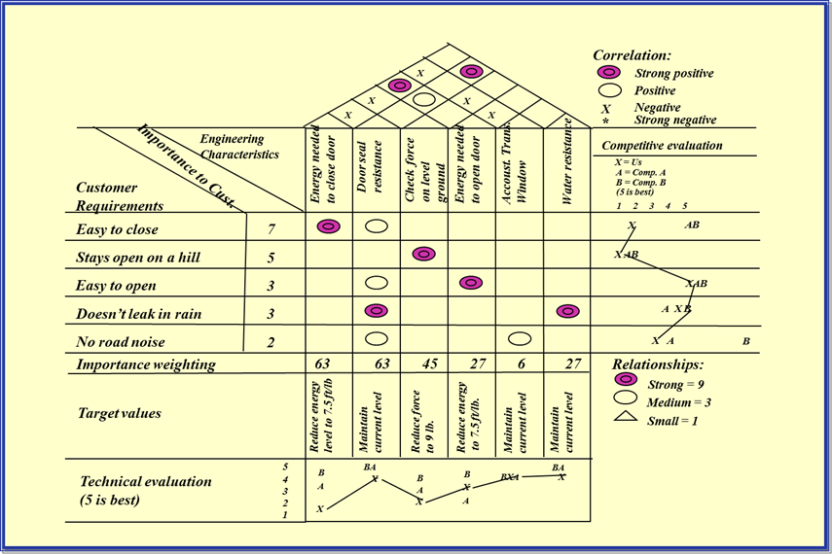
Figure 3.2: House of quality
Ethics and Environmentally Friendly Designs: It is possible to enhance productivity, drive down costs, and preserve resources. Ethics and Environmentally Friendly Designs is Effective at any stage of the product life cycle includingDesign, Production, Destruction, View product design from a systems perspective, Inputs, processes, outputs, Costs to the firm/costs to society, and Consider the entire life cycle of the product. The Goals for Ethical and Environmentally Friendly Designs are; Developing safe and more environmentally sound products, Minimizing waste of raw materials and energy, Reduce environmental liabilities, Increase cost-effectiveness of complying with environmental regulations, and Be recognized as a good corporate citizen
Dear friends, the following are Guidelines for Environmentally Friendly Designs
- Make products recyclable
- Use recycled materials
- Use less harmful ingredients
- Use lighter components
- Use less energy
- Use less material
Make or buy: For many products, firms have the option of producing components or purchasing them from outside sources. Choosing between these options is known as the make-or-buy decision. The make-or-buy decision distinguishes between what the firm is willing to produce and what it is willing to purchase. Many items can be purchased as a “standard item” produced by someone else. Such a standard item does not require its own bill-of-material or engineering drawing because its specification as a standard item is adequate.

Design of services and flexible manufacturing systems
Activity 1
What are the processes in designing service? What is flexible manufacturing system? Give a specific example of how product simplification principles have been used in the design of a common service product.
______________________________________________________________________________
Dear learners, as all of us are aware in the previous topic we have discussed the design and development of manufactured products. The product-development process discussed there also applies to the design and development of new services; however, there are several important differences.
Dear students, in planning manufactured products, a great deal of attention must be paid to technical specifications such as size, weight, and engineering specifications. For physical characteristics, standard may be determined and the conformance to these standards can be monitored for quality assurance. The quality of services, on the other hand, depends on the skill and training of personnel who produce the services. It is more difficult to set standards on performance, and consistent quality is more difficult to ensure. For example, all meals on an airline may be of the same quality, but service may vary considerably with different flight crews. Another important difference between manufactured products and services is that manufactured products can be stored for future use, whereas services must be made available to the customer on demand. This difference is another important consideration for quality assurance. The general design principles and procedures, such as simplicity, CE, and prototyping, apply to designing service products as well as goods. However, there are additional considerations of special importance when designing service products. These are: To what extent will the customer be involved in the process? How quickly will service be provided? How standardized or customized will the service be? What variety of services will be offered? and What geographical area will be served?
Dear students, you now understand the basic difference between product and service design. Now request you all to pay due attention to the concept of Flexible Manufacturing System (FMS).
Activity
When FMS is appropriate?
______________________________________________________________________________
Dear students, An FMS is generally appropriate when:
- All products are variations of a stable basic design
- All products utilize the same family of components
- The number of components is only moderate (10 to 50)
- The volume of each component is moderate (1000 to 30,000 units annually), but in lot sizes as small as one unit.
Activity
Dear learners, can you now tell me some of its main advantages?
______________________________________________________________________________
Well, here goes. The Main advantages of FMS are: -
- Improved capital utilization
- Lower direct labor cost
- Reduced inventory
- Consistent quality
Dear students, please bear in mind that an FMS also has certain disadvantages. Let me discuss these now. The disadvantages of FMS are: -
- Limited ability to adapt to changes in product
- Substantial preplanning and capital
- Tooling and fixture requirements

PROCESS SELECTION
Dear learners, in the previous section we focused on the product and service designs. After products and services design now, we concentrate on process selection. To make products or provide services, a process is a prerequisite.
Students, in this topic we will address various issues related to process selection.
Activity
Dear students, does anyone have any idea as to the situations when Process decisions must be made?
_____________________________________________________________________________________
Let me help you out in the process. Process decisions must be made when
- A new or substantially modified product or service is being offered
- Quality must be improved
- Competitive priorities have changed
- Demand for a product or service is changing
- Current performance is inadequate
- The cost or availability of inputs has changed
- Competitors are gaining by using a new process; or
- New technologies are available
Classification of process selection
All processes can be grouped into two broad categories: intermittent operations and repetitive operations.
Intermittent Operations: Intermittent operations are used to produce a variety of products with different processing requirements in lower volumes. Examples are an auto body shop, a tool and die shop, or a healthcare facility.
Repetitive Operations: Repetitive operations are used to produce one or a few standardized products in high volume. Examples are a typical assembly line, cafeteria, or automatic car wash. Resources are organized in a line flow to efficiently accommodate production of the product. Note that in this environment it is possible to arrange resources in a line because there is only one type of product.To efficiently produce a large volume of one type of product, these operations tend to be capital intensive rather than labor intensive. An example is “mass-production” operations, which usually have much invested in their facilities and equipment to pro- vide a high degree of product consistency.
Activity
Differentiate between Intermittent and Repetitive Operations?
_____________________________________________________________________________________
Dear learners, here is the differences;
Table 3.1: Differentiate between Intermittent and Repetitive Operations
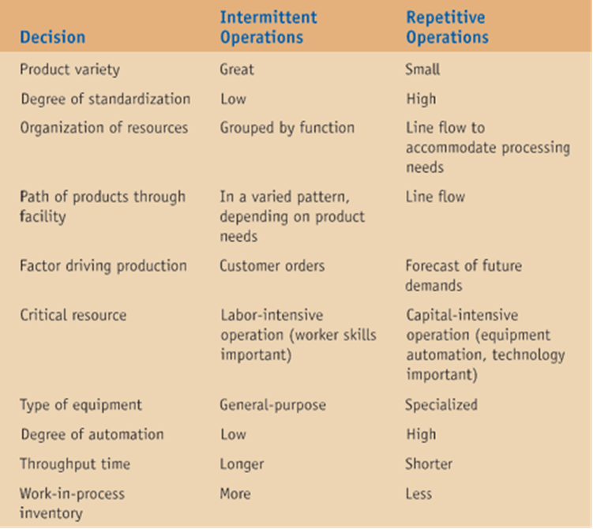
Dear learners, the Continuum of Process types dividing processes into two fundamental categories of operations is helpful in our understanding of their general characteristics. To be more detailed, we can further divide each category according to product volume and degree of product standardization, as follows. Intermittent operations can be divided into project processes and batch processes. Repetitive operations can be divided into line processes and continuous processes.
Dear learners, let’s now focus on the various constituents.
Project process: In fact, some manufacturer’s processes provide a service and do not involve manufacturing, as demonstrate with project process examples. A high degree of job customization, the large scope of each project, and the release of substantial resources characterize a project process.
A job process creates the flexibility needed to produce a variety of products or services in significant quantities. Customization is relatively high and volume for any one product or service is low. A job process primarily organizes all like resources around itself; equipment and workers capable of certain types of work are located together. These resources process all jobs requiring that type of work. This process choice creates jumbled flows through the operations as customization is high and most jobs have a different sequence of processing steps.
Dear students, after job process let’s analyze batch process. A batch process (disconnected flow processes) differs from the job process with respect to volume, variety, and quantity. The primary difference is that volumes are higher because the same or similar products or services are provided repeatedly. Another difference is that a narrower range of products and services is provided.
Then moving over to the Line process; a line process (repetitive or discrete flow process) lies between the batch and continuous processes on the continuum; volumes are high, and products or services are standardized, which allows resources to be organized around a product or service. There are line flows, with little inventory held between operations. Each operation performs the same process over and over, with little variability in the products or services provided.
Dear students, we would focus now on continuous process. A continuous process is the extreme end of high-volume, standardized production with rigid line flows. Its name derives from the way materials move through the process. Usually, the primary material, such as liquid, gas, or powder, moves without stopping through the facility. The processes seem more like separate entities than a series of connected operations.
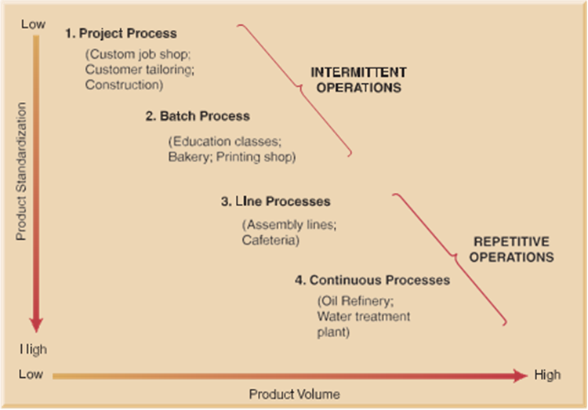
Figure 3.3: Different types of process selection
Note that both project and batch processes have low product volumes and offer customization. The difference is in the volume and degree of customization. Project processes are more extreme cases of intermittent operations compared to batch processes. Also, note that both line and continuous processes primarily produce large volumes of standardized products. Again, the difference is in the volume and degree of standardization. Continuous processes are more extreme cases of high volume and product standardization than are line processes.
Cellular processes
Organizations often capture some of the efficiencies of flow processes and the flexibility of job-shop processes by creating hybrids of the two, called cellular processes. A cellular process can be thought of as a mixture of mini flow processes, called work cells (or cells), and a job-shop operation. The work cells may perform only two or three activities in a spatially connected flow process, or they may perform several activities connected in sequence. Cellular processes are most commonly used as substitutes for job-shop processes that need increased productivity.

CAPACITY PLANNING

Meaning
Capacity: can be defined as the maximum output rate that can be achieved by a facility. The facility may be an entire organization, a division, or only one machine. Planning for capacity in a company is usually performed at two levels, each corresponding to either strategic or tactical decisions.
Capacity planning is the process of establishing the output rate that can be achieved by a facility.

Capacity planning is to be carried out keeping in mind future growth and expansion plans, market trends, sales forecasting, etc. Capacity decisions are strategic in nature. Capacity is usually expressed as volume of output per period of time. Capacity planning is the first step when an organization decides to produce more or new products.
Activity
Why is capacity planning important?
______________________________________________________________________________
If a company does not plan its capacity correctly, it may find that it either does not have enough output capability to meet customer demands or has too much capacity sitting idle. Planning for capacity is important if a company wants to grow and take full advantage of demand. At the same time, capacity decisions are complicated because they require long-term commitments of expensive resources, such as large facilities.

Measuring Capacity
Dear students, earlier we described capacity as one of the basic measures of performance. The capacity of a process sets the maximum amount of a product that can be made in a given time. All operations have some limit on their capacity: a factory has a maximum number of units it can make a week; a university has a maximum intake of students; an airplane has a maximum number of seats.
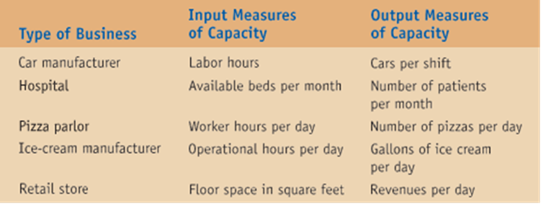
Designed and effective Capacity
Production systems design involves planning for the inputs, transformation activities, and outputs of a production operation. Design plays a major role because they entail significant investment of funds and establish cost and productivity patterns that continue in future. The capacity of the manufacturing unit can be expressed in number of units of output per period. The relationship between capacity and output is shown in the following figure.
Figure 3.4: capacity and output relationship

The capacity of a process is its maximum output. We can arrow for these effects by defining several types of capacity as follows:
Designed Capacity is the maximum possible output in ideal conditions.
Effective Capacity is the maximum realistic output in normal conditions.
Actual output is normally lower than effective Capacity.
Dear learners, following are two of the most common measures of capacity.

Design capacity is the maximum output rate that can be achieved by a facility under ideal conditions. In our example, this is 30 pies per day.
Design capacity can be sustained only for a relatively short period of time. A company achieves this output rate by using many temporary measures, such as overtime, over- staffing, maximum use of equipment, and subcontracting. For example, the designed capacity of the cement plant is 100TPD (Tones per day).
Effective capacity is the maximum output rate that can be sustained under normal conditions. These conditions include realistic work schedules and breaks, regular staff levels, scheduled machine maintenance, and none of the temporary measures that are used to achieve design capacity.

Note that effective capacity is usually lower than design capacity. The system efficiency is expressed as ratio of actual measured output to the system capacity.
Discrete capacity
Capacity can be increased by using another machine, opening another shop, employing another person, using another vehicle, building another factory, and so on. Capacity utilization simply tells us how much of our capacity we are actually using. Capacity utilization can simply be computed as the ratio of actual output over capacity:
Actual output
Efficiency = Effective capacity
Actual output
Utilization = Design capacity
Illustration 1: Dear students; lets solve the following example. Given the information below, compute the efficiency and the utilization of the vehicle repair Department.
Design capacity = 100 trucks/day
Effective capacity = 80 trucks/day
Actual output = 72 units/day
Solution
Efficiency = actual output/ effective capacity = 72units per day/80 unitsper day = 90%
Utilization = actual output/ design capacity = 72 units per day/100 units per day = 72%

Process of Capacity Planning
Capacity planning is concerned with defining the long-term and the short-term capacity needs of an organization and determining how those needs will be satisfied. Capacity planning decisions are taken based upon the consumer demand and this is merged with the human, material and financial resources of the organization. Capacity requirements can be evaluated from two perspectives—long-term capacity strategies and short-term capacity strategies.
- Long-term capacity strategies: Long-term capacity planning is concerned with accommodating major changes that affect overall level of the output in long-term. Marketing environmental assessment and implementing the long-term capacity plans in a systematic manner are the major responsibilities of management.
- Short-term capacity strategies: Many short-term adjustments for increasing or decreasing capacity are possible. The adjustments to be required depend upon the conversion process like whether it is capital intensive or labor intensive or whether product can be stored as inventory. Capital-intensive processes depend on physical facilities, plant and equipment. Short-term capacity can be modified by operating these facilities more or less intensively than normal. In labor intensive processes short-term capacity can be changed by laying off or hiring people or by giving overtime to workers.
The short-term capacity strategies are: Inventories, Backlog, Employment level (hiring or firing), Employee training, Subcontracting, Process design, and Making Capacity Planning Decisions
Activity
Dear learners, can you guess the steps in capacity planning decision?
______________________________________________________________________________
Let’s look at these steps in a little more detail.The three-step procedure for making capacity planning decisions is as follows:
Step 1: Identify Capacity Requirements
Step 2: Develop Capacity Alternatives
Step 3፡ Evaluate Capacity Alternatives
Tactics for Matching Capacity to Demand
- Making staffing changes (increasing or decreasing the number of employees or shifts)
- Adjusting equipment
- Purchasing additional machinery
- Selling or leasing out existing equipment
- Improving processes to increase throughput
- Redesigning products to facilitate more throughput
- Adding process flexibility to meet changing product preferences
- Closing facilities
Capacity Cushions: Companies often add capacity cushions to their regular capacity requirements. A capacity cushion is an amount of capacity added to the needed capacity in order to provide greater flexibility. Capacity cushions can be helpful if demand is greater than expected. Also, cushions can help the ability of a business to respond to customer needs for different products or different volumes.

FACILITY LOCATION AND LAYOUT

Facility Location
Location of an industry is an important management decision. It is a two-step decision: first, choice of general area or region and second, the choice of site within the area selected. The objective of plant location decision-making is to minimize the sum of all costs affected by location. Plant location is important because of the following:
- Location influences plant layout facilities needed.
- Location influences capital investment and operating costs.
Location decisions are strategic, long-term and non-repetitive in nature. Without sound and careful location planning in the beginning itself, the new facilities may create continuous operating problems in future.

Activity
Define facility location

Facility location is determining the best geographic location for a company’s facility.
Facility location decisions are particularly important for two reasons. First, they require long-term commitments in buildings and facilities, which means that mistakes can be difficult to correct. Second, these decisions require sizable financial investment and can have a large impact on operating costs and revenues. Poor location can result in high transportation costs, inadequate supplies of raw materials and labor, loss of competitive advantage, and financial loss.
Need for Location Decisions
- Location decisions arise for a variety of reasons:
- Addition of new facilities
- As part of a marketing strategy to expand markets
- Growth in demand that cannot be satisfied by expanding existing facilities
- Depletion of basic inputs/resources (e.g. mining & fishing)
- Cost advantages
Strategic Importance of Location Decisions
- Location decisions are strategically important:
- Are closely tied to an organization’s strategies
- Effect capacity and flexibility
- Represent a long-term commitment of resources/costs
- Impact competitive advantage
- Importance to supply chains
- Impact on investments, revenues, and operations
Factors Affecting Location Decisions
Activity
Can you specify some of the factors that affect location decisions?
_________________________________________________________________________________________________________________________________________________________________________________________________________________________________.
Many factors can affect location decisions, including proximity to customers, transportation, source of labor, community attitude, proximity to suppliers, and many other factors. The nature of the firm’s business will determine which factors should dominate the location decision.
Dear learners, next we look more closely at some factors that affect location decisions.
- Proximity to Sources of Supply
- Proximity to Customers
- Proximity to Source of Labor
- Community Consideration
- Site Considerations፡
- Quality-of-Life Issues
- Globalization
Making Location Decisions
Dear students, as with capacity planning, managers need to follow a three-step procedure when making facility location decisions. These steps are as follows:
Step 1: Identify Dominant Location Factors.
Step 2: Develop Location Alternatives.
Step 3: Evaluate Location Alternatives.
Procedures for Evaluating Location Alternatives
A number of procedures can help in evaluating location alternatives. These are decision- support tools that help structure the decision-making process. Some of them help with qualitative factors that are subjective, such as quality of life. Others help with quantita- tive factors that can be measured, such as distance.
Factor Rating: You have seen by now that many of the factors that managers need to consider when evaluating location alternatives are qualitative in nature. An excellent procedure that can be used to give structure to this process is called factor rating. Factor rating can be used to evaluate multiple alternatives based on a number of selected factors. The following steps are used to develop a factor rating:
Step 1: Identify dominant factors (e.g., proximity to market, access, competition, quality of life).
Step 2: Assign weights to factors reflecting the importance of each factor relative to the other factors. The sum of these weights must be 100.
Step 3: Select a scale by which to evaluate each location relative to each factor. A commonly used scale is a five-point scale, with 1 being poor and 5 excellent.
Step 4: Evaluate each alternative relative to each factor, using the scale selected in Step 3. For example, if you chose to use a five-point scale, a location that was excel- lent based on quality of life might get a 5 for that factor.
Step 5: For each factor and each location, multiply the weight of the factor by the score for that factor and sum the results for each alternative. This will give you a score for each alternative based on how you have rated the factors and how you have weighted each of the factors at each location.
Step 6: Select the alternative with the highest score.
The Center of Gravity Approach: When we used the load–distance model, we com- pared only two location alternatives. An easy way to do this is to start by testing the location at the center of gravity of the target area. The X and Y coordinates that give us the center of gravity for a particular area are computed in the following way:
X_{c.g} = $\frac{GiXi}{Xi}$
Y_{c.g} =$\frac{GiYi}{Yi}$
c.g = Center of gravity
The X coordinate for the center of gravity is computed by taking the X coordinate for each point and multiplying it by its load. These are then summed and divided by the sum of the loads. The same procedure is used to compute the Y coordinate.The location identified with the center of gravity puts a larger penalty on long dis- tances. This can have practical value given that longer distances impose more costs on the organization. However, the location identified may not be a feasible site be- cause of geographic restrictions.

What kinds of location decisions are appropriate for use of center-of-gravity analysis? What variable is being optimized in this analysis?
__________________________________________________________________________________________________________________________________________.
Break-Even Analysis Break-even analysis: is a technique used to compute the amount of goods that must be sold just to cover costs. The break-even point is precisely the quantity of goods a company needs to sell to break even. Whatever is sold above that point will bring a profit.
Dear learners, remember that break-even analysis works with costs, such as fixed and variable costs. It can be an excellent technique when the factors under consideration can be expressed in terms of costs. Let’s briefly review the basic break-even equations:
Total cost = F + cQ
Total revenue = pQ
where F = fixed cost, c = variable cost per unit, Q = number of units sold, p = price per unit
At the break-even point, total cost and total revenue are equal. We can use those equations to solve for Q, which is the break-even quantity:
$$Q=\frac{F}{p-c}$$
Step 1: For Each Location, Determine Fixed and Variable Costs.
Step 2: Plot the Total Costs for Each Location on One Graph. To plot any straight line we need two points. One point is Q = 0, which is the y intercept. An- other point can be selected arbitrarily, but it is best to use the expected volume of sales in the future.
Step 3: Identify Ranges of Output for Which Each Location Has the Lowest Total Cost.
Step 4: Solve Algebraically for the Break-Even Points over the Identified Ranges. Select the location that gives the lowest cost for the range of output required by the new facility.
Assumptions
- Fixed costs are constant
- Variable costs are linear
- Output can be closely estimated
- Only one product involved

Example 1: Cost-Volume Analysis
Fixed and variable costs for four potential locations and the expected output level is 10,000 units per year.
Table 3.2: Fixed and variable costs
Location |  | Fixed Cost |  | Variable Cost (Dollars)
A |  | 250,000 |  | 11
B |  | 100, 000 |  | 30
C |  | 150,000 |  | 20
D |  | 200,000 |  | 35
Location | Fixed Cost |  | Variable Cost (Dollars) |  | Total Cost (Dollars)
A | 250,000 |  | 11 (10,000) |  | 360,000
B | 100, 000 |  | 30(10,000) |  | 400,000
C | 150,000 |  | 20(10,000) |  | 350,000
D | 200,000 |  | 35(10,000) |  | 550,000
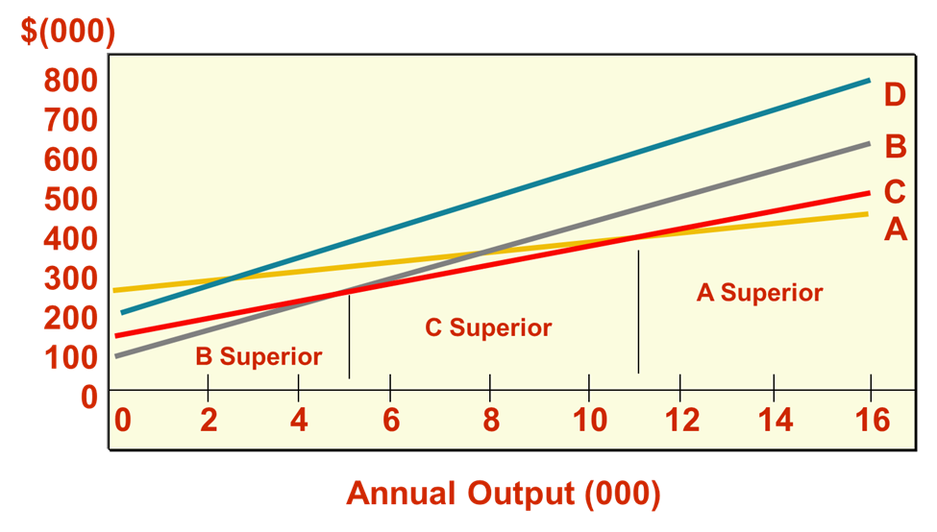
Figure 3.5: Cost volume analysis
The Transportation Method: The transportation method of linear programming is a useful technique for solving specific location problems; the method relies on a specific algorithm to evaluate the cost impact of adding potential location sites to the network of existing facilities. For example, an existing network of facilities may consist of multiple sending and receiving sites. Our task might be to evaluate adding a new location site to this network, either a receiving site or a sending site. We might also wish to evaluate adding multiple new sites or completely redesigning the network.

Facility Layout
Dear learners, now we shall deal with the arrangement of work areas and equipment. Plant layout is related to a number of aspects of production and operations management. This, we shall bring out, while discussing as to what results a good plant layout should produce.

Layout planning is deciding on the best physical arrangement of all resources that consume space within a facility. These resources might include a desk, a work center, a cabinet, a person, an entire office, or even a department.
Decisions about the arrangement of resources in a business are not made only when a new facility is being designed; they are made any time there is a change in the arrangement of resources, such as a new worker being added, a machine being moved, or a change in procedure being implemented. Also, layout planning is performed any time there is an expansion in the facility or a space reduction.
To develop a good facility layout, what must be determined?
______________________________________________________________________________
Features of Layout
- Ease of Working, Maximum Safety, and Minimum Health
- Hazards for People Working in/Using the Facility
- Minimum Handling of Materials
- Minimum Damage and Spoilage of Materials
- Reduced Congestion of Materials, Machinery and Men
- Flexibility with Regard to Changing Production Conditions
Types of layouts
There are four basic layout types: process, product, hybrid, and fixed position.
Process Layouts or Layout by Function

Process layouts are layouts that group resources based on similar processes or functions. This type of layout is seen in companies with intermittent processing systems.
This is typical of the job-shop type of production where the equipment performing similar operations is grouped together. For instance, grinding machines could be grouped together to form a work area, milling machines could be grouped together, drilling machines could be grouped together, etc.
Activity 1
Why is a process layout suited to job-shop type production?
___________________________________________________________________________________________________________________________________.
Job-shop type production is characterized by a large variety of jobs, which are distinct from each other. If the machines performing similar operations are grouped together, the idle times of machines and operators can be better controlled and better time-shared thereby increasing machine and labour utilization.
Product Layouts and Line Production

Product layouts are layouts that arrange resources in a straight-line fashion to promote efficient production. They are called product layouts because all resources are arranged to meet the production needs of the product. This type of layout is used by companies that have repetitive processing systems and produce one or a few standardized products in large volume.
The equipment here is laid out according to the sequence in which it is used for making the product layout is usually suitable for assembling operations, for example in the automobile industry. Since a machine is assigned for each operation, the amount of equipment’s in a Product layout is much more as compared to the Process layout Therefore; the utilization of the equipment has to be sufficiently high to justify the higher level of capital investment necessary in a Product layout.
Characteristics of Process and Product Layouts
Table 3.3: Characteristics of Process and Product Layouts
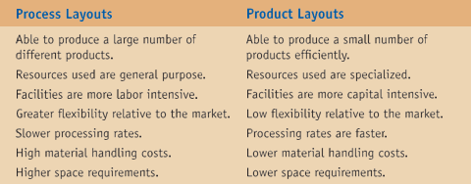
Hybrid Layouts
Hybrid layouts combine aspects of both process and product layouts. This is the case in facilities where part of the operation is performed using an intermittent processing system and another part is performed using a continuous processing system. Hybrid layouts are often created in an attempt to bring the efficiencies of a product layout to a process layout environment.
Fixed-Position Layouts
A fixed-position layout is used when the product is large and cannot be moved due to its size.

In fixed position layouts all the resources for producing the product including equipment, labor, tools, and all other resources have to be brought to the site where the product is located.
Examples of fixed-position layouts include building construction, dam or bridge construction, shipbuilding, or large aircraft manufacture. The challenge with a fixed-position layout is scheduling different work crews and jobs and managing the project.
Other Service Layouts
Warehouse Layouts: Warehouse layouts have the key characteristics of process layouts: products are stored based on their function, and there is movement of goods. The main difference is that movement within a warehouse is primarily between the loading/unloading dock and the areas where goods are stored.
Office Layouts: Office layouts are another special case of process layouts. Merely looking at the number of trips between departments or the movement of goods is not sufficient to design a good office layout because human interaction and communication are the primary factors that need to be considered when designing office layouts.
Retail layouts: Allocates shelf space and responds to customer behavior.
Designing Product Layouts
This type of layout is used in repetitive processing systems that produce a large volume of one standardized product. In product layouts the material moves continuously and uniformly through a sequence of operations until the work is completed. The sequence of operations allows for the simultaneous performance of work. To accomplish this, we need to consider the logical order of the tasks to be performed and the time required to perform each task. Also, we need to consider the speed of the production process, which will tell us how much time there is at each workstation to perform the assigned tasks. This entire process is called line balancing. Next we will go through the steps that must be followed in designing product layouts.
Line balancing: is the process of assigning tasks to workstations in a product layout in order to achieve a desired output and balance the workload among stations. The goal of line balancing is to minimize idle time along the line and result in high utilization of labor and equipment.
Cycle time: is the maximum time allowed at each work station to perform assigned task a before the work moves on.
Output capacity = $\frac{OT}{CT}$
Where; OT- operating time per day
CT-Cycle time
Example: Suppose that work required to fabricate a certain product can be divided into five elemental tasks, with the task times and precedence relationship as shown below.
0.2 minute
0.7 minute
1.0 minute
0.5 minute
0.1minute
Precedence Diagram: a diagram that shows elemental tasks and their precedence requirements.
The task times govern the range of possible cycle times.
Minimum cycle time: is equal to the longest task time (1.0 min) and the maximum cycle time is equal to the sum of task times. (0.1+0.7+1.0+0.5+0.2=2.5 minutes)
Maximum Cycle time would apply if all tasks were performed at a single work station where as minimum cycle time would apply if there were five work stations.
Example: Assume that line will operate for 8 hours per day (480 minutes). With a cycle time of 1.0-minute, output would be;
$\frac{480\min{}}{1.0\min{}}$= 480 unit per day
With a cycle time of 2.5 min, the output would be:
$\frac{480\min{}}{2.5\min{}}$ = 192 units per day
Cycle time = $\frac{TOT}{D}$ , Where: OT- Operating time per day and D- Desired output rate
NB. If the cycle time does not fall between the maximum and minimum bounds, the desired output rate must be revised. For example, suppose that the desired output rate is 480 units and the operating time per day is 480 minutes per day, the cycle time is:
$\frac{480 minutes}{480 minutes}$ = 1.0 minutes per unit.
Determining the minimum number of work stations required
We can determine the theoretical minimum number of stations necessary to provide a specific rate of output as follows:
N_{min} =$\frac{D∑t}{CT}$
Where: N_{min} – theoretical minimum number of work stations
$∑t$ – Sum of task times and CT- Cycle time
Example: suppose that the desired rate of output is the maximum of 480 units per day. (This will require a cycle time of 1.0 minute). The minimum number of work stations required to achieve is;
$∑t$ = (0.1+0.7+1.0+0.5+0.2) = 2.5 minutes per unit
N_{min} =$\frac{480 units per day X 2.5 minutes per day }{480 minutes per day}$ = 2.5 stations
Because 2.5 stations are not feasible, it is necessary to round up to 3 stations.
Example: Assembly line Balancing
Percentage of idle time of the line: also called balance day: percentage of idle time of a line
Percentage of idle time =$\frac{idle time per cycle }{Nactual X cycle time}$X 100
Where: N actual –Actual number of work stations
So, Percentage of idle time = $\frac{0.5 }{3 }$ X 1 X 100 = 16.7%
Efficiency: the ratio of total productive time divided by total time, given as a percentage or
Efficiency = 100% - percent idle time
Here efficiency = 100%-16.7% = 83.3%
Heuristic (Intuitive) Rule
Generally, no techniques are available that guarantee an optimal set of assignments. So this provides good and sometimes optimal set of assignments. It is used to select one of the tasks that will fit and a task is assigned. The objective is to minimize idle time.
- The sum of task times assigned to any work station must not exceed the cycle time.
- If a task can be assigned to a work station without exceeding the cycle time, then the task will fit.
Example 2
Using the information contained in the table shown, do each of the following
- Draw a precedence diagram
- Assuming an 8-hour workday, compute the cycle time needed to obtain an output of 400 units per day.
- Determine the minimum number of work stations required.
- Assign task to work stations using this rule: assign tasks according to greatest number of following tasks. In case of a tie, use the tie breaker of assigning the task with the longest processing time first.
Task | Immediate follower | Task time (in minutes)
A | B | 0.2
B | E | 0.2
C | D | 0.8
D | F | 0.6
E | F | 0.3
F | G | 1.0
G | H | 0.4
H | End | 0.3
 |  | ∑t = 3.8
- Compute the resulting efficiency of the system

Solution
- 0.2 0.2 0.3
a

f
d
b
e
c
g
h

0.8 0.6 1.0 0.4 0.3
2. Cycle time = $\frac{OT}{D}$ = $\frac{480 minutes per dya}{400 units per day}$ = 1.2 minutes per cycle
3. N_{min} =$\frac{D∑t}{OT}$ : N_{min} =$\frac{480 units per day X 3.8 units per minutes}{480 units per day per station}$ = 3.17 stations (round up to 4) = 4
4. Assigning tasks to work station
Station | Time Remaining | Eligible | Will fit | Assign (task time) | Revised Remaining | Idle
1 | 1.2 | a, c* | a, c* | a(0.2) | 1.0 | -
 | 1.0 | c, b** | c, b** | c(0.8) | 0.2 | -
 | 0.2 | b, d | B | b(0.2) | 0.0 | -
 | 0.0 | e, d | None | - | - | 0.0
2 | 1.2 | e, d | e, d | d(0.6) | 0.6 | -
 | 0.6 | E | E | e(0.3) | 0.3 | -
 | 0.3*** | F | None | - | - | 0.3
3 | 1.2 | F | F | f(1.0) | 0.2 | -
 | 0.2 | G | None | - | - | 0.2
4 | 1.2 | G | G | g(0.4) | 0.8 | -
 | 0.8 | H | H | h(0.3) | 0.5 | -
 | 0.5 | - | - | - | - | 0.5
 |  |  |  |  | Total | 1.0 minute
C*- neither A or C has many predecessors, so both are eligible. Task A was assigned since it has more followers.
B** - once A is assigned, B and C are now eligible. Both will fit in the time remaining of 1.0 minute. The tie cannot be broken by the ‘most followers’ rule, so the longer task is assigned.
0.3*** - although F is eligible, this task will not fit, so station 2 is left with o.3 minute of idle time per 1.2-minute cycle.
Percentage of idle time =$\frac{idle time per cycle }{Nactual X cycle time}$X 100፡
So, Percentage of idle time = $\frac{1}{4X 1.2}$ X 100 = 20.833%
5. Efficiency = 100%-20.83% = 79.17%
Site selection
Site selection is not an easy problem because if the selection is-not proper then all money spent on factory building, machinery and their installation etc. will go as waste and the owner has to suffer a great loss.
The problem of the selection of a factory or a plant can be solved in the following two stages: The general location of the plant and the selection of a particular site.
(A) The General Location of the Plant
Following factors must be considered for selecting a region where the factory is to be located:
- Availability of Raw Materials.
- Proximity of Markets.
- Transport Facilities.
- Availability of Power and Fuel.
- Climatic and Atmospheric Conditions
- Availability of Water.
- Availability of capital
- Social and Recreational Facilities.
- Business and Commercial Facilities.
- Existence of Related Industries.
- Other Factors. The factors like Local bye-laws, Taxes, Fire protection facilities, Post and Telegraph facilities should also be considered.
(B) Selection of a Particular Site
After selecting a general area for the plant, next step is to select a suitable site in that area. This is most important consider technical commercial and financial aspects so as to take maximum advantage. Important points which should be considered while selecting a site are: Community attitude, Community facilities, Transportation facilities, Topography, Waste disposal, Ecology and pollution, Size of land, Supporting Industries.

JOB DESIGN AND WORK MEASUREMENT
First a company determines its objectives, and then it develops an operations strategy to achieve those objectives. Part of the operations strategy is designing a work system, which provides the structure for the productivity of the company. The work system includes job design, work measurement, and worker compensation. The company determines the purpose of each job, what the job consists of, and the cost of the employees to do the job. A job must add value and enable the company to achieve its objectives.

Job Design
Job design specifies the work activities of an individual or a group in support of an organization’s objectives.
Activity
To design your jobs, think about your job and answer the following questions: What is your description of the job? What is the purpose of the job? Where is the job done? Who does the job? What background, training, or skills does an employee need to do the job?
______________________________________________________________________________
If one of your company’s objectives is to establish itself as a leader in customer service, jobs must be designed to encourage and reward good customer service practices. In addition, performance measurements for each job must validate the behavior that supports the company’s objective. Let’s look at three additional factors in job design: technical feasibility, economic feasibility, and behavioral feasibility.
Technical Feasibility: The technical feasibility of a job is the degree to which an individual or group of individuals is physically and mentally able to do the job. The more demanding the job, the smaller is the applicant pool for that job.
Economic Feasibility: The economic feasibility of a job is the degree to which the value a job ads and the cost of having the job done create profit for the company. If the job as it is designed costs more than the value it adds, then it is not economically feasible.
Behavioral Feasibility: The behavioral feasibility of a job is the degree to which an employee derives intrinsic satisfaction from doing the job. The challenge is to design a job so the worker feels good about doing the job and adds value by doing it.
Specialization in Business: Specialization is work that concentrates on some aspect of a product or service. The higher the level of specialization, the narrower is the employee’s scope of expertise. The professions medicine, law, academics are highly specialized; however, some low- level assembly or service jobs are also specialized.
Table 3.5: Advantages and dis advantages of specialization
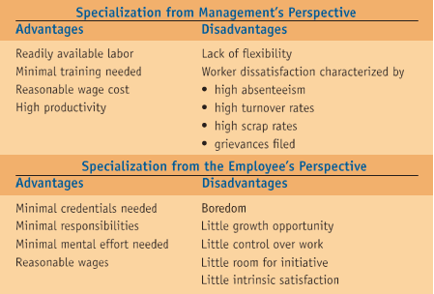
Eliminating Employee Boredom
Companies that choose highly specialized job design have several options for reducing worker boredom, including job enlargement, job enrichment, and job rotation.
Job enlargement: is the horizontal expansion of a job. The job designer adds other related tasks to the job so the worker produces a portion of the final product that he or she can recognize. For example, an assembly worker gets to do additional tasks that complete a portion of the final product, which enables the worker to experience pride in the final product.
Job enrichment: is the vertical expansion of a job. The job designer adds worker responsibility for work planning and/or inspection. This allows the worker some control over the workload in terms of scheduling although not in terms of how much work to do—and instills a sense of pride in the worker.
Job rotation: Exposes a worker to other jobs in the work system. Rotation allows workers to see how the output from their previous assignment is used later in the production or service process. Workers see more of the big picture and have a better over- all understanding of the work system. In addition, they acquire more skills that may increase their value to the company. Job rotation provides more flexibility for the company, as its workers have upgraded skills.
Team Approaches to Job Design: Another option for job design is using teams rather than individuals for certain assignments. Problem-solving teams, special-purpose teams, and self-directed teams are three different kinds of employee teams.
Ergonomics and the Work Environment
Ergonomics (human factors)
  - The scientific discipline concerned with the understanding of interactions among human and other elements of a system
  - Ergonomics is the study of the interface between man and machine
  - Operator input to machines
  - Feedback to operators
  - The work environment: Illumination, Noise, Temperature, Humidity
Three domains of ergonomics
  - Physical (repetitive movements, layout, health, safety)
  - Cognitive (mental workload, decision making, and work stress)
  - Organizational (communication, teamwork, work design, and telework)
Methods Analysis
Methods analysis: is the study of how a job is done. Whereas job design shows the structure of the job and names the tasks within the structure, methods analysis details the tasks and how to do them. Methods analysis is used by companies when developing new products or services and for improving the efficiency of methods currently in use. Suppose your restaurant has an accepted procedure for communicating a customer’s dinner choices to the kitchen without errors. Methods analysis documents this accepted procedure, including specific notations that identify customer preferences. The result is a standard operating procedure your restaurant can use for training new employees and for evaluating the performance of existing employees.
Motion Study: is systematic study of the human motions used to perform an operation
In developing work methods that are motion efficient, the analyst attempts to eliminate unnecessary motions, combine activities, reduce fatigue/tiredness, Improve the arrangement of the workplace, Improve the design of tools and equipment
Quality of Work Life: It is important for organizations to develop suitable compensation plans for their employees. The Compensation approaches are time-based systems, output-based (Incentive) systems, and knowledge-based systems.
What is quality of work life? What is its relation to a firm's human resource strategy?
______________________________________________________________________________

Work Measurement
The other component in work system design, work measurement, is a way of determining how long it should take to do a job. Work measurement techniques are used to set a standard time for a specific job. The standard time is the time it should take a qualified operator, working at a sustainable pace and using the appropriate tools and process, to do the job.
The standard time is the sustainable time it takes to do either a whole job or a portion or element of a job.

In our restaurant example, the time needed to take the customer’s order and communicate that information to the kitchen staff can be calculated as the standard time.
Work Measurement Techniques
The commonly used work measurement techniques:
- Stopwatch time study/time studies
- Historical times/historical experience/ standard elemental time
- Predetermined data/predetermined time standards
- Work Sampling
- Stopwatch Time Study/Time studies
It is used to develop a time standard based on observations of one worker taken over a number of cycles.
- Involves timing a sample of a worker’s performance and using it to set a standard
- Requires trained and experienced observers
- Cannot be set before the work is performed
Steps
- Define the task to be studied, and inform the worker who will be studied
- Divide the task into precise elements
- Decide how many times to measure the task (number of times or cycles needed)
- Time and record element times and rating of performance/time the job, and rate the worker’s performance
- Compute average observed time
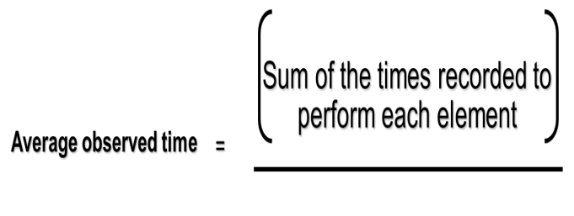
Number of observations
- Determine performance rating and normal time
Normal time = Average Observed Time x Performance Rating Factor
- Add the normal times for each element to develop the total normal time for the task
- Compute the standard time
Standard Time = $\frac{Total Normal Time}{1-Allowance Factor}$
Rest Allowances
- Personal time allowance
  - 4% - 7% of total time for use of restroom, water fountain, etc.
- Delay allowance
  - Based upon actual delays that occur
- Fatigue allowance
  - Based on our knowledge of human energy expenditure
Time Study Example 1
Average observed time = 4.0 minutes
Worker rating = 85%
Allowance factor = 13%
Normal time = (Average observed time) x (Rating factor)
= (4.0) x (.85) = 3.4 minutes
Standard Time = $\frac{Total Normal Time}{1-Allowance Factor}$ Standard Time = $\frac{3.4}{1-0.13}$ = 3.9 minutes

Time Study Example 2
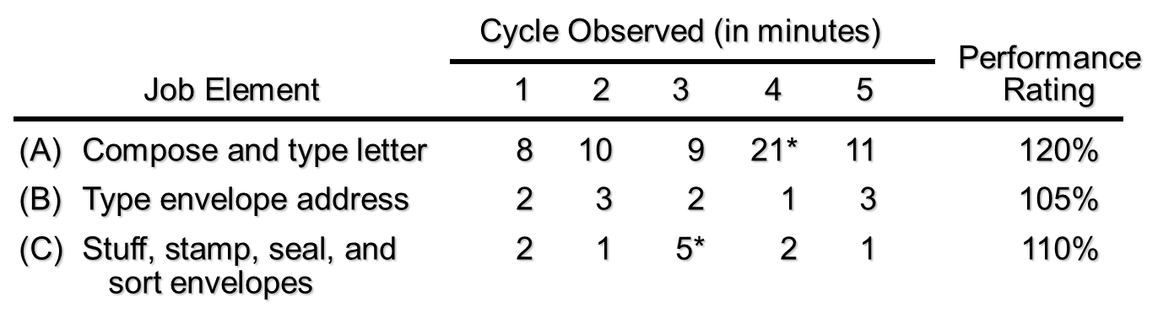
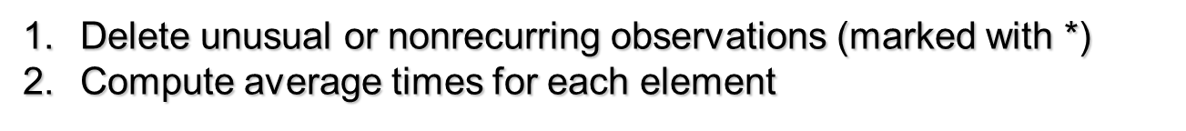
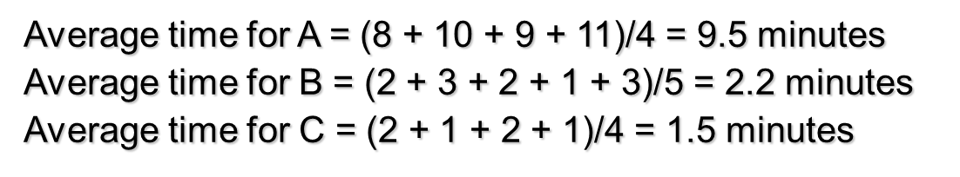
- Compute the normal time for each element
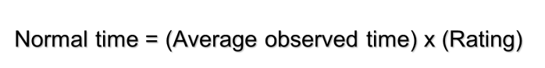
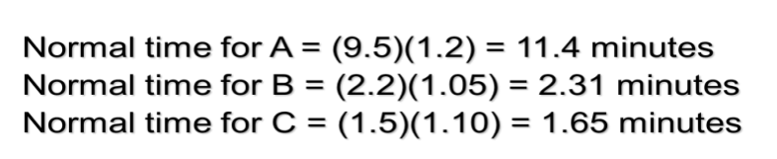
- Add the normal times to find the total normal time
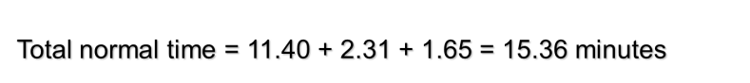
- Compute the standard time for the job
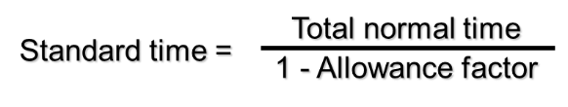
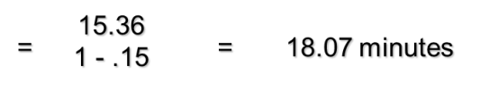
Determining Sample Size
- The number of cycles that must be timed is a function of three things:
- The variability of observed times
- The desired accuracy, and
- The desired level of confidence for the estimated job time
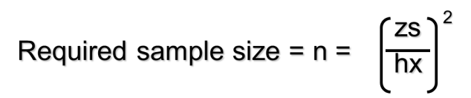
where h = accuracy level desired in percent of the job element expressed as a decimal
z = number of standard deviations required for the desired level of confidence
s = standard deviation of the initial sample
x = mean of the initial sample
n = required sample size

Common z Values
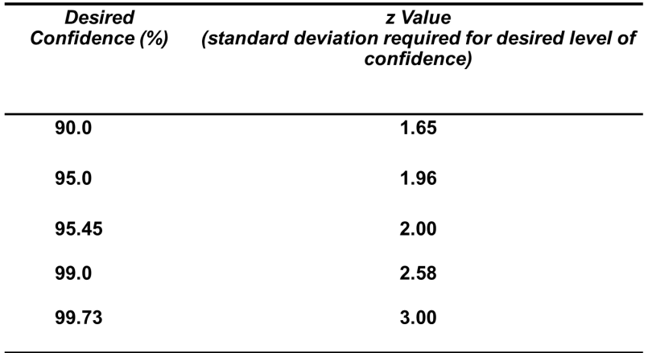
- Standard Elemental Times/historical experience
  - Are derived from a firm’s own historical time study data.
- How the task was performed last time
- Easy and inexpensive
- Data available from production records or time cards
- Data is not objective and may be inaccurate
- Not recommended
- Predetermined time standards
- Involve the use of published data on standard elemental times.
- Divide manual work into small basic elements that have established times
- Can be done in a laboratory away from the actual production operation
- Uses Methods Time Measurement (MTM)
- Can be set before the work is actually performed
- No performance ratings are necessary
- Work sampling
- A technique for estimating the proportion of time that a worker or machine spends on various activities and idle time.
- Estimates percent of time a worker spends on various tasks
- Requires random observations to record worker activity
- Determines how employees allocate their time
- Can be used to set staffing levels, re-assign duties, estimate costs, and set delay allowances
Advantages of work sampling
  - Less expensive than time study
  - Observers need little training
  - Studies can be delayed or interrupted with little impact on results
  - Worker has little chance to affect
results
  - Less intrusive / disturbance
Disadvantages of work sampling
  - Does not divide work elements as completely as time study
  - Can yield biased results if observer does not follow random pattern
  - Less accurate, especially when
job element times are short
Work Sampling Steps
- Take a preliminary sample to obtain estimates of parameter values
- Compute the sample size required
- Prepare a schedule for random observations at appropriate times
- Observe and record worker activities
- Determine how workers spend their time
Determining the sample size
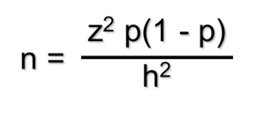
where n = required sample size
z = standard normal deviation for desired confidence level
p = estimated value of sample proportion
h = acceptable error level in percent
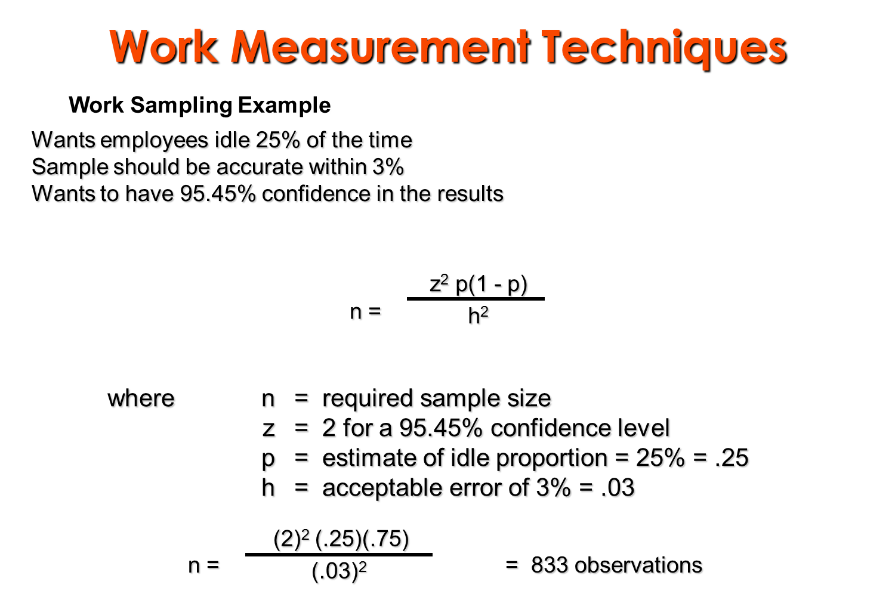
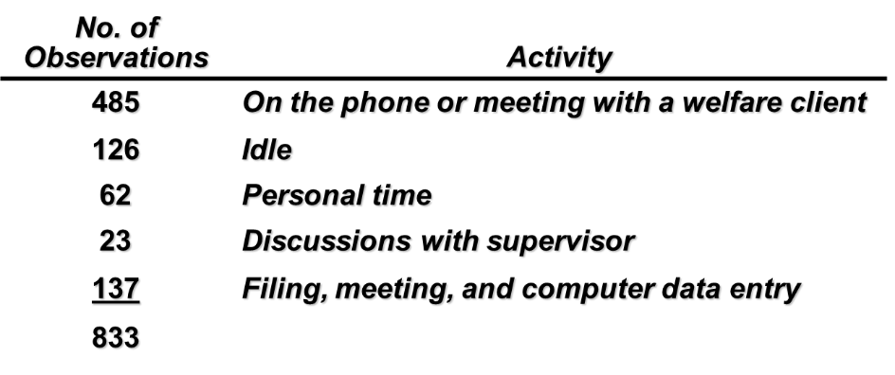
All but idle and personal time are work related.
Percentage idle time = (126 + 62)/833 = 22.6%.
Since this is less than the target value of 25%, the workload needs to be adjusted.

SUMMARY

Developing and designing great products are keys to success in business. Product and Service Design together form the very basis of design aspect of operations. After products and services design process selection should be concentrated, because to make products or provide services, a process is a prerequisite. Capacity planning is also to be carried out keeping in mind future growth and expansion plans, market trends, sales forecasting, etc. Location of an industry is another important management decision. It is a two-step decision: first, choice of general area or region and second, the choice of site within the area selected. In addition, the arrangement of work areas and equipment should be dealt since plant layout is related to a number of aspects of production and operations management. After a company’s objectives and operations strategy has developed, Part of the operations strategy is designing a work system that includes job design, work measurement, and worker compensation.
Check list
Part I: Say True if the Statement is Correct and False if it is Incorrect.
- Computer-aided design (CAD) refers to the use of specialized computer programs to direct and control manufacturing equipment.
- Robust design is a method that ensures that small variation in production or assembly does not adversely affect the product.
- The term “concurrent engineering” refers to having both engineering and manufacturing personnel working independently early in the design phase.
- Intermittent processes are organized around processes.
- Design capacity is the theoretical maximum output of a system in a given period under ideal conditions.
- Capacity decisions are based on technological concerns, not demand forecasts.
- The efficiency of our operations will increase as the ratio of design capacity to actual output increases (Design capacity divided by actual output).
- Process-oriented layouts typically have low levels of work-in-process inventory.
- The biggest advantage of a product layout is its flexibility to handle a varied product mix.
- An enlarged job has more responsibility than the same job enriched.
- The purpose of labor standards is to accurately define the skills required to complete a job.
- Standard time may be less than average observed time.
- A time-study procedure involves timing a sample of worker's performance and using it to set a standard.
Part II: Please Select the Alternative that Best Answers the Question.
- ______________ is used to rank a company's products to determine which products represent the best use of the firm's resources, or, perhaps, to determine which products are to be eliminated.

- Value analysis
- Value engineering
- Financial analysis
- Product-by-value analysis
- Product cost justification

- Quality function deployment (QFD)
- Determines what will satisfy the customer
- Translates customer desires into the target design
- Is used early in the design process
- Is used to determine where to deploy quality efforts
- All of the above
- Which of the following is true regarding computer-aided design?
- It is too expensive to use in most manufacturing and design settings.
- It is an old technology, no longer in significant use.
- It results in longer development cycles for virtually all products.
- It is the use of computers to interactively design products and prepare engineering documentation.
- All of the above are true.

- Which service design technique(s) would ordinarily not be appropriate for full-service restaurant meals?

- Modularizing the product
- Customization as late in the process as possible
- Reducing customer interaction
- The moment of truth
- All of the above are appropriate.

- Service design generally differs from product design in which of the following ways?
- Service design tends to focus on tangible factors.
- There is less latitude in detecting and correcting errors prior to delivery.
- There is a lesser requirement to be aware of competitors' offerings.
- There is less visibility to customers.
- Once designed, service tends to remain constant while product design will change often.
- A job shop is an example of a(n)

- Repetitive process
- Continuous process
- Line process
- Intermittent process
- Specialized process

- A product-focused process is commonly used to produce
- High-volume, high-variety products
- Low-volume, high-variety products
- High-volume, low-variety products
- Low-variety products at either high- or low-volume
- High-volume products of either high- or low-variety
- Which one of the following products is most likely made in a job shop environment?

- A daily newspaper
- Paper forms
- Television sets
- Cigarettes
- Canned vegetables

- Which of the following is false regarding repetitive processes?
- They use modules.
- They allow easy switching from one product to the other.
- They are the classic assembly lines.
- They have more structure and less flexibility than a job shop layout.
- They include the assembly of basically all automobiles.
- The system that has the highest equipment flexibility is:

- A job shops
- A batch system
- Repetitive production
- Continuous processing

- Effective capacity is the
- Maximum output of a system in a given period
- Capacity a firm expects to achieve given the current operating constraints
- Average output that can be achieved under ideal conditions
- Minimum usable capacity of a particular facility
- Sum of all of the organization's inputs
- The Academic Computing Center has five trainers available in its computer labs to provide training sessions to students. Assume that the capacity ofthe system is 1900 students per semester and the utilization is 90%. If the number of students who actually got their orientation session is 1500, what is the efficiency of the system?

- 1350 students
- 1710 students
- 75%
- 87.7%
- 90%

- The staff training center at a large regional hospital provides training sessions in CPR to all employees. Assume that the capacity of this training system was designed to be 1200 employees per year. Since the training center was first put in use, the program has become more complex, so that 1050 now represents the most employees that can be trained per year. In the past year, 950 employees were trained. The efficiency of this system is approximately _____ and its utilization is approximately _____.

- 79.2 percent; 90.5 percent
- 90.5 percent; 79.2 percent
- 87.5 percent; 950 employees
- 950 employees; 1050 employees
- 110.5 percent; 114.3 percent

- The layout strategy that deals with low-volume, high-variety production is

- Fixed-position layout
- Retail layout
- Warehouse layout
- Office layout
- None of the above

- For which of the following operations would a fixed-position layout be most appropriate?

- Assembling automobiles
- Producing TV sets
- Constructing a highway tunnel or bridge
- Refining of crude oil
- Running an insurance agency

- The major problem addressed by the process-oriented layout strategy is
- The movement of material to the limited storage areas around the site
- Requiring frequent contact close to one another
- The provision of low-cost storage with low-cost material handling
- Minimizing difficulties caused by material flow varying with each product
- Balancing product flow from one work station to the next
- Which of the following is true for process layouts, but false for product-oriented layouts?

- Low in-process inventories
- Flexibility in equipment and labor assignments
- Low variety of products
- High volume of output
- Often solved by assembly line balancing
- A production line is to be designed for a job with four tasks. The task times are 2.4 minutes, 1.4 minutes, 0.9 minutes, and 1.7 minutes. The maximum cycle time is ______ and the minimum cycle time is ______ minutes.

- 1.8; 1.4
- 1.6; 0.9
- 6.4; 2.4
- 2.4; 0.9
- None of these

- Four hundred and eighty minutes of production time are available per day. The schedule calls for the production of 80 units per day. Each unit of the product requires 30 minutes of work. What is the theoretical minimum number of workstations?

- 2
- 3
- 4
- 5
- 6

- An assembly line consists of 158 tasks grouped into32 workstations. The sum of all task times is 105 minutes. Cycle time for the line is 4 minutes. The efficiency of this line is approximately

- 8 percent
- 21 percent
- 82 percent
- 100 percent
- none of the above

- Which of the following is usually not one of the top considerations in choosing a country for a facility location?

- Availability of labor and labor productivity
- Exchange rates
- Attitude of governmental units
- Zoning regulations
- Location of markets

- Process A has fixed costs of $1000 and variable costs of $5 per unit. Process B has fixed costs of $500 and variable costs of $15 per unit. The crossover point between process A and process B is

- 50 units
- 200 units
- $2,500
- $5,000
- $9,500

- Process X has fixed costs of $10,000 and variable costs of $2.40 per unit. Process Y has fixed costs of $9,000 and variable costs of $2.25 per unit. Which of the following statements is true?
- The crossover point is approximately 6667 units.
- It is impossible for one process to have both of its costs lower than those of another process.
- Process Y is cheaper than process X at all volumes; there is no crossover point.
- Process X should be selected for very large production volumes.
- Process X is more profitable than process Y and should be selected.

- Which of the following terms implies an increase in responsibility and control?

- Job rotation
- Job enrichment
- Job re-design
- Job enlargement
- Job satisfaction

- The difference between job enrichment and job enlargement is that
- Enlarged jobs involve vertical expansion, while enriched jobs involve horizontal expansion
- Enriched jobs enable an employee to do a number of boring jobs instead of just one
- Job enlargement is more psychologically satisfying than job enrichment
- Job enrichment is suitable for all employees, whereas job enlargement is not
- Enriched jobs involve vertical expansion, while enlarged jobs involve horizontal expansion
- Which of the following is an ergonomics issue with ethical implications?

- Job enrichment
- Equal opportunity
- Equal pay for equal work
- A noisy workplace
- Foot printing

- In time studies, normal time is
- Average observed time multiplied by a performance rating factor
- Larger than standard time
- Determined by historical experience
- Converted to standard time by the performance rating factor
- One hour later during the summer months
- The actual average observed time for a given job is 10 minutes. The performance rating is 80%, and allowances are set by contract at 10%. What is the time standard?

- 8.80 minutes
- 8.88 minutes
- 10 minutes
- 19.0 minutes
- 19.8 minutes

- The accuracy of a labor standard is to be within5%, and the confidence level is 95%. The standard deviation of the sample is 2 and the mean is 8. What sample size should be used?

- 8
- 10
- 96
- 127
- cannot be determined from the information given

- Sample observations of a claims processor made over a 160-hour work month reveal that the worker produced a total of 384 completed claims forms. The performance rating was 80%. The worker was idle 20% of the time (so that idle time should be subtracted from the total time when computing the average observed time). The allowance factor is 8%. What is the normal time per unit?

- 0.42 minutes
- 16.0 minutes
- 17.4 minutes
- 20.0 minutes
- 21.7 minutes

Part III: Write Short Answer for the Following Questions
- What is a product-by-value analysis, and what type of decision does it help managers make?
- Identify the general benefits derived from CAD.
- Is it possible for a product's life cycle stage to affect its product strategy? In particular, describe how one product in growth and another in maturity might have different product strategies.
- Identify the specific guidelines that can help an operations manager achieve environmentally friendly designs.
- Compare an intermittent process to a continuous process on the basis of variety, volume, equipment utilization, and inventory.
- What is the fundamental distinction between design capacity and effective capacity? Provide a brief example.
- Distinguish between utilization and efficiency.
- Why is the capacity decision important?
- A sugar mill receives sugar cane from farmers, extracts the juice, boils it into syrup, and then crystallizes the syrup into raw sugar. There has been an ongoing consolidation of sugar mills, and an increase in the capacity of those that remain. The number of mills in Louisiana was 48 in the 1960s, was 18 in 1999 and is currently 13. In 1999 the break-even point for a typical mill was 600,000 tons. But as the surviving mills have added capacity, the break-even point is now 1,000,000 tons. In 1999, the state's farmers produced 16,000,000 tons of cane, but by 2004, the crop was down to 13,000,000 tons. Analyze this situation with what you have learned about the capacity decision. Is the industry better off with fewer but larger mills, or not?
- Define the following terms that occur in assembly line balancing: cycle time, minimum number of workstations, and efficiency.
- How might ergonomics be used to help design an employee workstation?
Part IV: Solve the Following Work out questions
- The staff training center at a large regional hospital provides training sessions in CPR to all employees. Assume that the capacity of this training system was designed to be 1800 employees per year. Since the training center was first put in use, the program has become more complex, so that 1400 now represents the most employees that can be trained per year. In the past year, 1350 employees were trained. Calculate the efficiency and the utilization of this system.
- An executive conference center has the physical ability to handle 1,100 participants. However, conference management personnel believe that only 1,000 participants can be handled effectively for most events. The last event, although forecasted to have 1,000 participants, resulted in the attendance of only 950 participants. What are the utilization and efficiency of the conference facility?
Design Capacity = 1,100 participants, Effective Capacity = 1,000 participants, Actual Output = 950 participants
- A fleet repair facility has the capacity to repair 800 trucks per month. However, due to scheduled maintenance of their equipment, management feels that they can repair no more than 600 trucks per month. Last month, two of the employees were absent several days each, and only 400 trucks were repaired. What are the utilization and efficiency of the repair shop?
Design Capacity = 800 trucks, Effective Capacity = 600 trucks, Actual Output = 400 trucks

- Cyclone Appliances has developed a new European-style convection oven that will be made on an assembly line. The schedule requires 80 ovens in an 8-hour day. The assembly includes seven tasks. The table below indicates the performance time and the sequence requirements for each task.
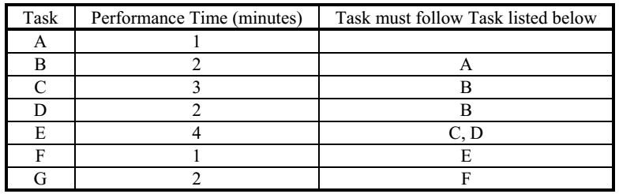
a. What is the cycle time for this assembly operation?
b. What is the minimum number of workstations?
c. Draw the precedence diagram.
- The owner of a millwork shop is considering three alternative locations for a new plant for building embossed-and-clad steel exterior doors for residences. Fixed and variable costs follow. Since the plant ships nationwide, revenue is assumed the same regardless of plant location. Plot the total cost lines in the chart provided below, and identify the range over which each location is best.
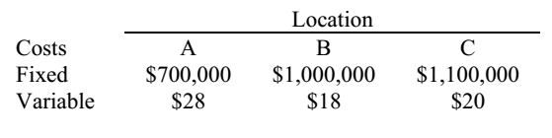
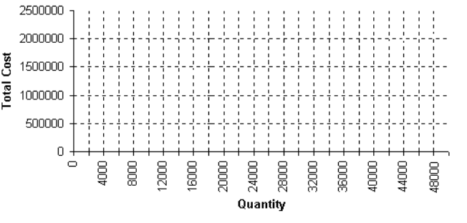
- How many observations would be necessary for a time studies analyst to be 99% confident that the average time is within .1 minutes of the true value if the average time is 10.5 minutes and the standard deviation is 3 minutes?
- A brake system installer in an auto factory has an actual average time of 10 minutes on her task. The performance rating of the worker timed was estimated at 110%. Practice in this department is to allow 9% for the constant allowances. There is currently no variable allowance.
a. Find the normal time for the operation.
b. Compute the standard time for the operation.
c. Recompute the standard time if a variable allowance of 7% is factored in.

CHAPTER FOUR

OPERATION PLANNING AND CONTROL
Operation planning and scheduling system concern the volume and timing of the outputs, utilizations of the operations capacity, and the balancing outputs with capacity at desired levels for competitive effectiveness.
Dear learners, the overview structure can be better understood with the help of the figure given below:
Figure 4.1: The operations planning and scheduling systems
Learning Objectives
After reading this lesson you will be able to understand
- Aggregate capacity planning
- Master production schedule
- Sequencing through multiple work centers
- Operating schedule
Aggregate Production (Output) Planning: This plan is the production portion of the business plan and addresses the demand side of the firm's activities by showing the outputs it will produce, expressed in numbers of units of its product groups or families. The division's aggregate output plan covers the coming 6 to 18 months on a weekly or monthly basis. Planning at this level ignores such details as how many of each individual product, style, color option, or model to produce. The plan recognizes the division's existing fixed capacity and the - company's overall policies for maintaining inventories and backlogs, employment stability, and subcontracting.
Aggregate Capacity Planning: A statement of desired output is useful only if it is feasible. This is the role of aggregate capacity planning-to keep capacity utilization at desired levels and to test the feasibility of planned output against existing capacity. Thus, it addresses the supply side of the firm's ability to meet the demand. As for aggregate output plans, each plant, facility, or division requires its own aggregate capacity plan. Capacity and output must be in balance, as indicated by the arrow between them in Figure. A capacity plan translates an output plan into input terms, approximating how much of the division's capacity will be consumed. Aggregate planning process balances output levels, capacity constraints, and temporary capacity adjustments to meet demand and utilize capacity at desired levels during the coming months. The resulting plan sets limits on the master production schedule.
Master Production Scheduling (MPS): The purpose of master production scheduling is to meet the demand for individual products in the product group. This more detailed level of planning disaggregates the product groups into individual products and indicates when they will be produced. The MPS is an important link between marketing and production. It shows when incoming sales orders can be scheduled into production, and when each shipment can be scheduled for delivery. It also takes into account current backlogs so that production and delivery schedules are realistic.
Rough-Cut Capacity Planning: Rough-cut capacity planning (sometimes called resource requirements planning) is done in conjunction with the tentative master production schedule to test its feasibility in terms of capacity before the MPS is finally settled. This step ensures that a proposed MPS does not inadvertently overload any key department, work center, or machine, making the MPS unworkable.
Material Requirements Planning: The MPS is the driving force for material requirements planning. As discussed in Chapter 8, MRP shows the time phased requirements for releasing materials and receiving materials that enable the master production schedule to be implemented.
Detailed Capacity Planning: Detailed capacity planning, also called capacity requirements planning, is a companion process used with MRP to identify in detail the capacity required to execute the MRP. At this level, more accurate comparisons of available and needed capacity for scheduled workloads are possible.
Shop Floor Control: Coordinates the weekly and daily activities that get jobs done. Individual jobs are assigned to machines and work centers (loading), the sequence of processing the jobs for priority control is determined, start times and job assignments for each stage of processing are decided (detailed scheduling), and materials and work flows from station to station are monitored and adjusted (expediting). All these activities are co-coordinated into smooth flow, especially when there are delays and priorities arise, last minute adjustments of outputs and capacities is known as short term capacity control.
Dear friends, we would elaborate the above concepts in the next lecture. With that, we have come to the end of today’s discussions. I hope it has been an enriching and satisfying experience.

AGGREGATE PRODUCTION PLANNING
Introduction
Hello students, today we are going to introduce the concept of what is known as aggregate planning.

An operation planning is concerned with the determination, acquisition and arrangement of all facilities necessary for the future operations, whereas Operations control is concerned with the implementation of a predetermined operations plan or policy and the control of all aspects of operations according to such a plan or policy.
Aggregate planning is an intermediate term planning decision. It is the process of planning the quantity and timing of output over the intermediate time horizon (3 to 18 months). Within this range, the physical facilities are assumed to be fixed for the planning period.

Overall approach to planning
Dear students, in the above section we saw how capacity planning fitted in with other planning. The mission, corporate and business strategies give the long-term direction of the whole organization. These lead to strategic decisions within the central functions - including an operations strategy. Now we are going to look at the next stages of planning, which move down to tactical and operational levels.
Level of planning
Mission

For the
Whole
organisation
Corporate
strategy

Includes planning
decisions
Business
strategy

Capacity
plans
Operations
strategy

Within
operations
Tactical
plans
Production
plans

Operational
plans
Schedules
For activities

Figure 4-2: Summary of planning process

Capital Trains move down from strategic capacity plans, through medium-term schedules of operations, and on to detailed timetables for all of their resources. This planning process is essentially the same for all organizations. Unfortunately, there is some disagreement about the terms used for different levels of planning. We will use the fairly standard terms:
- Capacity plans, which we have already discussed earlier, make sure that there is enough capacity to meet long-term demand.
- Aggregate plans show the overall production for families of products, typically by month at each location.
- Master schedules show a detailed timetable for making individual products, typically by week.
- Short-term schedules show detailed timetables for jobs and resources, typically by day.
Aggregate plans
Aggregate plans and master schedules bridge the gap between strategic capacity plans and operational details. Dear learners, in this section we look at aggregate plans, and move on to master schedules in the next section. Aggregate planning takes the forecast demand and capacity, and uses them to design production plans for each family of products for, typically, each of the next few months: Aggregate plans only look at families of products and are not concerned with individual products.
Dear students, the aim of aggregate planning is to design medium-term schedules for making families of products that:
- Meet all forecast demand;
- Keep within the constraints of the capacity plan;
- Keep production relatively stable;
- Use available resources efficiently;
- Meet any other specific objectives and constraints.
Dear learners, to achieve this, the planners have a number of variables they can control. Essentially, aggregate planners follow one of three alternative policies: produce at constant rate, chase demand, or a mixture of these two.
1. Produce at a constant rate -Production is constant at the average demand for the planning period.

2. Chase demand -Production exactly matches demand. This gives no stocks" but we have to change production every period. This can be very difficult to organize, as well as expensive. None the less, it is often the best policy, particularly with services that cannot be kept in stock.
3. Mixed Policy -is a combination of the first two policies. The policy finds a compromise that gives fairly stable production, but with some changes. In practice, this is the most commonly used plan.

Master schedule
Dear learners, we can expand the aggregate plan to give more details, which are shown in a master schedule. The Master Production Schedule (MPS) formalizes the production plan and translates it into specific end-item requirements over a short to intermediate planning horizon. The end items are then exploded into specific material and capacity requirements by the Material Requirements Planning (MRP) and Capacity Requirements Planning (CRP) systems. Thus, the MPS essentially drives the entire production and inventory system.
The major inputs to the master production schedule are:
- Forecasts of demand, e.g., of end items and service parts.
- Customer orders, i.e., including any warehouse and interplant needs.
- Inventory on-hand from the previous period.

Master schedule 'disaggregates' the aggregate plan and shows the number of individual products to be made in, typically, each week.
This detailed timetable of planned production shows 'the due dates or completion times of individual products. The master schedule gives a detailed timetable for making individual products.
Designing master schedules
In principle, designing the master schedule is similar to designing an aggregate plan, so methods again range from discussion through to mathematical models.
Dear learners, the figure below shows a simple master schedule. Lines 2 and 3 show the monthly and quarterly production targets from the aggregate plan. Lines 6, 7 and 8 show the master schedule (for three products Alpha, Beta and Gamma) for meeting, these targets. Lines 9 and 10 confirm that the master schedule matches the aggregate plan.
Table 4.1: Designing master schedule
1 |  | Jan |  |  |  | Feb. |  |  |  | Mar.
2 | Month | 1680
3 | Quarter | 4670
4
5 | Week | 1 | 2 | 3 | 4 | 1 | 2 | 3 | 4 | 1
6 | Alpha | 300 | 250 | 0 | 100 | 0 | 300 | 0 | 150 | 0
7 | Beta | 0 | 400 | 200 | 200 | 200 | 120 | 140 | 200 | 200
8 | Gamma | 80 | 0 | 100 | 50 | 120 | 160 | 80 | 0 | 120
9 | Totals | 380 | 650 | 300 | 350 | 320 | 580 | 220 | 350 | 320
10 | Planned | 1680 |  |  |  | 1470 |  |  |  | 1520
11
12 | Alpha | 650 |  |  |  | 450 |  |  |  | 500
13 | Orders | 200 | 80 | 70 | 50 | 20 | 10 | 10
14 | Committed | 80 | 60 | 50 | 20 | 10
15 | Planned |  |  |  | 40 | 80 | 60 | 40
16 | Forecast |  |  |  |  |  | 30 | 80 | 110 | 200
17 | Total | 280 | 140 | 120 | 110 | 110 | 100 | 130 | 110 | 200
The bottom part of Figure 4-7 looks at demand for Alpha. Line 12 shows the planned monthly production, and line 13 shows the orders already received. Lines 14 and 15 show other intermediate stages where production is 'committed' (perhaps for orders that are expected but still being negotiated) and 'planned'(perhaps for tentative orders or other management reasons). The remaining f demand is still 'forecast', as shown in line 16. There are no obvious problems here, as the master schedule for Alpha meets all the weekly targets. This table cam be extended downwards to show the master schedules for Beta and Gamma, and to the right to cover more time in the future.
Worked Example: Comark Bicycles produce two basic bicycles: a women's and a men's. The aggregate plan has 8,000 bicycles made next month, and 6,400 the month after. Current stocks are 500 men's and 300 women's, and the factory has a capacity of 2,200 bicycles a week. Men's bicycles usually account for 60 percent of sales, and actual orders have been received for the following deliveries:

Week 1 2 3 4 5 6
Men's 1,400 1,200 1,000 700 300 -
Women's 2,000 800 400 100 - -
Design a master schedule for the next eight weeks.
Solution
There are unexpectedly high sales of women's bicycles in the first week. There are 300 in stock, so Comark Bicycles have to make 1,700 more. Even using the full capacity of 2,200 bicycles a week, this leaves only enough capacity for 500 men’s bicycles. These, together with current stocks of 500, still leave a shortage of 400 men’s bicycles which must be met by back-orders. In the second week the back-orders for 400 men's bicycles can be cleared together with the 1,200 actually ordered. This leaves only capacity for 600 women's bicycles, so 200 must be back-ordered to meet the 800 orders.
The aggregate plan calls for 8,000 bicycles the first month. 4,400 were made fin the first two weeks, so another 1,800 should be made in each of the last two weeks, so another 1,800 should be made in each of the last two weeks. In week 3 the back-orders for 200 women's can be cleared, plus the 1,400 ordered (both men's and women's), and an additional 200 for stock (say 100 men's and 100 women’s). In week 4 dividing the 1,800 into 1,800 men’s and 720 women’s (to match the expected 60:40 ratio) covers all orders and adds spare units to stock. In weeks 5 to 8 the planned production of 6,400 can be divided into weekly production of 1,600 (960 men's and 640 women's). So far there are only orders for 300 units in this period, and the rest are added to stock. This reasoning gives the following master schedule. You can see that there is an apparent build-up of stock in later weeks, as this production has not been allocated to customers yet (so this would be the stock level if no more orders were received).

Week 1 2 3 4 5 6 7 8

Men's
Actual orders 1,400 1,200 1,000 700 300 - - -
Opening stock 500 -400 0 100 480 1,140 2,100 3,060
Production 500 1,600 1,100 1,080 960 960 960 960

Women's
Actual orders 2,000 800 400 100 - - - -
Opening stock 300 0 -200 100 720 1,360 2,000 2,640
Production 1,700 600 700 720 640 640 640 640
Total production 2,200 2,200 1,800 1,800 1,600 1,600 1,600 1,600
Aggregate plan 8,000 6,400

This is, of course, only one of many feasible schedules. It has the advantages of meeting the aggregate plan and keeping production at a stable level, but we could now start looking for improvements.

Aggregate planning strategies
Several different strategies have been employed to assist in aggregate planning. Two options are recognized.
- Demand Options: Demand management is proactive strategy
- Influencing demand
  - Using advertising or promotion to increase demand in low periods
  - Using pricing differentials to shift demand from peak periods to off-peak periods
  - Attempt to shift demand to slow periods
  - May not be sufficient to balance demand and capacity
- Back ordering during high- demand periods
  - Requires customers to wait for an order without loss of goodwill or the order
  - Orders are taken in one period and deliveries promised for a later period
  - The success of this approach depends on how willing customers are to wait for delivery
  - Most effective when there are few if any substitutes for the product or service
  - Often results in lost sales, disappointed customers, and perhaps additional paperwork
- Counter seasonal product and service mixing/New demand
  - Develop a product mix of counter seasonal items
  - May lead to products or services outside the company’s areas of expertise
- Capacity/Supply Options
1. Changing inventory levels: Demand fluctuations can be met by large amount of inventory.
  - Increase inventory in low demand periods to meet high demand in the future
  - Increases costs associated with storage, insurance, handling, obsolescence, and capital investment 15% to 40%
  - Shortages can mean lost sales due to long lead times and poor customer service
2. Varying workforce size by hiring or layoffs: Output is controlled by hiring or laying off workers in proportion to changes in demand.
  - Match production rate to demand
  - Training and separation costs for hiring and laying off workers
  - New workers may have lower productivity
  - Laying off workers may lower morale and productivity
3. Varying production rate through overtime or idle time: Maintain the stable workforce, but permit idle time when there is a slack and permit over time (OT) when demand is peak.
  - Allows constant workforce
  - May be difficult to meet large increases in demand
  - Overtime can be costly and may drive down productivity
  - Absorbing idle time may be difficult
- Subcontracting: Upward shift in demand from low level. Constant production rates can be met by using subcontractors to provide extra capacity.
  - Temporary measure during periods of peak demand
  - May be costly
  - Assuring quality and timely delivery may be difficult
  - Exposes your customers to a possible competitor
5. Using part-time workers
  - Useful for filling unskilled or low skilled positions, especially in services
Techniques for Aggregate Planning
Techniques for Aggregate Planning:
- Graphical Techniques/Trial-and-Error Techniques
- Mathematical Techniques
Graphical Techniques
- Popular techniques
- Easy to understand and use
- Trial-and-error approaches that do not guarantee an optimal solution
- Require only limited computations

Graphical Technique: Example
Month | Expected Demand | Production Days | Demand Per Day (computed)
Jan | 900 | 22 | 41
Feb | 700 | 18 | 39
Mar | 800 | 21 | 38
Apr | 1,200 | 21 | 57
May | 1,500 | 22 | 68
June | 1,100 | 20 | 55
 | 6,200 | 124
=
6200 ∕124 = 50 units per day
Average requirement
=
Total expected demand
Number of production days

Mathematical Techniques
Linear programming: Methods for obtaining optimal solutions to problems involving allocation of scarce resources in terms of cost minimization.
Linear decision rule: Optimizing technique that seeks to minimize combined costs, using a set of cost-approximating functions to obtain a single quadratic equation.
Aggregate Planning in Services
- Services occur when they are rendered
- Demand for service can be difficult to predict
- Capacity availability can be difficult to predict
- Labor flexibility can be an advantage in services
- Controlling the cost of labor is critical
- Accurate scheduling of labor-hours to assure quick response to customer demand
- An on-call labor resource to cover unexpected demand
- Flexibility of individual worker skills
- Flexibility in rate of output or hours of work

OPERATIONS SCHEDULING
Overview of scheduling

Scheduling is establishing the timing of the use of equipment, facilities and human activities in an organization. Having determined the sequence that work is to be tackled in, some operations require a detailed timetable showing at what time or date jobs should start and when they should end– this is scheduling. Schedules are familiar statements of volume and timing in many consumer environments. For example, a bus schedule shows that more buses are put on routes at more frequent intervals during rush-hour periods. The bus schedule shows the time each bus is due to arrive at each stage of the route. Schedules of work are used in operations where some planning is required to ensure that customer demand is met. Other operations, such as rapid-response service operations where customers arrive in an unplanned way, cannot schedule the operation in a short-term sense. They can only respond at the time demand is placed upon them.

Scheduling is the time phase of loading. It is assignment of job to a facility specifying the particular sequence of the work and the time of actual performance.

Examples of scheduling include: railway time-table, examination schedule, the time table for teaching various subjects. Scheduling should be done at relatively lower level of the organization. Scheduling activities are highly dependent on the type of the production system and the output volume delivered by the system. Scheduling activities differ in
(a) High-volume system
(b) Intermediate-volume system, and
(c) Low-volume Systems
High-Volume (flow) Systems
They make use of specialized equipment that routes work on a continuous basis through the same fixed path of operations, generally at a rapid rate. The problems of order release, dispatching, and monitoring are less complex than in low-volume, make-to-order systems.
Intermediate-volume (flow and batch) Systems
They utilize a mixture of equipment and similar processes to produce an intermittent flow of similar products on the same facilities. The sequencing of jobs and production-run lengths are of significant concern to schedulers, as they attempt to balance the costs of changeover time against those of inventory accumulations.
Low-Volume (batch or single job) Systems
They use general-purpose equipment that must route orders individually through a unique combination of work centers. The variable work-flow paths and processing time generates queues, work-in-process inventories, and capacity utilization concerns that can require more day-to-day attention than in the high- or intermediate-volume systems.
Dear learners, the figure below gives a summary of some of the important characteristics of high, intermediate, and low-volume systems.
Table 4.3: characteristics of scheduling system
Effective scheduling can yield Cost savings and increases in productivity.
Principles of Scheduling
1. The principle of optimum task size: Scheduling tends to achieve maximum efficiency when the task sizes are small, and all tasks of same order of magnitude.
2. Principle of optimum production plan: The planning should be such that it imposes anequal load on all plants.
3. Principle of optimum sequence: Scheduling tends to achieve the maximum efficiencywhen the work is planned so that work hours are normally used in the same sequence.
Scheduling Strategies
Scheduling strategies vary widely among firms and range from ‘no scheduling’ to very sophisticated approaches.
These strategies are grouped into four classes:
1. Detailed scheduling: Detailed scheduling for specific jobs that are arrived from customers is impracticable in actual manufacturing situation. Changes in orders, equipment breakdown, and unforeseen events deviate the plans.
2. Cumulative scheduling: Cumulative scheduling of total work load is useful especially for long range planning of capacity needs. This may load the current period excessively and under load future periods. It has some means to control the jobs.
3. Cumulative detailed: Cumulative detailed combination is both feasible and practical approach. If master schedule has fixed and flexible portions.
4. Priority decision rules: Priority decision rules are scheduling guides that are used independently and in conjunction with one of the above strategies, i.e., first come first serve.
These are useful in reducing Work-In-Process (WIP) inventory.
Techniques of Scheduling
Friends, two techniques of scheduling should be discussed here. These are master scheduling, shop manufacturing schedule, backward scheduling and forward scheduling.
(a) Master Scheduling (MS): It shows the dates on which important production items are to be completed. It’s a weekly or monthly break-up of the production requirements for each product. Whenever any order is received, it is accommodated first in the MS considering the availability of the machine and labor. It helps production manager for advance planning & to have check over the production rate and efficiency.
(b) Shop Manufacturing Schedule: After preparing the MS, shops schedules (SS) are prepared.
It assigns a definite period of time to a particular shop for manufacturing products in required quantity. It shows how many products are to be made, and on what day or week.
(c) Backward or Reverse Scheduling: Backward scheduling determines the start and finish times for waiting jobs by assigning them to the latest available time slot that will enable each job to be completed just when it is due, but done before. By assigning jobs as late as possible, backward scheduling minimizes inventories since a job is not completed until it must go directly to the next work centre on its routing. A major problem with such reverse or ‘due date’ scheduling is in estimating the total time to be allowed for each operation, in particular the time to be allowed for waiting or queuing at facilities.
(d) Forward Scheduling: is commonly used in job shops where customers place their orders on “needed as soon as possible” basis. Forward scheduling determines start and finish times of next priority job by assigning it the earliest available time slot and from that time, determines the earliest possible completion date for a job.
Example. A job is due to be delivered at the end of 12th week. It requires a lead time of 2 weeks for material acquisition, 1 week of run time for operation-1, 2 weeks for operation-2, and 1 week for final assembly. Allow 1 week of transit time prior to each operation. Illustrate the completion schedule under (a) forward, and (b) backward scheduling methods.
Solution: The solution is shown in Figure 5.4.
Figure 4.3: forward and backward scheduling
(e) Optimized Production Technique (OPT): Recognizes the existence of bottlenecks through which the flow gets restricted. It consists of modules that contain data on products, customer orders, work center capacities, etc., as well as algorithms to do the actual scheduling. A key feature of the program is to simulate the load on the system, identify bottleneck (as well as other) operations, and develop alternative production schedule. OPT has some similarities with materials requirement planning (MRP). It can be considered an extension of MRP: MRP can be used to form the basis of a system for computer-aided scheduling and inventory control, to which can be added the OPT approach for the identification of bottlenecks and the maximization of throughputs.
Explain, in your own words, how backward scheduling and forward scheduling differ.
_____________________________________________________________________________________

Scheduling Methodology
The scheduling methodology depends upon the type of industry, organization, product, and level of sophistication required. They are:
1. Charts and boards,
2. Priority decision rules, and
3. Mathematical programming methods.
1. Gantt Charts and Boards
A Gantt chart is a visual representation of a schedule over time. They are used in several forms, namely,
(a) Scheduling or progress charts, which depicts the sequential schedule;
(b) Load charts, which show the work assigned to a group of workers or machines; and
(c) Record a chart, which are used to record the actual operating times and delays of workers and machines.
Two kinds of Gantt charts are the load chart and the progress chart. Load chart is a chart that visually shows the workload relative to the capacity at a resource whereas progress chart a chart that visually shows the planned schedule compared to actual performance.
Dear students, a logical question to ask would be, what is loading and what is sequencing?
Loading is assignment of jobs to process centers, while sequencing is determining the order in which jobs will be processed.

Loading is the amount of work that is allocated to a work centre.
For example, a machine on the shop floor of a manufacturing business is available, in theory, 168 hours a week. However, this does not necessarily mean that 168 hours of work can be loaded on to that machine. Figure below shows what erodes this available time. For some periods the machine cannot be worked; for example, it may not be available on statutory holidays and weekends. Sometimes the machine may be waiting for parts to arrive or be ‘idling’ for some other reason. In a job shop operation, we have many work centers. We also have customer’s orders. Each order has a unique specification and hence it has to be routed through various work centers in the facility. The new orders are assigned or allocated among the work centers. Then each work center has a certain load of various orders in the planning period. This assignment is known as Loading.
Example: A piece of mining equipment requires the manufacturing times shown in Table 5.3. Each of the activities must be done sequentially, except that steel fabrication can begin 2 weeks after purchasing begins, and the hydraulics and electrical activities can be done concurrently. Construct a Gantt chart for this job.
Table 4.5
Table 4.4
Two kinds of work scheduling or work loading are infinite loading and finite loading.
Infinite loading፡ scheduling that calculates the capacity needed at work centers in the time period needed without regard to the capacity available to do the work. Manufacturing companies can use infinite loading according to a proposed master production schedule (MPS).
Finite loading፡ scheduling that loads work centers up to a predetermined amount of capacity. Finite loading is an operational schedule with start and finish times for each activity. The finite loading schedule shows how a company plans to use available capacity at each work center. In a manufacturing company, the schedule shows the jobs to be done at a particular work center if the Companies benefit from both infinite and finite loading. Finite loading develops the operational schedule that uses the available capacity. Finite and infinite loading assign work to specific work centers based on a proposed schedule. Both techniques use either a schedule (infinite loading) or a prioritized list of jobs to be done (finite loading).
2. Priority Decision Rules
Priority decision rules are simplified guidelines for determining the sequence in which jobs will be done. In some firms these rules take the place of priority planning systems such as MRP systems. Following are some of the priority rules followed.
3. Mathematical Programming Methods
Scheduling is a complex resource allocation problem. Firms process capacity, labor skills, materials and they seek to allocate their use so as to maximize a profit or service objective, or perhaps meet a demand while minimizing costs.
The following are some of the models used in scheduling and production control.
Linear programming model: Here all the constraints and objective functions are formulated as a linear equation and then problem is solved for optimality. Simplex method, transportation methods and assignment method are major methods used here.
PERT/CPM network model: PERT/CPM network is the network showing the sequence of operations for a project and the precedence relation between the activities to be completed.
Note: Scheduling is done in all the activities of an organization i.e., production, maintenance etc. Therefore, all the methods and techniques of scheduling is used for maintenance management.
Input-Output Control: Input/output control is a capacity-control technique used to monitor workflow at individual work centers. Input/output control monitors the planned inputs and outputs at a work center against the actual inputs and outputs. Actual output is used to identify possible problems in the work center, such as an equipment problem or unexpected absences.
Assignment Method/model: This is used for solving the loading problems. It is a linear program to assign jobs so that a specific criterion is optimized. Managers often have choices about which jobs should be assigned to which job centers or perhaps the best center is not available because it is already assigned to a job and can process one job at a time.
Further on scheduling methodology
Dear learners, let’s focus on finite loading. It is a scheduling technique that combines into a single system the loading, sequencing and detailed scheduling. Here the system starts with a specified capacity for each work center and a list of jobs. The work center’s capacity is then allocated unit by unit (for e.g. Labor hours) to the jobs by simulating job stating times and completion times. Thus the system creates a detailed schedule for each job and each work center based on the centers capacities. Jobs are allotted to the centers according to their capacities hour-by-hour and day by ay into the future.
Dear students, we guess we had enough of theoretical inputs. Let us try to understand the above concepts through an example given below:
Example: A ZXS company has received two orders, A & B, both of which require processing at M/c 1 & 2. The first come first serve rule is applied to sequence the jobs, here job A arrived in advance of job B. The sequence of routings for the jobs A & B, both of which are due in 8 hours, is given below. Each machine is available for 8 hrs/day and no other jobs are currently scheduled from them. We will develop schedules using the forward and backward procedures.
Table 4.6. Forward and backward scheduling
The forward schedule job assigns top priority job A the earliest time slot available for the first machine on its routing i.e. first machine 1, for two hours. Then job A is assigned for 3 hours through 5 on machine 2,
Figure 4.6. Forward and backward scheduling
Figure 4.7: Forward and backward scheduling for ZXC Company
Backward scheduling assigns the highest priority job so that it finishes just as it is due for the next station. Therefore, Job A is assigned to the last machine on its routing, machine 1, for hours 8. Then it is assigned to the preceding machine on its routing machine2, for hours 5 through 7, again as late as possible. Similarly, job A is assigned to the first machine on its routing, machine 1, for hours 3 & 4. Now job B is assigned to the last machine on its routing, machine 2, for hours 8, 4 & 3. It is assigned to machine 1 for hours 1 & 2.
Advantages and disadvantages in forward and backward scheduling
1. Both the jobs are completed in time.
2. Job A completes two hours in advance than due time
3. Job B finishes at the first machine in its routing one hour before it can go to the second on its routing.
4. In the backward schedule, job B is interrupted at machine 2 in hour 4 to allow the high priority job A to pass through. Then the job B resumes in hour 8. It means assignment of job to a facility, viz: machine, men, department, etc.
Assigning a subject to a teacher is loading. For example, many different facilities may be capable of performing the operations required on one customer or item. One simple, rapid, but approximate method of facility/job assignment is best described by means of an example shown in Figure below.
Figure 4.4: Loading
Assignment Method/model Steps
- Row reduction: subtract the smallest number in each row from every number in the row
  - Enter the result in a new table
- Column reduction: subtract the smallest number in each column from every number in the column
  - Enter the result in a new table
- Test whether an optimum assignment can be made
  - Determine the minimum number of lines needed to cross out all zeros
  - If the number of lines equals the number of rows, an optimum assignment is possible. Go to step 6
  - Else, go to step 4
- If the number of lines is less than the number of rows, modify the table:
  - Subtract the smallest number from every uncovered number in the table
  - Add the smallest uncovered number to the numbers at intersections of cross-out lines
  - Numbers crossed out but not at intersections of cross-out lines carry over unchanged to the next table
- Repeat steps 3 and 4 until an optimal table is obtained
- Make the assignments
  - Begin with rows or columns with only one zero
  - Match items that have zeros, using only one match for each row and each column
  - Eliminate both the row and the column after the match
Example: Determine the optimum assignment of jobs to workers for the following data:
 |  | Worker
 |  | A | B | C | D
Job | 1 | 8 | 6 | 2 | 4
Job | 2 | 6 | 7 | 11 | 10
Job | 3 | 3 | 5 | 7 | 6
Job | 4  Subtract the smallest number in each row from every number in the row | 5 | 10 | 12 | 9
 |  | Worker |  |  |  | Row  Minimum
 |  | A | B | C | D | Row  Minimum
Job | 1 | 8 | 6 | 2 | 4 | 2
Job | 2 | 6 | 7 | 11 | 10 | 6
Job | 3 | 3 | 5 | 7 | 6 | 3
Job | 4 | 5 | 10 | 12 | 9 | 5

 |  | Worker
 |  | A | B | C | D
Job | 1 | 6 | 4 | 0 | 2
Job | 2 | 0 | 1 | 5 | 4
Job | 3 | 0 | 2 | 4 | 3
Job | 4 | 0 | 5 | 7 | 4
Column min.  Determine the minimum number of lines needed to cross out all zeros. (Try to cross out as many zeros as possible when drawing lines |  | 0 | 1 | 0 | 2

 |  | Worker
 |  | A | B | C | D
Job | 1 | 6 | 4 | 0 | 2
Job | 2 | 0 | 1 | 5 | 4
Job | 3 | 0 | 2 | 4 | 3
Job | 4 | 0 | 5 | 7 | 4
 |  | Worker
 |  | A | B | C | D
Job | 1 | 6 | 3 | 0 | 0
Job | 2 | 0 | 0 | 5 | 2
Job | 3 | 0 | 1 | 4 | 1
Job | 4 | 0 | 4 | 7 | 2
 |  | Worker
 |  | A | B | C | D
Job | 1 | 6 | 3 | 0 | 0
Job | 2 | 0 | 0 | 5 | 2
Job | 3 | 0 | 1 | 4 | 1
Job | 4 | 0 | 4 | 7 | 2
Subtract the smallest number in each column from every number in the column

Since only three lines are needed to cross out all zeros and the table has four rows, this is not the optimum. Note: the smallest uncovered value is 1

 |  | Worker
 |  | A | B | C | D
Job | 1 | 7 | 3 | 0 | 0
Job | 2 | 1 | 0 | 5 | 2
Job | 3 | 0 | 0 | 3 | 0
Job | 4 | 0 | 3 | 6 | 1
Subtract the smallest uncovered value from every uncovered number, and add it to the values at the intersection of covering lines.
Determine the minimum number of lines needed to cross out all zeros. (Try to cross out as many zeros as possible when drawing lines
 |  | Worker
 |  | A | B | C | D
Job | 1 | 7 | 3 | 0 | 0
Job | 2 | 1 | 0 | 5 | 2
Job | 3 | 0 | 0 | 3 | 0
Job | 4 | 0 | 3 | 6 | 1
Since four lines are needed to cross out all zeros and the table has four rows, this is an optimal assignment can be made
Worker
Make assignments: Start with rows and columns with only one zero. Match jobs with machines that have a zero cost
 |  | A | B | C | D
Job | 1 | 7 | 3 | 0 | 0
Job | 2 | 1 | 0 | 5 | 2
Job | 3 | 0 | 0 | 3 | 0
Job | 4 | 0 | 3 | 6 | 1

Assignment | Cost
2-B | $7
4-A | $5
1-C | $2
3-D | $6
Total | $20

Sequencing
Whether the approach to loading is finite or infinite, when work arrives, decisions must be taken on the order in which the work will be tackled. This activity is termed sequencing. The priorities given to work in an operation are often determined by some predefined set of rules, some of which are relatively complex. Some of these are summarized below.
- Sequencing: Determine the order in which jobs at a work center will be processed.
- Workstation: An area where one person works, usually with special equipment, on a specialized job.
- Priority rules: Simple heuristics used to select the order in which jobs will be processed.
- Job time: Time needed for setup and processing of a job.
Sequencing rules are applied to all jobs waiting in the queue. Then, when the work center becomes open for a new job, the one with the highest priority is assigned
My dear students, let us pick up the threads of the last discussion and start with a comparison. Not quite the start we usually have, but there’s a reason for it. Let’s see why.
A comparison
When we compare the performance of FCFS and SPT we see that SPT is superior. Although total completion time is 55 days for both sequences, SPT affords a lower average flow time, so inventories are tied up to a lesser extent, and quicker service can be provided to customers. With SPT, the average number of jobs in the system is reduced, so the shop is less congested and inventory levels are lower. Finally, since average lateness is reduced, deliveries to customers are more prompt.
Commonly Used Priority Rules
Dear learners, now let us look at some priority sequencing rules. The following rules are representative of the many used today in manufacturing and service industries:
First cum first served (FCFS): As its name suggests, incoming jobs or customers are processed in their order of arrival. FCFS is commonly applied in service industries such as banks, supermarkets', etc.
Last come first served (LCFS): the last job in to the work center or at the top of the stack is processed.
Earliest due date (EDD): Top priority is assigned to the waiting job whose due date is earliest. EDD ignores when the jobs arrive and the time each of them takes to process.
Shortest processing time (SPT): The job that can be completed in the shortest time at this work center is processed next. The jobs' due dates and order of arrival are immaterial.
Longest processing time (LPT): the job that requires the longest processing time has the highest priority.
Critical ratio (CR): the job with the smallest ratio of time remaining until due date to its processing time remaining has the highest priority.
Least slack (LS): Highest priority goes to the jobs whose slack time is least. Slack is calculated as the difference of the length of time remaining until the job is due, and the length of its operation time. The order of arrival is ignored.
Assumptions of priority Rules
- The set of job is known, no new jobs arrive after processing begins and no jobs are cancelled.
- Set up time is independent of processing sequence
- Set up time is deterministic
- Processing times are deterministic rather than variable
- There will be no interruptions in processing such as machine breakdowns, accidents or worker illness.
The effectiveness of any given sequence is frequently judged in terms of one or more performance measures. The most frequently used performance measures are the following:
- Job flow time: this is the length of time a job is at a particular work station or work center.
- The average flow time for a group of jobs is equal to the total flow time for the jobs divided by the number of jobs
- Job lateness: is the length of time the job completion date is expected to exceed the date the job was due or promised to a customer.
- It is the difference between the actual completion time and the due date.
If we only record differences for jobs with the completion times that exceed due dates and assign zeros to jobs that are early, the term we use refer to that is job tardiness.
- Make span: is the total time needed to complete a group of jobs from the beginning of the first job to the completion of the last job.
Average number of jobs = total flow time ∕ make span
Dear learners, let’s examine some of these rules and illustrate how they work.
Example: processing time (including set up times) and due dates for six jobs waiting to be processed at work center are given in the following table.
Determine the sequence of jobs, average flow time, average tardiness and average number of jobs at the work center for each of these rules.
- FCFS B. SPT C. EDD D. CR
Job | Processing time (Days) | Due Date (Days)
A | 2 | 7
B | 8 | 16
C | 4 | 4
D | 10 | 17
E | 5 | 15
F | 12 | 18
Assume jobs arrived in the order shown.
Solution:
A. the First Come First Served (FCFS) Rule, job sequence is simply: A-B-C-D-E-F
Job sequence | Processing time(1) | Flow time (2) | Due date (3) | Days Tardy (2-3)  (0 if negative)
A | 2 | 2 | 7 | 0
B | 8 | 10 | 16 | 0
C | 4 | 14 | 4 | 10
D | 10 | 24 | 17 | 7
E | 5 | 29 | 15 | 14
F | 12 | 41 | 18 | 23
Total | 41 | 120 |  | 54
Measures of effectiveness are:
  - Average flow time: 120 ∕ 6 = 20 days
  - Average tardiness: 54 ∕ 6 = 9 days
  - The make span is 41 days
  - The average number of jobs at the work center: 120 ∕ 41 = 2.93
- Using the Shortest Processing Time (SPT) rule, the job sequence is A-C-E-B-D-F

Job sequence | Processing time (1) | Flow time (2) | Due date (3) | Days Tardy (2-3)  (0 if negative)
A | 2 | 2 | 7 | 0
C | 4 | 6 | 4 | 2
E | 5 | 11 | 15 | 0
B | 8 | 19 | 16 | 3
D | 10 | 29 | 17 | 12
F | 12 | 41 | 18 | 23
Total | 41 | 108 |  | 40
Measures of effectiveness are:
- Average flow time: 108 ∕ 6 = 18 days
- Average tardiness: 40 ∕ 6 = 6.67 days
- The make span is 41 days
- The average number of jobs at the work center: 108 ∕ 41 = 2.63
C. Using EDD rule, as the selection criterion, the job sequence is C-A-E-B-D-F
Job sequence | Processing time(1) | Flow time (2) | Due date (3) | Days Tardy (2-3)  (0 if negative)
C | 4 | 4 | 4 | 0
A | 2 | 6 | 7 | 0
E | 5 | 11 | 15 | 0
B | 8 | 19 | 16 | 3
D | 10 | 29 | 17 | 12
F | 12 | 41 | 18 | 23
Total | 41 | 110 |  | 38
Measures of effectiveness are:
- Average flow time: 110 ∕ 6 = 18.33 days
- Average tardiness: 38 ∕ 6 = 6.33 days
- The make span is 41 days
- The average number of jobs at the work center: 110 ∕ 41 = 2.68
D. Using the Critical Ratio (CR) we find
Job | Processing time (Days) | Due Date (Days) | Critical Ration Calculation
A | 2 | 7 | (7-0) ∕ 2 = 3.5
B | 8 | 16 | (16-0) ∕ 8 = 2.0
C | 4 | 4 | (4-0) ∕ 4 = 1.0 - Lowest
D | 10 | 17 | (17-0) ∕ 10 = 1.7
E | 5 | 15 | (15-0) ∕ 5 = 3.0
F | 12 | 18 | (18-0) ∕ 12 = 1.5
At day 4 (C completed), the critical ratios are:
Job | Processing time (Days) | Due Date (Days) | Critical Ration Calculation
A | 2 | 7 | (7-4) ∕ 2 = 1.5
B | 8 | 16 | (16-4) ∕ 8 = 1.5
C | - | - | -
D | 10 | 17 | (17-4) ∕ 10 = 1.3
E | 5 | 15 | (15-4) ∕ 5 = 2.2
F | 12 | 18 | (18-4) ∕ 12 =1.17 - Lowest
At day 16 (C and F completed), the critical ratios are:
Job | Processing time (Days) | Due Date (Days) | Critical Ration Calculation
A | 2 | 7 | (7-16) ∕ 2 = -4.5 - Lowest
B | 8 | 16 | (16-16) ∕ 8 = 0.0
C | - | - | -
D | 10 | 17 | (17-16) ∕ 10 = 0.1
E | 5 | 15 | (15-16) ∕ 5 = -0.2
F | - | - | -
At day 18 (C, F and A completed), the critical ratios are:
Job | Processing time (Days) | Due Date (Days) | Critical Ration Calculation
A | - | - | -
B | 8 | 16 | (16-18) ∕ 8 = -0.25
C | - | - | -
D | 10 | 17 | (17-18) ∕ 10 = -0.10
E | 5 | 15 | (15-18) ∕ 5 = -0.60 -Lowest
F | - | - | -
At day 23 (C, F, A and E completed), the critical ratios are:
Job | Processing time (Days) | Due Date (Days) | Critical Ration Calculation
A | - | - | -
B | 8 | 16 | (16-23) ∕ 8 = -0.875-Lowest
C | - | - | -
D | 10 | 17 | (17-23) ∕ 10 = -0.60
E | - | - | -
F | - | - | -
So, the job sequence is C-F-A-E-B-D
Job sequence | Processing time (1) | Flow time (2) | Due date (3) | Days Tardy (2-3)  (0 if negative)
C | 4 | 4 | 4 | 0
F | 12 | 16 | 18 | 0
A | 2 | 18 | 7 | 11
E | 5 | 23 | 15 | 8
B | 8 | 31 | 16 | 15
D | 10 | 41 | 17 | 24
Total | 41 | 133 |  | 58
Measures of effectiveness are:
- Average flow time: 133 ∕ 6 = 22.17days
- Average tardiness: 58 ∕ 6 = 9.67 days
- The make span is 41 days
- The average number of jobs at the work center: 133 ∕ 41 = 3.24
Scheduling Service Operations
Dear students, at this point we would like to bring to your attention the fact that the scheduling systems also find extensive applicability in Services. In many service organizations, scheduling is complicated because service demand quantity, type of service, and timing is often variable and hard to forecast. In addition, inventories may not be possible and capacity is limited. For example, a movie theater cannot show the movie before the customers arrive and hope to satisfy demand. The theater is also limited as to how many people can occupy the theater at any given time. Because of these constraints, some additional techniques are available for scheduling services. These include scheduling the services demanded and scheduling the workforce.
Scheduling Services Demanded
Techniques for scheduling services demanded range from setting appointments, requiring reservations, using a public schedule, and delaying or back-ordering the service. Let’s look at each of these individually.
Appointments፡ Appointment systems set a time for the customer to use the service. For example, students make appointments with professors to discuss class work. Appointments minimize customer waiting time and make good use of the service provider’s capacity.
Reservations፡ A reservation system enables the customer to take control or temporary possession of an item for example, a hotel room, an automobile, or a banquet hall. A reservation system provides advance notice of when the item is needed and for how long.
Posted Schedules፡ Many service providers post a schedule indicating when a service is available. Movie theaters, universities, airlines, trains, buses, retail stores, museums, concerts, and sporting events are all examples of services that post schedules. The posted schedule tells the customer the event’s date and time.
Delayed Services or Backlogs፡ Another method used to schedule customer demand is delayed services or backlogs. Restaurants that do not take reservations are one ex- ample. The restaurant puts customers on a waiting list until a table becomes available. Other examples are banks, grocery stores, retail stores, repair services, and barber shops. In most of these organizations, customers are served in the order in which they arrive. These methods are aimed at better managing the service organization’s capacity. An alternative method for managing capacity involves the way the workforce is scheduled.
Scheduling Employees፡ Since organizations may not always be able to schedule demand, the alternative is to manage capacity in the way they schedule employees. Organizations can staff for peak demand, use floating personnel, have employees on call, or use temporary employees, seasonal employees, part-time employees, or any combination of the above.
Staffing for Peak Demand፡ with this procedure, the organization has enough service providers to accommodate the maximum level of customer demand. The obvious problem with this is cost. The workforce is fully used only during peak demand. Otherwise, a portion of the workforce is idle. Organizations typically staff for peak demand when the service providers have significant skills and the size of the workforce cannot be changed quickly. An example is your local fire or police department.
Floating Employees፡ When customer demand for services can change daily, organizations use floating employees to their advantage. Floating employees perform a number of services and are assigned where they are needed each day. Hospitals use floating employees because the number of patients and degree of care needed can change daily. A disadvantage of this approach for some employees is the uncertainty of their work location and the transient nature of short-term assignments.
Employees on Call፡ Some organizations use on-call employees during specific periods of the week. Physicians at a hospital may be on call in case of emergencies, though not physically present unless needed. Maintenance employees may also be on call in case of emergencies. Although being on call restricts an employee’s normal free time, it also means the employee does not have to be physically present in the workplace during the specified period.
Temporary Employees፡ Using temporary employees is another way for an organization to adjust workforce level. An organization can hire temporary employees with al- most any skill set through a temp agency. The agency provides the employees and bills the organization.
Seasonal Employees፡ Service organizations such as retailers with seasonal customer demand hire seasonal employees. These are short-term hires who expect their job to be terminated at the end of the season. Growers, for example, use seasonal employees to process items as they ripen. These organizations need an expanded workforce for a short period of time and cannot justify hiring additional permanent employees.
Part-Time Employees፡ For some organizations, customer demand is higher during certain times of the day and lower at other times. At a fast-food restaurant, for example, demand is high at meal times breakfast, lunch, and dinner—and lower during the rest of the day. Instead of hiring employees for a full eight-hour shift, the organization uses its capacity more effectively by hiring part-time employees.
Organizations can combine any of these techniques to manage their service capacity effectively. Although these techniques provide the means for managing capacity, organizations still need to develop employee schedules that comply with legal requirements and contractual obligations. Legal requirements may dictate the minimum number of employees physically present and on duty at a fire station, for example. Contractual obligations are determined by labor agreements. These obligations may limit overtime and concern the number of consecutive days off each week.

SUMMARY
Operation planning and scheduling system concern the volume and timing of the outputs, utilizations of the operations capacity, and the balancing outputs with capacity at desired levels for competitive effectiveness. An operation planning is concerned with the determination, acquisition and arrangement of all facilities necessary for the future operations. Specifically, Aggregate plans and master schedules bridge the gap between strategic capacity plans and operational details. ggregate planning is the process of planning the quantity and timing of output over the intermediate time horizon, while the Master Production Schedule formalizes the production plan and translates it into specific end-item requirements over a short to intermediate planning horizon. On the other hand, Scheduling is establishing the timing of the use of equipment, facilities and human activities in an organization using different techniques such as master scheduling, shop manufacturing schedule, backward scheduling and forward scheduling. The scheduling methodology depends upon the type of industry, organization, product, and level of sophistication required. They are: Charts and boards, Priority decision rules, and Mathematical programming methods.
Check list
Part I: Say True if the Statement is Correct and False if it is Incorrect
- The only objective of aggregate planning is to minimize the cost of matching capacity to demand over the planning period.
- In forward scheduling, jobs are scheduled as late as possible within the time allowed by the customer due dates.
- A Gantt load chart shows the loading and idle time of several departments, machines, or facilities.
- The assignment method provides an optimum, one-to-one assignment of jobs to resources.
- Earliest due date is a shop floor dispatching (sequencing) rule that relates the time available to complete a job to the amount of work left to be completed.
Part II: Please Select the Alternative that Best Answers the Question.
- Which of the following is the term used for medium range capacity planning with a time horizon of three to eighteen months?

    - Material requirements planning
    - Short-range planning
    - Strategic planning
    - Aggregate planning
    - None of the above

- Planning tasks associated with loading, sequencing, expediting, and dispatching typically fall under

- Short-range plans
- Intermediate-range plans
- Long-range plans
- Mission-related planning
- Strategic planning

- Which of these is among the demand options of aggregate planning?

- Subcontracting
- Back-ordering during high-demand periods
- Changing inventory levels
- Varying workforce size
- All of the above are demand options.

- Which scheduling technique should be employed when due dates are important for a job order?

- Forward scheduling
- Loading
- Dispatching
- Backward scheduling
- Master scheduling

- The short-term scheduling activity called loading
- Assigns dates to specific jobs or operations steps
- Specifies the order in which jobs should be done at each center
- Assigns jobs to work centers
- Assigns workers to jobs
- Assigns workers to machines
- Five jobs are waiting to be processed. Their processing times and due dates are given below. Using the earliest due date dispatching rule, in which order should the jobs be processed?
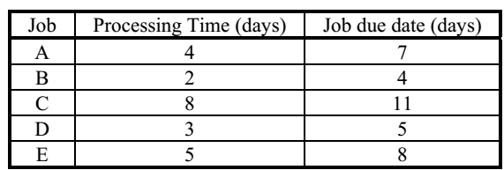

- C, E, A, D, B
- A, B, C, D, E
- B, D, A, E, C
- C, B, A, E, D
- none of the above

- Which of the following dispatching rules is typically the best technique for taking first those jobs with the most urgent needs?

- Shortest processing time
- Critical ratio
- Earliest due date
- Longest processing time
- None of the above

Part III: Fill in the blank Space
- __________________ is an approach to determine the quantity and timing of production for the intermediate future.
- A(n) ______________ is the result of the disaggregation of the aggregate plan.
- __________ scheduling begins with the due date and schedules the final operation first and the other job steps in reverse order.
- The ______________ is a special class of linear programming models that involves assigning tasks or jobs to resources.
- ________ determines the order in which jobs should be done at each work center.
Part IV: Write Short Answer for the Following Questions
- What four things are needed to develop an aggregate plan?
- Identify (a) the demand options for aggregate planning; and (b) the capacity (supply) options for aggregate planning.
- How does aggregate planning in services differ from aggregate planning in manufacturing?
Part V: Solve the Following Work out questions
- Jack's Refrigeration Repair is under contract to repair, recondition, and/or refurbish commercial and industrial icemakers from restaurants, seafood processors, and similar organizations. Jack currently has five jobs to be scheduled, shown in the order in which they arrived.
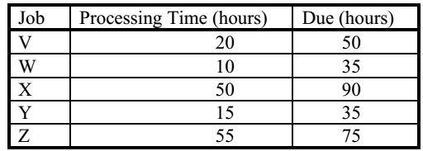
a. Complete the following table. (Show your supporting calculations below).
b. Which dispatching rule has the best score for flow time?
c. Which dispatching rule has the best score for work-in-process (jobs in the system)?
d. Which dispatching rule has the best score for lateness?
e. What dispatching rule would you select? Support your decision.
- The following jobs are waiting to be processed at your work center, which cleans valve body castings. Job numbers are assigned sequentially upon arrival in the facility (a missing number means that job does not require your work center). All dates are specified as days from present. Job Due Date Duration (days)
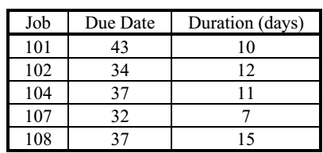
a. In what sequence should the jobs be processed according to the FCFS scheduling rule?
b. In what sequence should the jobs be processed according to the EDD scheduling rule?
c. In what sequence should the jobs be processed according to the SPT scheduling rule?
d. In what sequence should the jobs be processed according to the LPT scheduling rule?
e. In what sequence should the jobs be processed according to the critical ratio scheduling rule?
- Lockport Marine Services, Inc. wishes to assign a set of jobs to a set of machines. The following table provides data on the cost of production of each job when performed on a specific machine.
a. Determine the set of assignments that maximizes production value.
b. What is the total production value of your assignments?
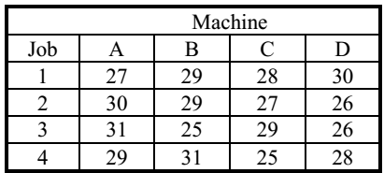

CHAPTER FIVE

QUALITY MANAGEMENT AND CONTROL
  - Meaning and Nature of Quality
Different meaning could be attached to the word quality under different circumstances. The word quality does not mean the quality of manufactured product only. It may refer to the quality of the process (i.e., men, material, and machines) and even that of management. Where the quality manufactured product referred as or defined as “Quality of product as the degree in which it fulfills the requirement of the customer. It is not absolute but it judged or realized by comparing it with some standards”.
Crosby defined as “Quality is conformance to requirement or specifications”. Juran defined as “Quality is fitness for use”. “The Quality of a product or service is the fitness of that product or service for meeting or exceeding its intended use as required by the customer.”
Today, there is no single, universal definition of quality. Some people view quality as “performance to standards.” Others view it as “meeting the customer’s needs” or “satisfying the customer.” Let’s look at some of the more common definitions of quality.
Conformance to specifications፡ measures how well the product or service meets the targets and tolerances determined by its designers. For example, the dimensions of a machine part may be specified by its design engineers as 3 ± 0.05 inches. This would mean that the target dimension is 3 inches, but the dimensions can vary between 2.95 and 3.05 inches. Similarly, the wait for hotel room service may be specified as 20 minutes, but there may be an acceptable delay of an additional 10 minutes. Also, consider the amount of light delivered by a 60-watt light bulb. If the bulb delivers 50 watts, it does not conform to specifications. As these examples illustrate, conformance to specification is directly measurable, though it may not be directly related to the consumer’s idea of quality.
Fitness for use፡ focuses on how well the product performs its intended function or use. For example, a Mercedes-Benz and a Jeep Cherokee both meet a fitness for use definition if one considers transportation as the intended function.
Value for price paid፡ is a definition of quality that consumers often use for product or service usefulness. This is the only definition that combines economics with consumer criteria; it assumes that the definition of quality is price sensitive.
Support services፡ provided are often how the quality of a product or service is judged. Quality does not apply only to the product or service itself; it also applies to the people, processes, and organizational environment associated with it.
Psychological criteria፡ is a subjective definition that focuses on the judgmental evaluation of what constitutes product or service quality. Different factors con- tribute to the evaluation, such as the atmosphere of the environment or the perceived prestige of the product.
Differences between Manufacturing and Service Organizations
Defining quality in manufacturing organizations is often different than it is for service organizations. Manufacturing organizations produce a tangible product that can be seen, touched, and directly measured. Examples include cars, CD players, clothes, computers, and food items. Therefore, quality definitions in manufacturing usually focus on tangible product features.
Dimensions of Quality for Manufacturing versus Service Organizations

The most common quality definition in manufacturing is conformance, which is the degree to which a product characteristic meets preset standards. Other common definitions of quality in manufacturing include performance, such as acceleration of a vehicle; reliability, meaning that the product will function as expected without failure; features, the extras that are included beyond the basic characteristics; durability, the expected operational life of the product; and serviceability, how readily a product can be repaired. In contrast to manufacturing, service organizations produce a product that is in- tangible. The intangible nature of the product makes defining quality difficult. Also, since a service is experienced, perceptions can be highly subjective. In addition to tangible factors, quality of services is often defined by perceptual factors. These include responsiveness to customer needs, courtesy and friendliness of staff, promptness in resolving complaints, and atmosphere. Other definitions of quality in services include time, the amount of time a customer has to wait for the service; and consistency, the degree to which the service is the same each time. For these reasons, defining quality in services can be especially challenging.

Overview of Total Quality Management (TQM)
TQM: An integrated effort designed to improve quality performance at every level of the organization. As per Feigebaum, “Total Quality Management is an effective system of integrating the quality development, quality maintenance and quality improvement efforts of various groups in an organization so as to enable marketing, engineering, production and service at the most economical levels which allow for full customer satisfaction”.
Benefits of TQM
The benefits of TQM can be classified into the following two categories:
1. Customer satisfaction-oriented benefits.
2. Economic improvements-oriented benefits.
1. Customer satisfaction-oriented benefits: The benefits under this category are listed below:
(a) Improvement in product quality.
(b) Improvement in product design.
(c) Improvement in production flow.
(d) Improvement in employee morale and quality consciousness.
(e) Improvement of product service.
(f) Improvement in market place acceptance.
2. Economic improvements-oriented benefits: The benefits under this category are as follows:
(a) Reductions in operating costs.
(b) Reductions in operating losses.
(c) Reductions in field service costs.
(d) Reductions in liability exposure.
The concept of quality has existed for many years, though it’s meaning has changed and evolved over time. The meaning of quality for businesses changed dramatically in the late 1970s. Before then quality was still viewed as something that needed to be inspected and corrected. However, in the 1970s and 1980s, many U.S. industries lost market share to foreign competition. In the auto industry, manufacturers such as Toyota and Honda became major players.
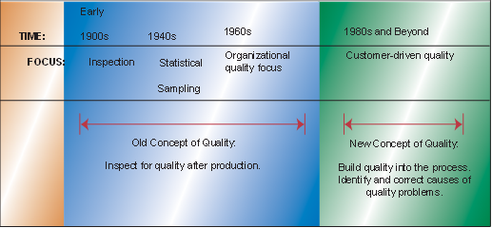
Quality Gurus: To fully understand the TQM movement, we need to look at the philosophies of individuals who have shaped the evolution of TQM. Their philosophies and teachings have contributed to our knowledge and understanding of quality today.
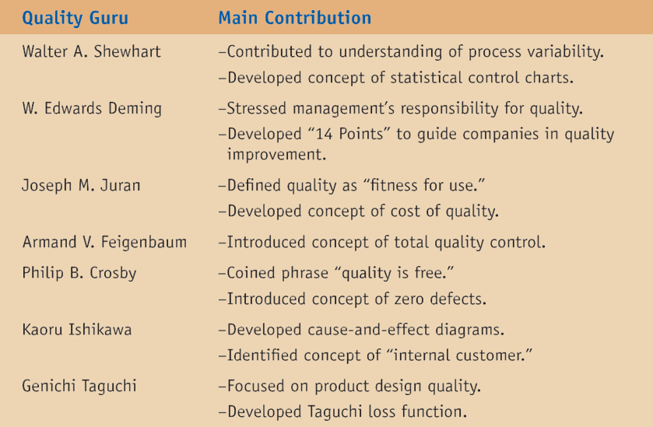
Customer Focus: The first, and overriding, feature of TQM is the company’s focus on its customers. Quality is defined as meeting or exceeding customer expectations. The goal is to first identify and then meet customer needs. TQM recognizes that a perfectly produced product has little value if it is not what the customer wants.
Continuous improvement፡ A philosophy of never-ending improvement. Another concept of the TQM philosophy is the focus on continuous improvement. Traditional systems operated on the assumption that once a company achieved a certain level of quality, it was successful and needed to make no further improvements.
Quality Specification
The Malcolm Baldrige National Quality Award (MBNQA)
The Malcolm Baldrige National Quality Award was established in 1987 when Congress passed the Malcolm Baldrige National Quality Improvement Act. The award is named after the former Secretary of Commerce Malcolm Baldrige, and is intended to reward and stimulate quality initiatives. It is designed to recognize companies that establish and demonstrate high-quality standards and is given to no more than two companies in each of three categories: manufacturing, service, and small business.
The Deming Prize
The Deming Prize is a Japanese award given to companies to recognize their efforts in quality improvement. The award is named after W. Edwards Deming, who visited Japan after World War II upon the request of Japanese industrial leaders and engineers. While there, he gave a series of lectures on quality. The Japanese considered him such an important quality guru that they named the quality award after him.
ISO 9000 Standards
Increases in international trade during the 1980s led to the development of universal standards of quality. Universal standards were seen as necessary in order for companies to be able to objectively document their quality practices around the world. Then in 1987 the International Organization for Standardization published its first set of standards for quality management, called ISO 9000. The purpose of the International Organization for Standardization (ISO) is to establish agreement on international quality standards. It currently has members from 91 countries, including the United States.

Statistical Process Control
Statistica1 quality control (SQC): is the term used to describe the set of statistical tools used by quality professionals. Statistical quality control can be divided into three broad categories:
- Descriptive statistics: are used to describe quality characteristics and relation- ships. Included are statistics such as the mean, the standard deviation, the range, and a measure of the distribution of data.
- Statistical process control (SPC): involves inspecting a random sample of the output from a process and deciding whether the process is producing products with characteristics that fall within a predetermined range. SPC answers the question of whether or not the process is functioning properly.
- Acceptance sampling: is the process of randomly inspecting a sample of goods and deciding whether to accept the entire lot based on the results. Acceptance sampling determines whether a batch of goods should be accepted or rejected.
Descriptive Statistics
The Mean is a statistic that measures the central tendency of a set of data. Knowing the central point of a set of data is highly important. Just think how important that number is when you receive test scores!
To compute the mean, we simply sum all the observations and divide by the total number of observations. The equation for computing the mean is
The Range and Standard Deviation: There are two measures that can be used to determine the amount of variation in the data. The first measure is the range, which is the difference between the largest and smallest observations. Another measure of variation is the standard deviation. The equation for computing the standard deviation is
Distribution of Data: When a distribution is symmetric, there is the same number of observations below and above the mean. This is what we commonly find when only normal variation is present in the data. When a disproportionate number of observations are either above or below the mean, we say that the data have a skewed distribution.

Statistical Process Control Methods
Statistical process control methods employ descriptive statistics to monitor the quality of the product and process. As we have learned so far, there are common and assignable causes of variation in the production of every product. Using statistical process control, we want to determine the amount of variation that is common or normal. Then we monitor the production process to make sure production stays within this normal range. That is, we want to make sure the process is in a state of control. The most commonly used tool for monitoring the production process is a control chart. Different types of control charts are used to monitor different aspects of the production process.
Developing Control Charts
A control chart (also called process chart or quality control chart) is a graph that shows whether a sample of data falls within the common or normal range of variation. A control chart has upper and lower control limits that separate common from assignable causes of variation. The common range of variation is defined by the use of control chart limits. We say that a process is out of control when a plot of data reveals that one or more samples fall outside the control limits.

Types of Control Charts
Control charts can be used to measure any characteristic of a product, such as the weight of a cereal box, the number of chocolates in a box, or the volume of bottled water. The different characteristics that can be measured by control charts can be divided into two groups: variables and attributes. A control chart for variables is used to monitor characteristics that can be measured and have a continuum of values, such as height, weight, or volume.

A control chart for attributes, on the other hand, is used to monitor characteristics that have discrete values and can be counted. Often, they can be evaluated with a simple yes-or-no decision.
Control Charts for Variables
Control charts for variables monitor characteristics that can be measured and have a continuous scale, such as height, weight, volume, or width. When an item is inspected, the variable being monitored is measured and recorded. Two of the most commonly used control charts for variables monitor both the central tendency of the data (the mean) and the variability of the data (either the standard deviation or the range).
Mean (x-Bar) Charts
A mean control chart is often referred to as an x-bar chart. It is used to monitor changes in the mean of a process. To construct a mean chart, we first need to construct the center line of the chart. To do this we take multiple samples and compute their means. Usually these samples are small, with about four or five observations. Each sample has its own mean, x. The center line of the chart is then computed as the mean of all k sample means, where k is the number of samples:
The following example shows the construction of a mean (x-bar) chart.
Another way to construct the control limits is to use the sample range as an estimate of the variability of the process. Remember that the range is simply the difference between the largest and smallest values in the sample. The spread of the range can tell us about the variability of the data. In this case, control limits would be constructed as follows.

Range (R) Charts
Range (R) charts are another type of control chart for variables. Whereas x-bar charts measure a shift in the central tendency of the process, range charts monitor the dispersion or variability of the process. The method for developing and using R-charts is the same as that for x-bar charts. The center line of the control chart is the average range, and the upper and lower control limits are computed as follows:
Where values for D4 and D3 are obtained from the Table.
Using Mean and Range Charts Together
You can see that mean and range charts are used to monitor different variables. The mean or x-bar chart measures the central tendency of the process, whereas the range chart measures the dispersion or variance of the process. Since both variables are important, it makes sense to monitor a process using both mean and range charts. It is possible to have a shift in the mean of the product but not a change in the dispersion.
Control Charts for Attributes
Control charts for attributes are used for quality characteristics that are counted rather than measured. Attributes are discrete in nature and entail simple yes-or-no decisions. P-charts are used to measure the proportion of items in a sample that are defective, while C-charts count the actual number of defects. To summarize:
P- Charts: Used when observations are placed in either of two groups. Examples:
  - Defective or not defective
  - Good or bad
  - Broken or not broken
C-Charts: Used when defects can be counted per unit of measure. Examples:
  - Number of dents per item
  - Number of complaints per unit of time (e.g., hour, month, year)
  - Number of tears per unit of area (e.g., square foot, square meter)
Problem-Solving Tip ፡the primary difference between using a p-chart and a c-chart is as follows. A p-chart is used when both the total sample size and the number of defects can be computed. A c-chart is used when we can compute only the number of defects but cannot compute the proportion that is defective.
P-Charts
P-charts are used to measure the proportion that is defective in a sample. The computation of the center line as well as the upper and lower control limits is similar to the computation for the other kinds of control charts. The center line is computed as the average proportion defective in the population, p. This is obtained by taking a number of sample observations at random and computing the average value of p across all samples.
To construct the upper and lower control limits for a p-chart, we use the following formulas:
As with the other charts, z is selected to be either 2 or 3 standard deviations, depending on the amount of data we wish to capture in our control limits. Usually, however, the deviations are set at 3. The sample standard deviation is computed as follows:
Where n is the sample size.
C-Charts
C-charts are used to monitor the number of defects per unit. Examples are the number of returned meals in a restaurant, the number of trucks that exceed their weight limit in a month, the number of discolorations on a square foot of carpet, and the number of bacteria in a milliliter of water. Note that the types of units of measurement we are considering are a period of time, a surface area, or a volume of liquid.
The average number of defects, c, is the center line of the control chart. The upper and lower control limits are computed as follows:

We have discussed several types of statistical quality control (SQC) techniques. One category of SQC techniques consists of descriptive statistics such as the mean, range, and standard deviation. These tools are used to describe quality characteristics and relationships. Another category of SQC techniques consists of statistical process control (SPC) methods that are used to monitor changes in the production process. Common causes of variation are random causes that cannot be identified. A certain amount of common or normal variation occurs in every process due to differences in materials, workers, machines, and other factors. Assignable causes of variation, on the other hand, are variations that can be identified and eliminated. An important part of statistical process control (SPC) is monitoring the production process to make sure that the only variations in the process are those due to common or normal causes.

SUMMARY
TQM is an integrated effort designed to improve quality performance at every level of the organization. We need to look at the philosophies of individuals who have shaped the evolution of TQM including should Walter A. Shewrt, Edwards Deming, Juran, Crospy, Taguchi, etc to fully understand the TQM movement. Their philosophies and teachings have contributed to our knowledge and understanding of quality today. Statistica1 quality control (SQC) is the term used to describe the set of statistical tools used by quality professionals. Statistical quality control can be divided into three broad categories such as Descriptive statistics, Statistical process control (SPC), and acceptance sampling. Statistical process control methods also employ descriptive statistics to monitor the quality of the product and process.
Check list
Part I: Say True if the Statement is Correct and False if it is Incorrect.
- For most, if not all organizations, quality is a tactical rather than a strategic issue.
- Improved quality can increase profitability via flexible pricing.
- Kaizen is similar to TQM in that both are focused on continuous improvement.
Part II: Please Select the Alternative that Best Answers the Question.
- "Employees cannot produce goods that on average exceed the quality of what the process is capable of producing" expresses a basic element in the writings of

- Vilfredo Pareto
- Armand Feigenbaum
- Joseph M. Juran
- W. Edwards Deming
- Philip B. Crosby

- Total quality management emphasizes
- the responsibility of the quality control staff to identify and solve all quality-related problems
- a commitment to quality that goes beyond internal company issues to suppliers and customers
- a system where strong managers are the only decision makers
- a process where mostly statisticians get involved
- ISO 14000 certification
- Among the tools of TQM, the tool ordinarily used to aid in understanding the sequence of events through which a product travels is a

- Pareto chart
- Process chart
- Check sheet
- Taguchi map
- Poka-yoke

- Which of the following is false regarding control charts?
- Values above the upper control limits always imply that the product’s quality is exceeding expectations.
- Control charts are built so that new data can be quickly compared to past performance data.
- Control charts graphically present data.
- Control charts plot data over time.
- None of the above is false.
Part III: Solve the Following Work out questions
- An operator trainee is attempting to monitor a filling process that has an overall average of 705 cc. The average range is 17 cc. If you use a sample size of 6, what are the upper and lower control limits for the X-bar and R chart?
- A part that connects two levels should have a distance between the two holes of 4". It has been determined that X-bar and R-charts should be set up to determine if the process is in statistical control. The following ten samples of size four were collected. Calculate the control limits, plot the control charts, and determine if the process is in control.

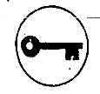
Answer for self-test questions
Chapter 1
Part I

- True
- True
- False
- D
- E

Part II

- D
- C
- A
- A
- A
- D
- D
- E
- A

Part III
- Operations management can be defined as the management of all activities directly related to the creation of goods and/or services through the transformation of inputs into outputs.
- A service is usually intangible; it is often produced and consumed simultaneously; often unique; it involves high customer interaction; product definition is inconsistent; often knowledge-based; and frequently dispersed
Part IV
- A. 16 ornaments/8 hours = 2 ornaments/hour B. 20 ornaments/8 hours = 2.5 ornaments/hour C. Change in productivity = 0.5 ornaments/hour; percent change = 0.5/2= 25%
- MFP before: 500 boxes / ($10x5x16 + $3000 + $400) = 500 / 4200 = 0.119 boxes/dollar MFP after: 600 boxes / ($10x5x16 + $3200 + $400) = 600 / 4400 = 0.136 boxes/dollar
Chapter 2
Part I

- False
- True
- False
- True
- True

Part II

- E
- C
- B
- E
- B
- A
- C
- C

Part III
- A firm's mission is its purpose or rationale for an organization’s existence, whereas a firm's strategy is how it expects to achieve its mission and goals.
- A set of skills, talents, and activities that a firm does particularly well.
- Strategies should be dynamic because of changes within the organization; and changes in the environment.
- The multi domestic strategy decentralizes operating decisions to each country to enhance local responsiveness. The primary example is McDonald's. The global strategy centralizes operating decisions, with headquarters coordinating the standardization and learning between facilities. The textbook names Texas Instruments and Caterpillar. The international strategy uses exports and licenses to penetrate the global markets. Students may cite Pier One, World Market, or any wine store. The transnational strategy exploits the economies of scale and learning, as well as pressure for responsiveness, by recognizing that core competence does not reside in just the "home" country, but can exist anywhere in the organization. Examples from the textbook include Bertelsmann, Reuters and Nestlé.
Chapter 3
Part I

- False
- True
- True
- True
- True
- False
- False
- False
- False
- False
- False
- True
- True

Part II

- D
- E
- D
- C
- B
- D
- C
- B
- B
- A
- B
- D
- H
- E
- C
- D
- B
- C
- D
- C
- D
- A
- C
- B
- E
- D
- A
- B
- C
- B

Part III
- A product-by-value analysis lists products in descending order of their individual dollar contribution to the firm, as well as the total annual dollar contribution of the product. It helps managers evaluate possible strategies for each product. The product-by-value report focuses management's attention on the strategic direction for each product.
- Product quality (better adherence to standards); shorter design time; production cost reductions (from better design); database availability (for new products); and new range of capabilities (ease programming of CNC machines).
- There is no reason for the strategy to be static through the life cycle stages. Organizations often treat new products differently than older ones, in terms of support for changes, aggressiveness in pursuit of market, etc. In particular, growth is associated with stabilization of design, and with ensuring that sufficient capacity exists. Maturity is a time for high-volume operations and cost control.
- Specifically, the following ideas are presented in the text: make products recyclable, use recycled material, use less harmful ingredients, use lighter components, use less energy, and use less material.
- Intermittent has high variety, low volume, low utilization, general purpose equipment. Since most output is made to order, there is little inventory of raw materials or finished goods. Continuous has low variety, high volume, high utilization, and specialized equipment. Just in time practices keep inventory very low.
- Design capacity is the theoretical maximum output of a system in a given period under ideal conditions. Effective capacity, on the other hand, is the capacity that a firm expects to achieve given the current operating constraints. Effective capacity is often lower than design capacity because the facility may have been designed for an earlier version of the product or a different product mix than is currently being produced. As an example, a restaurant might have 100 seats, but it only opens up 60 every night because it cannot find enough qualified servers.
- Both are ratios, not item counts. Both use actual output in the ratio numerator. Utilization is the ratio of actual output to design capacity, so it measures output as a fraction of ideal facility usage. Efficiency is the ratio of actual output to effective capacity, so it measures output as a fraction of the practical or current limits of the facility.
- The capacity decision is important for several reasons. First, capacity costs represent a large portion of fixed costs. Second, a facility of the wrong size means that costs are not as low as they could be. If a facility is too large, and portions of it remain idle, the firm's costs are too high because of the higher fixed costs. If a plant is too small, costs are again higher than they might be due to inefficiencies of working in cramped and crowded spaces. Further, a facility too small may lead to lost sales, perhaps even lost markets.
- There are several possible paths students can take. The most obvious is the economic argument that economies of scale call for ever larger plants. Students may want to address the lead, lag, or straddle strategies of growing to meet demand. But demand is not growing very much —it's up from 890,000 tons per mill to 1,000,000 tons per mill over 5 years. Students may alternately try to analyze the considerations of matching capacity to demand, and describe pricing strategies or internal changes to meet demand. But the broadest view suggests that the industry (not individual mills) operated somewhat above break-even in 1999, but is squarely at break-even now. The increased capacities do not seem much of an improvement.
- Cycle time is the ratio of allowed work time to units scheduled. The theoretical minimum number of workstations in an assembly line is determined by dividing the total task-duration time for the product by the cycle time. The efficiency of a line balance is determined by dividing the total task time assigned by the product of the number of workstations times the cycle time.
- Ergonomics deals with the human factors of work. Ergonomic studies take into account the height, weight, range of motion, and other physical attributes typical of employees, along with variations from those norms. Ergonomic influences should result in workstations that are the proper height for employees, comfortable for the range of motions of that job, and free from unnecessary danger, noise, or other environmental detriments to work.
Part IV
- Efficiency = 1350 / 1400 = .964 or 96.4 percent; utilization = 1350 / 1800 = .75 or 75 percent
- Utilization = actual output/design capacity = 950/1100 = 86.4%
Efficiency = actual output/effective capacity = 950/1000 = 95.0%
- Utilization = actual output/design capacity = 400/800 = 50.0%
Efficiency = actual output/effective capacity = 400/600 = 66.7%
- (a) The cycle time is 480 minutes per day / 80 ovens = 6 minutes/oven. (b) The minimum number of workstations is the sum of all task times, 15 minutes, divided by the cycle time, 6 minutes; 15 / 6 = 2.5 or 3 workstations. (c) The precedence diagram appears below.
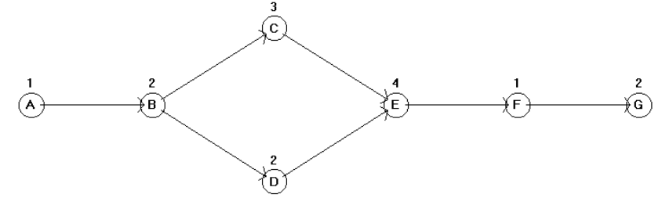

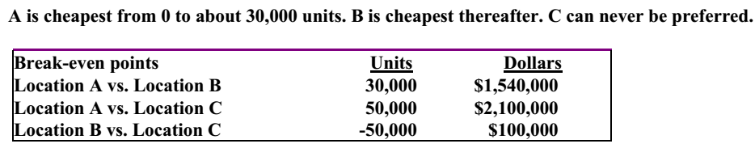
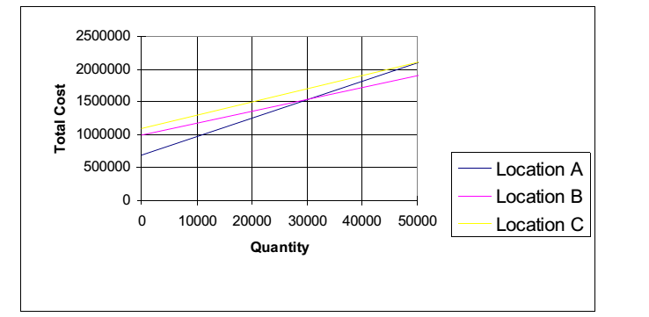
- ,
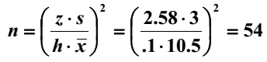
- , 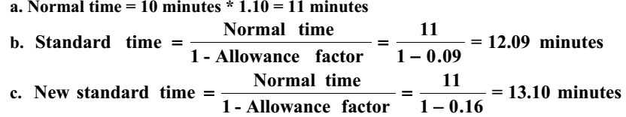
Chapter 4
Part I

- False
- False
- True
- True
- False

Part II

- D
- A
- B
- D
- C
- C
- E

Part III
- Aggregate planning
- Master production schedule
- Backward
- Assignment method
- Sequencing
Part IV
- To develop an aggregate plan, you need a logical overall unit for measuring sales and output, a forecast of demand for reasonable intermediate planning period in aggregate planning terms, a method for determining the cost associated with an aggregate plan, and a model that combines forecasts and costs so that scheduling decisions can be made for the planning period.
- Demand options are: influencing demand (through price, promotion, advertising, selling), back ordering during high-demand periods, and counter seasonal product and service mixing.
Capacity options are: changing inventory levels, varying workforce size by hiring or layoffs, varying production rates through overtime or idle time, subcontracting, and using part-time workers.
- Aggregate planning in services differs from aggregate planning in manufacturing in the following ways:
- Most services are perishable and cannot be inventoried. It is virtually impossible to produce the service early in anticipation of higher demand at a later time.
- Demand for services is often difficult to predict. Demand variations are typically more severe and more frequent.
- Services are more customized than manufactured goods and can be offered in many different forms. This variability makes it difficult to allocate capacity. Units of capacity may also be hard to define.
- Because most services cannot be transported, service capacity must be available at the appropriate place as well as at the appropriate time.
- Service capacity is generally altered by changes in labor, rather than by equipment or space, and labor is a highly flexible resource.

Part V

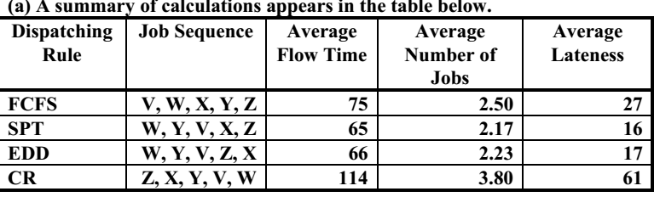
(b, c, d) SPT is best on all three criteria: flow time, work-in-process, and lateness. (e) Most students will select SPT as quite obvious, but EDD is a close second in all criteria. Supporting calculations for each priority rule appear in the tables below.
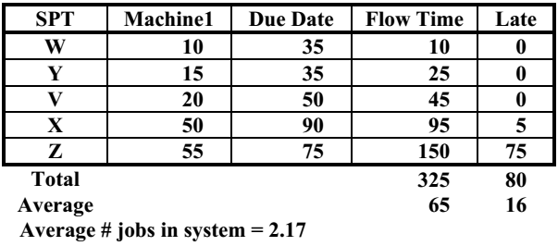
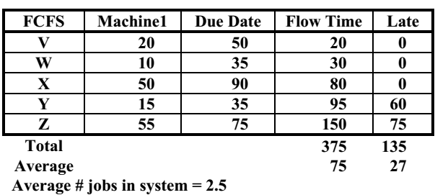
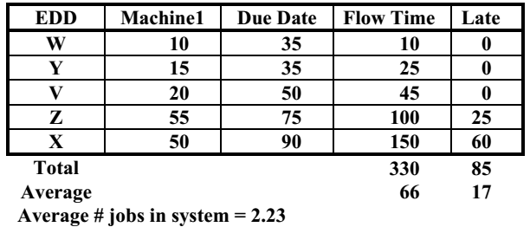
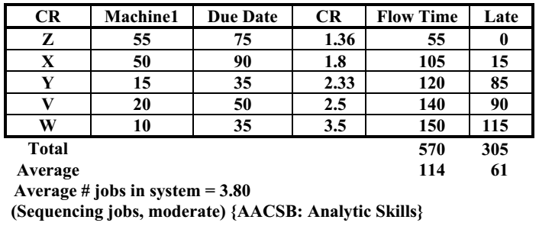
- FCFS: 101, 102, 104, 107, 108 EDD: 107, 102, 104 and 108 (tie), 101
SPT: 107, 101, 104, 102, 108
LPT: 108, 102, 104, 101, 107
CR: 108 (2.47), 102 (2.67), 104 (3.36), 101 (3.40), 107 (6.14)
- (a) The optimal set of assignments is Job 1Machine A, Job 2Machine D, Job 3Machine B, and Job 4Machine C. (b) The total production value is 103.
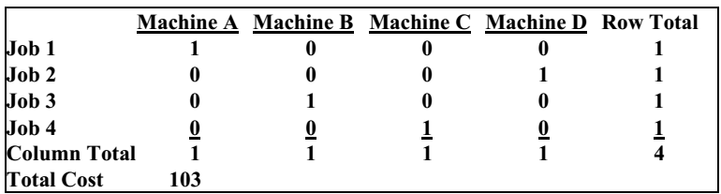

Chapter 5
Part I

- False
- True
- True

Part II

- D
- B
- B
- A

Part III

